**San Francisco Bay University**

**EE488 - Computer Architecture**

**Homework Assignment #4**

**Due day: 3/27/2025**

**Instructions:**

1. **The homework answer sheet should contain the original questions and corresponding answers.**
2. **The answer sheet must be in MS-Word file format with Github links for the programming questions. As follows is the answer sheet name format.**

***<course_id>_week<week_number>_StudentID_FirstName_LastName.pdf***

1. **The program name in Github must follow the format like   
   *<course_id>_week<week_number>_q<question_number>_StudentID_FirstName_LastName***
2. **Show screenshot of all running results, including the system date/time.**
3. **The calculation process must be typed if needed, handwriting can’t be accepted.**
4. **Only accept homework submission uploaded via Canvas.**
5. **Overdue homework submission can’t be accepted.**
6. **Takes academic honesty and integrity seriously (Zero Tolerance of Cheating & Plagiarism)**
7. Implement the following subroutine function in the *utils.asm* file, properly documenting them, and include programs to test them.
   1. *Mult10* - take an input parameter and return that parameter multiplied by *10* using ONLY shift and add operations.
   2. *ToUpper* - take a *32*-bits input which is *3* characters and a null, or a *3-* characters string. Convert the *3* characters to upper case if they are lower case or do nothing if they are already upper case.
   3. *ToLower* - take a *32-*bits input which is 3 characters and a null, or a *3*-characters string. Convert the *3* characters to lower case if they are upper case or do nothing if they are already lower case.

#####################################################

# utils.asm

# Q1: Mult10, ToUpper, ToLower + tes)

#####################################################

.data

newline: .asciiz "\n"

test_val_mult: .word 7

# pack 'a','b','c' into low 3 bytes: 0x00 63 62 61 → 0x00636261

test_val_upper: .word 0x00636261

# pack 'X','Y','Z' into low 3 bytes: 0x00 5A 59 58 → 0x005A5958

test_val_lower: .word 0x005A5958

.text

.globl main

main:

# Test 1: Mult10(7) → print 70

la $t0, test_val_mult

lw $a0, 0($t0)

jal Mult10

move $a0, $v0

li $v0, 1

syscall

# newline

la $a0, newline

li $v0, 4

syscall

# Test 2: ToUpper("abc") → print "ABC"

la $t0, test_val_upper

lw $a0, 0($t0)

jal ToUpper

move $t2, $v0

# print byte 0

andi $t1, $t2, 0xFF

move $a0, $t1

li $v0, 11

syscall

# print byte 1

srl $t1, $t2, 8

andi $t1, $t1, 0xFF

move $a0, $t1

li $v0, 11

syscall

# print byte 2

srl $t1, $t2, 16

andi $t1, $t1, 0xFF

move $a0, $t1

li $v0, 11

syscall

# newline (ASCII 10)

li $a0, 10

li $v0, 11

syscall

# Test 3: ToLower("XYZ") → print "xyz"

la $t0, test_val_lower

lw $a0, 0($t0)

jal ToLower

move $t2, $v0

# print byte 0

andi $t1, $t2, 0xFF

move $a0, $t1

li $v0, 11

syscall

# print byte 1

srl $t1, $t2, 8

andi $t1, $t1, 0xFF

move $a0, $t1

li $v0, 11

syscall

# print byte 2

srl $t1, $t2, 16

andi $t1, $t1, 0xFF

move $a0, $t1

li $v0, 11

syscall

# newline

li $a0, 10

li $v0, 11

syscall

hang:

j hang

nop

# ------------------------------------------------------------

# Mult10:

# Multiply $a0 by 10 → $v0 using only shifts & adds

# Clobbers: $t0, $t1

# ------------------------------------------------------------

Mult10:

sll $t0, $a0, 3

sll $t1, $a0, 1

add $v0, $t0, $t1

jr $ra

nop

# ------------------------------------------------------------

# ToUpper:

# Lowercase→uppercase for up to three ASCII bytes in $a0 → $v0

# Clobbers: $t0–$t4

# ------------------------------------------------------------

ToUpper:

move $t2, $a0

li $t3, 0x20

# byte 0

andi $t0, $t2, 0xFF

li $t1, 'a'

li $t4, 'z'

blt $t0, $t1, U0skip

bgt $t0, $t4, U0skip

sub $t0, $t0, $t3

U0skip:

andi $t2, $t2, 0xFFFFFF00

or $t2, $t2, $t0

# byte 1

srl $t0, $a0, 8

andi $t0, $t0, 0xFF

li $t1, 'a'

li $t4, 'z'

blt $t0, $t1, U1skip

bgt $t0, $t4, U1skip

sub $t0, $t0, $t3

U1skip:

sll $t0, $t0, 8

andi $t2, $t2, 0xFFFF00FF

or $t2, $t2, $t0

# byte 2

srl $t0, $a0, 16

andi $t0, $t0, 0xFF

li $t1, 'a'

li $t4, 'z'

blt $t0, $t1, U2skip

bgt $t0, $t4, U2skip

sub $t0, $t0, $t3

U2skip:

sll $t0, $t0, 16

andi $t2, $t2, 0xFF00FFFF

or $t2, $t2, $t0

move $v0, $t2

jr $ra

nop

# ------------------------------------------------------------

# ToLower:

# Uppercase→lowercase for up to three ASCII bytes in $a0 → $v0

# Clobbers: $t0–$t4

# ------------------------------------------------------------

ToLower:

move $t2, $a0

li $t3, 0x20

# byte 0

andi $t0, $t2, 0xFF

li $t1, 'A'

li $t4, 'Z'

blt $t0, $t1, L0skip

bgt $t0, $t4, L0skip

add $t0, $t0, $t3

L0skip:

andi $t2, $t2, 0xFFFFFF00

or $t2, $t2, $t0

# byte 1

srl $t0, $a0, 8

andi $t0, $t0, 0xFF

li $t1, 'A'

li $t4, 'Z'

blt $t0, $t1, L1skip

bgt $t0, $t4, L1skip

add $t0, $t0, $t3

L1skip:

sll $t0, $t0, 8

andi $t2, $t2, 0xFFFF00FF

or $t2, $t2, $t0

# byte 2

srl $t0, $a0, 16

andi $t0, $t0, 0xFF

li $t1, 'A'

li $t4, 'Z'

blt $t0, $t1, L2skip

bgt $t0, $t4, L2skip

add $t0, $t0, $t3

L2skip:

sll $t0, $t0, 16

andi $t2, $t2, 0xFF00FFFF

or $t2, $t2, $t0

move $v0, $t2

jr $ra

nop

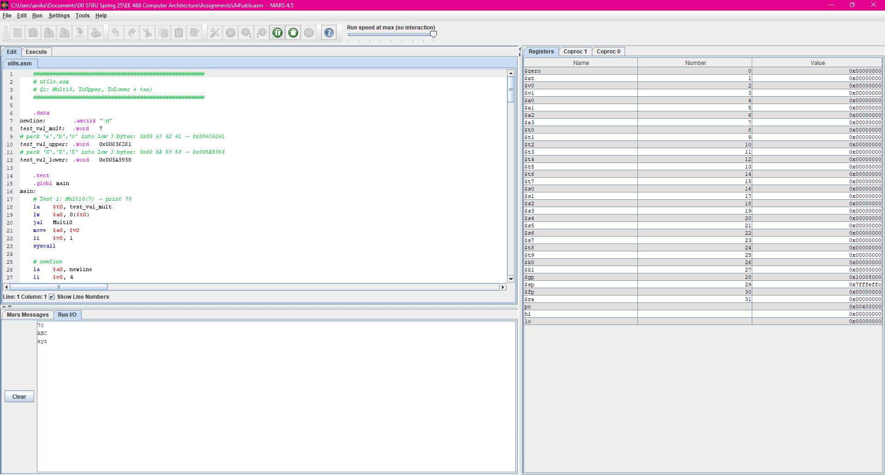

1. Write a program to find prime numbers from *3* to *n* in a loop in MIPS assembly.

#####################################################

# a4q2.asm

# Q2: Read n (>=3), print primes 3..n, then exit

#####################################################

.data

prompt_n: .asciiz "Enter an integer n (>= 3): "

newline: .asciiz "\n"

.text

.globl main

main:

# Prompt for n

li $v0, 4

la $a0, prompt_n

syscall

# Read n into $t5

li $v0, 5

syscall

move $t5, $v0 # t5 = n

# Initialize i = 3

li $t0, 3

loop_i:

# If i > n, exit

bgt $t0, $t5, exit

# Test divisors j = 2..√i

li $t1, 2 # j = 2

test_j:

mul $t2, $t1, $t1 # t2 = j * j

bgt $t2, $t0, is_prime # if j^2 > i, it's prime

div $t0, $t1 # divide i by j

mfhi $t3 # t3 = remainder

beq $t3, $zero, next_i # divisible → not prime

addi $t1, $t1, 1 # j++

j test_j

is_prime:

# Print i

li $v0, 1

move $a0, $t0

syscall

# Print newline

li $v0, 4

la $a0, newline

syscall

next_i:

addi $t0, $t0, 1 # i++

j loop_i

exit:

# Clean exit

li $v0, 10

syscall

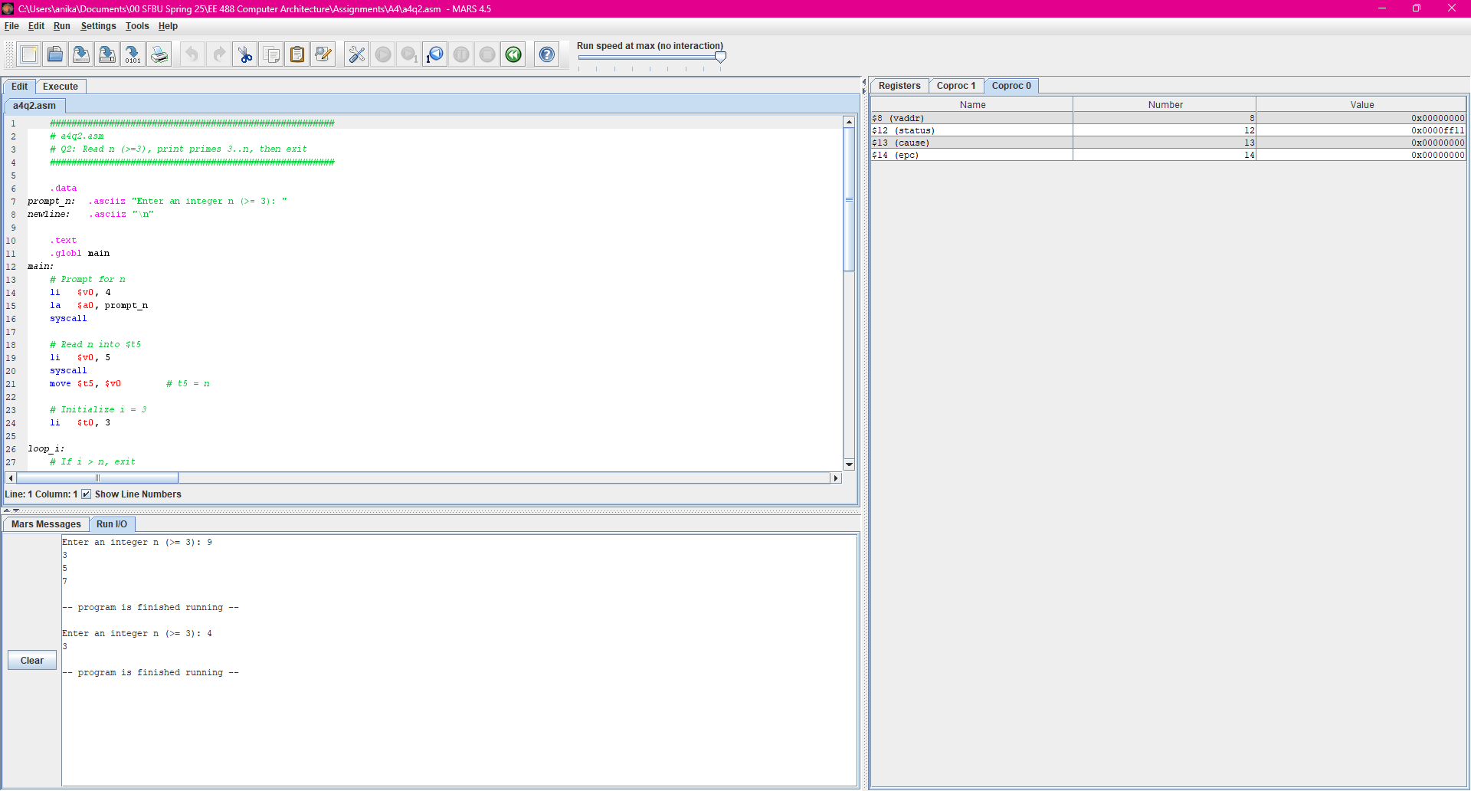

1. Prompt the user for a number from *3…100* and determine the prime factors for that number. For example, *15* has prime factors *3* and *5*. *60* has prime factors *2, 3*, and *5*. You ONLY have to print out the prime factors.

#####################################################

# a4q3.asm

# Q3: Read n (3–100), print its prime factors (with repeats),

# then exit.

#####################################################

.data

prompt_n: .asciiz "Enter an integer n (3-100): "

prompt_fact: .asciiz "Prime factors: "

comma_space: .asciiz ", "

newline: .asciiz "\n"

.text

.globl main

main:

# — Prompt for n —

li $v0, 4

la $a0, prompt_n

syscall

# — Read n into $t1 —

li $v0, 5

syscall

move $t1, $v0 # t1 = n

# — Print header —

li $v0, 4

la $a0, prompt_fact

syscall

# — Initialize factor = 2 —

li $t0, 2

factor_loop:

# if factor > remaining (t1), we’re done

bgt $t0, $t1, done_factors

# divide remaining by factor

div $t1, $t0

mfhi $t2 # t2 = remainder

# if not divisible, bump factor

bne $t2, $zero, next_factor

# — divisible: print factor —

li $v0, 1

move $a0, $t0

syscall

# — print ", " —

li $v0, 4

la $a0, comma_space

syscall

# update remaining = quotient

mflo $t1

# loop again with same factor (to catch repeats)

j factor_loop

next_factor:

addi $t0, $t0, 1 # factor++

j factor_loop

done_factors:

# newline

li $v0, 4

la $a0, newline

syscall

# exit

li $v0, 10

syscall

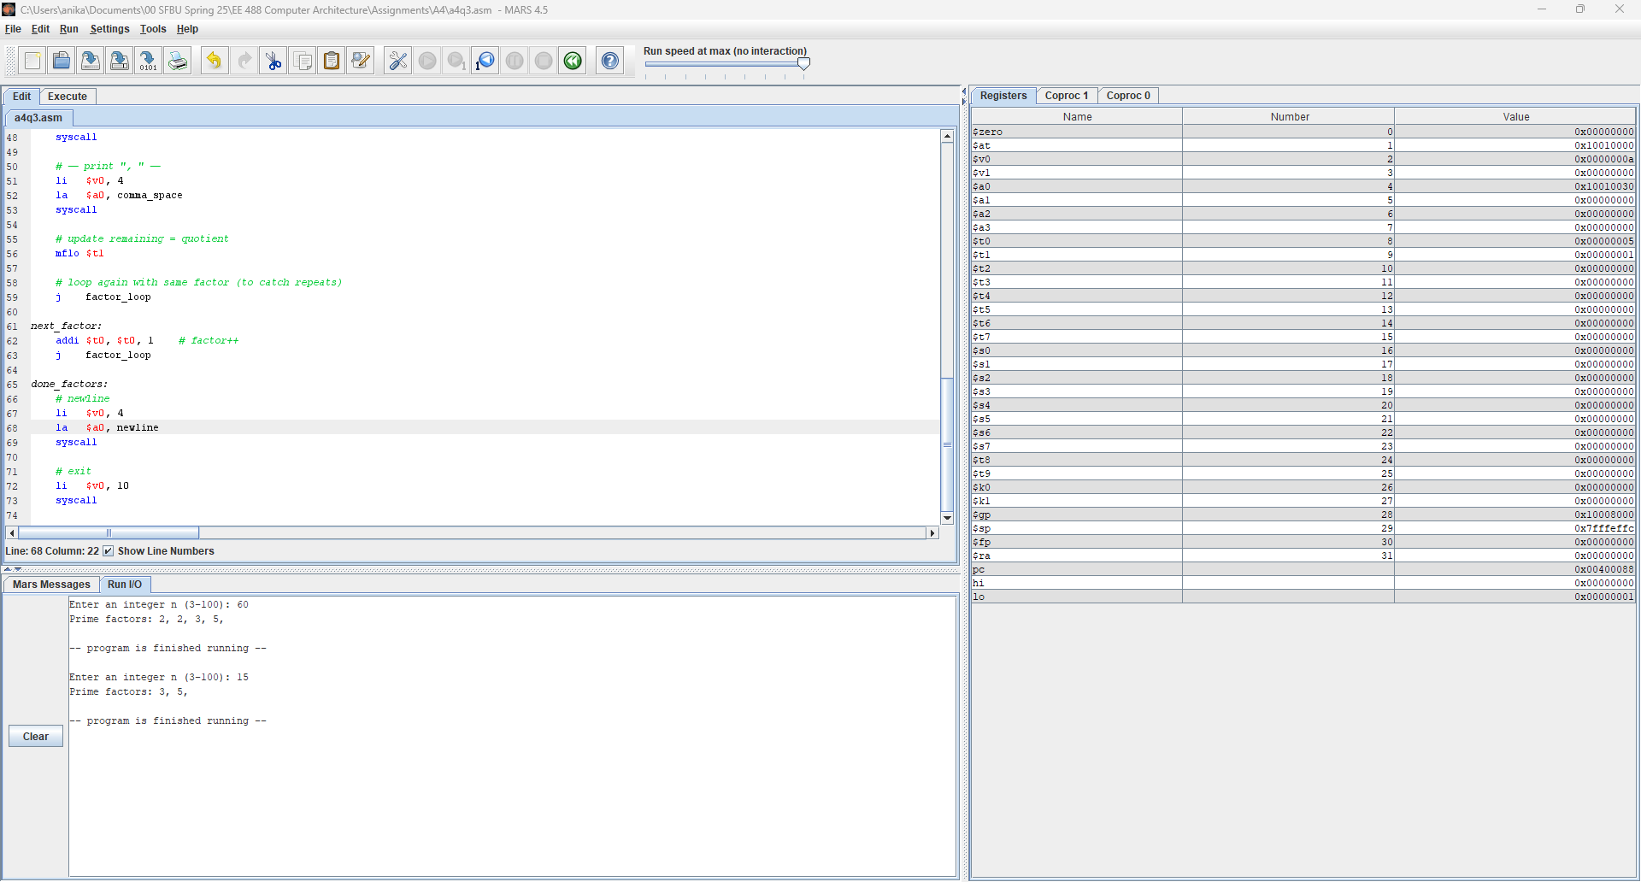

1. Using only *sll* and *srl*, implement a program to check if a user input value is even or odd. The program should read a user input integer and print out "The number is even" if the number is even, or "The number is odd", if the number is odd.

#####################################################

# a4q4.asm

# Q4: Read an integer and print “even” or “odd”

# using only srl/sll for the test.

#####################################################

.data

prompt_even: .asciiz "Enter an integer: "

even_str: .asciiz "The number is even\n"

odd_str: .asciiz "The number is odd\n"

.text

.globl main

main:

# Call the even/odd tester

jal even_odd

# Exit program

li $v0, 10

syscall

# ------------------------------------------------------------

# even_odd:

# Prompts for an integer, reads it, and prints

# even_str if it’s even, odd_str if it’s odd.

# Only uses srl/sll to test the low bit.

# ------------------------------------------------------------

even_odd:

# Print prompt

li $v0, 4

la $a0, prompt_even

syscall

# Read integer into t0

li $v0, 5

syscall

move $t0, $v0

# Compute t1 = (t0 >> 1) << 1

srl $t1, $t0, 1

sll $t1, $t1, 1

# If t1 == t0, it was even

beq $t1, $t0, EVEN

# Otherwise, odd

li $v0, 4

la $a0, odd_str

syscall

jr $ra

EVEN:

li $v0, 4

la $a0, even_str

syscall

jr $ra

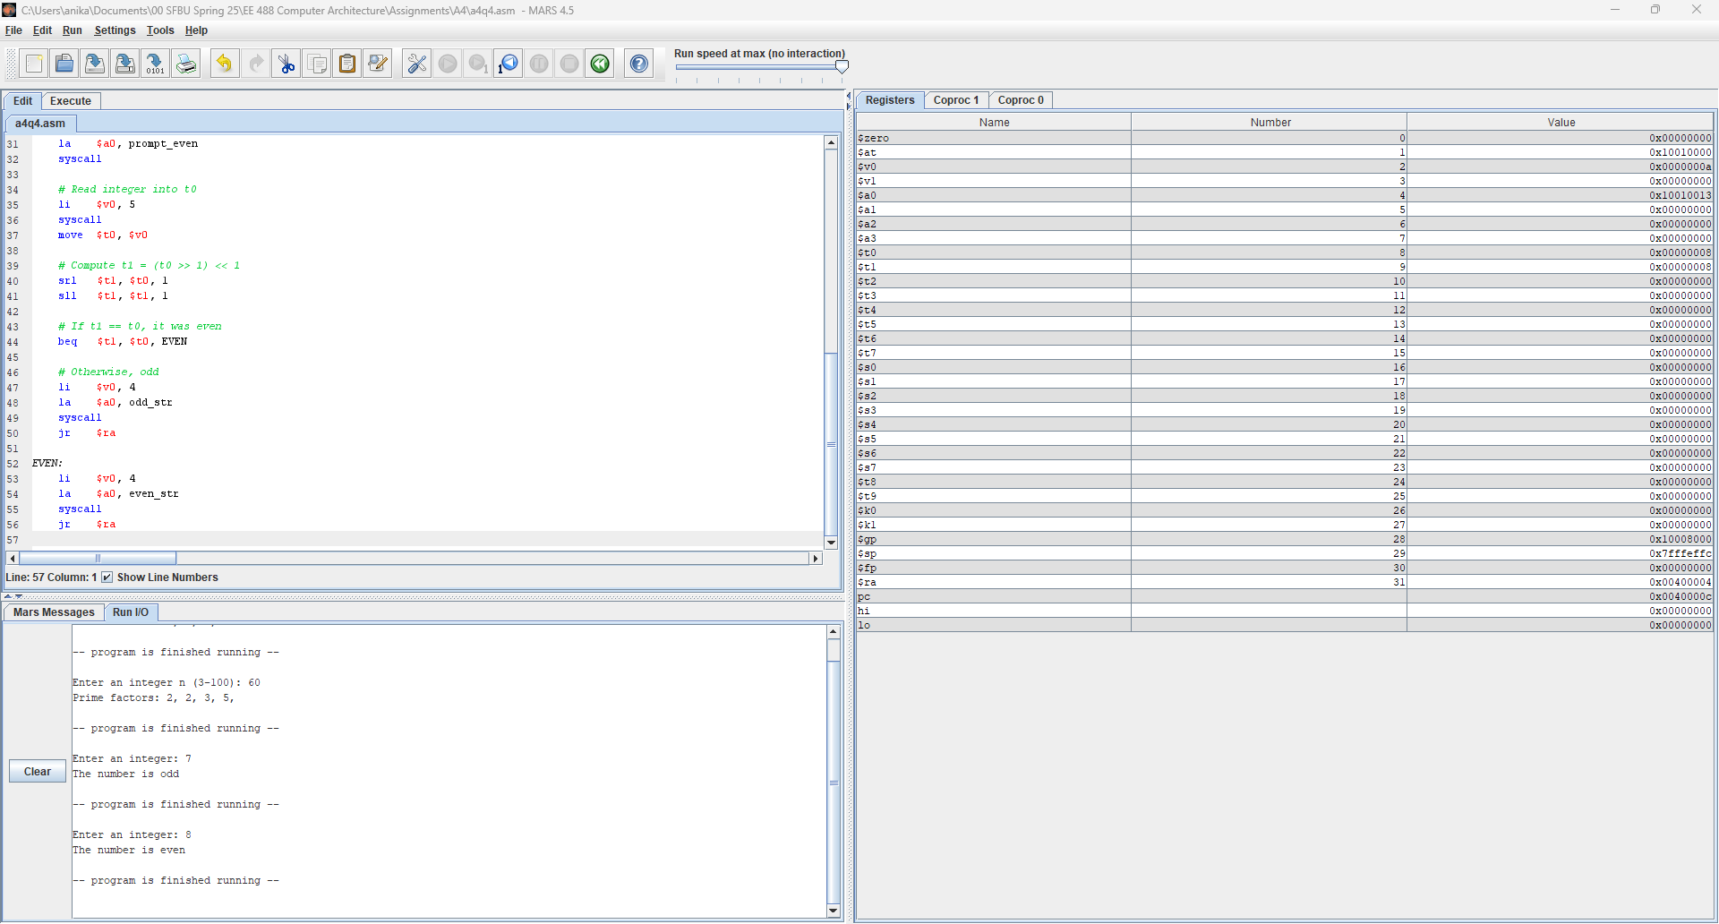

1. Prompt the user for a number *n*, *0 < n < 100*. Print out the smallest number of coins

(quarters, dimes, nickels, and pennies) which will produce *n*. For example, if the user enters *"66",* your program should print out "*2* quarters, *1* dime, *1* nickel, and *1* penny".

#####################################################

# a4q5.asm

# Q5: Read an amount (1–99 cents), compute change in

# quarters, dimes, nickels, pennies, then exit.

#####################################################

.data

prompt_amt: .asciiz "Enter amount in cents (1-99): "

quarter_lbl: .asciiz " quarters, "

dime_lbl: .asciiz " dimes, "

nickel_lbl: .asciiz " nickels, "

penny_lbl: .asciiz " pennies\n"

.text

.globl main

main:

# Call the coin_change routine

jal coin_change

# Exit program

li $v0, 10

syscall

# ------------------------------------------------------------

# coin_change:

# Prompts for an amount in cents, reads it, then computes

# the number of quarters, dimes, nickels, and pennies, and

# prints each count with its label.

# Uses only div/mflo/mfhi for arithmetic.

# ------------------------------------------------------------

coin_change:

# Prompt the user

li $v0, 4

la $a0, prompt_amt

syscall

# Read the amount into t0

li $v0, 5

syscall

move $t0, $v0 # t0 = amount

# Compute quarters

li $t1, 25

div $t0, $t1

mflo $t2 # t2 = #quarters

mfhi $t0 # t0 = remainder

# Compute dimes

li $t1, 10

div $t0, $t1

mflo $t3 # t3 = #dimes

mfhi $t0 # t0 = remainder

# Compute nickels

li $t1, 5

div $t0, $t1

mflo $t4 # t4 = #nickels

mfhi $t0 # t0 = remainder

# Remaining pennies

move $t5, $t0 # t5 = #pennies

# Print quarters

li $v0, 1

move $a0, $t2

syscall

li $v0, 4

la $a0, quarter_lbl

syscall

# Print dimes

li $v0, 1

move $a0, $t3

syscall

li $v0, 4

la $a0, dime_lbl

syscall

# Print nickels

li $v0, 1

move $a0, $t4

syscall

li $v0, 4

la $a0, nickel_lbl

syscall

# Print pennies

li $v0, 1

move $a0, $t5

syscall

li $v0, 4

la $a0, penny_lbl

syscall

jr $ra

nop

