Phase 1 — Requirements & Architecture
Air-Gapped Predictive Copilot for Secure MPLS Operations
Deliverables 1–5 · Week 1–2

1. Device & Protocol Inventory
The system is designed to be vendor-agnostic, but the initial deployment targets the following MPLS device families and telemetry protocols. This list should be adjusted to match the actual hardware inventory of the target network before Phase 2 begins.
Device / Vendor | Role in MPLS Network | Telemetry Protocol(s) | Data Collected
Cisco IOS-XE routers (PE / P routers) | MPLS core / edge | SNMP v3, Syslog, NetFlow/IPFIX | CPU, memory, interface errors, LSP status, traffic counters
Cisco IOS-XR routers | MPLS core | SNMP v3, Syslog, gNMI (telemetry streaming) | BGP/LDP session state, queue drops, latency
Juniper MX Series (PE routers) | MPLS edge | SNMP v3, Syslog, JTI/gNMI | Interface stats, LSP/RSVP state, packet loss
Juniper ACX / QFX (P routers, aggregation) | MPLS core / aggregation | SNMP v3, Syslog | Bandwidth utilization, error rate, uptime
Generic SNMP-capable switches | Access / aggregation | SNMP v2c/v3 | Port stats, error counters, uptime
Network Management System (existing, if any) | Aggregation point | Syslog forwarding, SNMP trap forwarding | Consolidated alerts and traps
Collector notes: SNMP polling covers standard MIBs (interfaces, CPU, memory); Syslog captures event-driven data (link flaps, protocol state changes); NetFlow/IPFIX and gNMI/JTI provide higher-resolution traffic and streaming telemetry where supported. Where a device supports both polling (SNMP) and streaming (gNMI), streaming should be preferred for lower latency.

2. User Roles & Permissions
Three roles are defined for the initial release. Permissions are enforced at both the API layer (backend RBAC middleware) and the UI layer (dashboard view restrictions).
Role | Description | Key Permissions | Restrictions
Admin | System owner / configuration authority | - Manage users, roles, and devices  - Configure AI model thresholds and risk tiers  - View full audit trail | None within the system (highest privilege)
Network Engineer | Day-to-day operator responding to alerts | - View devices, alerts, predictions, recommendations  - Log actions taken and outcomes  - Acknowledge / close alerts | Cannot manage users or change model configuration
Viewer | Read-only stakeholder (manager, auditor) | - View dashboard, historical trends, reports | No write access of any kind; no action logging

3. Data Flow Diagram
The diagram below shows the end-to-end flow from device telemetry collection through AI-driven prediction to engineer action and feedback, all contained within the air-gapped boundary.
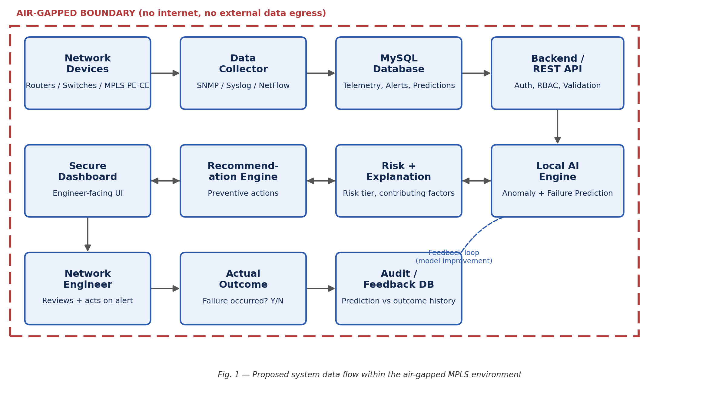

4. Air-Gap Boundary Definition
The project uses two clearly separated zones: a production zone with zero internet access, and a development/build zone used only to write and train software before it is transferred into production.
Zone | Internet Access | Contains | Notes
Production / Deployed Environment | None (fully air-gapped) | Devices, collectors, MySQL DB, backend/API, local AI inference, dashboard, audit DB | No component in this zone may reach the public internet at any time, including for OS/package updates
Development / Build Environment | Allowed (isolated from production) | Source code, model training, CI, package/dependency downloads, documentation | Used only to build and train artifacts; nothing here touches live network data
Transfer Point | N/A — one-way, manual | Signed/verified build artifacts, model files, patches | Moved into production via approved offline media (e.g., verified USB) with checksum validation; no live data path back out
Transfer procedure (summary): build and test in the development zone → freeze and checksum the release artifact (backend build, AI model file, frontend build) → transfer via approved offline media → verify checksum in the production zone before deployment → no automated or scheduled channel exists between the two zones.

5. One-Page Requirements Document

5.1 Functional Requirements
ID | Requirement
FR-1 | System shall continuously collect telemetry from configured MPLS devices via SNMP/Syslog/NetFlow.
FR-2 | System shall store telemetry, alerts, incidents, predictions, recommendations, actions, and outcomes in MySQL.
FR-3 | System shall detect anomalous device/network behaviour using a local AI model.
FR-4 | System shall predict potential failures and assign a risk level (Low/Medium/High/Critical).
FR-5 | System shall generate a human-readable explanation of contributing factors for each prediction.
FR-6 | System shall generate preventive recommendations linked to each prediction.
FR-7 | System shall allow engineers to log actions taken and record actual outcomes.
FR-8 | System shall maintain a tamper-evident audit trail of predictions, actions, and outcomes.
FR-9 | System shall provide a centralized dashboard with RBAC-based views.

5.2 Security Requirements
ID | Requirement
SR-1 | All AI inference and data storage shall occur within the air-gapped boundary; no telemetry or derived data leaves the environment.
SR-2 | All users shall authenticate before accessing the system; sessions shall expire after a defined idle period.
SR-3 | Access shall be enforced via RBAC (Admin / Network Engineer / Viewer) at both API and UI layers.
SR-4 | All administrative and data-altering actions shall be recorded in an append-only audit log.
SR-5 | Data in the MySQL database shall be protected via least-privilege DB accounts and encrypted at rest where feasible.
SR-6 | Any code, models, or dependencies brought in from the development environment shall be checksum-verified before use in production.

5.3 Non-Functional Requirements
ID | Requirement | Target
NFR-1 | Dashboard alert latency (event to display) | ≤ 60 seconds
NFR-2 | System uptime (production) | ≥ 99.5% monthly
NFR-3 | Prediction inference time per device | ≤ 5 seconds
NFR-4 | False-positive rate for High/Critical alerts | ≤ 10% (target, to be validated in Phase 5–6)
NFR-5 | Audit log retention | ≥ 12 months, tamper-evident
NFR-6 | Concurrent engineer sessions supported | ≥ 10
Note: Device inventory, role definitions, and target metrics above are working assumptions for planning purposes. Confirm against the actual target network and organizational policy before Phase 2 (Database & Data Layer) begins.

