Phase 2 — Database & Data Layer
Air-Gapped Predictive Copilot for Secure MPLS Operations
MySQL Schema Design · Week 2–3

1. Entity Overview
The schema below implements the eleven tables called for in the project plan: users, roles, devices, telemetry, alerts, incidents, predictions, recommendations, engineer_actions, outcomes, and audit_log.
Table | Purpose | Key Relationships
roles | Defines system roles (admin, network_engineer, viewer) | Referenced by users
users | Login accounts and role assignment | FK → roles; referenced by incidents, actions, outcomes, audit_log
devices | Inventory of monitored MPLS network equipment | Referenced by telemetry, alerts, incidents, predictions
telemetry | Time-series performance metrics per device | FK → devices
alerts | Threshold/rule-based alerts raised on devices | FK → devices; referenced by incidents
incidents | Human-tracked investigation opened from an alert or prediction | FK → devices, alerts, users
predictions | AI model output: risk score, risk level, explanation | FK → devices, incidents; referenced by recommendations, actions, outcomes
recommendations | Preventive actions suggested for a prediction | FK → predictions; referenced by engineer_actions
engineer_actions | Log of what an engineer actually did | FK → predictions, recommendations, users
outcomes | Actual result recorded after the fact (feeds the feedback loop) | FK → predictions (1:1), users
audit_log | Append-only record of sensitive actions across the system | FK → users (nullable, for system events)

2. Entity-Relationship Diagram
Primary/foreign keys and cardinalities across the schema. Note the two feedback-loop-critical relationships: predictions → outcomes is strictly 1:1 (one recorded result per prediction), while predictions → recommendations and predictions → engineer_actions are 1:N.
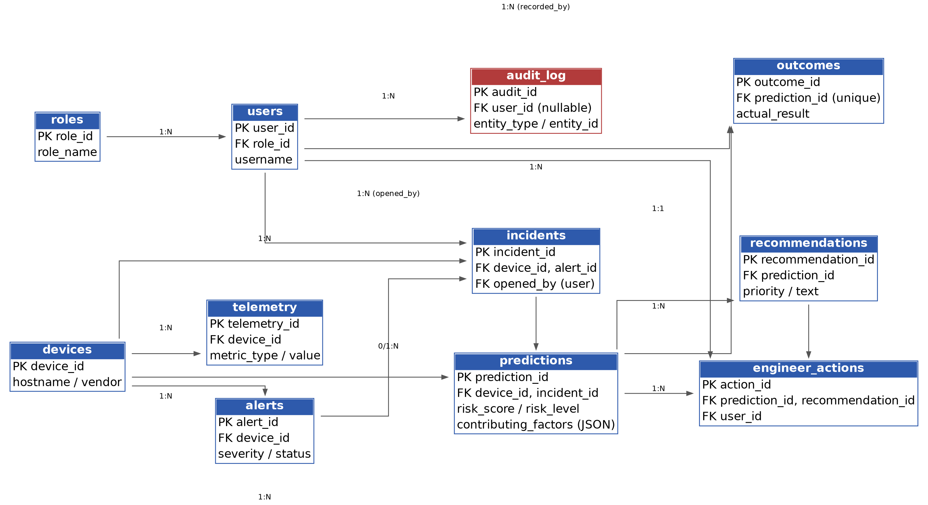

3. Key Design Decisions
Decision | Rationale
InnoDB storage engine | Required for foreign key enforcement and transactional writes (predictions/actions/outcomes must stay consistent)
utf8mb4 character set | Full Unicode support for device names, notes, and free-text fields
JSON columns for contributing_factors and audit details | Explainability output and audit payloads are variable-shape; JSON avoids a rigid key/value table while staying queryable in MySQL 5.7.8+/8.0
Separate outcomes table (not a column on predictions) | Keeps the prediction record immutable once made; the outcome is recorded independently, later, possibly by a different user — this is what makes the feedback loop auditable
ENUM for status/severity/risk_level fields | Constrains values at the database layer, not just in application code, for a system with security requirements
Composite index on telemetry(device_id, collected_at) | The dominant query pattern is "recent metrics for one device" — this index serves it directly
ON DELETE CASCADE from devices → telemetry/alerts | Decommissioning a device should not leave orphaned metrics
ON DELETE RESTRICT on users → engineer_actions | An engineer's action history must not silently disappear if their account is later removed

4. Deliverable
The full, ready-to-run DDL is in schema.sql (attached separately), including CREATE DATABASE, all eleven CREATE TABLE statements with primary keys, foreign keys, indexes, and seed data for the three default roles plus a placeholder admin account.
To load it: mysql -u root -p < schema.sql
Before Phase 3 (Backend & APIs) begins: replace the placeholder password_hash for the seed admin user with a real bcrypt/argon2 hash generated by the application, and confirm the metric_type values in telemetry against the actual fields your collector (Phase 4) will populate.

