

SOFTWARE ENGINEERING ASSIGNMENT REPORT
ON :
SAVANA E-COMMERCE PLATFORM

TITLE PAGE

Course Name: Introduction to Software Engineering

Course Code: IS1103-1

Assignment Number & Title: Assignment 1 – Software process models and requirement engineering

Student Name: Anika Sama

USN / Roll Number: NNM24IS026

Semester & Section: 4th Semester & ‘A’ section

Department: Information Science & Engineering

Institution Name: NMAM Institute Of Technology

Academic Year: 2025 – 2026

Instructor Name: Dr.Jason Elroy Martis

ABSTRACT

This report is about Savana. Savana is a website that helps women. It tells them what to wear and how to look good. It also gives them ideas about lifestyle and things to learn. The big problem we are trying to solve is which way is best to make Savana. We need to pick a Software Development Lifecycle model that works for Savana. You have three choices. Waterfall, Incremental and Spiral. We have to figure out which one of these models is best, for Savana. We need to look at how each one handles the requirements (both functional and non-functional), deals with risks, adapts to changes, and delivers value over time.

The thing about Savana is that it needs machine learning to make recommendations. Machine learning is a part of Savana. You cannot just make Savana. Then forget about it. You have to keep working on it to make it better. This is because you need to look at what the users of Savana do.

Security is very important for Savana. This is because Savana deals with payments and personal information of users. So security has to be really good.

The system of Savana also has to be able to handle a lot of users at the time. This happens during times like when there is a big sale on Savana.

I do not think Waterfall is a way to do this. Waterfall seems strict for something, like Savana that needs to keep changing. Savana needs machine learning. It needs to be secure. You'd think having everything planned out would be good, but fashion trends change so fast that what you plan in month 1 might be outdated by month 6. The Incremental and Spiral models look more promising. Spiral especially caught my attention because it focuses heavily on managing risks, which seems important when you're building something that handles money and personal data

INTRODUCTION
Recommendation systems are around us nowadays. Netflix helps you figure out what to watch. Amazon tells you what to buy. Spotify really gets what kind of music you like. Savana is doing something like this. It is for a specific group of people. Young women who want advice on fashion and lifestyle. The problem is not about making a system that can recommend things to you. Savana is trying to make a system that can give women good advice, on fashion and lifestyle. Building a recommendation engine is one part of it. It's about doing it in a way that can adapt to trends (which change constantly in fashion), keep user data secure, and actually perform well when lots of people are using it at once.
Recommendation systems usually work in a few ways. They look at what other people with tastes liked, which is called collaborative filtering.. They look at the content itself to see what it is about. Some systems even do both of these things.
The hard part is that these systems need a lot of information to work well. When you first start out you do not have a lot of information about the people using your system so the recommendations might not be very good.. As more people start using it and you get more information the recommendations get better. Recommendation systems get better over time as they collect data, on the people who use them and the things they like. This creates an interesting problem for development - you can't really know if your algorithm works until people start using it, but you need to build something before people can use it.
Picking the right development model matters more than you might think. It affects how much the project costs, how long it takes, whether you can fix problems when you find them, and ultimately whether users will actually like what you build. There's plenty of research on this [2][3], but every project is a bit different. For something like Savana where trends matter and user preferences shift quickly, we need to think carefully about which approach makes sense.

PROBLEM STATEMENT
So here is the deal. We need to figure out which Software Development Life Cycle model works best for developing Savana. This is not easy because Savana has different things that are important. We want to launch Savana so we can get customers before other companies do. But Savana is dealing with payment information and personal data so we cannot. Compromise the security of Savana. We want to be able to add features to Savana and respond to new trends but we also need some rules so the code, for Savana does not become a mess. We need to find a Software Development Life Cycle model that works best for Savana. It's about finding the right balance. Traditional waterfall development assumes you can figure out all the requirements at the start [2].
But that's rarely true for consumer apps. Users don't always know what they want until they see it. Plus, in fashion, what's trending in January might be completely different by June. If you lock down all your requirements at the beginning, you might end up building features nobody cares about by the time you launch. There are real risks with this project too. The recommendation algorithm is uncertain - you won't know if it works well until real users try it. Security vulnerabilities could pop up if the payment system isn't designed carefully. The system might slow down under heavy load. The UI might not click with users. Each of these risks points to different priorities for how you should approach development.

SYSTEM DESCRIPTION
Savana connects three groups: regular users who want recommendations, vendors who sell products, and admins who keep everything running smoothly. Each group needs different things from the platform. Regular users sign up, fill out their preferences (like what styles they like, their age range, interests, etc.), and then start getting recommendations. The system watches what they click on, what they buy, and what they rate, then uses that to improve future suggestions. They can search for specific things, save items to a wish list, and buy stuff through the integrated checkout. Pretty standard e-commerce flow, just with personalized recommendations driving it. Vendors have their dashboard on the platform. They can use this dashboard to list the products they want to sell. They can also upload photos of these products. Set prices for them. The vendors can even see how well their products are doing. The platform makes money by taking a part of the sales. This means that if the vendors do well and sell a lot of products the platform also does well.
There are admins who watch over everything. They can look at the products and flag anything that does not seem right. If there are any problems between buyers and vendors the admins can help solve them. They also keep an eye on how thing are going to make sure everything runs smoothly. The recommendation engine is working in the background. It looks at what the users are doing and uses machine learning models to figure out what they might like. The recommendation engine is always processing user data to make the platform better, for the users and the vendors. These models train on historical data and keep updating as new data comes in. The challenge is doing this fast enough that recommendations feel instant to users.

DEVELOPMENT TOOLS
For this project analysis, I used:
• Microsoft Word for documentation
• Draw.io for creating diagrams
• GitHub for version control

5. SDLC MODELS ANALYSIS

5.1 Waterfall Model

Waterfall is the classic approach [2]. You do requirements first, then design, then implementation, then testing, then deployment. Each phase has to finish completely before you move to the next one. The whole model is built on the assumption that you can nail down all the requirements right at the start and they won't change.

There are some good things about this approach. Everything is well documented. You always know exactly what phase you're in. Progress is easy to track. If you're building something where requirements are stable and well-understood, this clarity can be valuable. The problem is that Savana doesn't fit that description at all.

Think about fashion trends they change every month sometimes every week. When you are gathering requirements for something it seems like certain things are very important but six months later when you are ready to launch those things might not be important all.

Fashion trends and recommendation algorithms have something in common they are always changing. There is another problem with the Waterfall method you cannot really test your recommendation algorithm until people start using it. The Waterfall method puts testing at the very end.

So what happens if you find out that your recommendation algorithm is not working well with data from users of the recommendation algorithm you are, in a tough spot. Going back to redesign the recommendation algorithm is going to cost a lot of money and take a lot of time. Plus, you get zero user feedback until you're almost done, which means you're basically guessing about what users want for the entire development process

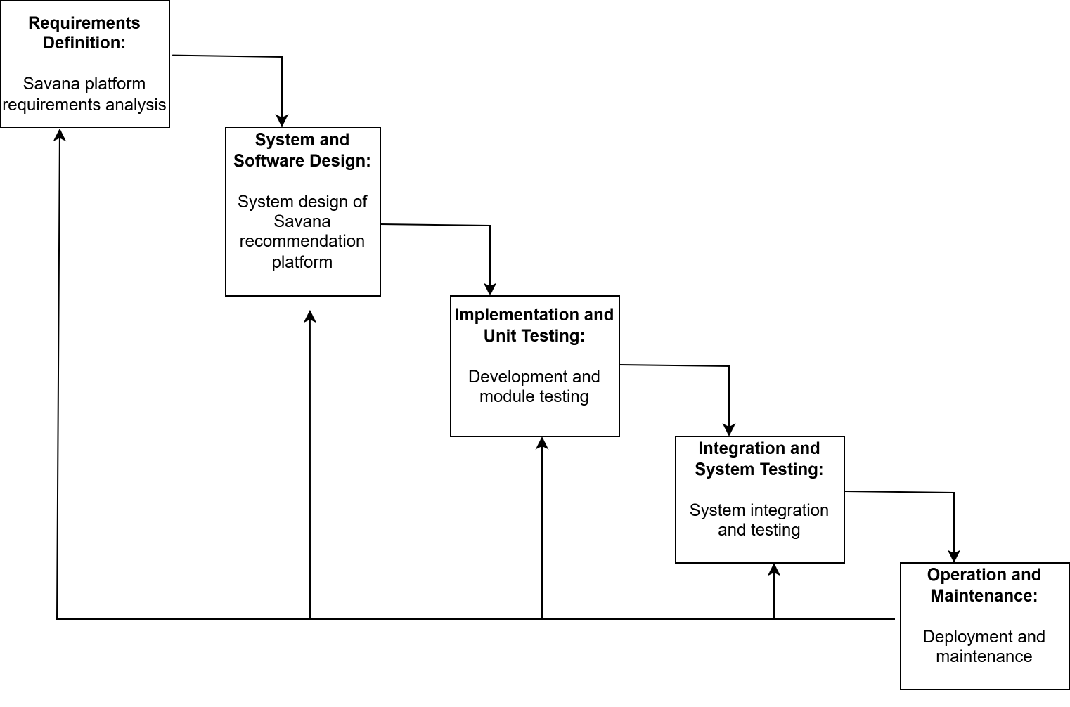

5.2 Incremental Model

The Incremental model breaks things down into smaller chunks [2][3]. Each chunk goes through its own mini-cycle of requirements, design, implementation, and testing. You deliver functionality in stages instead of all at once.

For Savana the first step is pretty simple. We start with user accounts and browsing. This means users can sign up for an account look at the products we have and maybe even add some things to a wishlist. That is all we do for now. We launch this version. See how people use it. We want to make sure our ideas about the interface and architecture are correct.

Then we move on to the step. We add a recommendation engine to Savana.. We do not make it too complicated at first. We just start with a version. We collect data to see how well the recommendation engine works. We use this data to make it better, over time. We refine our approach to make sure Savana works the way we want it to. Later increments add payment processing, vendor tools, social features, whatever makes sense based on what you learned.

The benefits of this approach are really easy to see. Users of the platform start to see results. You get feedback from users that helps you decide what to build next. If a simple recommendation algorithm does the job then you do not need to invest in an one right away. This means you can focus on features of the platform instead.

The hard part is planning the order of the steps very carefully. There are a lot of things that depend on each other. For example the recommendation engine needs information, about how users behave. You only get this information after people have started using the platform. So the architecture needs to be designed from the start to accommodate these future additions without requiring major rewrites [6].

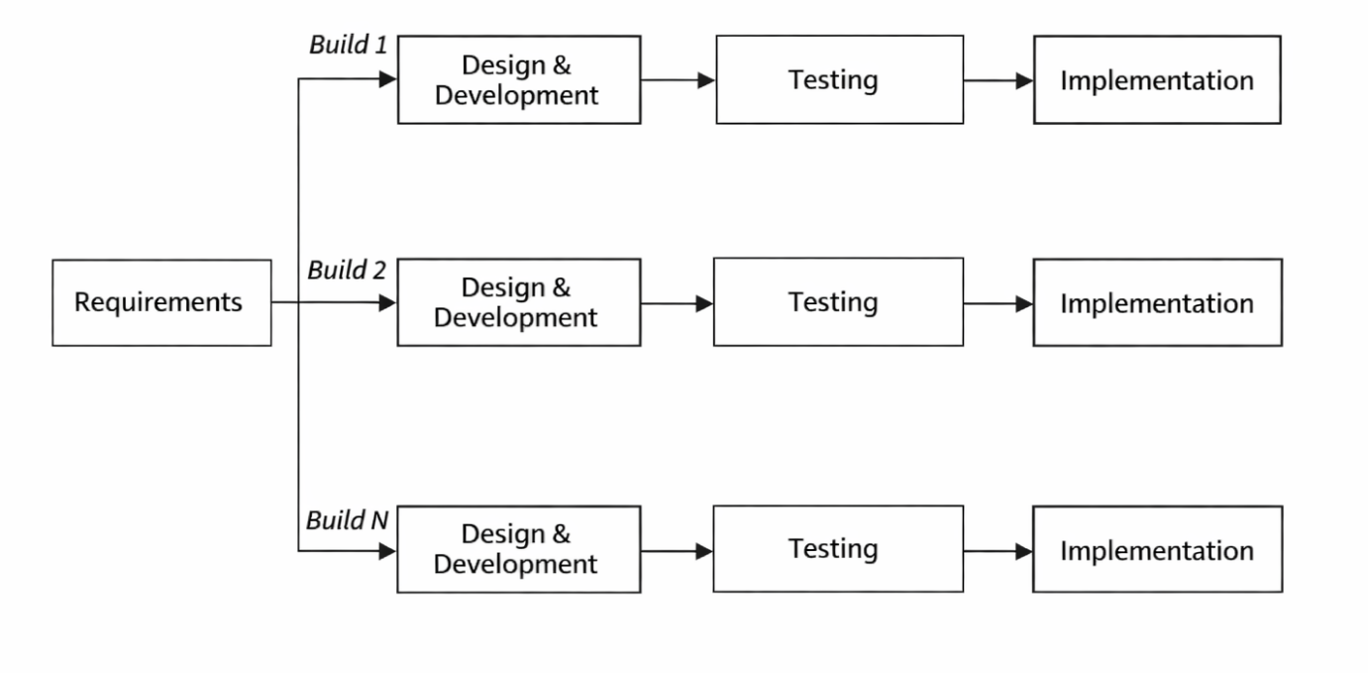

5.3 Spiral Model

Spiral is all about managing risk [4]. Each iteration starts by identifying what you're trying to achieve and what constraints you're working with. Then you analyze the biggest risks before building prototypes and planning the next round. This cycle repeats, and the system grows more complete each time.

For Savana, you'd identify the main risks upfront. Technical risks: Will the recommendation algorithm work with limited initial data? Can the system handle peak loads during sales? Can we secure the payment integration properly? Business risks: Will users actually find this valuable? Will vendors want to participate?

Your first step is to look at the recommendation algorithm because it's the biggest risk. You make a version with some sample data to see what works best. This version does not have to be perfect. You just want to make sure you are on the track. When you are sure, about how to do it you can move on to the thing. On you might work on security by making a prototype of the payment system and testing it to see if it is safe. The recommendation algorithm is very important. Another step could be to make sure the system can handle a lot of users by testing how much it can handle. You test the recommendation algorithm again to see how it works with a lot of users. Throughout all these spirals, the core system keeps evolving, but each iteration specifically targets risk reduction, not just feature addition. For a platform like Savana where security breaches could kill the business and poor recommendations could drive users away, tackling these risks early makes a lot of sense.

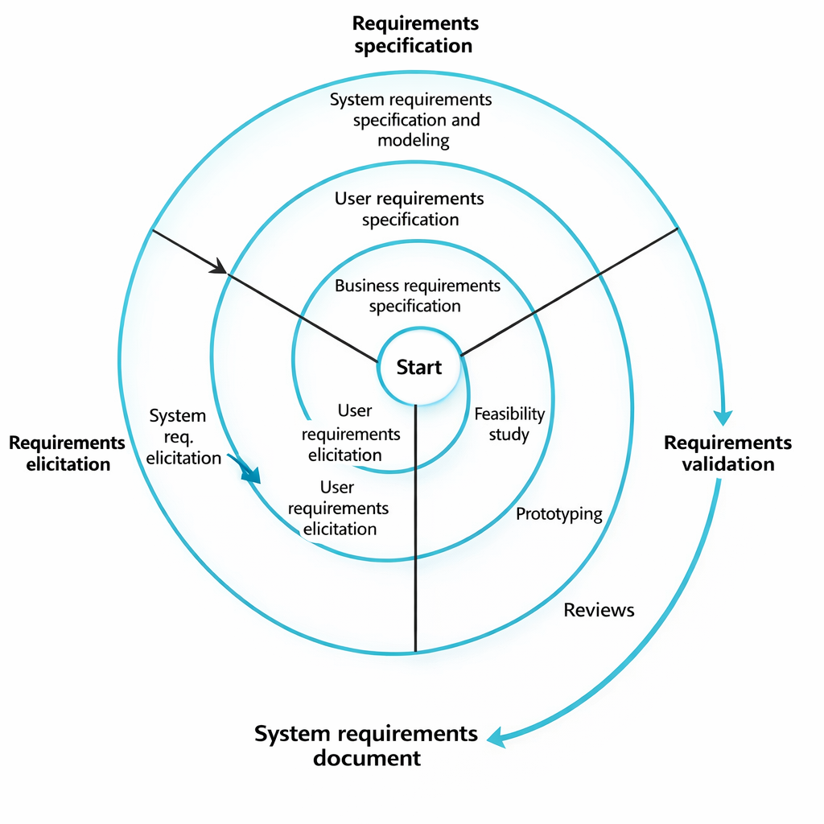

6. REQUIREMENTS SPECIFICATION

6.1 Functional Requirements

These are the basic things the system needs to do [5]:

User Authentication and Profiles:

• Users need to register with email and password

• Password reset via email

• Profiles should capture age range, style preferences, interests

Recommendations:

• System generates personalized suggestions based on user profile and behavior

• Recommendations update as preferences change

• Users can rate recommendations to improve the algorithm

Shopping Features:

• Search by keyword, category, price range

• Persistent shopping cart

• Checkout with major credit cards and digital wallets

6.2 Non-Functional Requirements

These specify how well the system needs to perform [5]. Often these matter more than functional requirements for user satisfaction:

Performance:

• Pages should load in under 2 seconds

• Search results appear within 500ms

• Handle 10,000 concurrent users without slowdown

Security:

• Payment info encrypted using PCI DSS standards

• Passwords hashed with Bcrypt minimum

• Rate limiting to prevent abuse

Availability:

• 99.9% uptime (excluding planned maintenance)

• Responsive interface that works on mobile

7. COMPARATIVE ANALYSIS

7.1 Handling Requirements Changes

Waterfall really struggles when requirements change. Once you finish a phase, going back is expensive and disruptive. For Savana where fashion trends shift constantly, this is a major problem. Something that seemed crucial during requirements might be irrelevant by the time you're implementing it.

Incremental handles changes better. Each increment learns from the previous ones. If user feedback suggests different priorities, the next increment can adjust accordingly. But changes affecting the core architecture or earlier increments still require coordination and possibly rework. Spiral treats changing requirements as normal, not exceptional. Each spiral revisits requirements considering new info from prototypes and feedback. The flexibility comes with added complexity though - planning becomes more involved and teams need experience with iterative methods to avoid chaos

7.2 Risk Management

Waterfall tries to address risk through upfront planning and documentation. The problem is many risks don't show up until you're actually building or testing. Performance issues might not be obvious until you stress test the system. By then, fixing fundamental architecture problems is extremely hard and expensive.

Incremental helps reduce risk because it gives you something of value on. If one part of the project does not work out you only waste the time and effort you spent on that one part, not the project. The thing is, incremental does not really focus on the parts that are most likely to cause problems. Teams might put off dealing with the tough parts until later and that is when they will find out if there are any issues. Spiral is really good at managing risk it is actually what it is meant to do. Each time you go through the process you figure out what the biggest risks are and you deal with them first. This way the spiral method makes sure that the project team is paying attention to the things that could cause the trouble and they are doing something, about it right away. For Savana's security needs, performance requirements, and scalability challenges, this early risk tackling through prototypes makes a lot of sense.

7.3 Time and Cost Considerations
Waterfall looks predictable on paper. You define everything upfront, estimate time and cost, and execute. But this predictability is kind of an illusion if requirements change (and they usually do). Late changes can blow up cost’s way beyond initial estimates.
Incremental delivery is really good because it gives you something to show for your work sooner. You can actually put the part of the project out there while you are still working on the rest of it. This means you can start making money or getting feedback from people sooner. The whole project might take a little longer to finish if you have to do a lot of work to get all the parts to work together.
Spiral is a way of doing things and it can be a lot of extra work with all the planning and testing you have to do. If you are working on a project that's pretty simple and you are sure it will work then all this extra work might not be necessary. For something like Savana, where you are not really sure what will happen it is probably better to take the extra time to plan things out. The cost of building something that does not work could be a lot more, than the cost of taking an extra time to make sure you are doing it right. Spiral's continuous prototyping catches both technical and usability issues early, reducing the risk of building features nobody wants.

8. LIMITATIONS AND FUTURE WORK

I should be clear that this analysis is mostly theoretical. It's based on established SDLC principles [2][3][4] rather than actual data from building Savana. Real-world development always throws curveballs you don't expect. Team experience, company culture, specific tech choices - all of these would influence which model actually works best in practice.

There is more to explore here. This analysis is based on development methods but modern approaches like Agile and DevOps can combine elements from different models [6]. I did not go into details about the recommendation algorithm. The specific machine learning approach you choose will have a big impact on priorities. Vendor management tools were mentioned, Not fully examined. These tools might be complicated enough to require separate consideration. The machine learning approach and vendor management tools are factors to consider when exploring this topic further. The recommendation algorithm and vendor management tools, like these can affect how things are done. Future work could test these ideas with a pilot implementation, tracking metrics like development speed, bug rates, and user satisfaction to see if the theory holds

9. CONCLUSION

As for the SDLC selection for Savana, it is important to consider what is really important. For example, the Waterfall approach is a good idea at first because it is so organized and easy to understand. However, the problem with the Waterfall approach is that it does not allow us to make changes. This is a problem for the consumer-based platform of Savana because it needs to be able to change and grow with the latest fashion trends and what the users want. The SDLC selection for the Savana is important. It is important that we select something that is going to work well for the company. The Incremental approach and the Spiral approach are better than the Waterfall approach for the application. This is because the Incremental approach is going to give the user something early on and allow us to make changes. In addition, the Spiral approach is good because it takes care of the risks and the business risks associated with creating a recommendation platform. Both Spiral methodology and Incremental methodology are good, at handling these risks because they are part of the recommendation platform development process. As far as Savana is concerned, Spiral is the choice because it handles a lot of risky things. These things include the effectiveness of the algorithm, security, and the need to be able to handle a lot of users. When Spiral is used, there needs to be a team of developers who really know what they are doing. It is also very important to manage things carefully. It is very important to keep records of all the Spiral cycles, so that one can remember why one did certain things with Savana and Spiral. This way one can look back. Know what one did with Spiral, for Savana.

Good projects tend to mix things up in terms of method. The Savana development team might choose to do a style to manage their risks when they first start, and then do things a little at a time when they have managed their big risks. The basic idea behind this is that the way in which something is developed should suit the project. For instance, if you are working on a website or application that people are going to use, and there are competing businesses, being flexible with managing risks is more important than having a perfect plan with loads of documents

REFERENCES
[1] Aggarwal, C. C. (2016). Recommender Systems: The Textbook. Springer.
[2] Pressman, R. S. (2014). Software Engineering: A Practitioner's Approach (8th ed.). McGraw-Hill Education.
[3] Sommerville, I. (2016). Software Engineering (10th ed.). Pearson.
[4] Boehm, B. W. (1988). A Spiral Model of Software Development and Enhancement. Computer, 21(5), 61-72.
[5] ISO/IEC/IEEE 29148:2018. Systems and Software Engineering — Life Cycle Processes — Requirements Engineering.
[6] Schwaber, K., & Sutherland, J. (2020). The Scrum Guide. Scrum.org.

DECLARATION OF ACADEMIC INTEGRITY
I declare that this report is my own work. All sources I consulted have been properly cited using numbered references. No part of this work has been copied without acknowledgement.

Signature:


Date: 15-02-2026

