Lab1

ID:2019-1-60-195 Mst. Fateha Islam Shorna

ID:2021-2-60-155 Chaity Bhuiyan

**Uber**

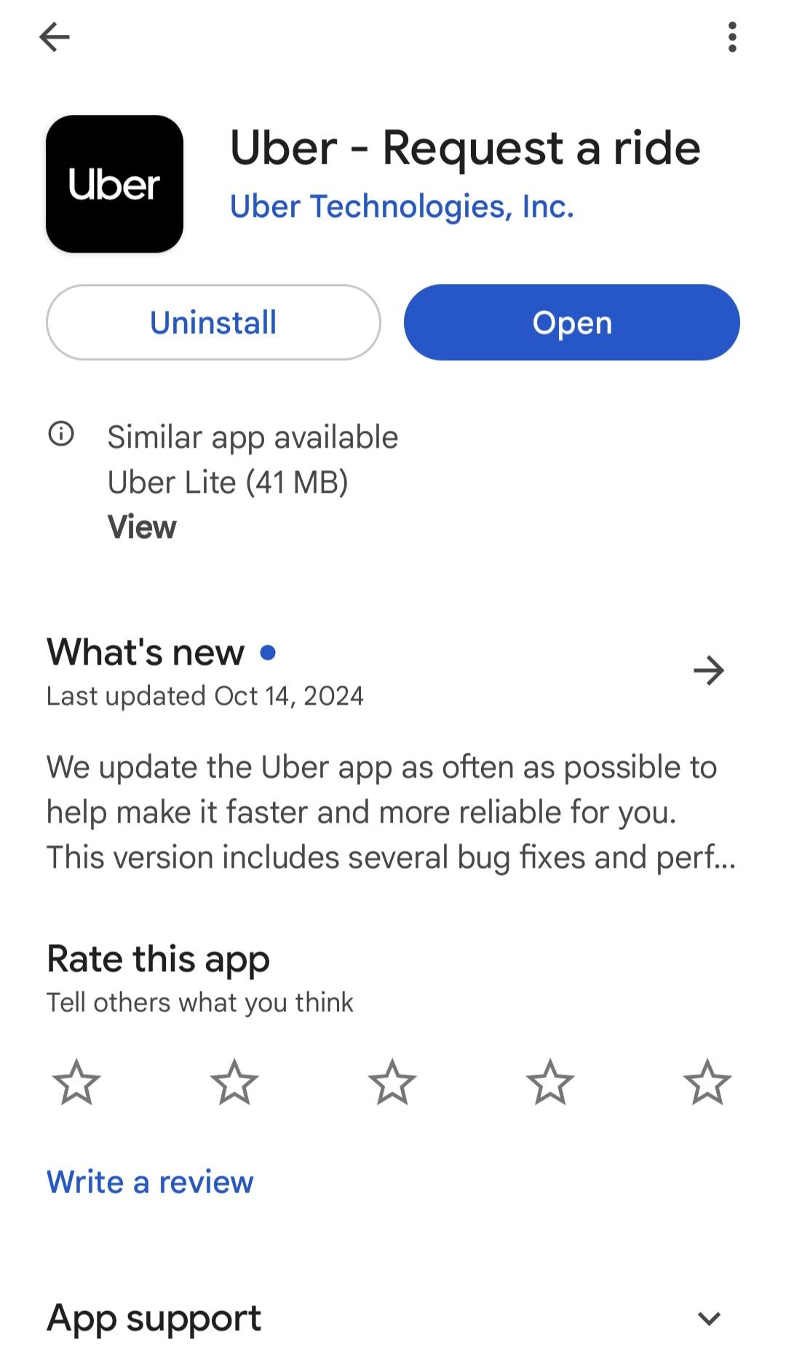

**Features**

Uber is a ride app. It has some unique features like–

* Rental car
* Pre-booking
* Easy and intuitive user interface
* Real-time ride tracking sharing
* Real-time ride sharing
* Earn money
* Trip history
* Choose vehicle as require

**Non-functional Attribute**

* Performance → It has 442 MB memory and speed is high. It is faster and easy to understand
* Security→ It is a secure app, driver screening
* Usability→ People use for travel, food delivery, purcell deliver
* Reliability→ For drivers, it provides flexibility and a range of perks, like immediate payouts, the right to keep 100% of tips, and simple driver requirements.
* Scalability→ Microservices Architecture, Load Balancing, Real-Time Data Processing. Allows dynamic resource scaling based on demand.Database Optimization, Caching ,Geolocation Services.

**Clients Satisfaction**

* Feedback→**Uber's** two-way **feedback** system has long helped ensure both riders and drivers uphold certain standards by requiring **feedback** on issues like vehicle quality
* Size→5 MB to download
* Version → Lite
* Rating→ 4.7
* Download→500M+
* Competitors→ inDrive, Pathao, DiDi Rider, foodpanda