PolicyHub Collector Flow Query Chunking Design

Contributors | anikaushik
Reviewers
Security &  Compliance link/s | N/A
  - Change History
Date | Changes done | Author | Reviewers/Approvers
26-03-2026 | Document Inception | anikaushik

  - Table of Contents
Introduction 1
Problem Statement 1
Goals 1
Design Requirements 1
Current Design 2
In Scope 2
Out of Scope 2
Design Proposal/s 2
Detailed Design 3
Components Interaction 3
Risks and Dependencies 4
Operational Concerns 4
Test Strategy 4
Telemetry and Monitoring 4
Flighting & Roll-out Strategy 4
Open Questions 4
AI Assistance in design 5
References 5
Appendix 5

Introduction

Introduction
The PolicyHub collector flow is a component of PolicyHub Azure Function App that incrementally syncs enforcement telemetry from the M365 Gating Kusto cluster (m365gating-kusto-prod) into the central PolicyHub kusto cluster (policyHub-kusto-prod) for compliance reporting and Power BI dashboarding. It collects data from 5 kusto tables and 1 Cosmos DB collection, processing ~4.1M rows (~972 MB) across the table RuleExecutionMetrics alone over a 7-day window, with peak daily volumes of ~770k rows (RuleExecutionMetrics) and ~630k rows (PolicyVersionMetrics).
The collector uses watermark-based incremental queries, fetching only records newer than the last successful sync. This document proposes adding time-window chunking and slicing by number of rows based on Gating Response size to the collector’s query strategy, replacing the current single-query-per-sync approach that causes OOM failures and silent data loss when the collector falls behind.

Problem Statement
The current collector query pattern:
- Kusto does not provide a continuation token or server-side cursor for pagination like Cosmos DB, so the collector issues a single query for the entire time window from the last sync watermark to now.
- Issues a single Kusto query spanning the entire time window from the last sync watermark to now
- Applies | order by [TimestampColumn] desc which forces Kusto to sort and materialize the full result set in memory
- Appends | take 100000 (via MaxRecords config) which silently drops rows when the window contains more than 100K records
- Does not advance the watermark on failure, causing the window to grow larger on each retry
This creates two compounding problems:
- Kusto OOM error compounding: When the collector fails with E_LOW_MEMORY_CONDITION, the watermark stays fixed while currentSyncTime moves forward. The next run queries an even larger window, consuming more memory, and is more likely to OOM again. A 7-day backlog on RuleExecutionMetrics produces approximately 4.1M sorted rows requiring 775 MB peak memory per node, enough to trigger OOM on a busy cluster.
- Silent data loss: The | take 100000 cap drops all rows beyond 100K per query. On peak days, RuleExecutionMetrics produces ~770K rows/day and PolicyVersionMetrics ~630K rows/day, meaning up to 87% and 84% of records respectively are permanently lost each run, as the watermark advances past them.

Goals
- Ensure Out-of-Memory Error does not compound on failure and does not accumulate with time.
- Break large time windows into smaller configurable chunks which are safely under kusto limits and can be adjusted as requirements change.
- Advance watermark after each successful chunk so that failures only lose progress on current chunk, not the entire window.
- Eliminate silent data loss.

Design Requirements
Requirement | Constraint
Data volume | ~4.1M rows/week for RuleExecutionMetrics and ~3.2M rows/week for PolicyVersionMetrics across 5 Kusto tables and 1 Cosmos DB collection.
Chunk Size | Each chunk query must stay under kusto limits by a safe margin, ~50MB peak memory per node to avoid E_LOW_MEMORY_CONDITION on shared clusters
No Data Loss | All records within the sync time window must be collected and there must not be a silent loss via | take MaxRecords
Watermark Safety | Watermarks must only advance after successful ingestion of a chunk, ensuring retry-on-failure without skipping data
Configurable per data source | Chunk duration must be configurable per data source, since tables have different volumes (21K/day for RawMetrics vs 770K/day for RuleExecutionMetrics)
Idempotency | Re-running a failed chunk must not produce duplicate rows in the destination kusto cluster
Execution Time | The full collection run (all chunks across all data sources) must complete within the Azure function timeout and before the next timer trigger fires.

Design Requirement: Time-based chunking
To prevent out-of-memory errors from compounding with time, implement fixed time-based chunks. For a backlog period of N days, when the collector flow runs, it breaks the window [lastSyncTime, currentSyncTime] into fixed-duration chunks (e.g., PT1H = 1 hour). Each chunk is queried, transformed, ingested, and its watermark committed independently. If the function times out after processing K chunks, the next run resumes from chunk K+1 — the system is self-healing and makes forward progress on every run.

Design Requirement: Row-based slicing
For a given time chunk, ensure the number of selected rows are split into manageable slices based on gating response size. The constraint is:
avgResponseSize * rowCount < MaxMemoryThreshold
Where MaxMemoryThreshold is a configurable limit per data source. Before fetching data for a chunk, the pipeline runs a lightweight pre-query to get count() and avg(estimate_data_size(*)). If the estimated total size exceeds MaxMemoryThreshold, the rows are fetched in slices of size floor(MaxMemoryThreshold / avgResponseSize) using | take sliceSize. This ensures each slice stays within memory limits regardless of data volume spikes within a single time window.

Current Design
The current collector query pattern:
- Issues a single Kusto query spanning the entire time window from the last sync watermark to now
- Applies | order by [TimestampColumn] desc which forces Kusto to sort and materialize the full result set in memory
- Appends | take 100000 (via MaxRecords config) which silently drops rows when the window contains more than 100K records
- Does not advance the watermark on failure, causing the window to grow larger on each retry
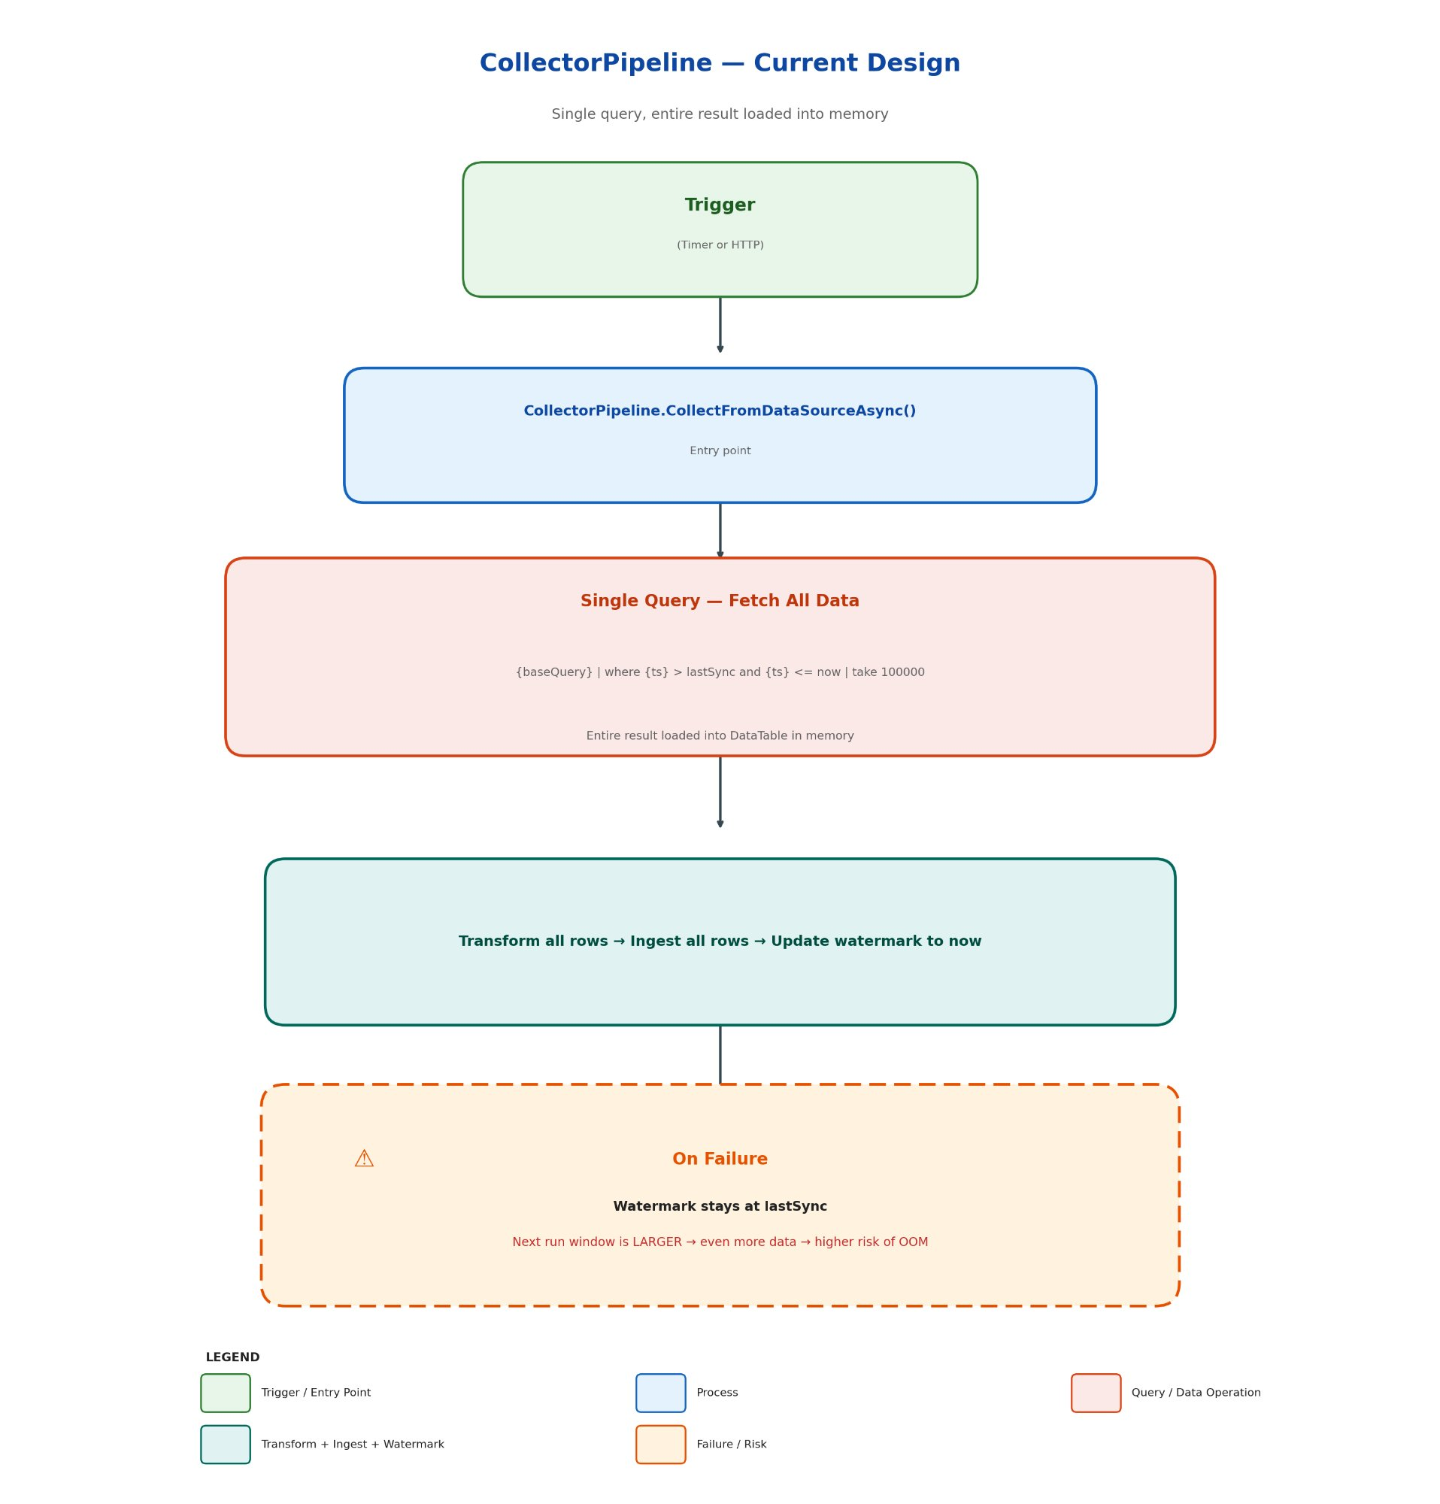

Measured impact of current design (prod cluster, RuleExecutionMetrics):
Window Size | Rows | Data Size | Peak Memory/Node | Exec Time
7 days | 4,095,471 | ~972 MB | 775 MB | 0.55s
1 day | 768,826 | ~182 MB | 175 MB | 0.06s
6 hours | 193,624 | ~45 MB | 51 MB | 0.007s
1 hour | 46,503 | ~11 MB | 16 MB | ~0s
30 minutes | 21,464 | ~5 MB | 13 MB | ~0s

In Scope
- Dealing with Kusto Low memory condition error
- Ensuring Collector Flow design scales and can accommodate an increase in the gating response size
- Backfilling data since last successful collector flow run.

Out of Scope
- Syncing of PolicyAssignments is OOS as this will be handled in the same way as Policy Sync service pagination via continuation token.

Design Proposal/s

Detailed Design

Overview
The solution introduces two layers of chunking to the collector pipeline:
- Time-window chunking (outer loop): Breaks the [lastSyncTime, currentSyncTime] range into fixed-duration chunks configured via ChunkDuration (ISO 8601 duration, e.g., "PT1H"). Each chunk is processed independently with its own watermark commit.
- Row-based slicing (inner loop): Within a single time chunk, a pre-query determines rowCount and avgResponseSize. If avgResponseSize * rowCount > MaxMemoryThreshold, the chunk’s rows are fetched in slices of floor(MaxMemoryThreshold / avgResponseSize) rows each. This handles anomalous spikes where a single hour may contain disproportionate data that exceeds memory limits even within a short time window.
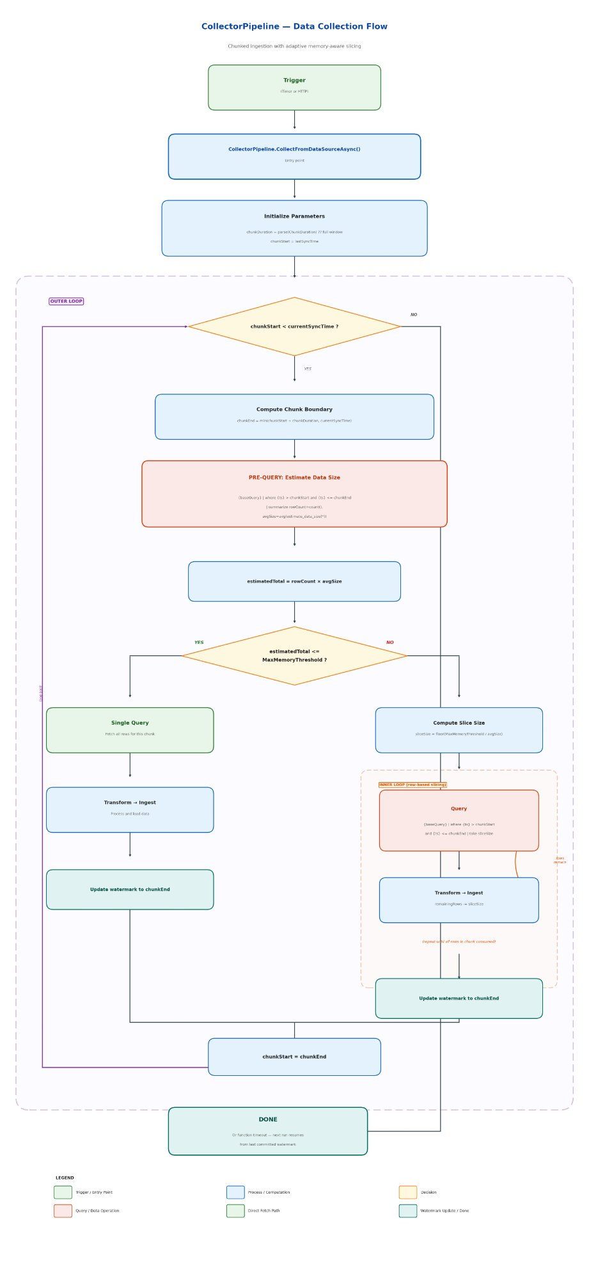

Chunked Collection Flow

Chunk Duration Selection
Based on smoke testing against the prod M365 Gating cluster:
ChunkDuration | Rows/chunk (RuleExecutionMetrics) | Peak Memory/Node | Recommendation
PT30M | ~21K | ~13 MB | Safest, more Cosmos watermark writes
PT1H | ~47K | ~16 MB | Recommended — safe margin, reasonable chunk count
PT6H | ~194K | ~51 MB | Acceptable for smaller tables
PT1D | ~770K | ~175 MB | Risky on busy clusters

Recommended default: PT1H for all data sources. Larger tables (RuleExecutionMetrics, PolicyVersionMetrics) stay well under memory limits. Smaller tables (RawMetrics, GatingRequestMetrics) produce near-empty chunks which are skipped efficiently.

Configuration Model
ChunkDuration and MaxMemoryThreshold are added to the per-data-source QueryConfig:
{
"Name": "RuleExecutionMetrics",
"Type": "Kusto",
"IsEnabled": true,
"Connection": { ... },
"Query": {
"QueryText": "RuleExecutionMetrics | order by InsertedAt desc",
"TimestampColumn": "InsertedAt",
"ChunkDuration": "PT1H",
"MaxMemoryThreshold": 52428800
},
"DestinationTable": { ... }
}

ChunkDuration (nullable string, ISO 8601 duration): When set, the pipeline chunks the time window. When null/omitted, the pipeline executes a single query over the full window (backward compatible).
MaxMemoryThreshold (nullable long, bytes): Maximum estimated data size per query. When set, the pipeline runs a pre-query for each chunk to get count() and avg(estimate_data_size(*)). If avgSize * rowCount > MaxMemoryThreshold, the chunk is fetched in row-based slices of floor(MaxMemoryThreshold / avgSize) rows each. When null, no row-based slicing is performed (time chunking alone controls query size). Example: 52428800 = 50 MB.
MaxRecords is removed from Kusto query generation. The | take N clause is no longer appended to queries — time-window chunking and row-based slicing replace it as the mechanism for bounding query size.

Files Modified
File | Change
Models/.../ICollectorConfigs.cs | Added ChunkDuration property to IQueryConfig interface
Models/.../CollectorConfigs.cs | Added ChunkDuration property to QueryConfig class
Services/.../CollectorPipeline.cs | Added chunking loop with per-chunk watermark advancement and GetChunkDuration() helper
Services/.../KustoQueryBuilderService.cs | Removed MaxRecords / | take N limit clause

Backward Compatibility
When ChunkDuration is null (not configured), GetChunkDuration() returns currentSyncTime - lastSyncTime (the full window). The while loop executes exactly once, producing identical behavior to the pre-change code. No existing data sources are affected until ChunkDuration is explicitly set.

Backlog Catch-Up Behavior
For a large backlog (e.g., 120 days), the system self-heals across multiple runs:
Run | Backlog | Chunks processed (example) | Remaining
1 | 120 days | 576 chunks (24 days) | 96 days
2 | 96 days | 576 chunks (24 days) | 72 days
3 | 72 days | 576 chunks (24 days) | 48 days
... | ... | ... | Caught up

Each run makes forward progress regardless of whether it completes the full backlog. The watermark advances after each successful chunk, so no work is repeated.

Idempotency
The destination Kusto tables use queued ingestion. If a chunk is ingested but the watermark update fails (e.g., Cosmos timeout), the next run re-queries the same time window and re-ingests. Kusto’s append-only model means duplicate rows may appear. This is the existing behavior and is mitigated by:
- Kusto’s deduplication policies on the destination tables (if configured)
- The narrow chunk window (1 hour) limits the scope of any duplication
- Downstream Power BI queries can deduplicate via arg_max() or distinct

Components Interaction

Data Flow
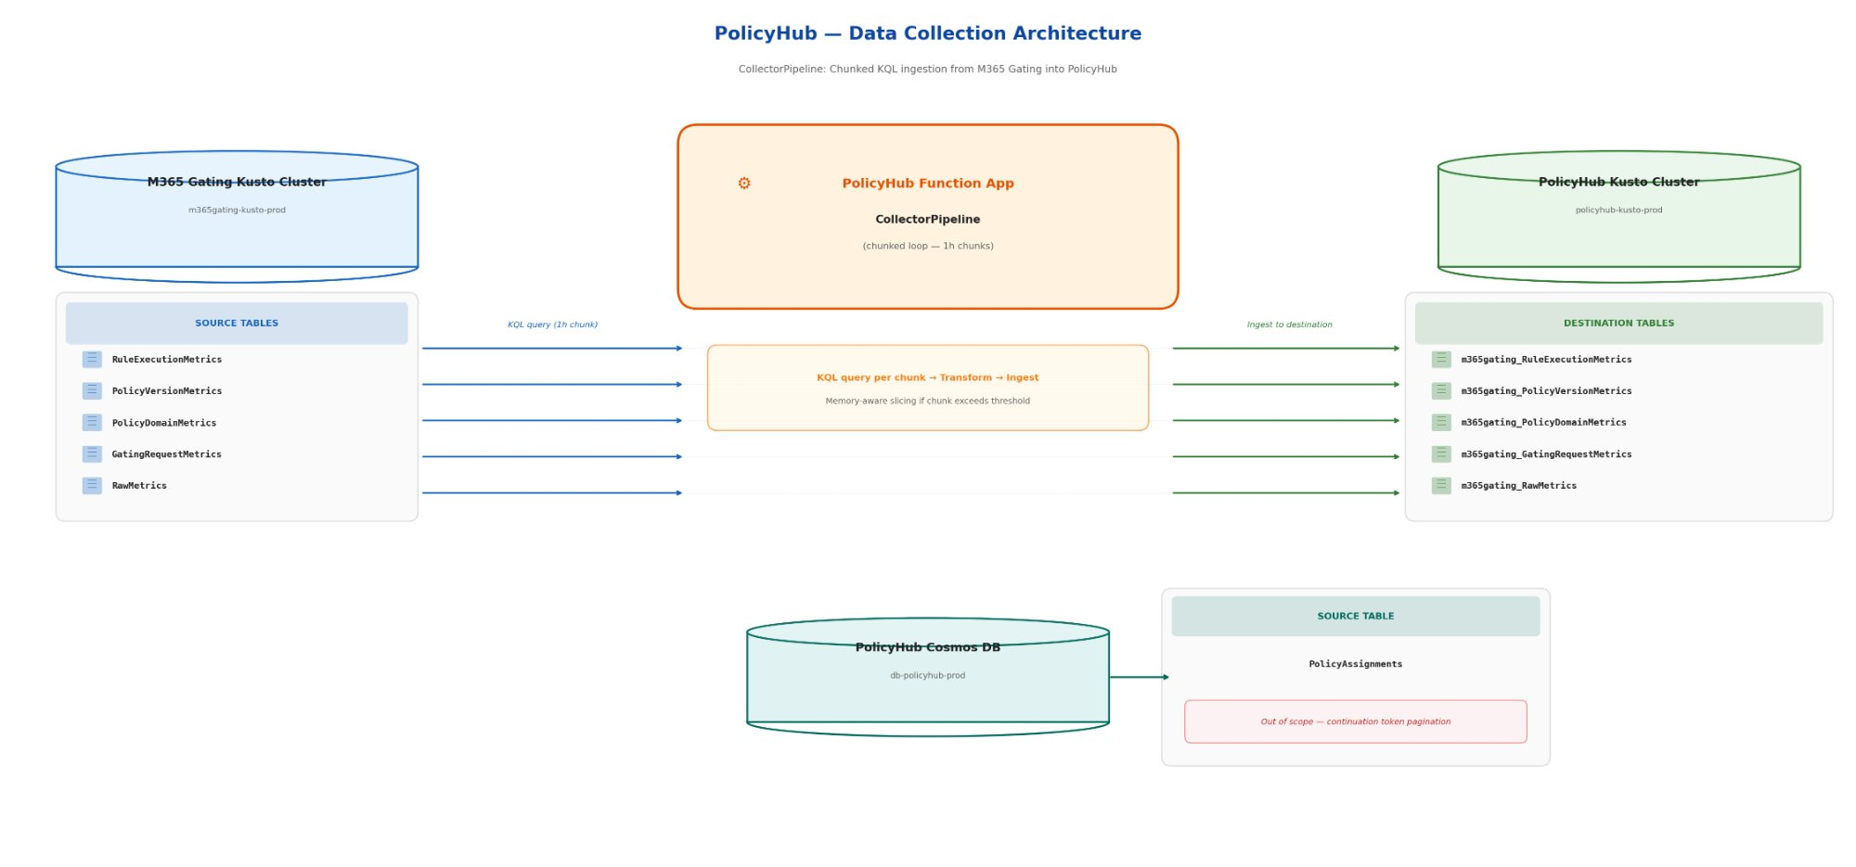

Module Interaction
Module | Role | Interaction
TimerDataCollectorFunction / HttpDataCollectorFunction | Trigger | Invokes CollectorWorkflow.ExecuteCollectionWorkflowAsync()
CollectorWorkflow | Orchestrator | Iterates enabled systems in parallel, calls CollectorPipeline per data source (sequential within a system)
CollectorPipeline | Chunking loop (modified) | Manages time-window iteration, calls provider per chunk, commits watermark per chunk
KustoDataSourceProvider | Data fetch | Executes KQL query for a single chunk time range, returns DataTable
KustoQueryBuilderService | Query builder (modified) | Builds {baseQuery} | where {ts} > chunkStart and {ts} <= chunkEnd (no | take)
DataTransformationService | Transform | Converts DataTable rows to JSON strings
DataIngestionService | Ingest | Parallel ingestion to destination Kusto cluster
SyncStateManagerService | Watermark | Reads/writes CollectorSyncState in Cosmos DB per chunk
ICollectorConfigs / QueryConfig | Config (modified) | Provides ChunkDuration per data source

Data Contract — CollectorSyncState (unchanged schema)
{
"id": "{enforcerName}_{clusterName}_{databaseName}_{tableName}",
"enforcerName": "M365Gating",
"lastSyncTimestamp": "2026-03-27T14:00:00Z",
"lastSyncStatus": "Success | Failed | Skipped",
"lastSyncRecordCount": 46503,
"lastSyncError": null
}

Behavior change: lastSyncTimestamp now advances per chunk (e.g., in 1-hour increments) rather than jumping to currentSyncTime at the end of the full run. The watermark only advances after all row slices within a chunk are successfully ingested. If any slice fails mid-chunk, the watermark stays at the previous chunk boundary and the entire chunk is retried on the next run. This keeps the chunk as the atomic unit of progress — simpler state management, and the bounded chunk size means re-ingesting a few slices on retry is low-cost.

Data Contract — QueryConfig (modified)
{
"QueryText": "RuleExecutionMetrics | order by InsertedAt desc",
"TimestampColumn": "InsertedAt",
"ChunkDuration": "PT1H",
"MaxMemoryThreshold": 52428800,
"Parameters": {}
}

Field | Type | Description
QueryText | string (required) | Base KQL query
TimestampColumn | string (required) | Column used for incremental filtering
ChunkDuration | string? (new) | ISO 8601 duration (e.g., "PT1H", "PT30M"). Null = full window (backward compatible).
MaxMemoryThreshold | long? (new) | Max estimated data size in bytes per query (e.g., 52428800 = 50 MB). When set, enables row-based slicing within each time chunk. Null = no row slicing.
MaxRecords | int? (existing, now ignored for Kusto) | No longer appended as | take for Kusto queries. Retained in config model for Cosmos PageSize usage.

Risks and Dependencies
Risk | Mitigation
Large backlog exceeds function timeout | Self-healing: each run makes partial progress. Watermark advances per chunk, next run resumes where the last left off. For initial catch-up, use HTTP trigger (longer timeout) or temporarily increase ChunkDuration.
Duplicate rows on retry | Existing behavior, not introduced by this change. Mitigated by destination deduplication policies and narrow chunk windows.
Kusto source retention expiry | If the source cluster’s retention policy drops data before the collector catches up, that data is permanently lost. Monitor watermark lag and alert when it approaches retention period.
Abnormal spike within a single chunk | A single hour with 10x normal volume could approach memory limits. Row-based slicing via MaxMemoryThreshold addresses this — the pipeline pre-queries to estimate data size and automatically slices when the threshold is exceeded. As a secondary control, ChunkDuration can be reduced to PT30M or PT15M for affected data sources.
Cosmos DB RU cost for watermark writes | One Cosmos write per non-empty chunk instead of one per run. At PT1H with 5 data sources, worst case ~120 writes/day. Negligible RU impact.
Dependency on PR 5027618 | The QueryDocumentsPageAsync method added by PR 5027618 is required for future Cosmos pagination (out of scope). Time-window chunking has no dependency on this PR.

Operational Concerns

Test Strategy

Unit Tests
- Existing 651 unit tests pass with no modifications — backward compatibility confirmed.
- ChunkDuration = null produces single-iteration loop identical to pre-change behavior.

Integration / Smoke Testing
Performed read-only Kusto queries against m365gating-kusto-prod/M365GatingAnalytics to validate:
- Data volume per chunk size: Counted rows and measured estimate_data_size(*) for PT30M, PT1H, PT6H, PT1D, and 7-day windows.
- Memory per chunk size: Measured peak_per_node memory via Kusto query completion stats with | order by + | serialize to force sort materialization.
- Confirmed PT1H produces ~47K rows / ~16 MB peak memory for the largest table (RuleExecutionMetrics) — well within safe Kusto limits.

Validation Plan
- Deploy to test environment with ChunkDuration: "PT1H" configured for all Kusto data sources.
- Trigger via HTTP endpoint (GET /data-collection).
- Verify in logs: chunk iteration count, rows per chunk, watermark advancement.
- Verify in destination Kusto: row counts match source cluster for the synced time window.
- Simulate failure mid-run (disable function after N chunks) and verify next run resumes from last committed watermark.

Telemetry and Monitoring

Current Telemetry and Monitoring
The collector flow currently has the following telemetry:
Application Insights Metrics (via MetricTracker wrapping TelemetryClient):
- PolicyHubLatency: Execution time in ms for the entire ExecuteDataCollectionAsync call, with dimensions Event (method name) and IsSucceeded. Emitted once per collector run by BaseDataCollectorFunction.
- PolicyHubStatus: Success/failure count with dimensions Event, Status, ErrorType, ErrorCode. Emitted once per collector run.
Azure Monitor Alert Rules (deployed via Ev2 Bicep):
- Latency alert: Fires when average latency of ExecuteDataCollectionAsync exceeds 10,000 ms over PT2H window. Currently disabled.
- Cron failure alert: Fires when success count of ExecuteDataCollectionAsync drops below 1 in a PT6H window. Enabled, routes to IcM via Policyhub://AzureMonitor routing ID.
- System error alert: Fires when ErrorType == "SystemErrorException" count > 0 in PT2H. Enabled, routes to IcM.
- Availability alert: Azure-native health check on the Function App, fires when HealthCheckStatus < 90% over PT30M. Enabled, routes to IcM.
Structured Logging (via ICustomLogger):
- All collector components (CollectorPipeline, CollectorWorkflow, KustoDataSourceProvider, SyncStateManagerService, etc.) log to Application Insights traces.
Watermark State (Cosmos DB):
- CollectorSyncState documents in Cosmos DB contain lastSyncTimestamp, lastSyncStatus, lastSyncRecordCount, and lastSyncError per data source. Not actively monitored — must be queried manually.

Why Current Monitoring Is Insufficient
The current monitoring was designed for a single-query-per-run model and does not account for the chunked pipeline or the failure modes that caused the OOM issue:
- No watermark lag visibility. The cron failure alert only fires if the function itself fails. If the collector runs successfully but processes stale data (e.g., watermark is 5 days behind), there is no alert.
- No per-chunk telemetry. The current metrics track the entire ExecuteDataCollectionAsync call as a single unit. With chunking, a run could process 20 chunks successfully then timeout on chunk 21, but it would be reported as a single failure.
- No error classification for RCA. The ErrorType and ErrorCode dimensions exist but are generic (SystemErrorException). An on-call engineer cannot distinguish between a Kusto OOM, a Cosmos timeout, an auth failure, or an ingestion error without reading raw logs.
- No resource utilization tracking. There is no visibility into Kusto query memory consumption, execution time per query, or how close queries are to cluster limits.
- No end-to-end latency metric. There is no measure of the time between when a gating metric is created at the source and when it becomes available in the destination PolicyHub Kusto cluster.
- No consecutive failure tracking. A single transient failure is different from 10 consecutive failures on the same data source. The current alerting treats them identically.

Proposed Additions
1. Data Freshness / Watermark Lag
Tracks how far behind the pipeline is per data source.
- Metric: CollectorWatermarkLagSeconds — currentTime - lastSyncTimestamp per data source
- Dimensions: SystemName, DataSourceName, DataSourceType
- Alert: Fire to IcM when lag exceeds 2x the cron interval (>12 hours for a 6-hour cron). A second, higher-severity alert when lag approaches the source Kusto cluster’s retention period (data loss imminent).
2. Per-Chunk Metrics
Enables visibility into partial progress and identifies which specific chunks are problematic.
- Metric: CollectorChunkLatency — execution time per chunk (query + transform + ingest)
- Metric: CollectorChunksProcessed — count of successfully processed chunks per run
3. Error Classification
Categorizes failures to enable faster root cause identification without reading raw logs.
ErrorCategory | Meaning | Remediation
KustoOOM | E_LOW_MEMORY_CONDITION from Kusto | Data volume spike — reduce ChunkDuration or increase MaxMemoryThreshold
KustoTimeout | Query exceeded server timeout | Query too broad or cluster under load — check cluster health
KustoAuthFailure | 401/403 from Kusto endpoint | MSI credential rotation or RBAC change — check identity permissions
CosmosTimeout | Cosmos DB request timeout | RU throttling or partition hotspot — check Cosmos metrics
CosmosAuthFailure | 401/403 from Cosmos | MSI or connection string issue
IngestionFailure | Destination Kusto ingestion failed | Destination cluster issue — check schema mismatch, cluster health
TransformationError | Data transformation failed | Schema drift in source data — check source table schema
WatermarkUpdateFailure | Failed to update sync state in Cosmos | Cosmos RU or connectivity — check Cosmos health
ConfigurationError | Invalid ChunkDuration, missing config | Deployment issue — check appsettings
4. Resource Utilization
Tracks how close queries are to cluster limits. Enables proactive resizing before failures occur.
- Metric: CollectorQueryResourceUsage — Kusto query stats per chunk
- Alert: Fire warning when PeakMemoryBytes exceeds 70% of MaxMemoryThreshold for any data source.
5. End-to-End Latency (Event Time to Ingestion Time)
Measures data staleness from the perspective of downstream consumers (Power BI dashboards).
- Metric: CollectorEndToEndLatencySeconds — ingestionTime - avg(eventTime) per chunk
- Alert: Fire when end-to-end latency exceeds a threshold (e.g., >24 hours).
6. Consecutive Failure Tracking
Distinguishes transient failures from systematic breakdowns.
- Metric: CollectorConsecutiveFailures — rolling count of consecutive failed runs per data source
- Alert: Fire at 3 consecutive failures. Escalate severity at 5+ consecutive failures.

Proposed Metrics Summary
Metric | Purpose | Key Dimensions | Alert Condition
CollectorWatermarkLagSeconds | Pipeline freshness | SystemName, DataSourceName | Lag > 12h (warn), lag approaching retention period (critical)
CollectorChunkLatency | Per-chunk execution time | SystemName, DataSourceName, ChunkIndex, RowCount | —
CollectorChunksProcessed | Partial progress visibility | SystemName, TotalChunks, SuccessfulChunks, FailedChunks | FailedChunks > 0
CollectorErrorClassification | Failure categorization | SystemName, DataSourceName, ErrorCategory | Any KustoOOM; 3+ consecutive failures
CollectorQueryResourceUsage | Proactive capacity tracking | SystemName, PeakMemoryBytes, RowCount, DataSizeBytes | PeakMemory > 70% of MaxMemoryThreshold
CollectorEndToEndLatencySeconds | Data staleness for consumers | SystemName, DataSourceName, ChunkStart | Latency > 24h
CollectorConsecutiveFailures | Transient vs systematic failure | SystemName, DataSourceName, LastErrorCategory | Count >= 3 (warn), >= 5 (critical)

Flighting & Roll-out Strategy

Deployment Plan
- Stage 1 — Test environment: Deploy with ChunkDuration: "PT1H" for all Kusto data sources. Validate via HTTP trigger.
- Stage 2 — PPE environment: Deploy and monitor for 1-2 days. Verify watermark advancement and data completeness.
- Stage 3 — Prod environment: Deploy with ChunkDuration: "PT1H". Monitor initial backlog catch-up via watermark lag dashboard.

Rollback Plan
- Config rollback: Remove ChunkDuration from appsettings to revert to single-query behavior (but re-introduces OOM risk).
- Code rollback: Revert the 4 modified files. No database migrations, schema changes, or external contract changes to unwind.
- Feature flag: EnableTimerDataCollectorFunction / EnableHttpDataCollectorFunction can disable the collector entirely if needed.

Open Questions
- What is the Kusto retention policy on m365gating-kusto-prod? This determines the maximum backlog that can be recovered.
- What alerting threshold should be set for watermark lag (e.g., alert if >6 hours behind)?
- What is the appropriate default MaxMemoryThreshold value? Based on smoke testing, 50 MB (~51 MB peak for 6h window) provides a safe margin. Should this be standardized or tuned per data source?

AI Assistance in Design
- Used Claude Code (Opus 4.6) to explore and understand the full PolicyHub collector codebase across 22+ source files.
- Claude performed read-only smoke testing against the prod Kusto cluster, executing count and memory-measurement queries for 5 different time-window sizes to determine optimal chunk duration.
- Claude implemented the time-window chunking code changes (4 files modified) and validated with build + 651 passing tests.
- Claude assisted in drafting sections of this design document based on codebase analysis and smoke test results.

References
- PR 5027618: Fix OutOfMemoryException in PolicySyncWorkflow — pagination pattern for Cosmos DB in the sync service
- PolicyHub Repository: https://o365exchange.visualstudio.com/O365%20Core/_git/PolicyHub
- Kusto E_LOW_MEMORY_CONDITION documentation: Error code 80DA0007

Appendix

Alternative Considered: MaxRecords with Offset Pagination
Instead of time-window chunking, paginate via | take N | skip M patterns in Kusto. Rejected because:
- Kusto does not support OFFSET / cursor-based pagination natively
- | take N after | order by still requires full materialization before truncation — does not reduce memory
- Time-window chunking naturally aligns with the existing watermark-based incremental sync model

Alternative Considered: Timestamp-Cursor Row Pagination
Within a time chunk, paginate rows by using the timestamp of the last processed row as a cursor. Rejected because:
- Timestamps are not unique identifiers — multiple rows can share the same timestamp value
- Rows with the same timestamp as the cursor would be either duplicated (if using >=) or dropped (if using >)
- The pre-query approach avoids this entirely by computing sliceSize from avg(estimate_data_size(*)) and fetching deterministic slices without needing a cursor

Alternative Considered: Reduce MaxRecords and Increase Timer Frequency
Run the collector every 5 minutes with MaxRecords: 50000 to keep each query small. Rejected because:
- Still silently drops data during spikes or outages
- Does not address the compounding failure problem (watermark stays fixed)
- Fragile — requires careful tuning of timer frequency vs data volume, breaks when volumes change

