SDP Compliance Materialized Pipeline
Design Document
M365 Safe Deployment Practices

Contributors | anikaushik
Reviewers
Security & Compliance

Change History
Date | Changes Done | Author | Reviewers
11-03-2026 | Document created | anikaushik

Table of Contents
Introduction 1
Problem Statement 1
Optimization Attempts 1
Goals 1
Design Requirements 1
Current Design 1
Why the Monolithic Query Cannot Be Incrementally Processed 1
In Scope 1
Out of Scope 1
Design Proposal 1
Why Decompose into 3 Tables 1
The 3-Table Architecture 1
Table 1: all-stage-runs (Scoping) 1
Table 2: yaml-to-run-list (Bridge + Pipeline Name) 1
Table 3: stage-telemetry-policy-compliance (Runtime Enrichment + ServiceTree) 1
Assembly Order 1
Incremental Processing Design 1
Day-N Processing Flow 1
ADF Pipeline Design 1
Daily Pipeline Flow 1
Key Risk Mitigations 1
Late-Arriving Data 1
Deduplication 1
Backfill 1
Service Classification Instability 1
Cross-Midnight Runs (RunDate) 1
Risks and Dependencies 1
Future Add-ons 1
Alternatives Considered 1
Open Questions 1
References 1

Introduction

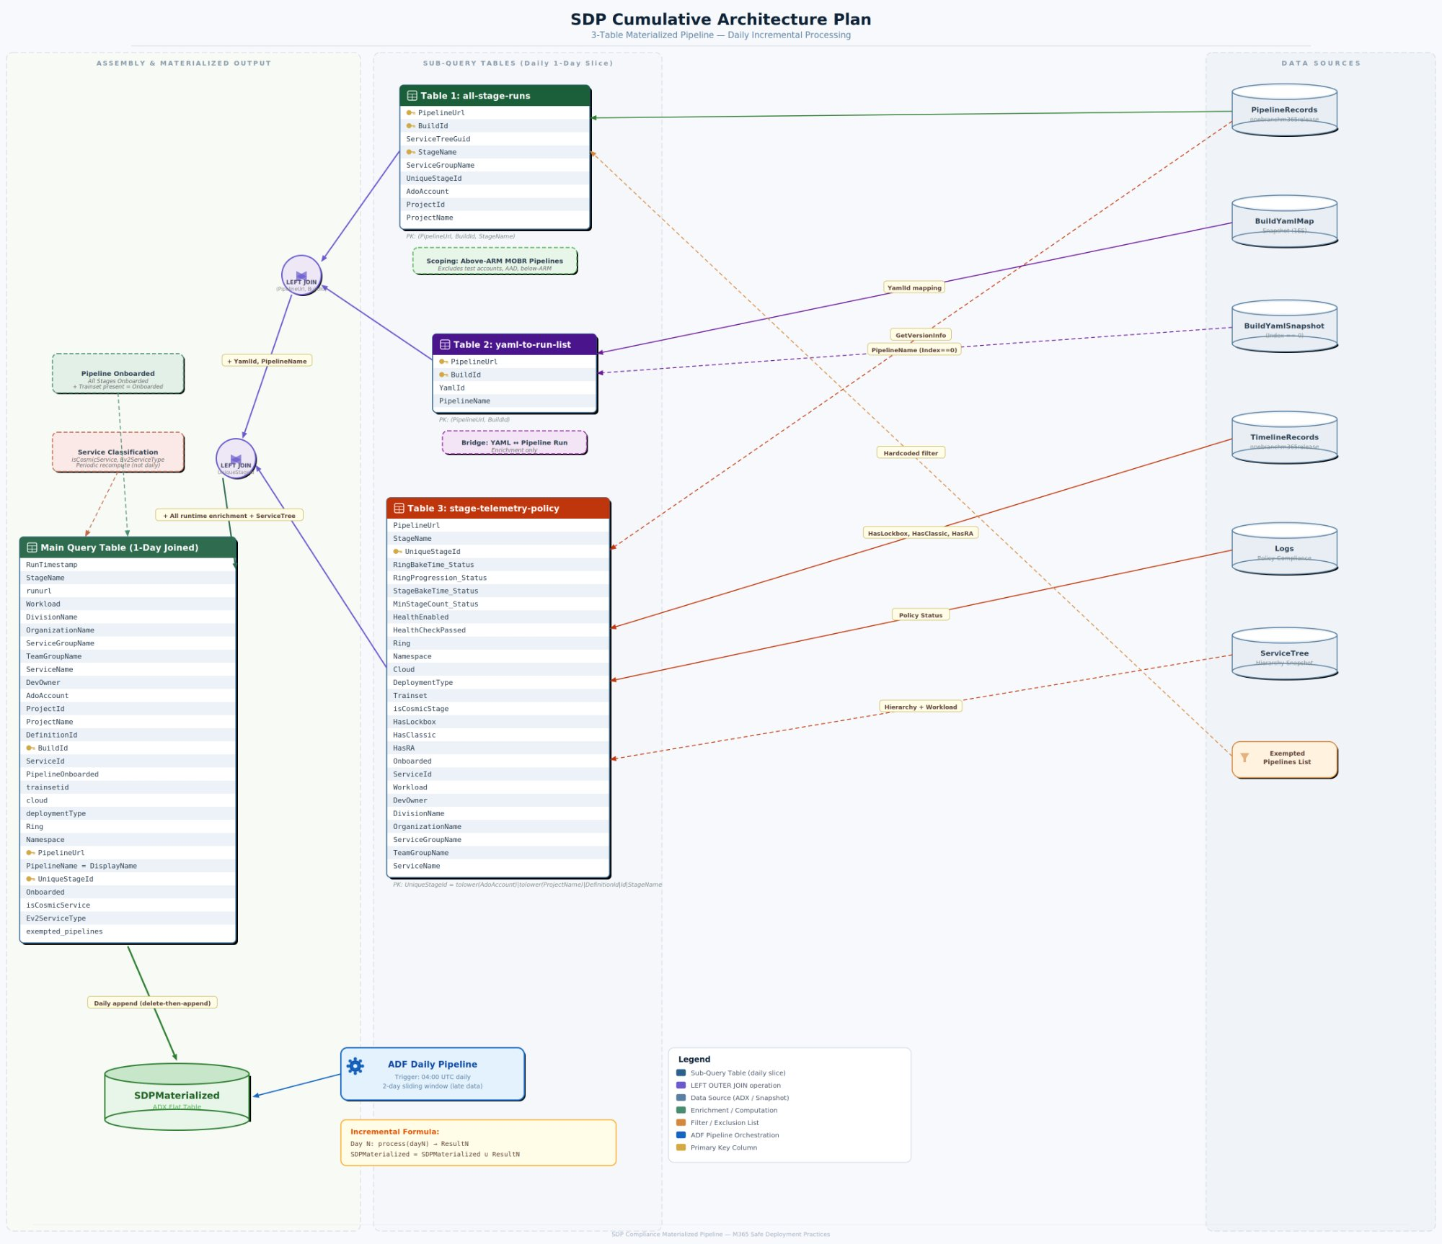
Figure 1: SDP Cumulative Architecture Plan

Problem Statement

- Joins data across 4 ADX clusters: servicetreepublic.westus, onebranchm365release.eastus, 1es, and s360prodro
- Performs 10+ left-outer joins with mv-expand, parse_json, and cross-cluster calls
- Uses set notruncation and set norequesttimeout as workarounds
- Only retrieves the latest run per pipeline (via arg_max) due to scale constraints

Limit | Threshold | Impact
Join memory budget | 5 GB default, 30 GB max | Error 80DA0001 — exceeded by 10+ joins on ~1.9M rows
Cross-cluster subquery truncation | 64 MB per subquery | May apply to remote calls; mitigated by local snapshots
Interactive query timeout | 4 min default, 1 hr max | ~252s ceiling after all optimizations

Optimization Attempts

# | Optimization | Result
1 | Rewrote query for all runs (stage x run expansion) | Timeout ~252s
2 | Added set servertimeout = 1h | Timeout ~252s
3 | Replaced all cross-cluster calls to 1es with local snapshots (10 calls eliminated) | Timeout
4 | Replaced cross-cluster calls to servicetreepublic with local snapshots (2 calls eliminated) | Timeout
5 | Replaced explicit same-cluster references with local table names | Timeout
6 | Added materialize() to cache intermediate result | Timeout
7 | Added hint.strategy=shuffle on 3 heaviest joins | Timeout
8 | Filtered pipeline info to only MOBR pipelines before joins | Timeout

Conclusion: The query’s complexity (10+ left-outer joins on ~1.9M stage-run rows) fundamentally exceeds ADX’s interactive query execution limits. A different architecture is required.

Goals
- Materialize all historical stage-run data into a single pre-joined flat ADX table
- Support daily incremental processing (1-day slices appended to the table)
- Use local snapshot tables to avoid cross-cluster overhead and reduce query complexity
- Serve the PowerBI dashboard with simple read queries against the materialized table

Design Requirements
Requirement | Constraint
Data volume | ~1.9M stage-run rows over 60 days
Incremental support | Daily append of new data without reprocessing full window
Late-arriving data | Must handle telemetry arriving up to 24-48 hours late
Idempotency | Reruns and retries must not create duplicate rows
Memory limits | Each sub-query must stay within ADX per-operator memory budget
Timeout limits | Each execution must complete within ADX management command timeout
Correctness | Join results must be identical to running the full query on X days of data

Current Design

- Queries servicetreepublic.westus (cross-cluster) for ServiceTree hierarchy
- Queries onebranchm365release.eastus (local) for PipelineRecords, TimelineRecords
- Queries 1es (cross-cluster, 10+ calls) for BuildYaml and BuildYamlMap
- Queries s360prodro (cross-cluster) for SDP action items
- Performs 10+ left-outer joins to combine all dimensions
- Returns only the latest run per pipeline via arg_max(Id, *)

Why the Monolithic Query Cannot Be Incrementally Processed
- Joins are interdependent. Intermediate results feed into downstream joins — stage ring analysis feeds into pipeline onboarding, which feeds into service classification.
- Service-level classification requires the full window. isCosmicService and Ev2ServiceType aggregate across ALL pipelines for a service.
- “Latest YAML” retroactive interpretation. The old query uses arg_max(BuildId, YamlId) to get the single latest YAML per pipeline, then applies it to all historical runs.
- Stage properties derived from YAML at query time. Ring, namespace, cloud, and task flags were extracted from YAML definitions, creating a dependency on the full YAML history.

In Scope
- Decomposition of the monolithic query into 3 modular sub-queries
- Schema design for each sub-table with defined keys and join relationships
- ADF daily pipeline for incremental materialization
- Initial backfill strategy (chunked by week)
- Deduplication and late-data handling

Out of Scope
- s360prodro SDP action items / wave classification — can be added as a future enrichment join
- PowerBI report redesign
- Materialized view design (e.g., SDP_LatestRun) — covered separately
- Service-level classification tables — addressed as a periodic recompute

Design Proposal

Why Decompose into 3 Tables

- Each sub-query reads from a single data source
- All join keys are scoped to a single run — a BuildId belongs to exactly one day
- No sub-query needs data from other days to produce correct output for its day
- Daily results can be joined and appended iteratively

The 3-Table Architecture

Table 1: all-stage-runs (Scoping)

Column | Type | Description
PipelineUrl | string | ADO pipeline URL
BuildId | long | Run/build identifier
ServiceTreeGuid | string | Effective ServiceId for this stage
StageName | string | Deployment stage name
ServiceGroupName | string | Service group from PipelineRecords
UniqueStageId | string | Composite key
AdoAccount | string | ADO account name
ProjectId | string | ADO project GUID
ProjectName | string | ADO project display name

Primary Key: (PipelineUrl, BuildId, StageName) / UniqueStageId

Table 2: yaml-to-run-list (Bridge + Pipeline Name)

Column | Type | Description
PipelineUrl | string | ADO pipeline URL
BuildId | long | Run/build identifier
YamlId | string | YAML definition identifier from BuildYamlMapSnapshot
PipelineName | string | Pipeline display name from BuildYamlSnapshot (Index == 0)

Primary Key: (PipelineUrl, BuildId)

Table 3: stage-telemetry-policy-compliance (Runtime Enrichment + ServiceTree)

Column | Type | Description
RingBakeTime_Status | int | Policy status (1=Pass, 2=Fail, 3=NotRun, 4=Missing)
RingProgression_Status | int | Policy status
StageBakeTime_Status | int | Policy status
MinStageCount_Status | int | Policy status
HealthEnabled | int | 1 if health-check-v1 exists
HealthCheckPassed | bool | true if all health checks passed
Ring | string | Deployment ring (from runtime MOBR/Cosmic logs)
Namespace | string | COSMIC namespace or “Non-Cosmic”
Cloud | string | Target cloud environment
DeploymentType | string | Normal / Emergency / GlobalOutage
Trainset | string | Trainset ID
isCosmicStage | int | 1 if COSMIC ring data exists
HasLockbox | int | 1 if Lockbox task present (TimelineRecords runtime)
HasClassic | int | 1 if ExpressV2Internal task present
HasRA | int | 1 if Ev2RARollout task present
Onboarded | int | 1 if Ring is non-empty AND in workload’s AllowedRings
ServiceId | string | ServiceTree GUID
Workload | string | Computed workload grouping

Primary Key: UniqueStageId

Assembly Order
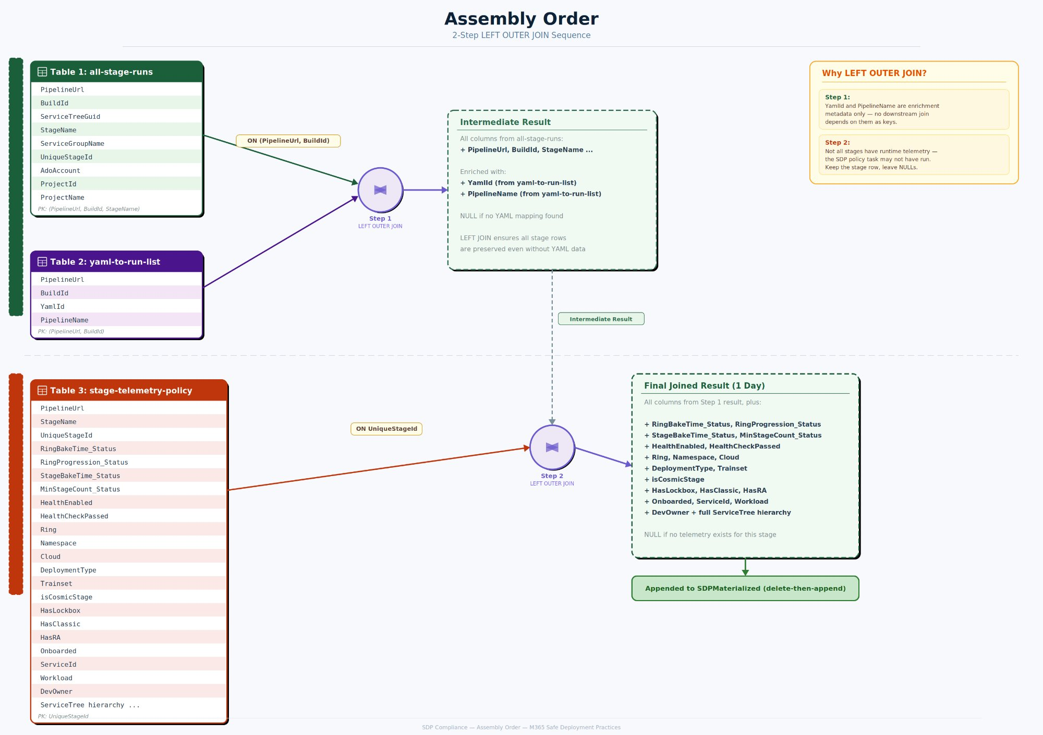
Figure 2: Assembly Order — 2-Step LEFT OUTER JOIN Sequence

Incremental Processing Design
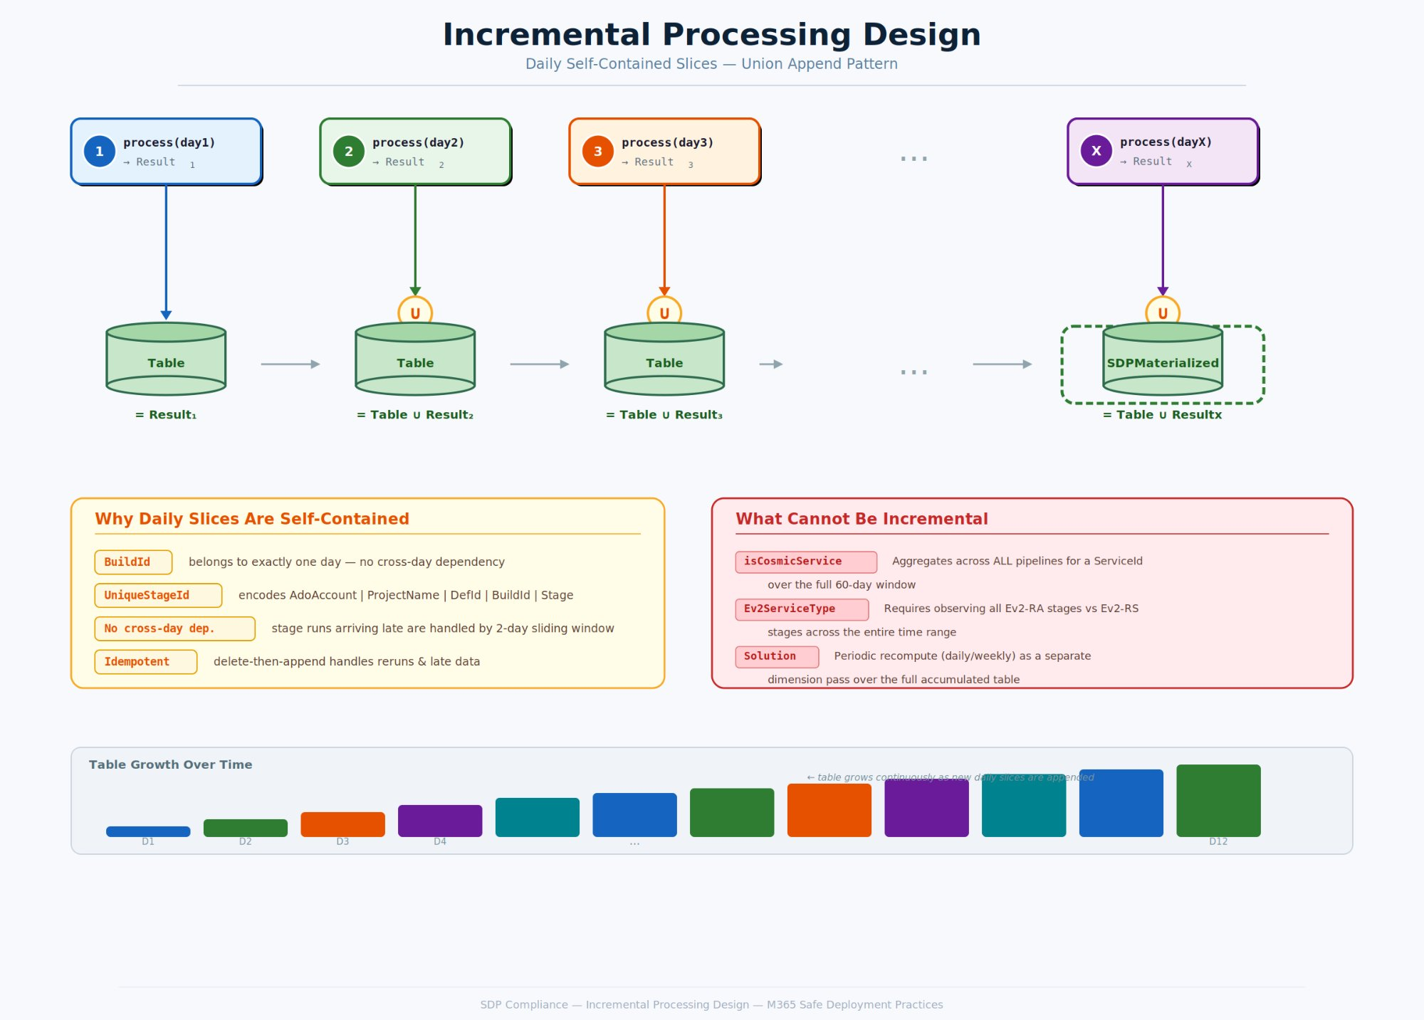
Figure 3: Incremental Processing Design — Daily Self-Contained Slices

Day-N Processing Flow
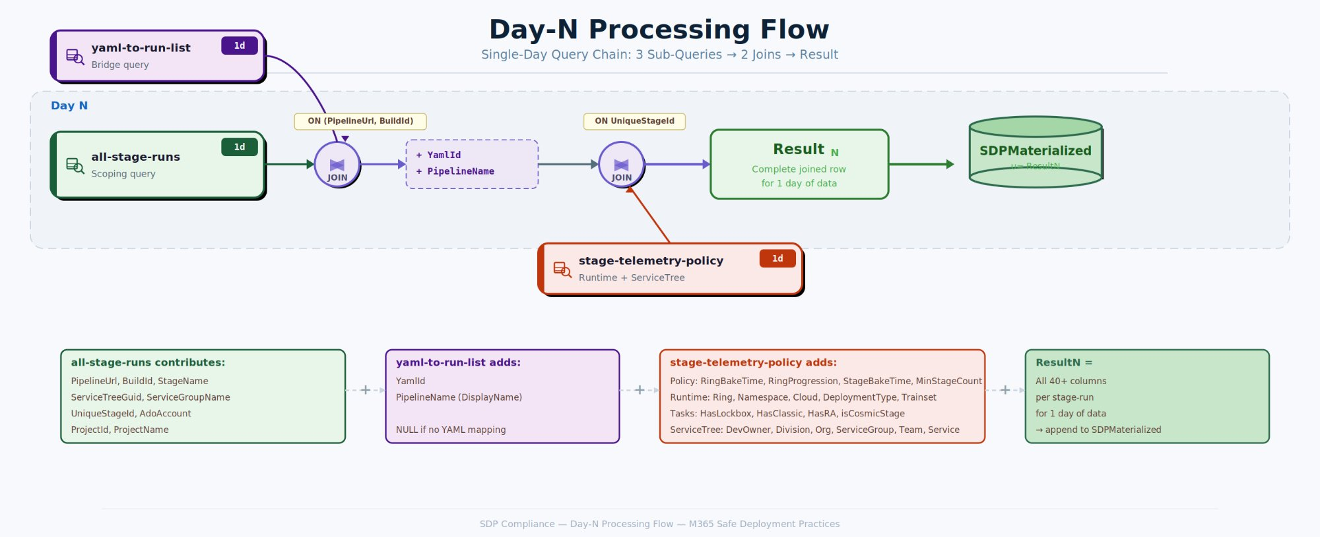
Figure 4: Day-N Processing Flow — Single-Day Query Chain

ADF Pipeline Design

Daily Pipeline Flow
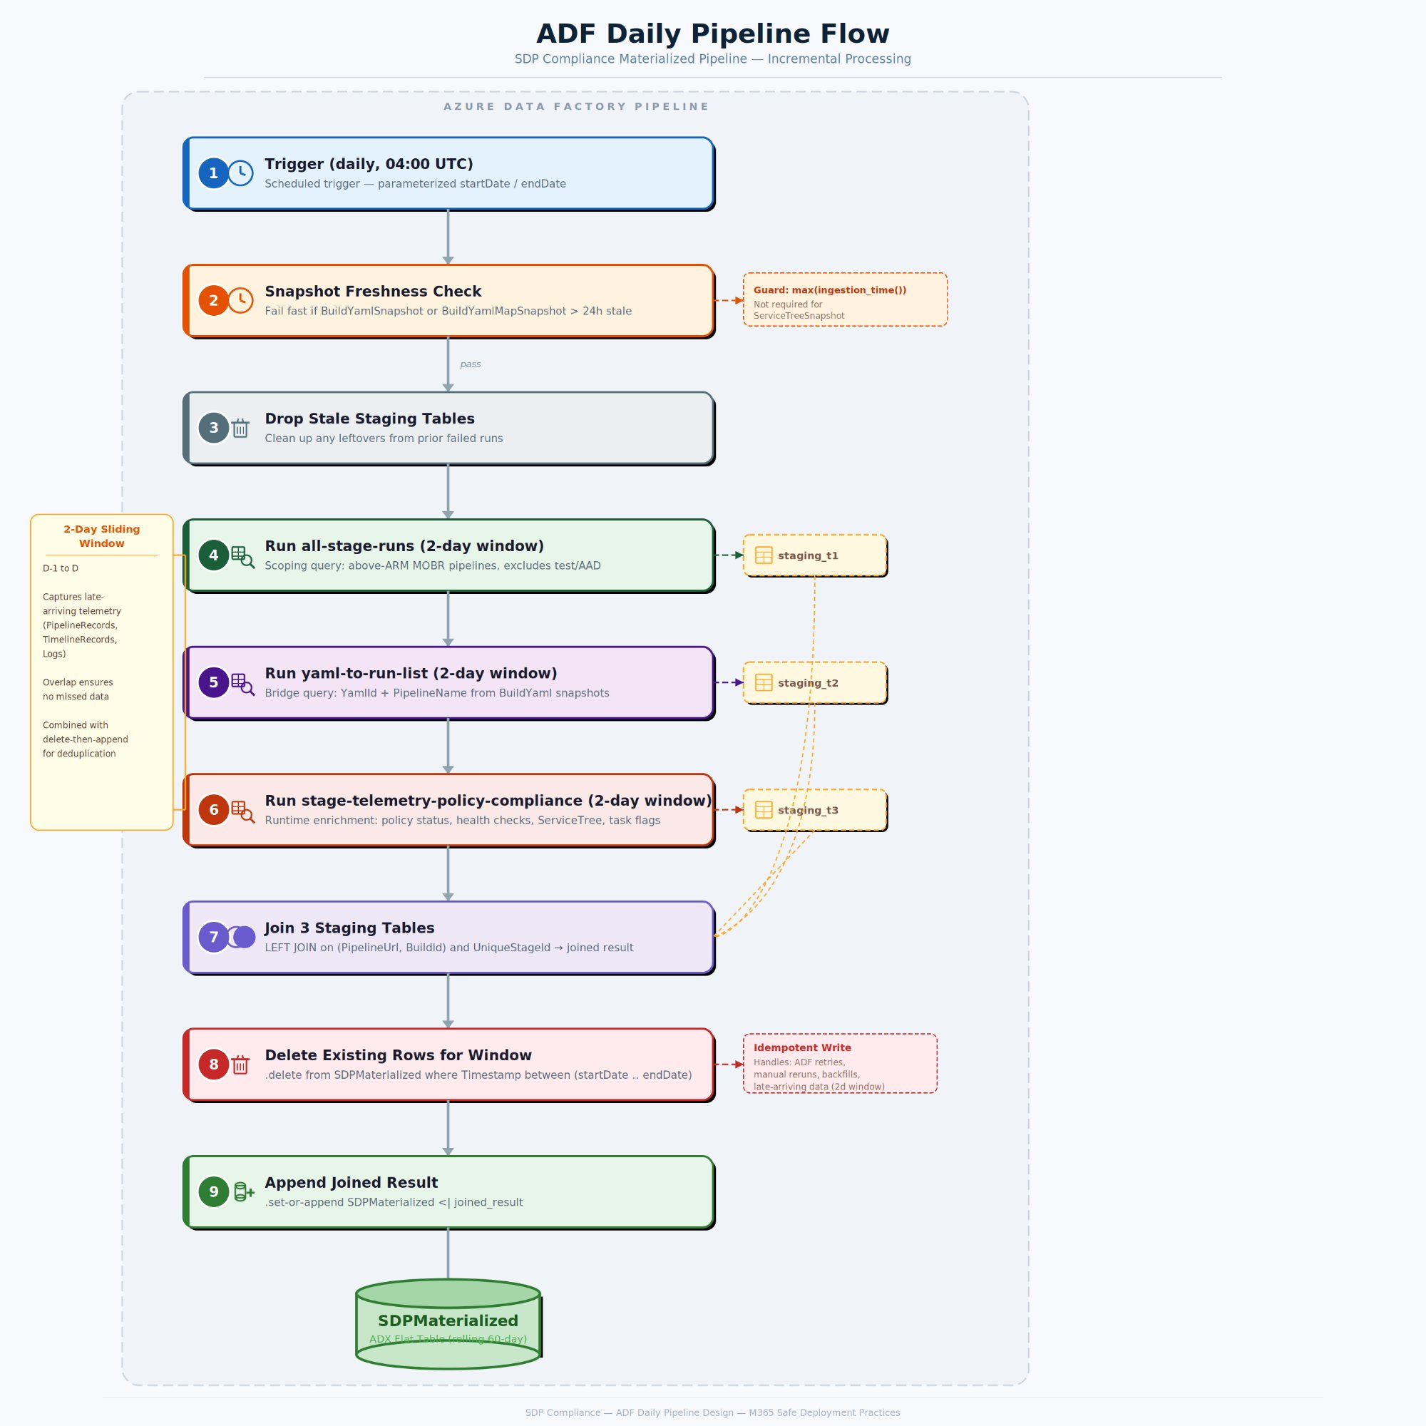
Figure 5: ADF Daily Pipeline Flow

Key Risk Mitigations

Late-Arriving Data

Deduplication

Backfill

Service Classification Instability

Cross-Midnight Runs (RunDate)

Risks and Dependencies
Risk | Mitigation
Snapshot tables stale (BuildYamlSnapshot, BuildYamlMapSnapshot) | Freshness check at pipeline start; fail fast if > 24h stale
2+ consecutive pipeline failures create data gaps | Manual backfill using SDP_BackfillChunk for affected date range
Type mismatch: BuildId (long) vs Id (string) | Join on UniqueStageId (string) avoids the mismatch

Future Add-ons

Alternatives Considered
Approach | Reason for Rejection
In-query optimization | 8 attempts, all timed out at ~252s. Join scale exceeds ADX interactive limits.
Spark / Fabric Lakehouse | Requires language rewrite (KQL → PySpark), new infrastructure. Overkill for ~570 MB.
ADX Update Policies | Designed for per-record enrichment, not global reconciliation.
ADX Continuous Export | Targets external storage, cannot write to another ADX table.
Daily windowing on monolith | Joins are interdependent — cannot partition by day.
Full replace daily | Correct but expensive — recomputes entire 60-day window daily.

Open Questions
- Exact ADF scheduling time and retry policy
- Retention period for the materialized table (e.g., rolling 90 days, or full history)
- Whether to implement a weekly full-rebuild consistency check

References
Resource | Description
schema.md | 3-table schema reference with keys, joins, and incremental processing analysis
all-stage-runs.md | Scoping sub-query
yaml-to-run-list.md | YAML bridge sub-query
stage-telemetry-policy-compliance.md | Runtime enrichment sub-query
Current state of SDP dashboard query.md | Old monolithic cross-cluster query
ADF-Pipeline-Design.md | ADF data risks and required protections

