Enriching Gating Normalized (Derived) Kusto Tables
Full plan to restructure and enrich the M365 Gating Kusto normalized tables to support SDP compliance dashboards and stage-level analytics.

Covers: Schema corrections | New column additions | Backfill strategy | Propagation to PolicyHub

Background
The SDP Compliance dashboards (Sdp-Compliance-Queries/Queries/) currently derive stage-level enrichment columns (Ring, Trainset, DeploymentType, Namespace, Cosmic status, EV2 service type, per-policy compliance) by joining across multiple external data sources (TimelineRecords, Logs, BuildYamlSnapshot, etc.) at query time. This is expensive and fragile.

The M365 Gating service already receives most of these values as request parameters and produces detailed per-policy results in RawGatingResult. By:
- Fixing the normalized table schemas to correctly represent the data hierarchy
- Adding missing enrichment columns at ingestion time
- Backfilling historical data from RawMetrics

This enables eliminating complex joins in downstream queries and provide accurate, pre-computed analytics tables.

Current Architecture

Data Flow
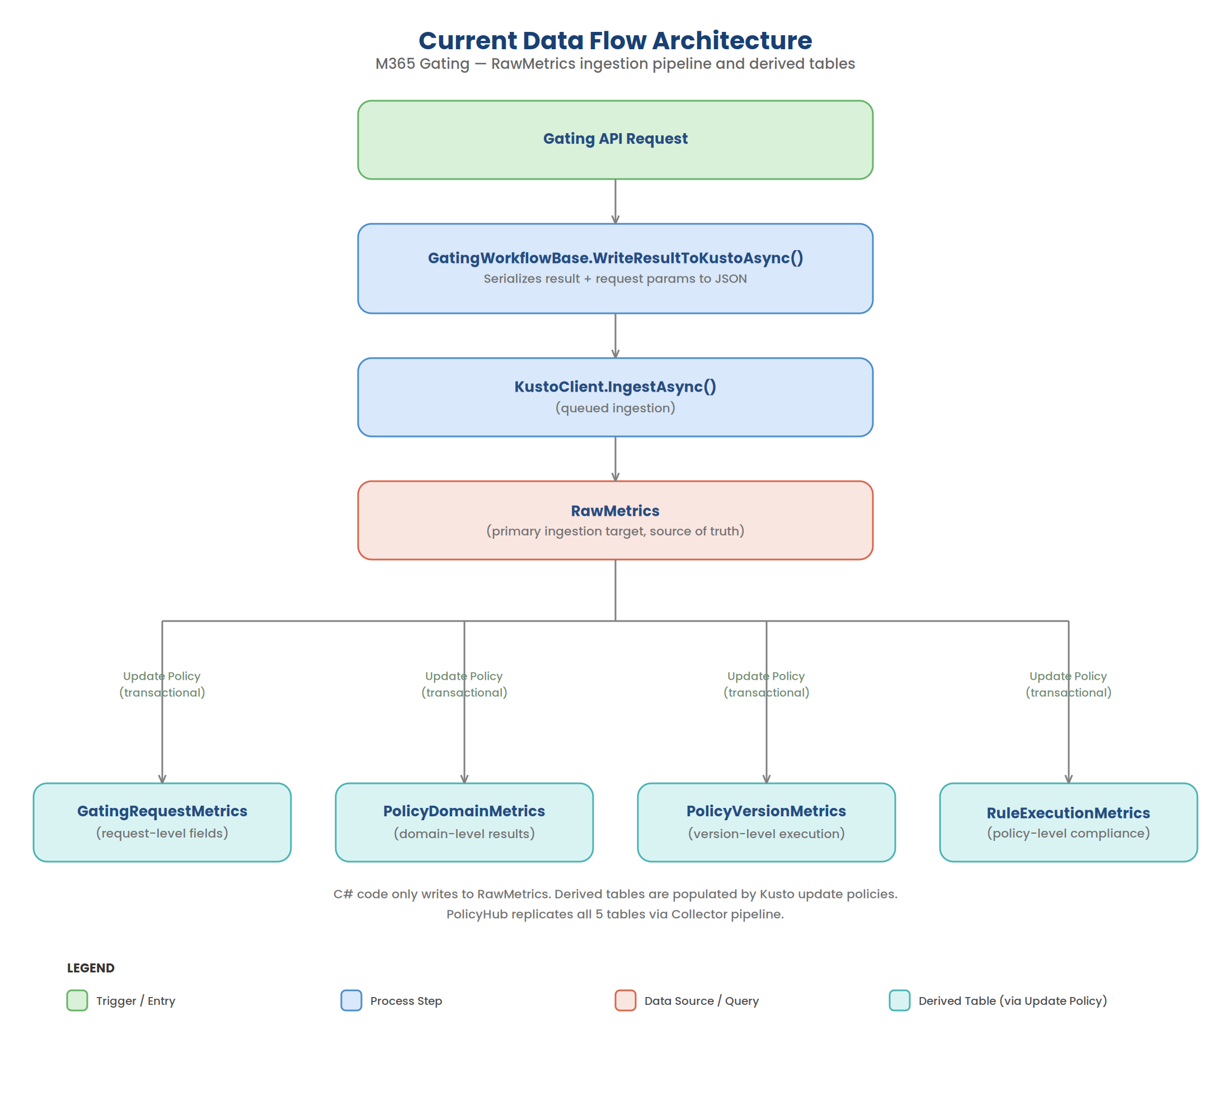

The C# code only writes to RawMetrics. The 4 derived tables are populated automatically by Kusto update policies — KQL queries that run on each ingested row and insert transformed results into the target tables.

PolicyHub then replicates all 5 tables from M365 Gating Kusto (M365GatingAnalytics) into its own Kusto (PolicyHubAnalytics) via a Collector pipeline.

RawGatingResult Hierarchy
The RawGatingResult dynamic column in RawMetrics contains the full nested policy evaluation result:
RawGatingResult
├── CompliantStatus (overall: Compliant/NotCompliant/CompliantWithRemediation)
├── DomainResults[] (V2 structure — versioned policies)
│ ├── PolicyDomain (SafeDeploymentPolicies, ChangeManagementPolicies)
│ ├── DomainCompliantStatus
│ └── PolicyResults[]
│ ├── PolicyName (e.g., "ring-bake-time", "min-stage-count")
│ ├── PolicyCompliantStatus (per-policy overall compliance)
│ └── PolicyVersionResults[]
│ ├── Version (e.g., "1.0.1_PR4909717_...")
│ ├── PolicyMode (Audit, Block, Warning, NotEnabled)
│ └── RuleResults[]
│ ├── BuildId
│ ├── PolicyRan (bool)
│ ├── PolicyPassed (bool)
│ ├── Data (evidence string)
│ └── MetaData (dynamic)
└── PolicyResults[] (V1 flat structure — non-versioned policies)
├── PolicyName
├── PolicyMode
├── RuleName
└── RuleResults[]
├── BuildId
├── PolicyRan
├── PolicyPassed
├── Data
└── MetaData

Key observation: All rows in the last 60 days (516,432 rows) have both DomainResults (V2) and flat PolicyResults (V1). The V2 branch contains versioned SDP/CMP policies; the V1 branch contains NotEnabled policies (functional-testing, code-review, etc.) with no PolicyCompliantStatus.

Current Table Schemas
Table | Current Columns
RawMetrics | MetricCreationTime, CorrelationId, OrganizationName, ProjectName, ProjectId, DefinitionId, BuildId, ServiceTreeId, StageName, StageAttempt, JobAttempt, Cloud, IsProduction, GateType, OverallGatingCompliantStatus, Metadata, RawGatingResult
GatingRequestMetrics | CorrelationId, InsertedAt, MetricCreationTime, OrganizationName, ProjectName, ProjectId, DefinitionId, BuildId, ServiceTreeId, StageName, StageAttempt, JobAttempt, Cloud, IsProduction, GateType, OverallGatingCompliantStatus, Metadata
PolicyDomainMetrics | CorrelationId, InsertedAt, PolicyDomain, DomainCompliantStatus
PolicyVersionMetrics | CorrelationId, InsertedAt, PolicyName, Version, PolicyMode
RuleExecutionMetrics | CorrelationId, InsertedAt, BuildId, PolicyRan, PolicyPassed, Data, MetaData

Key Files (M365 Gating)
File | Purpose
KustoTables.bicep | Table schemas + JSON ingestion mapping
KustoUpdatePolicies.bicep | Update policy definitions for derived tables
KustoCluster.bicep | Cluster + database provisioning
GatingWorkflowBase.cs | WriteResultToKustoAsync() — writes to RawMetrics
MOBRGatingRequestParams.cs | Request parameters (source of enrichment values)

Key Files (PolicyHub)
File | Purpose
KustoTables.bicep | Replicated table definitions + ingestion mappings
CollectorPipeline.cs | ETL pipeline that replicates M365 Gating tables
appsettings.{env}.json | Collector config (source queries, destination tables)

Problems with Current Schema

Problem 1: RuleExecutionMetrics has no PolicyName
RuleExecutionMetrics stores individual rule results (PolicyRan, PolicyPassed, Data, MetaData) but has no PolicyName column. Since multiple policies run per correlation ID, rows are indistinguishable — you cannot tell which rule result belongs to which policy.

Problem 2: PolicyRan/PolicyPassed/Data are at the wrong level
These columns are version-level outputs — they come from RuleResult inside PolicyVersionResult. They represent the outcome of a specific policy version’s rule execution, not the overall policy result. They belong in PolicyVersionMetrics, not RuleExecutionMetrics.

Problem 3: RuleExecutionMetrics should have overall PolicyCompliantStatus
RuleExecutionMetrics should represent the per-policy aggregate result — i.e., PolicyCompliantStatus from PolicyResult — not the individual rule-level booleans. This is the level that dashboards need for compliance reporting.

Corrected Data Hierarchy
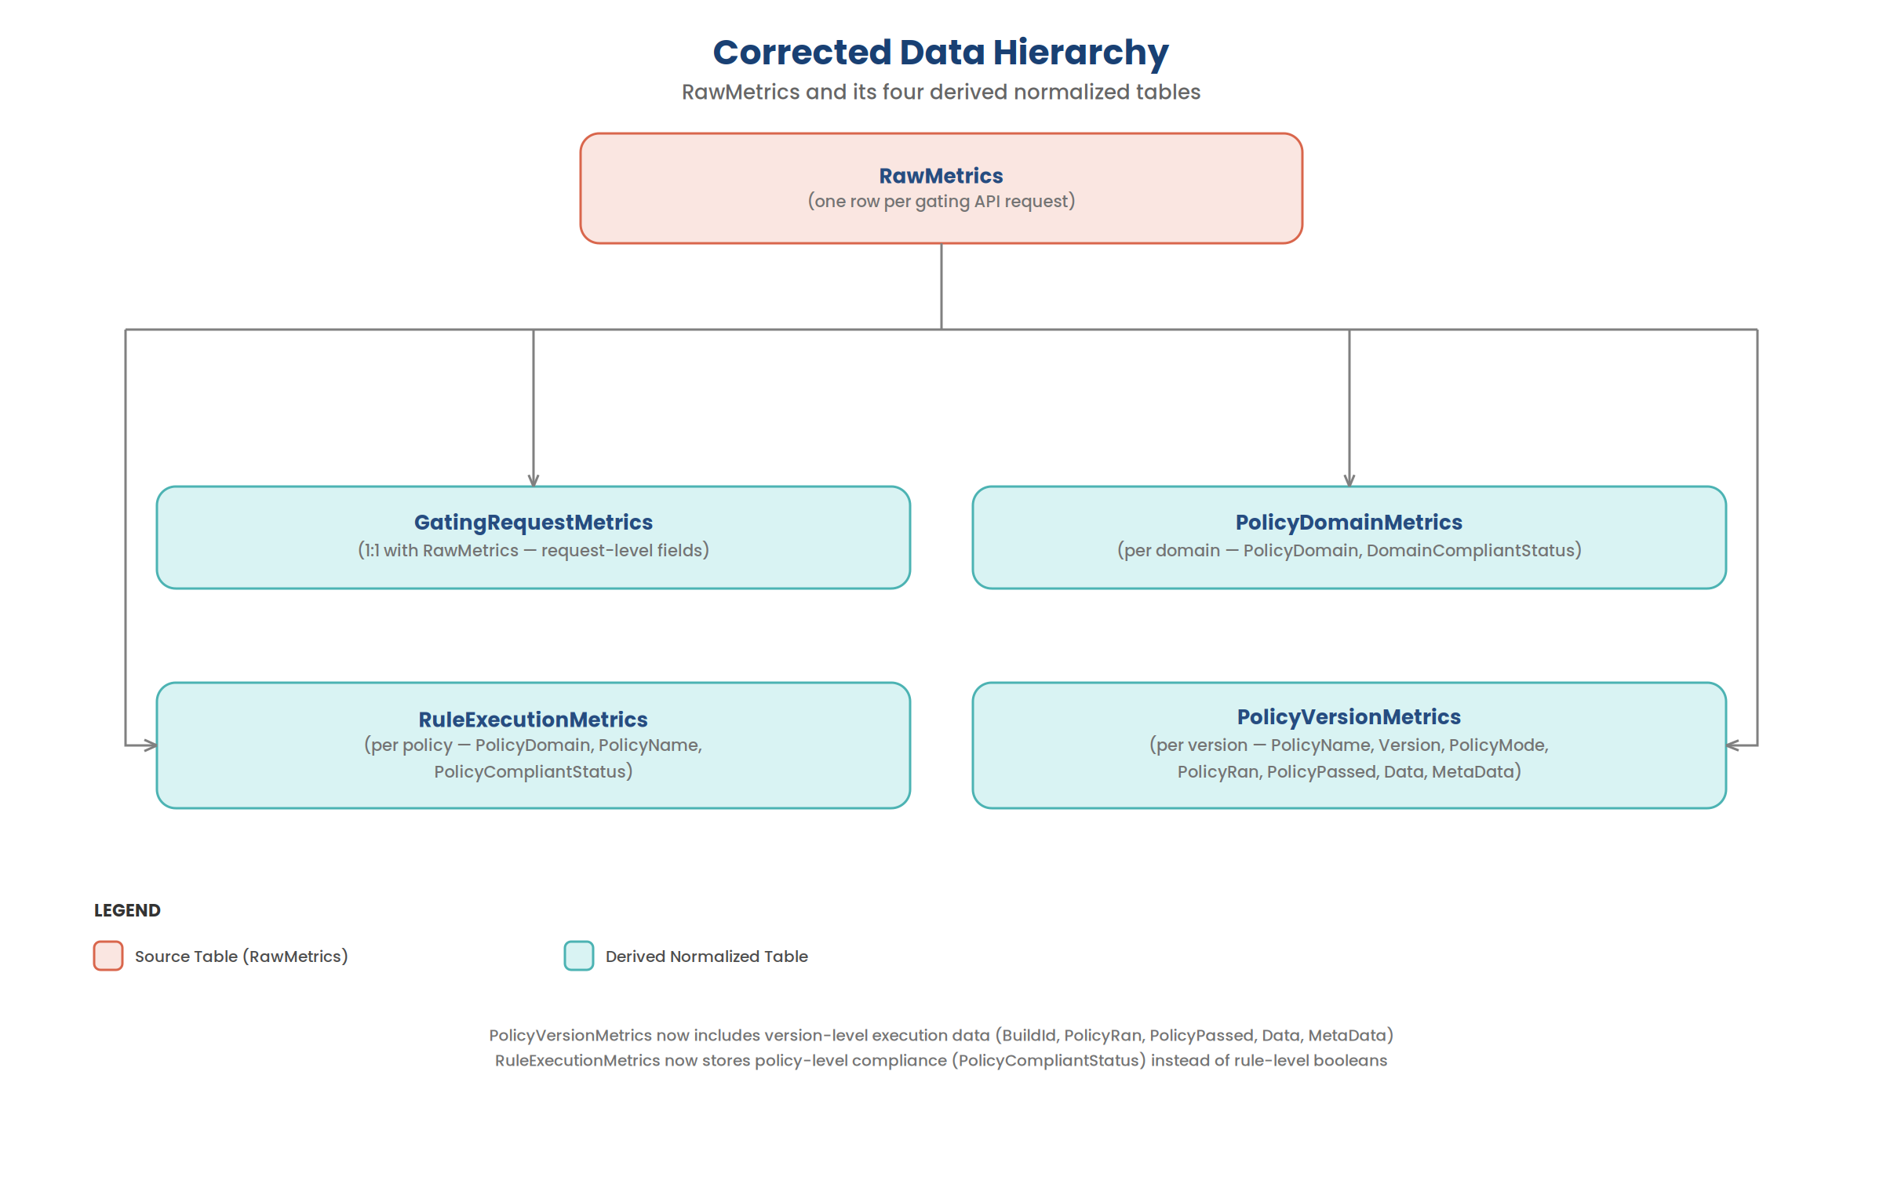

Phase 1: Fix Normalized Table Schemas

Corrected Table Schemas

PolicyVersionMetrics (add version-level execution data)
Column | Type | Status | Source
CorrelationId | string | Existing | RawMetrics row
InsertedAt | datetime | Existing | now()
PolicyName | string | Existing | PolicyResult.PolicyName
Version | string | Existing | PolicyVersionResult.Version (or "default" for V1)
PolicyMode | string | Existing | PolicyVersionResult.PolicyMode
BuildId | string | New | RuleResult.BuildId
PolicyDomain | string | New | DomainResult.PolicyDomain (V2) or "" (V1)
PolicyRan | bool | New | RuleResult.PolicyRan
PolicyPassed | bool | New | RuleResult.PolicyPassed
Data | string | New | RuleResult.Data
MetaData | dynamic | New | RuleResult.MetaData

RuleExecutionMetrics (replace rule-level booleans with policy-level compliance)
Column | Type | Status | Source
CorrelationId | string | Existing | RawMetrics row
InsertedAt | datetime | Existing | now()
BuildId | string | Existing | RawMetrics row (top-level)
PolicyDomain | string | New | DomainResult.PolicyDomain (V2) or "" (V1)
PolicyName | string | New | PolicyResult.PolicyName
PolicyCompliantStatus | string | New | PolicyResult.PolicyCompliantStatus
PolicyRan | bool | Removed | Moved to PolicyVersionMetrics
PolicyPassed | bool | Removed | Moved to PolicyVersionMetrics
Data | string | Removed | Moved to PolicyVersionMetrics
MetaData | dynamic | Removed | Moved to PolicyVersionMetrics

Scoping invariant: When PolicyDomain == "SafeDeploymentPolicies", the row’s existence guarantees the stage has lockbox + EV2 tasks and the pipeline is above-ARM MOBR. This does NOT hold for ChangeManagementPolicies. SDP dashboard consumers should filter on PolicyDomain == "SafeDeploymentPolicies" for scoping.
Evaluation denominator: This means the dashboard denominator is “stages with evaluated SDP policies”, NOT “all in-scope MOBR pipelines”. Stages that are in-scope but where the gating task didn’t run (skipped stages, pre-onboarding) are absent from this dataset.

GatingRequestMetrics and PolicyDomainMetrics
No schema changes needed. These are correct as-is.

Corrected Update Policy Queries

PolicyVersionMetrics Update Policy
Branch 1 — V2 (DomainResults path):
RawMetrics
| mv-expand DomainResult = RawGatingResult.DomainResults
| where isnotnull(DomainResult)
| mv-expand PolicyResult = DomainResult.PolicyResults
| where isnotnull(PolicyResult)
| mv-expand PolicyVersionResult = PolicyResult.PolicyVersionResults
| where isnotnull(PolicyVersionResult)
| mv-expand RuleResult = PolicyVersionResult.RuleResults
| where isnotnull(RuleResult)
| project
CorrelationId,
InsertedAt = now(),
PolicyName = tostring(PolicyResult.PolicyName),
Version = tostring(PolicyVersionResult.Version),
PolicyMode = tostring(PolicyVersionResult.PolicyMode),
BuildId = tostring(RuleResult.BuildId),
PolicyRan = tobool(RuleResult.PolicyRan),
PolicyPassed = tobool(RuleResult.PolicyPassed),
Data = tostring(RuleResult.Data),
MetaData = RuleResult.MetaData
PolicyDomain = tostring(DomainResult.PolicyDomain)

Branch 2 — V1 (flat PolicyResults path):
RawMetrics
| mv-expand PolicyResult = RawGatingResult.PolicyResults
| where isnotnull(PolicyResult)
| mv-expand RuleResult = PolicyResult.RuleResults
| where isnotnull(RuleResult)
| project
CorrelationId,
InsertedAt = now(),
PolicyName = tostring(PolicyResult.PolicyName),
Version = "default",
PolicyMode = tostring(PolicyResult.PolicyMode),
BuildId = tostring(RuleResult.BuildId),
PolicyRan = tobool(RuleResult.PolicyRan),
PolicyPassed = tobool(RuleResult.PolicyPassed),
Data = tostring(RuleResult.Data),
MetaData = RuleResult.MetaData
PolicyDomain = tostring(DomainResult.PolicyDomain)

RuleExecutionMetrics Update Policy
Branch 1 — V2 (DomainResults path):
RawMetrics
| mv-expand DomainResult = RawGatingResult.DomainResults
| where isnotnull(DomainResult)
| mv-expand PolicyResult = DomainResult.PolicyResults
| where isnotnull(PolicyResult)
| project
CorrelationId,
InsertedAt = now(),
BuildId,
PolicyDomain = tostring(DomainResult.PolicyDomain),
PolicyName = tostring(PolicyResult.PolicyName),
PolicyCompliantStatus = tostring(PolicyResult.PolicyCompliantStatus)

Branch 2 — V1 (flat PolicyResults path):
RawMetrics
| mv-expand PolicyResult = RawGatingResult.PolicyResults
| where isnotnull(PolicyResult)
| project
CorrelationId,
InsertedAt = now(),
BuildId,
PolicyDomain = "",
PolicyName = tostring(PolicyResult.PolicyName),
PolicyCompliantStatus = tostring(PolicyResult.PolicyCompliantStatus)

V1 flat PolicyResults have no domain wrapper — PolicyDomain is empty for these rows. These are all NotEnabled policies and will be excluded when filtering PolicyDomain == "SafeDeploymentPolicies".
Note: V1 flat PolicyResults have no PolicyCompliantStatus field. These rows will have empty/null values. All V1 policies are PolicyMode = "NotEnabled", so this is acceptable.

Files to Change (M365 Gating)
File | Change
KustoTables.bicep | Update PolicyVersionMetrics table (add BuildId, PolicyRan, PolicyPassed, Data, MetaData). Replace RuleExecutionMetrics table (remove PolicyRan/PolicyPassed/Data/MetaData, add PolicyName/PolicyCompliantStatus)
KustoUpdatePolicies.bicep | Update PolicyVersionMetrics update policy (add version-level execution columns). Replace RuleExecutionMetrics update policy (project policy-level compliance instead of rule-level booleans)

Files to Change (PolicyHub)
File | Change
KustoTables.bicep | Mirror same schema changes for m365gating_PolicyVersionMetrics and m365gating_RuleExecutionMetrics + their ingestion mappings
appsettings.*.json | No changes needed — collector queries are generic and will pick up new columns automatically

Phase 2: Backfill Derived Tables from RawMetrics via ADF
Since the table schemas are changing (columns added and removed), the existing derived tables must be dropped, recreated with new schemas, and backfilled from RawMetrics for the last 60 days.

Why ADF (not manual .set-or-append)
- Repeatable and auditable — ADF pipelines can be rerun if needed
- Chunked execution — 516K RawMetrics rows expand to ~55M version-level rows; ADF can chunk by time windows to avoid memory issues
- Monitoring — ADF provides built-in monitoring, retry, and alerting
- Applicable to all environments — same pipeline runs against Test, PPE, and Prod clusters

Backfill Execution Order
1. Disable update policies on all 4 derived tables
2. Drop and recreate PolicyVersionMetrics with new schema
3. Drop and recreate RuleExecutionMetrics with new schema
4. Backfill GatingRequestMetrics from RawMetrics (last 60d)
5. Backfill PolicyDomainMetrics from RawMetrics (last 60d)
6. Backfill PolicyVersionMetrics from RawMetrics (last 60d) [new schema]
7. Backfill RuleExecutionMetrics from RawMetrics (last 60d) [new schema]
8. Re-enable update policies with corrected queries

Backfill Queries
These KQL queries should be executed via ADF as .set-or-append management commands, chunked by time windows.

GatingRequestMetrics (no schema change)
.set-or-append GatingRequestMetrics <|
RawMetrics
| where MetricCreationTime between (datetime({start}) .. datetime({end}))
| project
CorrelationId, InsertedAt = MetricCreationTime, MetricCreationTime,
OrganizationName, ProjectName, ProjectId, DefinitionId, BuildId,
ServiceTreeId, StageName, StageAttempt, JobAttempt, Cloud,
IsProduction, GateType, OverallGatingCompliantStatus, Metadata

PolicyDomainMetrics (no schema change)
.set-or-append PolicyDomainMetrics <|
RawMetrics
| where MetricCreationTime between (datetime({start}) .. datetime({end}))
| mv-expand DomainResult = RawGatingResult.DomainResults
| where isnotnull(DomainResult)
| project
CorrelationId, InsertedAt = MetricCreationTime,
PolicyDomain = tostring(DomainResult.PolicyDomain),
DomainCompliantStatus = tostring(DomainResult.DomainCompliantStatus)

PolicyVersionMetrics (new schema)
.set-or-append PolicyVersionMetrics <|
RawMetrics
| where MetricCreationTime between (datetime({start}) .. datetime({end}))
| mv-expand DomainResult = RawGatingResult.DomainResults
| where isnotnull(DomainResult)
| mv-expand PolicyResult = DomainResult.PolicyResults
| where isnotnull(PolicyResult)
| mv-expand PolicyVersionResult = PolicyResult.PolicyVersionResults
| where isnotnull(PolicyVersionResult)
| mv-expand RuleResult = PolicyVersionResult.RuleResults
| where isnotnull(RuleResult)
| project
CorrelationId, InsertedAt = MetricCreationTime,
PolicyName = tostring(PolicyResult.PolicyName),
Version = tostring(PolicyVersionResult.Version),
PolicyMode = tostring(PolicyVersionResult.PolicyMode),
BuildId = tostring(RuleResult.BuildId),
PolicyRan = tobool(RuleResult.PolicyRan),
PolicyPassed = tobool(RuleResult.PolicyPassed),
Data = tostring(RuleResult.Data),
MetaData = RuleResult.MetaData
| union (
RawMetrics
| where MetricCreationTime between (datetime({start}) .. datetime({end}))
| mv-expand PolicyResult = RawGatingResult.PolicyResults
| where isnotnull(PolicyResult)
| mv-expand RuleResult = PolicyResult.RuleResults
| where isnotnull(RuleResult)
| project
CorrelationId, InsertedAt = MetricCreationTime,
PolicyName = tostring(PolicyResult.PolicyName),
Version = "default",
PolicyMode = tostring(PolicyResult.PolicyMode),
BuildId = tostring(RuleResult.BuildId),
PolicyRan = tobool(RuleResult.PolicyRan),
PolicyPassed = tobool(RuleResult.PolicyPassed),
Data = tostring(RuleResult.Data),
MetaData = RuleResult.MetaData
)

RuleExecutionMetrics (new schema)
.set-or-append RuleExecutionMetrics <|
RawMetrics
| where MetricCreationTime between (datetime({start}) .. datetime({end}))
| mv-expand DomainResult = RawGatingResult.DomainResults
| where isnotnull(DomainResult)
| mv-expand PolicyResult = DomainResult.PolicyResults
| where isnotnull(PolicyResult)
| project
CorrelationId, InsertedAt = MetricCreationTime,
BuildId,
PolicyName = tostring(PolicyResult.PolicyName),
PolicyCompliantStatus = tostring(PolicyResult.PolicyCompliantStatus)
| union (
RawMetrics
| where MetricCreationTime between (datetime({start}) .. datetime({end}))
| mv-expand PolicyResult = RawGatingResult.PolicyResults
| where isnotnull(PolicyResult)
| project
CorrelationId, InsertedAt = MetricCreationTime,
BuildId,
PolicyName = tostring(PolicyResult.PolicyName),
PolicyCompliantStatus = tostring(PolicyResult.PolicyCompliantStatus)
)

Chunking Strategy
Table | Est. Expansion | Recommended Chunk
GatingRequestMetrics | 1:1 with RawMetrics (~516K) | 1 day
PolicyDomainMetrics | ~2x RawMetrics (~1M) | 1 day
PolicyVersionMetrics | ~87x RawMetrics (~45M) | 1 hour
RuleExecutionMetrics | ~6x RawMetrics (~3M) | 1 day

PolicyVersionMetrics has the highest expansion factor due to many policies x versions x rules per request. Use 1-hour chunks (configured via ChunkDuration: "PT1H") to stay within Kusto memory limits.

Phase 3: Code Fixes and New Enrichment Columns
This phase covers two categories of code changes:
- Bug fixes — existing fields written as empty strings that must be populated
- New columns — enrichment data that doesn’t exist in RawMetrics yet

3A. Bug Fix: Populate DefinitionId and ProjectName (HARD BLOCKER)
DefinitionId and ProjectName are currently written as empty strings to RawMetrics in GatingWorkflowBase.WriteResultToKustoAsync(), even though both values are available on MOBRGatingRequestParams. This is a hard blocker — without these fields, PipelineUrl and UniqueStageId cannot be constructed.

Confirmed by querying prod: All 516K rows in GatingRequestMetrics have empty DefinitionId and ProjectName.

Current code (buggy):
var rawMetricsData = new
{
// ...
ProjectName = string.Empty, // BUG: always empty
// ...
DefinitionId = string.Empty, // BUG: always empty
// ...
};

Fixed code:
var rawMetricsData = new
{
// ...
ProjectId = gatingRequestParams.Project ?? string.Empty, // FIX
// ...
DefinitionId = gatingRequestParams.DefinitionId ?? string.Empty, // FIX
// ...
};

Where the values come from
Field | Source | Status | Notes
DefinitionId | MOBRGatingRequestParams.DefinitionId | Available | Clean fix — use gatingRequestParams.DefinitionId
ProjectId | MOBRGatingRequestParams.Project | Available* | This is the ProjectId GUID, not the display name

Impact
After this fix:
- PipelineUrl can be constructed: https://dev.azure.com/{org}/{projectId}/_build?definitionId={definitionId}
- The reworked SDP queries can fully scope from GatingRequestMetrics without any PipelineRecords dependency

3B. New Enrichment Columns
These columns do not yet exist in RawMetrics. They require code changes to the gating service to populate them at ingestion time.
Column | Type | Source in Code | Notes
Trainset | string | MOBRGatingRequestParams.Trainset | Already a request parameter. Direct passthrough
DeploymentType | string | MOBRGatingRequestParams.DeploymentType | ReleaseDeploymentType enum → string
Ring | string | MOBRGatingRequestParams.DeploymentRing | Already a request parameter
Namespace | string | MOBRGatingRequestParams.CosmicNamespace | Default to "Non-Cosmic" if empty
IsCosmicStage | bool | Derived | true if CosmicNamespace is non-empty
Ev2ServiceType | string | Derived from ReleaseStage | RS Only / RA Only / Hybrid Services / Unknown

Ev2ServiceType Derivation Logic
bool hasRS = stage.Ev2RSJobs?.Any() == true;
bool hasRA = stage.Ev2RAJobs?.Any() == true;

string ev2ServiceType = (hasRS, hasRA) switch
{
(true, false) => "RS Only",
(false, true) => "RA Only",
(true, true) => "Hybrid Services",
(false, false) => "Unknown"
};
hasRS | hasRA | Ev2ServiceType
true | false | RS Only
false | true | RA Only
true | true | Hybrid Services
false | false | Unknown

All Code Changes Required (Phase 3 Summary)
File | Change | Category
GatingWorkflowBase.cs | Fix ProjectName and DefinitionId (use request params instead of string.Empty) | Bug fix (3A)
GatingWorkflowBase.cs | Add 6 new enrichment fields to rawMetricsData | New columns (3B)
MOBRGatingRequestParams.cs | Add Ev2ServiceType property | New columns (3B)
KustoTables.bicep (Gating) | Add 6 columns to RawMetrics + JSON mapping | New columns (3B)
SDP policy evaluation code | Compute Ev2ServiceType from RS/RA jobs | New columns (3B)
KustoTables.bicep (PolicyHub) | Add 6 columns to m365gating_RawMetrics + mapping | New columns (3B)

GatingWorkflowBase.cs — Full Change
The rawMetricsData anonymous object in WriteResultToKustoAsync() should become:
var rawMetricsData = new
{
MetricCreationTime = DateTime.UtcNow,
CorrelationId = correlationId,
OrganizationName = gatingRequestParams.Organization ?? string.Empty,
ProjectName = gatingRequestParams.Project ?? string.Empty, // FIX
ProjectId = gatingRequestParams.Project ?? string.Empty,
DefinitionId = gatingRequestParams.DefinitionId ?? string.Empty, // FIX
BuildId = gatingRequestParams.BuildId ?? string.Empty,
ServiceTreeId = gatingRequestParams.ServiceTreeId ?? string.Empty,
StageName = gatingRequestParams.Environment ?? string.Empty,
StageAttempt = string.Empty,
JobAttempt = string.Empty,
Cloud = gatingRequestParams.Cloud ?? string.Empty,
IsProduction = gatingRequestParams.IsProduction,
GateType = gateType.ToString(),
OverallGatingCompliantStatus = result.CompliantStatus.ToString(),
Metadata = parsedMetadata,
RawGatingResult = resultForKusto,
// --- New enrichment columns (3B) ---
Trainset = gatingRequestParams.Trainset ?? string.Empty,
DeploymentType = gatingRequestParams.DeploymentType.ToString(),
Ring = gatingRequestParams.DeploymentRing ?? string.Empty,
Namespace = string.IsNullOrEmpty(gatingRequestParams.CosmicNamespace)
? "Non-Cosmic"
: gatingRequestParams.CosmicNamespace,
IsCosmicService = !string.IsNullOrEmpty(gatingRequestParams.CosmicNamespace),
Ev2ServiceType = gatingRequestParams.Ev2ServiceType ?? "Unknown"
};

KustoTables.bicep Changes
Add to RawMetrics table definition:
Trainset: string,
DeploymentType: string,
Ring: string,
Namespace: string,
IsCosmicService: bool,
Ev2ServiceType: string

Add to m365gating_RawMetrics_mapping:
{"column":"Trainset","path":"$.Trainset","datatype":"string"},
{"column":"DeploymentType","path":"$.DeploymentType","datatype":"string"},
{"column":"Ring","path":"$.Ring","datatype":"string"},
{"column":"Namespace","path":"$.Namespace","datatype":"string"},
{"column":"IsCosmicService","path":"$.IsCosmicService","datatype":"bool"},
{"column":"Ev2ServiceType","path":"$.Ev2ServiceType","datatype":"string"}

Phase 4: Backfill Enrichment Columns from Logs via ADF
Historical RawMetrics rows do not contain the 6 new enrichment columns. These values are not stored in RawGatingResult. However, they can be derived from the OneBranch release telemetry cluster.

Source Data
Column | Source Table | Extraction Method
Ring | Logs | extract(@"[?&]ring=([^&\s]+)", 1, Message)
DeploymentType | Logs | extract(@"[?&]deploymentType=([^&\s]+)", 1, Message)
Trainset | Logs | extract(@"[?&]trainset=([^&\s]+)", 1, Message)
Namespace | Logs | Extracted from NamespaceRingJson Cosmic log entries
IsCosmicService | Logs | Derived: true if Cosmic ring log entry exists
Ev2ServiceType | TimelineRecords | Derived from ExpressV2Internal (RS) and Ev2RARollout (RA) tasks

Cross-Cluster Backfill Strategy

Step 1: Extract enrichment data from OneBranch Logs
// Source: onebranchm365release.eastus.kusto.windows.net / onebranchreleasetelemetry
Logs
| where todatetime(Timestamp) > ago(60d)
| where TaskId == "d98bb041-d191-41c2-b770-3dc3e7b10d7e"
| where Message has "/api/GetMOBRDeploymentCompliantStatusByBuildId"
or Message has "NamespaceRingJson:"
| extend AdoAccount = tolower(AdoAccount)
| extend MsgType = case(
Message has "/api/GetMOBRDeploymentCompliantStatusByBuildId", "MOBR",
"Cosmic")
| extend _ring = iff(MsgType == "MOBR",
tostring(extract(@"[?&]ring=([^&\s]+)", 1, Message)), "")
| extend Ring = iif(isempty(_ring) or tolower(_ring) == "null", "", toupper(_ring))
| extend _depType = iff(MsgType == "MOBR",
tostring(extract(@"[?&]deploymentType=([^&\s]+)", 1, Message)), "")
| extend DeploymentType = iif(isempty(_depType) or tolower(_depType) == "null", "", _depType)
| extend _trainset = iff(MsgType == "MOBR",
tostring(extract(@"[?&]trainset=([^&\s]+)", 1, Message)), "")
| extend Trainset = iif(isempty(_trainset) or tolower(_trainset) == "null", "", _trainset)
| summarize
Ring = take_anyif(Ring, Ring != ""),
DeploymentType = take_anyif(DeploymentType, DeploymentType != ""),
Trainset = take_anyif(Trainset, Trainset != "")
by AdoAccount, ProjectId, DefinitionId, Id, Environment
| extend Namespace = iff(isempty(CosmicNamespace), "Non-Cosmic", CosmicNamespace)
| extend IsCosmicService = isnotempty(CosmicRing)

Step 2: Extract Ev2ServiceType from TimelineRecords
TimelineRecords
| where todatetime(StartTime) > ago(60d)
| summarize
HasClassic = max(iff(tostring(parse_json(Task).Name) == "ExpressV2Internal", 1, 0)),
HasRA = max(iff(tostring(parse_json(Task).Name) == "Ev2RARollout", 1, 0))
by AdoAccount, ProjectId, Id, Environment
| extend Ev2ServiceType = case(
HasClassic == 1 and HasRA == 0, "RS Only",
HasClassic == 0 and HasRA == 1, "RA Only",
HasClassic == 1 and HasRA == 1, "Hybrid Services",
"Unknown")

Step 3: Join with RawMetrics and update
The ADF pipeline would:
- Extract enrichment data from OneBranch (Steps 1 + 2) into a staging table in the M365 Gating cluster
- Join the staging table against RawMetrics on the matching key
- Use .set-or-replace to update RawMetrics with the enrichment columns populated
- Re-run the derived table backfill (Phase 2 queries) to propagate the new columns

Chunking Strategy
Step | Estimated Rows (60d) | Recommended Chunk
Logs extraction | ~1-2M entries | 1 day
TimelineRecords extraction | ~5-10M stage records | 1 day
RawMetrics update | 516K rows | 1 day

Important Notes
- Logs retention: The Logs table in OneBranch has its own retention policy. Ensure the backfill runs before data ages out.
- Partial coverage: Not every RawMetrics row will have a matching Logs entry. These rows will retain null values.
- Ev2ServiceType coverage: Only stages with ExpressV2Internal or Ev2RARollout tasks will have a non-"Unknown" classification.
- One-time operation: This backfill only needs to run once. After Phase 3 code changes ship, new ingestions will have these columns populated directly.

Propagation to PolicyHub
PolicyHub replicates M365 Gating Kusto tables via its Collector pipeline. Changes needed:

PolicyHub KustoTables.bicep
Replicated Table | Changes
m365gating_RawMetrics | Add 6 new columns (Trainset, DeploymentType, Ring, Namespace, IsCosmicService, Ev2ServiceType) + mapping entries
m365gating_PolicyVersionMetrics | Add 5 new columns (BuildId, PolicyRan, PolicyPassed, Data, MetaData) + mapping entries
m365gating_RuleExecutionMetrics | Replace columns: remove PolicyRan/PolicyPassed/Data/MetaData, add PolicyName/PolicyCompliantStatus + update mapping

PolicyHub Collector Config
No changes needed. The collector queries are generic — they select all columns. New columns in the source tables will automatically flow through the DataTransformationService.

PolicyHub Collector Code
No changes needed. The collector operates on generic DataTable rows and does not reference specific column names.

Deployment Order Summary
The changes span multiple repos and systems. The 4 phases must execute in order:
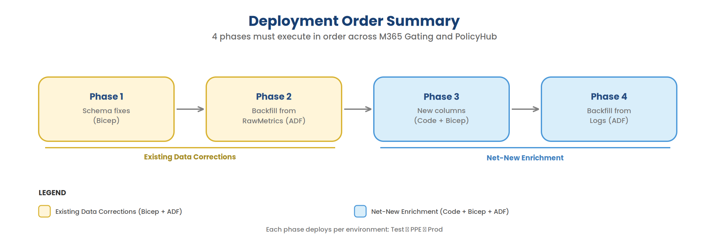

Phase 1: Fix Normalized Table Schemas
1. Deploy M365 Gating Bicep changes (per environment: Test → PPE → Prod)
- KustoTables.bicep: updated PolicyVersionMetrics + RuleExecutionMetrics schemas
- KustoUpdatePolicies.bicep: corrected update policy queries

2. Deploy PolicyHub Bicep changes (per environment: Test → PPE → Prod)
- KustoTables.bicep: mirror schema changes for replicated tables

Phase 2: Backfill Derived Tables from RawMetrics
3. Run ADF backfill pipeline (per environment: Test → PPE → Prod)
a. Disable update policies on all 4 derived tables
b. Drop and recreate PolicyVersionMetrics (new schema)
c. Drop and recreate RuleExecutionMetrics (new schema)
d. Backfill GatingRequestMetrics from RawMetrics (60d, chunked by day)
e. Backfill PolicyDomainMetrics from RawMetrics (60d, chunked by day)
f. Backfill PolicyVersionMetrics from RawMetrics (60d, chunked by hour)
g. Backfill RuleExecutionMetrics from RawMetrics (60d, chunked by day)
h. Re-enable update policies with corrected queries

4. PolicyHub Collector auto-syncs new data on next run

Phase 3: Code Fixes + Net-New Enrichment Columns
5. Deploy M365 Gating code changes (per environment: Test → PPE → Prod)
- BUG FIX: GatingWorkflowBase.WriteResultToKustoAsync()
- Populate DefinitionId from gatingRequestParams.DefinitionId (was string.Empty)
- Populate ProjectName from gatingRequestParams.Project (was string.Empty)
- NEW: MOBRGatingRequestParams.Ev2ServiceType (new property)
- NEW: GatingWorkflowBase.WriteResultToKustoAsync() (add 6 enrichment fields)
- NEW: Ev2ServiceType derivation logic in SDP policy evaluation

6. Deploy M365 Gating Bicep changes (per environment: Test → PPE → Prod)
- KustoTables.bicep: add 6 columns to RawMetrics + ingestion mapping

7. Deploy PolicyHub Bicep changes (per environment: Test → PPE → Prod)
- KustoTables.bicep: add 6 columns to m365gating_RawMetrics + mapping
After Phase 3, new ingestions will have DefinitionId, ProjectName, Trainset, DeploymentType, Ring, Namespace, IsCosmicService, and Ev2ServiceType populated. Historical rows still have nulls/empty strings.

Phase 4: Backfill Enrichment Columns from Logs
8. Run ADF cross-cluster backfill pipeline (per environment: Test → PPE → Prod)
a. Extract enrichment data from OneBranch Logs (60d, chunked by day)
b. Extract Ev2ServiceType from OneBranch TimelineRecords (60d, chunked by day)
c. Ingest into staging table in M365 Gating Kusto
d. Join staging table with RawMetrics and update enrichment columns
e. Re-run Phase 2 backfill to propagate enrichment columns into derived tables
f. Drop staging table

9. PolicyHub Collector auto-syncs updated data on next run
After Phase 4, the full 60 days of historical data will have enrichment columns populated (where source Logs data is available).

Reference: Data Volumes
Observed in Prod cluster on 2026-03-30 (last 60 days):
Table | Current Row Count | RawMetrics Source Rows
RawMetrics | 516,432 | —
GatingRequestMetrics | 1,825,180 | 516,432
PolicyDomainMetrics | 3,242,052 | 516,432
PolicyVersionMetrics | 44,950,591 | 516,432
RuleExecutionMetrics | 54,786,396 | 516,432

Row counts > RawMetrics are due to: (a) array expansion (mv-expand), and (b) both V1+V2 union branches producing rows for every RawMetrics row.

Estimated Post-Backfill Volumes
Table | Estimated Rows | Notes
GatingRequestMetrics | ~516K | 1:1 with RawMetrics
PolicyDomainMetrics | ~1M | ~2 domains per request
PolicyVersionMetrics | ~55M | Many policies x versions x rules + V1 union
RuleExecutionMetrics | ~3M | Fewer rows (policy-level, not rule-level)

Reference: Source Queries
The SDP compliance queries that motivated these enrichments:
Query File | What it computes | Columns it needs
Stage-telemetry-Policy-Compliance.md | Per-stage policy compliance with ring/cosmic/deployment enrichment | Ring, Namespace, DeploymentType, Trainset, isCosmicStage, HasRA, HasClassic, PolicyName, PolicyRan, PolicyPassed, PolicyMode
Current state of SDP dashboard query.md | Service-level onboarding status and EV2 classification | Ev2ServiceType, isCosmicService, Ring, Namespace, Trainset, deploymentType

By capturing enrichment columns at ingestion time and fixing the normalized table schemas, downstream queries can read directly from the derived tables without expensive joins against TimelineRecords, Logs, BuildYamlSnapshot, and ServiceTreeHierarchySnapshot.

