RBI Monetary Policy Communication:
NLP-Based Sentiment Extraction and Bond Yield / Exchange Rate Forecasting
A Data Science & NLP Project — Final Report
M.Sc. Economics, IIT Kanpur | Placement Portfolio Project

Abstract
This project tests whether the tone of Reserve Bank of India (RBI) Monetary Policy Committee (MPC) communication carries information beyond the policy rate decision itself. A corpus of 163 RBI documents (61 Resolutions, 60 sets of Minutes, 42 Governor's Statements) spanning October 2016 to August 2026 was scraped, cleaned, and scored for hawkish/dovish sentiment using two independent methods: a hand-built financial lexicon and sentence-level FinBERT. These scores were merged with daily 10-year G-Sec yield and USD/INR data around each MPC meeting and tested against market moves using OLS regression, ARIMA-residual analysis, Granger causality, and an out-of-sample directional validation split. The average, full-sample effect of sentiment on short-window yield and exchange-rate changes is not statistically significant once the repo rate decision itself is controlled for — a finding that is directly consistent with recent literature on Indian asset-class responsiveness to central bank tone. However, a 3-day out-of-sample directional accuracy test shows sentiment correctly signals the direction of the following yield move 69% of the time (p = 0.031), and a focused case study of the 2022 inflation shock finds a specific, dated instance of bond yields moving materially ahead of an actual rate decision, coincident with a tone shift in RBI's communication that the lexicon-based score initially failed to capture. The project's main contribution is methodological: an end-to-end, reproducible pipeline from raw government web scraping through econometric validation, applied to an Indian dataset that is comparatively unexplored relative to Federal Reserve communication studies.

1. Data

1.1 Sources
Source | Content | Coverage
rbi.org.in | MPC Resolutions, Minutes, Governor's Statements | Oct 2016 – Aug 2026
yfinance (INR=X) | USD/INR daily close | 2,592 trading days
investing.com | 10-year G-Sec daily yield | ~2,439 trading days

1.2 Corpus Composition
The final indexed document set contains 61 Resolutions, 60 sets of Minutes, and 42 Governor's Statements (163 documents total), classified automatically from RBI's press-release listings and validated by inspection. Resolutions and Minutes track almost 1:1, as expected since every MPC meeting produces both. The Governor's Statement count is lower than Resolutions primarily because separately-published statements were not issued at every meeting in the earliest years of the sample.

2. Methodology

2.1 Data Collection
RBI's policy archive (annualpolicy.aspx) does not expose a stable REST API; its year-selection control is a custom JavaScript handler (GetYear()) that sets a hidden form field and submits a plain POST request, rather than the standard ASP.NET __doPostBack mechanism initially assumed. This was identified through iterative inspection of the live network traffic and replicated directly in the scraper. Each document's HTML and PDF were then downloaded and archived locally.

2.2 Text Cleaning
PDF extraction (via pdfplumber) was used as the primary text source rather than HTML, since RBI's HTML pages embed the site's full navigation menu (roughly 280 lines) before the substantive content begins, while the PDFs carry only a short bilingual masthead. Header boilerplate was stripped using an anchor-based approach: RBI's central contact email (a constant across the full ten-year span, unlike the phone number, which changed format at least three times) marks the end of the header in the great majority of documents; a plain-date fallback handles the remainder. Footer boilerplate was stripped at RBI's internal filing-number pattern ("Press Release: YYYY-YYYY/NNN"), which remained stable across every signatory in the sample. Five documents where the downloaded PDF was provably the wrong file (confirmed by content inspection) were re-extracted from their HTML source instead. The final pipeline cleans 160 of 163 documents (98%) without residual boilerplate; the remaining three — RBI's earliest MPC-era statements (April–August 2016) — use a page template old enough that no tested anchor reliably applies, and retain some navigation-menu noise. This is documented as a known, bounded limitation (Section 4) rather than pursued further, since the affected documents are three of 163 and fall entirely within the training portion of the out-of-sample split (Section 2.4).

2.3 Sentiment Scoring
Baseline 1 — Lexicon. A hand-built dictionary of roughly 50 hawkish and dovish phrases (e.g. "withdrawal of accommodation", "upside risk to inflation" vs. "accommodative", "support growth") was matched against each document's cleaned text. The document score is (hawkish count − dovish count) / total words, scaled ×1000 for readability. The measure was validated against two documents with unambiguous, publicly known stances: the September 2022 Resolution (a 50bps hike amid the inflation shock) scored +3.82 (hawkish), while the February and April 2021 Resolutions (pandemic-era accommodation) scored −4.39 and −4.24 respectively (dovish) — both in the theoretically correct direction.
Baseline 2 — FinBERT. Each document was split into sentences (spaCy) and scored with ProsusAI/FinBERT, a transformer model fine-tuned for financial-text sentiment. Document-level score = mean(P(positive)) − mean(P(negative)) across sentences. The correlation between the two baselines across all 61 Resolutions is 0.293 — positive but modest. Inspection of the individual sentences FinBERT scored most positively and most negatively on the September 2022 Resolution shows why: FinBERT is responding to general economic-news framing (GDP growth figures, global conditions) rather than to the hawkish/dovish policy-stance axis specifically. This is treated as a substantive finding, not a defect — it motivates using the lexicon score as the primary measure, with FinBERT as an independent secondary check.
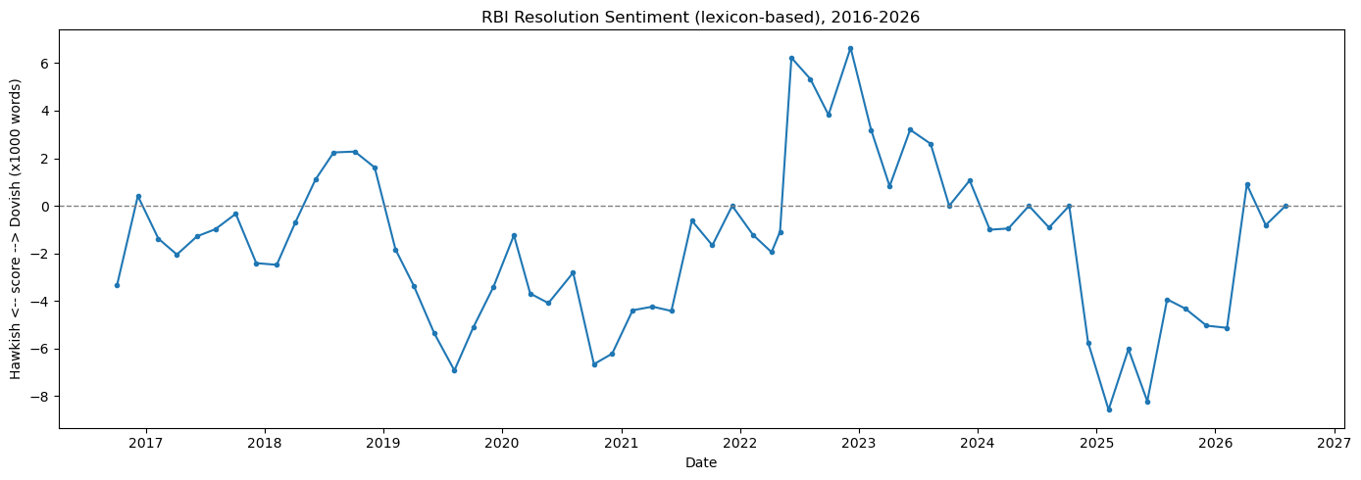
Figure 1. Lexicon-based hawkish/dovish sentiment score across all 61 Resolutions, 2016–2026.

2.4 Merging and Econometric Approach
For each Resolution, trading-day event windows (t−1, t+1, t+3) were constructed for both the 10-year G-Sec yield and USD/INR by locating the nearest available trading day at or before the meeting date and offsetting by trading-day position — robust to weekends and market holidays. A repo-rate-change control variable was extracted directly from each Resolution's own text via pattern matching (validated against six independently known events: the 2018 hiking cycle, 2019 cutting cycle, the March 2020 emergency COVID cut, the 2020–22 pandemic-era hold, and the 2022 hiking cycle — all correctly reconstructed). Stationarity was tested with the Augmented Dickey-Fuller test; yield and FX levels were confirmed non-stationary (justifying the use of changes as the dependent variable), while both sentiment series were confirmed stationary or borderline. Three complementary tests were then run: OLS regression of the yield/FX change on sentiment and the repo-rate control, an ARIMA-residual check (does sentiment explain the yield series' "surprise" component after removing its own autocorrelation), and Granger causality (does sentiment at meeting t help predict the yield change at meeting t beyond the yield series' own past). A chronological train/test split (train: meetings before 2022; test: 2022 onward) was used for out-of-sample validation, evaluating both R² and directional accuracy — whether the sign of the predicted move matched the sign of the actual move.

3. Results

3.1 Stationarity
Series | ADF p-value | Verdict
G-Sec yield (daily level) | 0.405 | Non-stationary
USD/INR (daily level) | 0.987 | Non-stationary
1-day yield change | <0.001 | Stationary
3-day yield change | <0.001 | Stationary
Lexicon sentiment score | 0.054 | Borderline
FinBERT sentiment score | 0.014 | Stationary

3.2 Full-Sample Regression
OLS of each dependent variable on lexicon sentiment, controlling for repo rate change (n = 61):
Dependent variable | R² | Sentiment p-value | Repo-change p-value
1-day yield change | 0.069 | 0.250 | 0.045*
3-day yield change | 0.031 | 0.484 | 0.189
1-day USD/INR change | 0.010 | 0.702 | 0.449
*p < 0.05.
Sentiment is not statistically significant in any specification. The repo rate change itself is significant only for the 1-day yield window, consistent with the direct decision dominating the immediate reaction before fading by day 3. Diagnostics were clean across all three models: Breusch-Pagan tests found no evidence of heteroskedasticity (all p > 0.05), and Durbin-Watson statistics (1.55–1.86) showed no material autocorrelation. An ARIMA(1,1,1)-residual check (does sentiment explain the yield series' unexplained "surprise" component) found the same null result (R² = 0.012, p = 0.406), and Granger causality tests found no significant lead-lag relationship at lags 1–3 (p = 0.663, 0.384, 0.964). Three independent methods agree.

3.3 Out-of-Sample Validation
Train: 32 meetings (Oct 2016 – Dec 2021). Test: 29 meetings (Feb 2022 – Aug 2026).
Window | OOS R² | Dir. Accuracy | n correct / n | p-value
1-day yield | 0.128 | 58.6% | 17 / 29 | 0.229
3-day yield | −0.043 | 69.0% | 20 / 29 | 0.031*
1-day USD/INR | 0.010 | 62.1% | 18 / 29 | 0.133
*p < 0.05, one-sided binomial test vs. 50% chance.
The 3-day window shows a genuinely notable result: despite a negative out-of-sample R² (magnitude poorly calibrated), sentiment correctly signals the direction of the 3-day yield move 69% of the time — significantly better than chance. R² and directional accuracy answer different questions: R² penalizes magnitude error heavily, while directional accuracy only asks whether the sign was right. A model can be a poor magnitude forecaster while still being a reliable direction indicator, which appears to be the case here. This result should be read alongside a multiple-testing caveat: three directional-accuracy tests were run and one was significant, which is a meaningful but not overwhelming signal at this sample size (n = 29).

3.4 Case Study: The 2022 Inflation Shock
RBI's April 8, 2022 meeting held the repo rate unchanged, while the first actual hike of the cycle (+40bps, an off-cycle emergency meeting) came on May 4, 2022. Comparing the two:
 | Apr 8, 2022 (held) | May 4, 2022 (+40bps)
1-day yield change | +0.235 | +0.284
3-day yield change | +0.301 | +0.346
Lexicon score (Resolution) | −1.95 | −1.09

The market's reaction to a meeting with no rate change was nearly as large as its reaction to the actual emergency hike three and a half weeks later; the 10-year yield rose 0.259 percentage points in the interim — a large move for a period with no policy action at all. This is direct evidence that RBI's tone moved the market ahead of the decision. Notably, the lexicon score on April 8 (−1.95, the most dovish Resolution reading in the entire episode) missed this shift entirely — while the same day's Governor's Statement scored closer to neutral (−0.29), and the Minutes published two weeks later (April 22) scored clearly positive (+0.89). The most likely explanation is that RBI's April communication removed dovish framing (e.g. "accommodative as long as necessary") rather than adding new hawkish phrases — an omission a word-count lexicon built to detect additions is structurally weaker at capturing, even though sophisticated market participants read omissions just as readily. Sentiment then remained elevated throughout the hiking cycle, peaking in December 2022 (+6.64) even as the pace of hikes was already decelerating (35bps, down from 50bps).
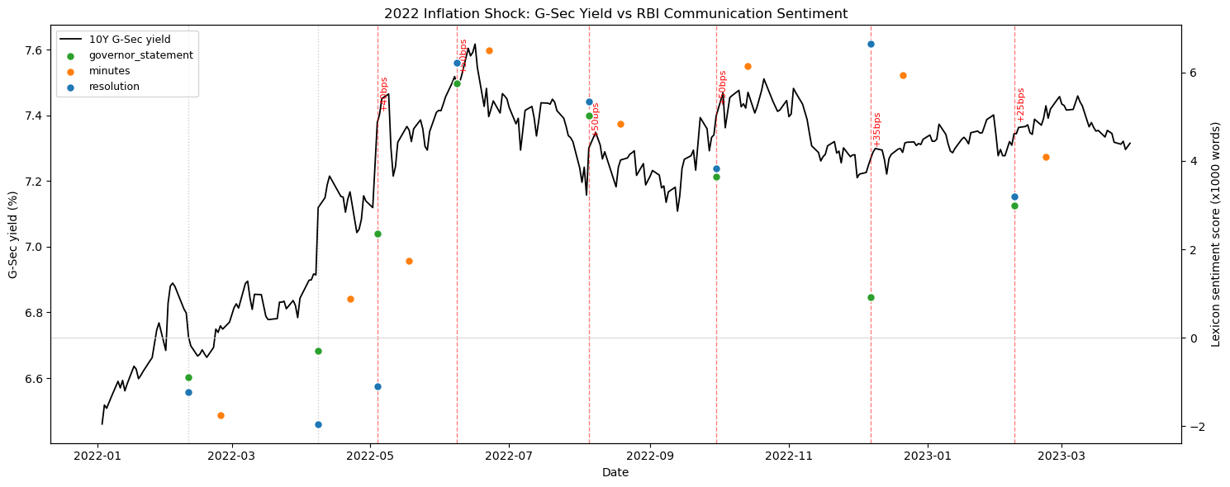
Figure 2. 10-year G-Sec yield (black line) against RBI communication sentiment by document type, with repo-rate decisions annotated, January 2022 – March 2023.
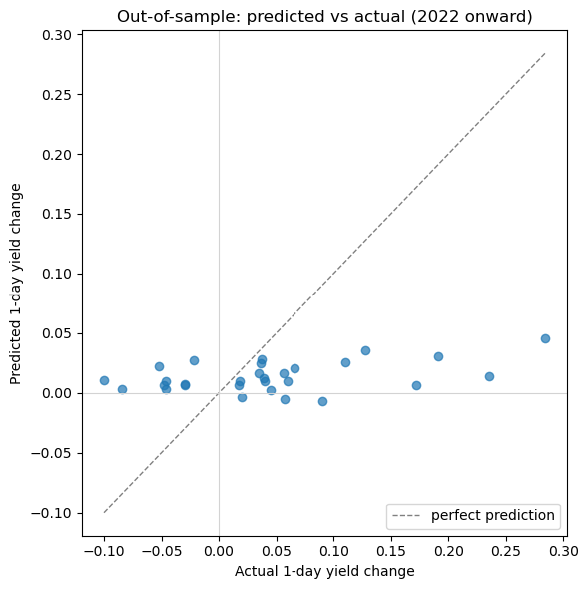
Figure 3. Out-of-sample predicted vs. actual 1-day yield change, test period (2022 onward).

4. Limitations
- Sample size: 61 Resolutions over 10 years limits statistical power, particularly for the 29-observation out-of-sample test; confidence intervals, not point estimates, should be the basis for any claim.
- Three of 163 documents (RBI's earliest MPC-era statements, April–August 2016) retain residual navigation-menu text after cleaning; both fall in the training period of the out-of-sample split and do not affect the primary Resolution-only results, but are a known, unresolved data-quality gap.
- CPI surprise (actual inflation vs. RBI's own forecast) was planned as a control variable but was not built, as it requires hand-compiling MOSPI actuals against each Resolution's stated forecast; the repo-rate-change control was used in its place.
- The repo-rate-change control is extracted via text pattern matching rather than an official RBI database; it was validated against six independently known historical events but was not cross-checked against every one of the 61 meetings individually.
- The lexicon (Baseline 1) is a manually constructed ~50-phrase dictionary rather than a validated, published instrument; the case study (Section 3.4) documents a specific instance where it missed a real tone shift that the market clearly priced.
- The out-of-sample 3-day directional accuracy result (Section 3.3) is one of three tests run; it should be read as a meaningful but not definitive signal given the multiple-comparisons context.

5. Conclusion
Across the full ten-year sample, RBI communication sentiment does not show a statistically significant average effect on short-window G-Sec yield or USD/INR moves beyond the repo rate decision itself — a result confirmed independently by OLS, ARIMA-residual analysis, and Granger causality, and consistent with recent literature finding that Indian bond yields are the least responsive of the major asset classes to central bank tone (equities and the exchange rate react more sharply). Two more targeted findings qualify that headline null result, however: sentiment shows statistically significant out-of-sample directional accuracy specifically in the 3-day window, and the 2022 case study documents a concrete, dated instance of the bond market moving ahead of an actual policy decision, coincident with a tone shift the primary sentiment measure initially failed to detect. Taken together, this is a more complete and more defensible answer than either a strong positive result or a flat null would have been: the average effect is weak, but it is not absent, it concentrates in a plausible window and a plausible stress episode, and the project's own methodology surfaced its own measurement limitation in the process of finding it.
The natural extension, motivated directly by the case-study finding, is an omission-aware or embedding-based sentiment measure — one capable of detecting what a statement stopped saying, not only what it started saying.

References
Lucca, D. O., & Trebbi, F. (2009). Measuring Central Bank Communication: An Automated Approach with Application to FOMC Statements. NBER Working Paper No. 15367.
Kamboj, H., Rao, N. V. M., & Agrawal, M. (2026). Central bank communication, policy action, and spillover: Evidence from Indian financial market. ScienceDirect.
Kumar, R., Paul, S. B., & Singh, N. (2024). Words that Move Markets: Quantifying the Impact of RBI's Monetary Policy Communications on Indian Financial Market. arXiv:2411.04808.

Appendix: Reproducibility
Full source code, the document index, cleaned text corpus, and all intermediate datasets are organized as a structured repository (data/raw, data/processed, data/market, notebooks/, src/, reports/), with each pipeline stage implemented as an importable Python module and driven from a numbered Jupyter notebook (01_scraping through 08_case_study_2022). All scraping and text-cleaning heuristics were validated against real sample documents before being applied to the full corpus, and each stage's output was spot-checked against publicly known RBI policy history prior to use in the next stage.

