System design document

Self-learning agent framework v4

Three-target compilation + harness activation + compliance verification
Based on arXiv:2605.30621 (Harness Evolution) + ACE (arXiv:2510.04618)
Google ADK BaseAgent | PostgreSQL | OCP | Python 3.12+
Version 4.0 | 2026-06-01

1. Executive summary
This document describes a self-learning agent framework that learns from user feedback through three-target compilation: corrections compile into decision tree rules (deterministic answers), validators (quality checks), and reasoning strategies (thinking protocols). The framework incorporates findings from arXiv:2605.30621 (Harness Updating Is Not Harness Benefit): separate cheap evolver from strong solver, explicit harness activation, and compliance verification.

Key insight from the paper: harness-updating is flat in capability (even a 9B model produces updates as good as Claude Opus), but harness-benefit requires both activation (recognizing when to use the harness) and following (faithfully executing the strategy). Our framework addresses both with explicit activation tracking and compliance verification.

2. Architecture overview
Figure 1 shows the complete architecture.
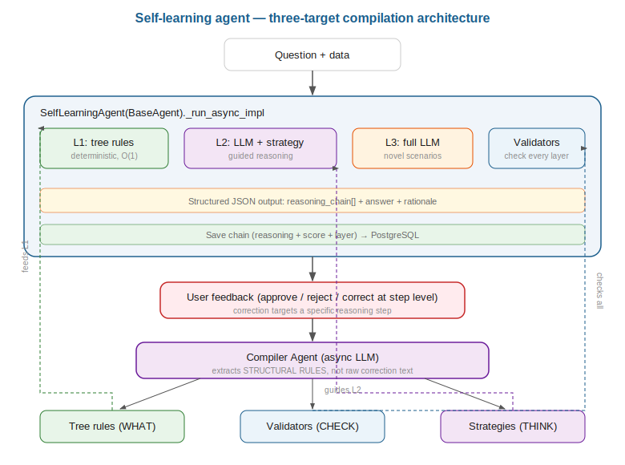

The SelfLearningAgent is a custom Google ADK BaseAgent. Its _run_async_impl method: (1) loads the harness (tree rules + validators + reasoning strategies), (2) activates relevant artifacts for THIS question, (3) tries L1 deterministic path, (4) falls back to L2 guided LLM with compiled strategy, (5) validates reasoning chain, (6) verifies harness compliance, (7) re-prompts on failures, (8) saves chain with activation and compliance metadata.

3. Paper findings incorporated
arXiv:2605.30621 identifies two distinct capabilities in self-evolving agents:

- Finding 1 (harness-updating is flat): small models produce harness updates as good as large models. Our Compiler Agent uses Gemini Flash (cheap evolver_model) to compile corrections into tree rules, validators, and strategies. The solver_model (Gemini 2.5 Flash) handles actual question answering. Capability budget goes to the solver.
- Finding 2 (harness-benefit requires activation + following): having great harness artifacts is useless if the agent fails to activate them or follow them. Our agent explicitly tracks activated_harness (which artifacts were loaded) and harness_followed (did the agent follow the thinking protocol). If compliance fails, the agent is re-prompted.
- Two failure modes addressed: (a) fail to activate: our agent loads all matching harness artifacts and logs which ones were activated. (b) activate but fail to follow: our _check_compliance function verifies that at least 60% of thinking steps appear in the reasoning chain. Failures trigger re-prompting with explicit instruction to follow each step.

4. Learning loop
Figure 2 shows the complete learning loop.
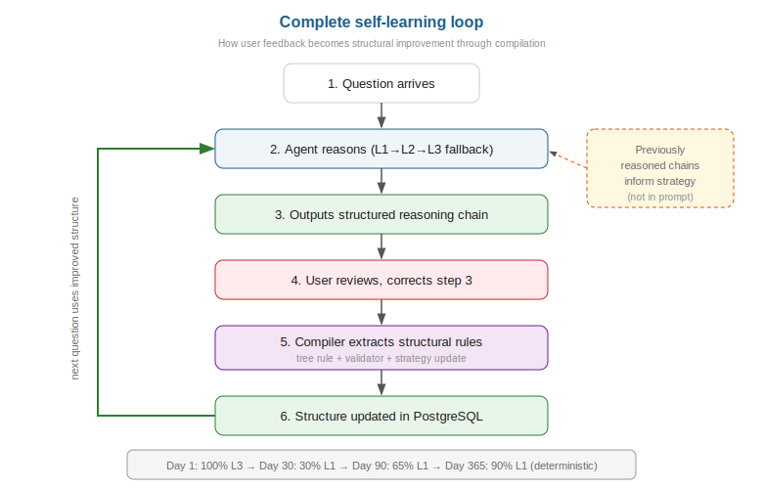

- Step 1: Question arrives with data.
- Step 2: Agent loads harness (tree + validators + strategy) and activates relevant artifacts.
- Step 3: L1 attempt (decision tree). If match + validators pass: instant answer.
- Step 4: L2 fallback: LLM with compiled reasoning strategy as system instruction + validator constraints.
- Step 5: Validate reasoning chain. Verify harness compliance. Re-prompt if either fails.
- Step 6: User reviews structured output. Corrects at step level.
- Step 7: Compiler Agent (cheap evolver model, async) extracts structural rules into three targets.
- Step 8: Next question uses improved harness. The loop compounds.

5. Three-target compilation
Figure 3 shows how one correction compiles into three structural outputs.
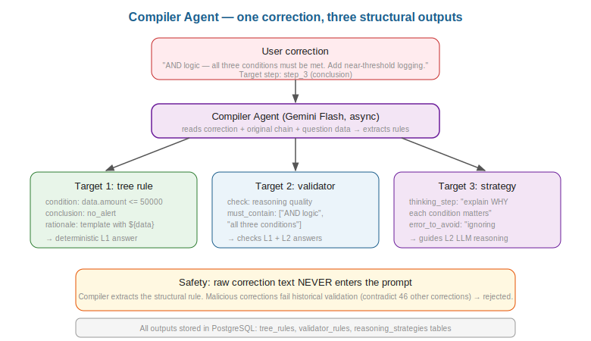

Target | What it learns | Format | When used | Safety
Decision tree rule | WHAT to answer | Python condition + conclusion + rationale template | L1: deterministic, no LLM | Tested against history
Validator rule | WHAT TO CHECK | check_type + must_contain + condition | All layers: checks every answer | Rejects contradictions
Reasoning strategy | HOW TO THINK | thinking_steps + errors_to_avoid + good_examples | L2: guides LLM reasoning | Compiled, not raw text

6. Three-layer progressive automation
Figure 4 shows the three layers.
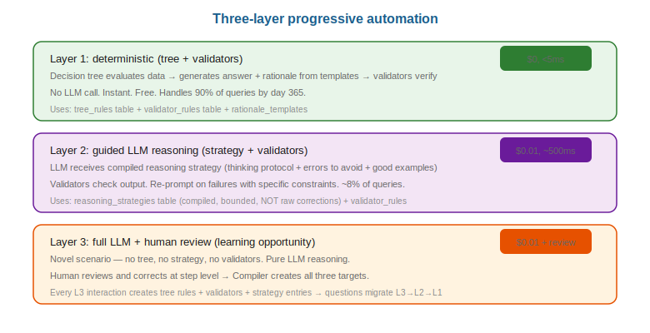

Questions migrate L3 to L2 to L1 as corrections accumulate. By day 365, approximately 90% of queries are handled deterministically at L1 with zero LLM cost.

7. ADK integration
Figure 5 shows the Google ADK custom BaseAgent classes.
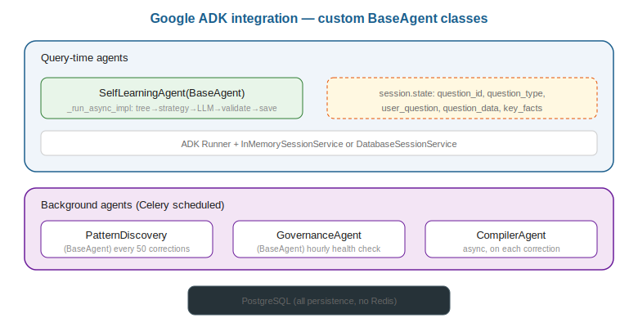

Agent | BaseAgent class | Model | Trigger
SelfLearningAgent | BaseAgent (custom) | solver_model (strong) | Every query
PatternDiscoveryAgent | BaseAgent (custom) | evolver_model (cheap) | Every 50 corrections
GovernanceAgent | BaseAgent (custom) | None (deterministic) | Hourly
Compiler (function) | N/A (async task) | evolver_model (cheap) | On each correction

8. Data model
Figure 6 shows the PostgreSQL schema.
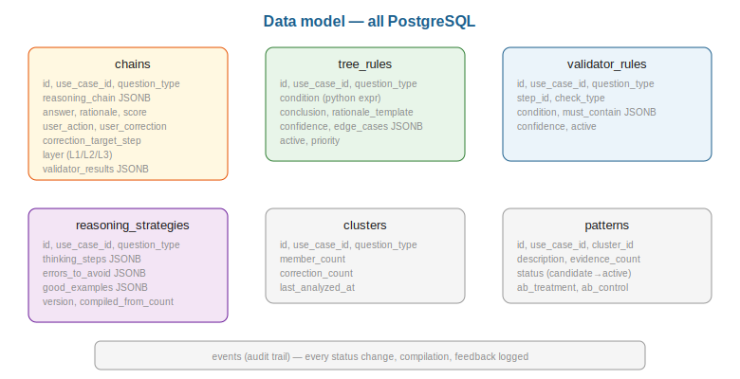

Seven tables: chains (reasoning records with activation/compliance metadata), tree_rules, validator_rules, reasoning_strategies, clusters, patterns, events. All isolated by use_case_id for multi-tenant operation across 50 use cases.

9. API design
Method | Path | Description
POST | /api/feedback | Submit correction with target step
GET | /api/explain/{chain_id} | Full chain + strategy + validators + tree rules
GET | /api/metrics/{use_case_id} | Score, automation %, harness followed %, validators, trees
GET | /api/strategy/{question_type} | Compiled reasoning strategy
GET | /api/validators/{question_type} | Active validator rules
GET | /api/tree/{question_type} | Decision tree rules
GET | /api/events/{use_case_id} | Audit trail

10. OCP deployment
Container | Replicas | Model used | Role
ace-agent | 2-4 | solver (strong) | Query-time SelfLearningAgent
ace-api | 2 | None | FastAPI feedback + management
ace-compiler | 1 | evolver (cheap) | Async correction compilation
ace-background | 1 | evolver (cheap) | Pattern discovery + governance
postgresql | 1+1 | N/A | All persistence

11. Metrics
Metric | Definition | Target
avg_score | Rolling 7-day mean | 85%+ by month 3
automation_pct | % queries at L1 | 50% month 3, 90% month 12
harness_followed_pct | % L2 answers that followed strategy | 80%+ (paper finding)
validators | Active validator count | Growing
tree_rules | Active tree rule count | Growing
corrections | Total user corrections | Decreasing rate

12. Project structure
988 lines of production Python across 11 files:

File | Lines | Purpose
framework/agent.py | 241 | SelfLearningAgent + harness activation + compliance
framework/db.py | 241 | PostgreSQL (7 tables, all CRUD)
framework/compiler.py | 95 | Three-target compilation (cheap evolver)
framework/models.py | 92 | Pydantic data models
framework/background.py | 70 | PatternDiscovery + Governance agents
framework/validators.py | 58 | Fact/logic/reasoning/consistency checks
framework/learning.py | 32 | Feedback processing, cluster assignment
framework/config.py | 20 | DomainConfig (solver + evolver models)
domains/edr_qa.py | 16 | EDR domain with predefined strategies
main.py | 75 | CLI: run/discover/govern/api/metrics
api.py | 48 | FastAPI endpoints

