AgentForge
Universal Meta-Agent System
Enterprise Architecture Design · End-to-End Reference
Architecture Version 1.0 | Confidential

Table of Contents

1. Executive Summary
AgentForge is a universal meta-agent system that transforms business artifacts — Excel QA scripts, PDF runbooks, process images, BPMN diagrams, and markdown SOPs — into fully deployable, production-grade multi-agent automation pipelines.
The operator uploads documents describing any process. AgentForge classifies the intent, extracts the structure, and generates a complete Google ADK SequentialAgent pipeline with typed YAML tool definitions, per-agent instructions, validated secret management, and a test suite. The system is pipeline-type agnostic — QA, QC, browser automation, data extraction, workflow, or report generation.

Core design principle
No hand-written agent code after deployment. All behaviour is driven by generated
questions.py, tools/*.yaml, and tool_registry.py. Changing a process means
re-running AgentForge on updated documents — not editing Python.

2. End-to-End Architecture Flow
Five phases from raw business artifacts to a running production pipeline: document intake (Excel, PDF, images, markdown, and video), meta-layer processing at compile time, forge-layer code generation, package deployment, and runtime execution. Video inputs follow a dedicated chunking path before reaching the meta layer — the rest of the pipeline is unaware the source was video.
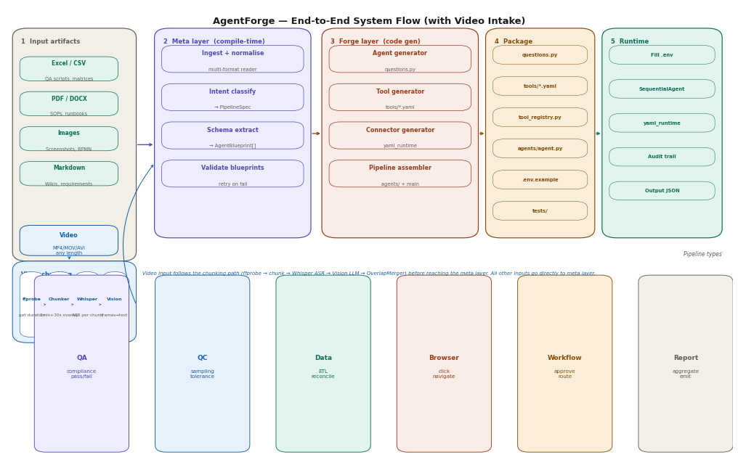
Figure 1 — End-to-end: artifacts → AgentForge compile → generated package → runtime → output

2.1 Phase Responsibilities
Phase | What happens | Key output
1a Intake (docs) | Upload Excel, PDF, images, BPMN, or markdown | Normalised to ParseContext directly
1b Intake (video) | VideoChunker splits into 3min+30s overlap chunks. Whisper ASR per chunk in parallel. Vision LLM analyses keyframes. OverlapMerger deduplicates and stitches. | ParseContext (same interface as docs)
2 Meta layer | Classify intent. Extract AgentBlueprint[]. Validate. | PipelineSpec + AgentBlueprint[]
3 Forge layer | Four generators run as SequentialAgent. | Complete Python package
4 Package | Fill .env. Run tests with mock connections. | Configured, test-passing deploy
5 Runtime | SequentialAgent runs. Audit trail written per agent. | Verdict JSON + audit records

3. Three-Tier Architecture
Tier 1 (meta) runs once at compile time. Tier 2 (forge) generates the pipeline code. Tier 3 (runtime) is the execution kernel — identical across all pipeline types.
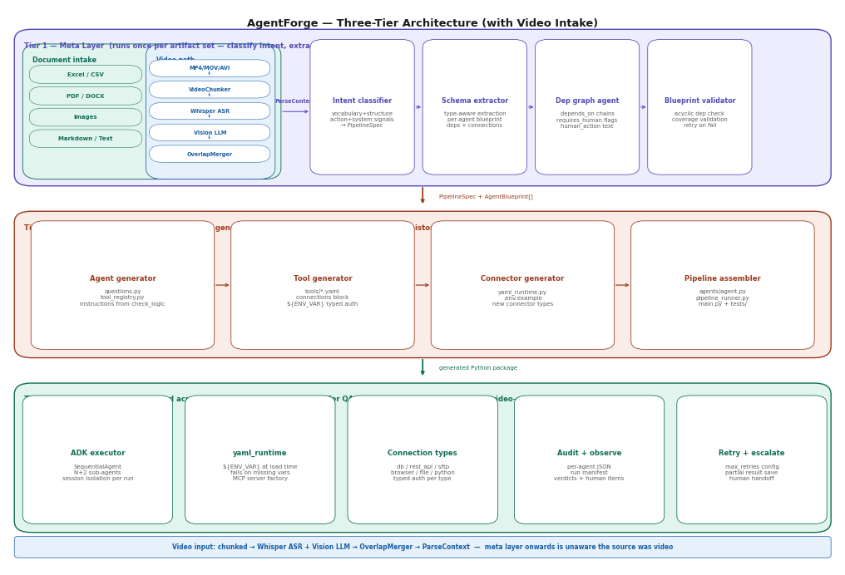
Figure 2 — Three tiers: meta layer → forge layer → runtime kernel

3.1 Tier 1 — Meta Layer
Four agents run in parallel via asyncio.gather(). All write to a shared ParseContext. When all complete, ParseContext is frozen and passed to the forge layer.
Component | Responsibility
Document ingestor | Accepts Excel, PDF, image, BPMN, markdown — normalises directly to ParseContext. Video files go through a separate chunking path (VideoChunker → Whisper ASR → Vision LLM → OverlapMerger) before emitting the same ParseContext interface.
Intent classifier | Extracts vocabulary, structure, system, and action signals. Assigns PipelineType. Produces PipelineSpec.
Schema extractor | Type-aware extraction. Produces one AgentBlueprint per agent: step text, check logic, deps, connection refs.
Blueprint validator | Checks for acyclic dep graph and complete coverage. Returns diff on failure; forge generators retry.

3.2 Tier 2 — Forge Layer
Itself a SequentialAgent. Four generators run in order — each generator's output feeds the next via conversation history.
Generator | Output
Agent generator | questions.py (one dataclass per step) + tool_registry.py (ToolConfig per agent, instruction from check_logic verbatim)
Tool generator | tools/*.yaml with connections block, typed auth, ${ENV_VAR} refs, sql/rest_api/sftp/python tool defs
Connector generator | yaml_runtime.py + .env.example listing every required env var with description
Pipeline assembler | agents/agent.py + pipeline_runner.py + main.py + tests/

3.3 Tier 3 — Runtime Kernel
Component | Provides
ADK executor | Builds all sub-agents. Constructs SequentialAgent. One InMemorySessionService session per run.
yaml_runtime.py | Resolves ${ENV_VAR} at init time. Fails immediately on missing vars. Builds typed connections. MCP servers.
Audit writer | Per-agent JSON + run manifest + run summary to audit/{run_id}/. Structured for compliance.
Retry + escalate | Retries up to MAX_RETRIES. Saves partial results. Escalates with failing step and error detail.

4. Intent Classifier
Every downstream decision flows from the PipelineSpec the classifier produces: which agent template, which tool types, how to structure instructions, what the output format is.
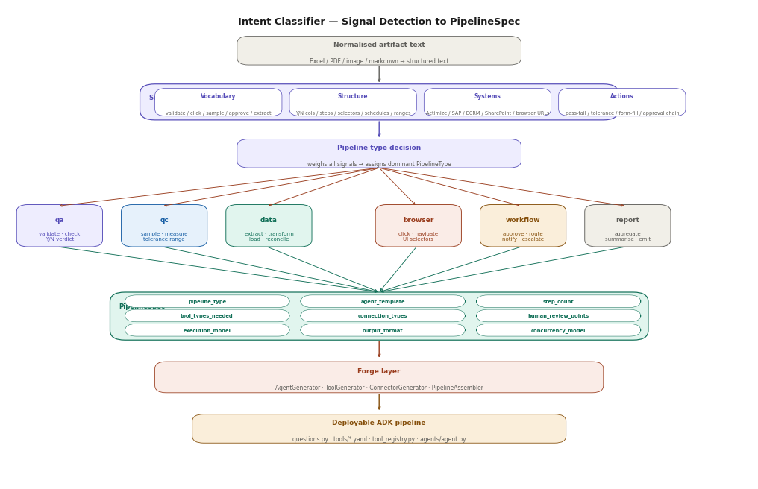
Figure 3 — Signal extraction → pipeline type decision → PipelineSpec → forge layer

4.1 Signal Categories
Signal | What the classifier looks for
Vocabulary | validate, check, sample, measure, click, navigate, approve, route, extract, aggregate
Structure | Y/N outcome columns (QA), UI element refs (browser), tolerance ranges (QC), approval chains (workflow)
System names | Actimize/ECRM/SAP → db or rest_api; SharePoint → sftp; browser URLs/selectors → browser
Action patterns | Pass/fail → QA; defect rate → QC; form-fill → browser; conditional routing → workflow

4.2 Pipeline Types
Type | Primary signals | Agent template
qa | validate, check, Y/N verdict, compliance | ingest → N×check → report
qc | sample, measure, tolerance, defect rate | ingest → N×measure → statistics → report
data | extract, transform, load, SQL, schedule | extract → N×transform → load → reconcile
browser | click, navigate, fill, selector, UI element | ingest → navigate → N×action → verify
workflow | approve, route, notify, escalate, SLA | trigger → N×decision → route → notify
report | aggregate, summarise, schedule, emit | collect → N×section → compile → emit

5. SequentialAgent Runtime Execution
All generated pipelines use the ADK SequentialAgent. ADK passes the full conversation history to each sub-agent automatically — eliminating all manual state management.
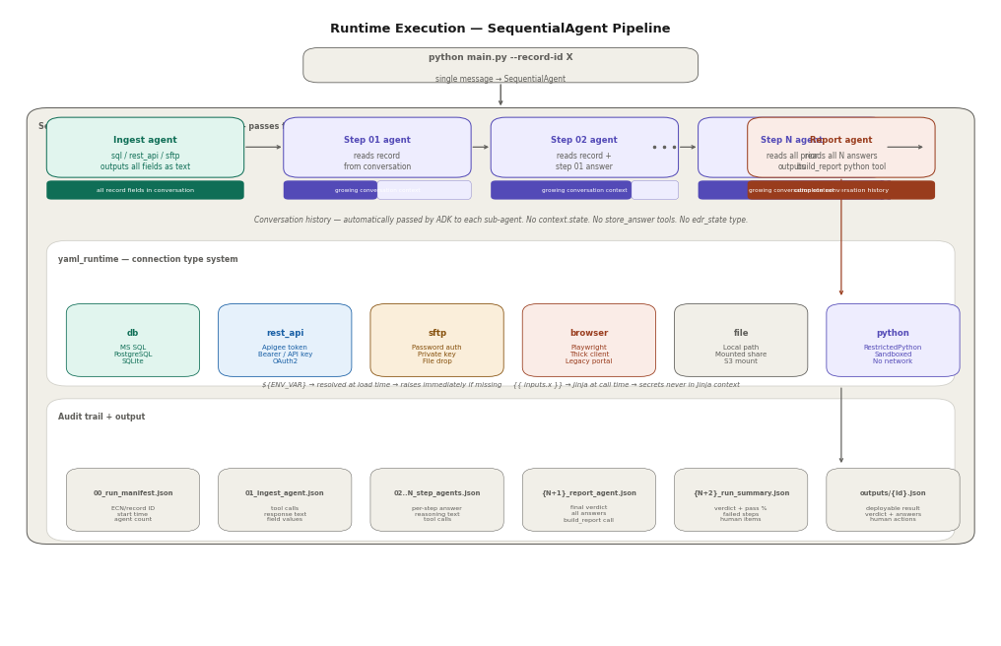
Figure 4 — Runtime: conversation flow, connection types, audit trail

5.1 Conversation History Flow
Ingest agent output (all record fields as structured text) is in context when step_01 runs. Step_01 answer is in context when step_02 runs. Report agent has the full conversation including all N answers.
What SequentialAgent eliminates
context.state — no manual key/value store
store_answer tools — no edr_state tool type
ToolContext injection — no FunctionTool wrapping
AgentTool delegation — no orchestrator wrapping sub-agents

5.2 Step Agent Pattern
- Read record fields from conversation history
- Read prior step answers from conversation history
- Call tools from YAML only if extra data needed (empty by default)
- Output structured answer with step-by-step reasoning referencing actual field values

6. YAML Tool and Connection System
Secrets resolved at load time via ${ENV_VAR} — missing vars raise immediately. Jinja {{ inputs.x }} used only for query params and request body at call time. Secrets are never in the Jinja context.
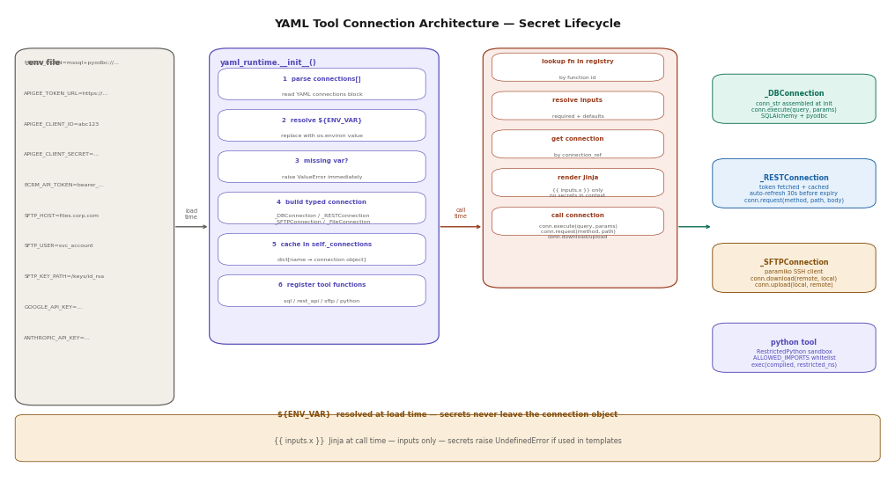
Figure 5 — Connection architecture: ${ENV_VAR} at load time, {{ inputs.x }} at call time

6.1 Connection Types
Type | Auth options | Use cases
db | connection_string | username_password | MS SQL (Actimize), PostgreSQL, SQLite, Oracle
rest_api | apigee_token | oauth2 | bearer_token | api_key | basic | Actimize API, ECRM, Salesforce, Apigee-gated endpoints
sftp | password | private_key | Shared drives, file drop servers, batch ingestion
browser | none (Playwright session) | Power Platform, SAP, legacy thick-client UIs
file | none | Local filesystem, mounted shares, S3-mounted paths
python | none (RestrictedPython sandbox) | Verdict computation, data transformation, report building

6.2 YAML Structure
connections:
- name: actimize_db
type: db
auth: { type: connection_string, value: ${MSSQL_CONN} }

functions:
- id: fetch_record
type: sql
connection_ref: actimize_db
config:
query: SELECT * FROM vw_records WHERE id = :id
params:
id: "{{ inputs.record_id }}"

7. Generated Pipeline Structure
Every pipeline AgentForge generates has the same file structure. Process-specific logic lives only in questions.py and tools/*.yaml. All framework files are identical across pipeline types.

7.1 File Inventory
File | Purpose
questions.py | Source of truth. One dataclass per step. QUESTION_MAP. HUMAN_REVIEW_SET. Never edited after deployment.
tool_generator.py | Regenerates tools/step_NN_tools.yaml from questions.py. Run after any question change.
tools/ingest_tools.yaml | Ingest agent tools — sql fetch or rest_api call with typed connection block.
tools/step_NN_tools.yaml | Per-step tools. Empty by default. Add to Q_EXTRA_TOOLS for extra lookups.
tools/report_tools.yaml | Report agent tools — python build_report, rest_api webhook, or file write.
tool_registry.py | All ToolConfig entries (N+2). Instructions auto-generated from check_logic verbatim.
yaml_runtime.py | Connection type system. ${ENV_VAR} at load time. MCP server factory. Tool execution.
agents/agent.py | SequentialAgent builder. N+2 sub-agents. Session isolation. Streams audit events.
pipeline_runner.py | Startup: generate YAMLs, build registry, validate. Per-run: session, retry, audit.
main.py | CLI: --record-id, --output, --concurrent, --generate-only
.env.example | All required ${ENV_VAR} with descriptions. Generated, not hand-written.
tests/test_pipeline.py | Generated suite: all checks, report logic, mock connections, architecture invariants.

7.2 Zero-Code-Change Guarantee
Change | Action | Code touched
Update check logic | Edit questions.py → python tool_generator.py | 0 files
Add DB lookup to one step | Add to Q_EXTRA_TOOLS in tool_generator.py | 1 config dict
Add new process step | Add to questions.py → python tool_generator.py | 0 files
Swap LLM model | Change QA_MODEL / INGEST_MODEL constant | 1 constant
Add new data source | Add connections block to YAML | 0 files
Deploy to new environment | Copy .env.example → .env, fill values | 0 files

8. Pipeline Types

8.1 QA Pipeline
Agent | Role
ingest_agent | Fetches record via sql. All fields as structured text to conversation. Gemini Flash.
step_01..step_N | Each answers one question from conversation history. NEEDS_HUMAN if requires_human. Claude claude-sonnet-4-6.
report_agent | Reads all N answers from conversation. Calls build_report python tool. Writes verdict JSON.

8.2 Browser Automation Pipeline
Agent | Role
ingest_agent | Reads input data (CSV/DB). Prepares task parameters.
navigate_agent | Login, session, navigation to correct screen via Playwright.
action_01..action_N | Each performs one UI action. Selector defined in YAML config. Screenshots completion.
verify_agent | Confirms expected state change. Flags discrepancies.
report_agent | Action log, screenshots, success/fail per step.

8.3 Data Pipeline
Agent | Role
extract_agent | Fetches source data via sql or rest_api. Outputs dataset summary.
transform_01..transform_N | Each applies one transformation rule from the SOP.
load_agent | Writes transformed data to target via sql or rest_api.
reconcile_agent | Compares source vs target counts and checksums.

8.4 Workflow Automation Pipeline
Agent | Role
trigger_agent | Receives event. Reads workflow parameters.
condition_01..condition_N | Each evaluates one condition. Outputs routing decision.
route_agent | Reads all condition outputs. Determines next action.
notify_agent | Sends notifications via rest_api (email, Slack, Teams).
audit_agent | Writes workflow record with timestamps, decisions, actors.

9. Deployment and Operations

9.1 Compile a New Pipeline
agentforge compile \
--docs process.xlsx runbook.pdf screenshot.png \
--name my_pipeline --output ./pipelines/my_pipeline/

9.2 Configure and Run
cp .env.example .env && nano .env # fill all ${ENV_VAR} values
pytest tests/ -v # verify with mock connections
python main.py --record-id X # run against real data
python main.py --concurrent # run multiple records in parallel

9.3 Update After Process Change
nano questions.py # update check logic
python tool_generator.py # regenerate YAMLs and instructions
# Zero other files change

9.4 Add a New Data Source
# tool_generator.py — add to Q_EXTRA_TOOLS:
Q_EXTRA_TOOLS = { 11: [{ "id": "verify_rro", "type": "sql",
"connection_ref": "actimize_db",
"config": {"query": "SELECT ...", "params": {...}} }] }
python tool_generator.py # no other files change

10. Video Intake — Chunking with Overlap
AgentForge can ingest video recordings — process walkthroughs, compliance screen captures, training videos, UI demonstrations — as a first-class input format. Because a single video may be 30–60 minutes long, it cannot be fed to a vision model in one shot. The system splits the video into overlapping chunks, processes each chunk in parallel, then merges the results before passing them to the standard ParseContext pipeline.

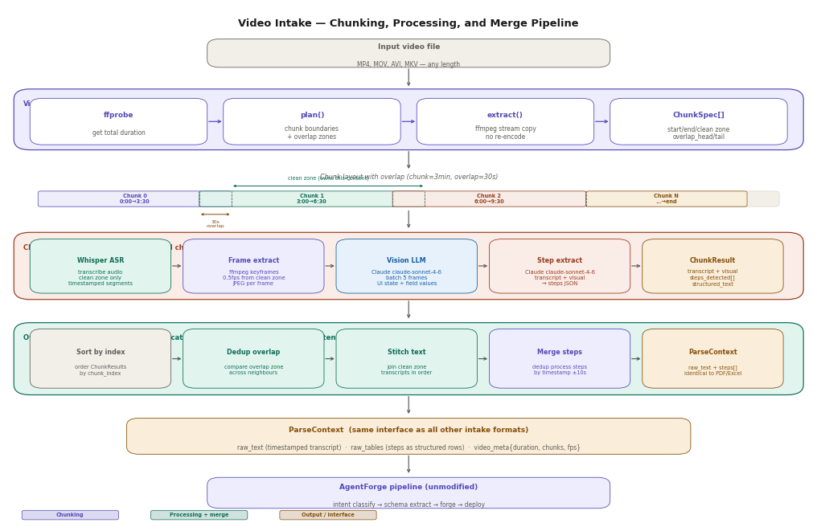
Figure 6 — Video intake: overlapping chunks → parallel processing → merge → ParseContext

10.1 Why Overlap
A process step demonstrated at 2:58 in a video would be split across a 3-minute chunk boundary. Without overlap both chunks miss the full context. With a 30-second overlap, the step appears in full in at least one chunk. The OverlapMerger then deduplicates — it sees the same content in the tail of chunk N and the head of chunk N+1 and keeps only one clean version.
Parameter | Default / description
chunk_duration | 180s (3 minutes) — how long each chunk is
overlap_duration | 30s — how much adjacent chunks share on each boundary
min_chunk_duration | 30s — trailing chunks shorter than this are merged into the previous
frames_fps | 0.5 — one keyframe every 2 seconds extracted for vision analysis
max_concurrent | 3 — max parallel chunk processing (Whisper + vision LLM)
processing_mode | transcribe_only | transcribe_visual

10.2 Chunk Layout
Given a 10-minute video with chunk_duration=180s and overlap_duration=30s:
Chunk 0 [0:00 → 3:30] clean=[0:00→3:00] overlap_tail=30s
Chunk 1 [3:00 → 6:30] clean=[3:00→6:00] overlap_head=30s overlap_tail=30s
Chunk 2 [6:00 → 9:30] clean=[6:00→9:00] overlap_head=30s overlap_tail=30s
Chunk 3 [9:00 → 10:00] clean=[9:00→10:00] overlap_head=30s (last chunk)
Each ChunkSpec records its clean zone boundaries. Transcript segments and video frames are filtered to the clean zone only during processing, so the OverlapMerger receives non-overlapping content that can be joined in order.

10.3 Processing Pipeline
ChunkProcessor runs all chunks concurrently via asyncio.gather() with a max_concurrent semaphore. Each chunk goes through four stages:
Stage | What happens
Whisper ASR | Audio extracted and transcribed. Segments outside the clean zone are discarded. Each segment timestamped in global video time (not chunk-local time).
Frame extraction | ffmpeg extracts JPEG keyframes at 0.5fps from the clean zone only. Frames from overlap zones are skipped to avoid duplicates.
Vision LLM | Claude claude-sonnet-4-6 receives batches of 5 frames with the transcript as context. Describes: system/app visible, field values, UI state, action in progress.
Step extraction | Claude claude-sonnet-4-6 reads transcript + visual notes. Returns structured JSON: [{timestamp_str, timestamp_sec, description, system, action_type}].

10.4 Overlap Merger
After all chunks complete, OverlapMerger stitches them into a single coherent document:
Step | Logic
Sort | Order ChunkResults by chunk_index.
Dedup transcript | Compare the tail of chunk N transcript with the head of chunk N+1. If semantic similarity > threshold, keep one copy. Implemented via sentence overlap detection.
Stitch text | Concatenate clean zone transcripts in order. Insert section headers with timestamp ranges for each chunk boundary.
Merge steps | Deduplicate process steps within ±10 seconds of each other across chunk boundaries. Keep the version with more detail.
Emit ParseContext | Output raw_text (full timestamped transcript), raw_tables (steps as structured rows), video_meta{duration, chunk_count, fps}.

10.5 ParseContext Output
The OverlapMerger emits a standard ParseContext — identical interface to Excel, PDF, and image intake. The rest of AgentForge (intent classifier, schema extractor, forge layer) is completely unaware that the input was a video.
ParseContext(
raw_text = "[00:00] Navigating to Actimize QA View...\n
[00:15] Selecting ECN record ECN-2024-001...\n
[00:42] Validating required fields...\n...",
raw_tables = [
[{"timestamp": "00:00", "system": "Actimize",
"action_type": "navigate", "description": "Open QA View"},
{"timestamp": "00:42", "system": "Actimize",
"action_type": "verify", "description": "Check required fields"}]
],
video_meta = {"duration_sec": 600, "chunk_count": 4, "fps": 0.5}
)

10.6 Supported Video Types
Video type | What AgentForge extracts
Process walkthrough | Step sequence, system names, field values, navigation path → browser or workflow pipeline
Compliance screen recording | QA check steps, Y/N decisions, Actimize field values → QA pipeline
Training video with narration | Process steps from speech + slides → SOP document → any pipeline type
UI demonstration | Click targets, form fields, selectors, page transitions → browser pipeline
Meeting recording | Approval decisions, assigned actions, SLA commitments → workflow pipeline

Appendix A — Connection Block Reference

Database — connection string
connections:
- name: actimize_db
type: db
config: {driver: mssql+pyodbc, odbc_driver: "ODBC Driver 18 for SQL Server"}
auth: {type: connection_string, value: ${MSSQL_CONN}}

REST API — Apigee token (auto-refresh)
connections:
- name: actimize_api
type: rest_api
config: {base_url: ${ACTIMIZE_API_URL}, timeout_seconds: 30}
auth: {type: apigee_token, token_url: ${APIGEE_TOKEN_URL},
client_id: ${APIGEE_CLIENT_ID}, client_secret: ${APIGEE_CLIENT_SECRET}}

REST API — bearer token
connections:
- name: ecrm_api
type: rest_api
config: {base_url: ${ECRM_API_URL}}
auth: {type: bearer_token, token: ${ECRM_API_TOKEN}}

SFTP — private key
connections:
- name: shared_drive
type: sftp
config: {host: ${SFTP_HOST}, port: 22}
auth: {type: private_key, username: ${SFTP_USER},
key_path: ${SFTP_KEY_PATH}, key_passphrase: ${SFTP_KEY_PASS}}

