**ANIKET CHAKRABORTY MSSQL ASSIGNMENT - 1 ANSWER COPY**

**Task – 1 MSSQL Query**

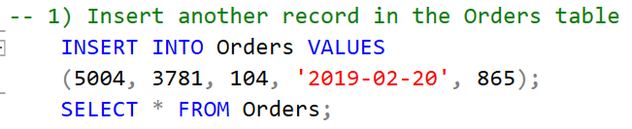

**Task – 1 Question Answer**

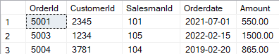

**Task – 2 MSSQL Query**

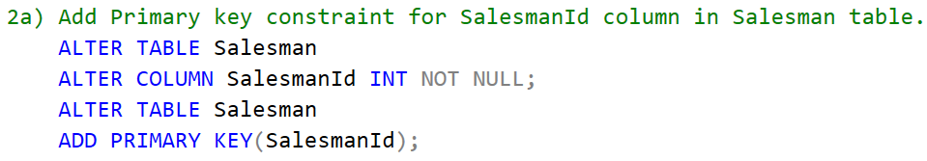

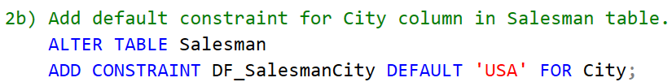

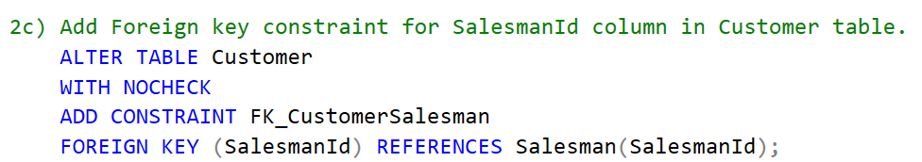

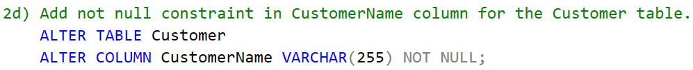

**Task – 3 MSSQL Query**

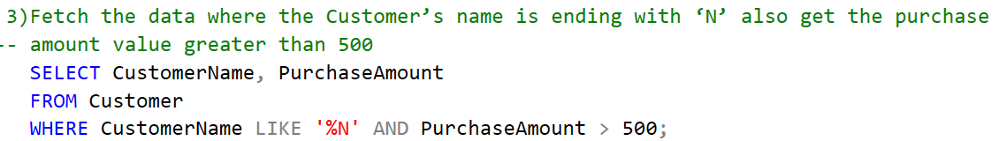

**Task – 3 Question Answer**

This returns an empty table having two columns ‘CustomerName’ & ‘PurchaseAmount’.

**Task – 4 MSSQL Query**

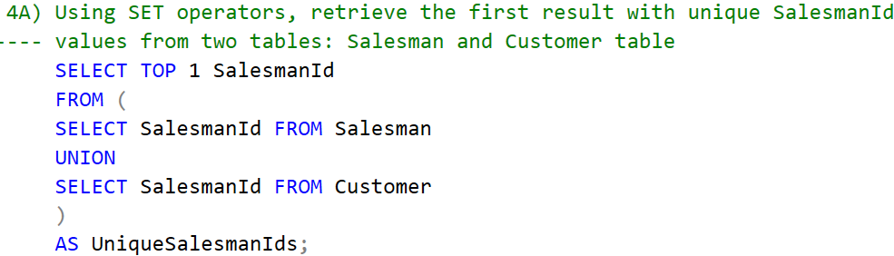

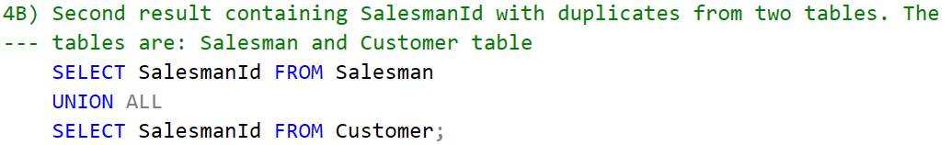

**Task – 4 Question Answer**

Answer for Query 4A)



Answer for Query 4B)

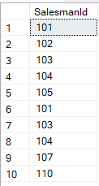

**Task – 5 MSSQL Query**

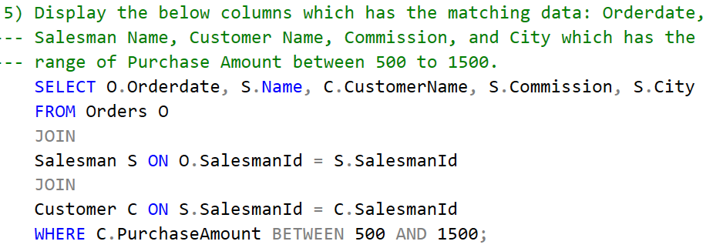

**Task – 5 Question Answer**



**Task – 6 MSSQL Query**

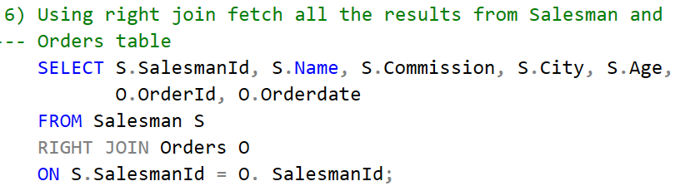

**Task – 6 Question Answer**

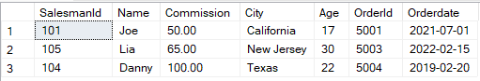

**Note:**

Since, according to the question 1 of assignment 1, one new record having ‘SalesmanId’ equal to 104 is added in the orders table. So, while using the orders table in the last question, the last row appears in result 6. Otherwise, there will be 2 rows having ‘SalesmanId’ with 101 and 105.