**NIKET CHAKRABORTY ASSIGNMENT 2 ANSWER COPY**

**Task-1 MSSQL Query:**

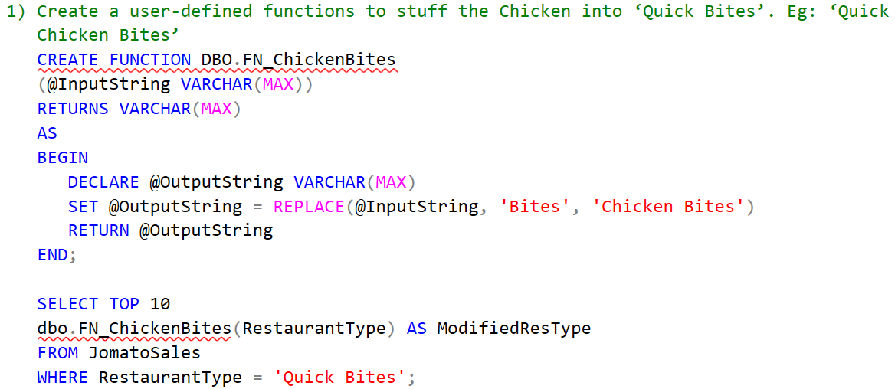

**Task-1 Result:**

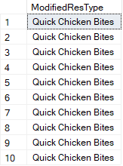

**Task-2 MSSQL Query:**

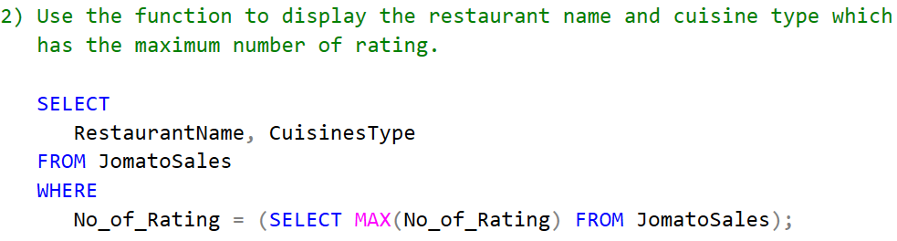

**Task-2 Result:**



**Task-3 MSSQL Query:**

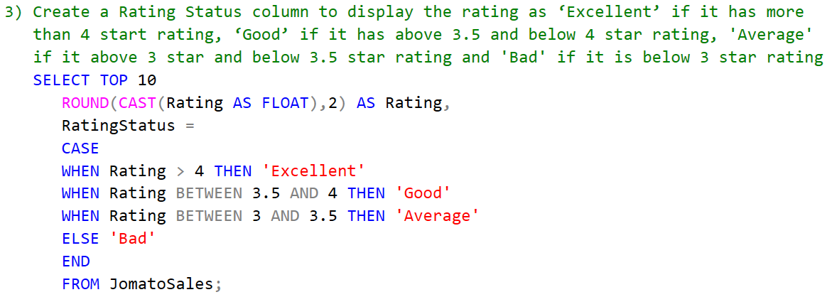

**Task-3 Result:**

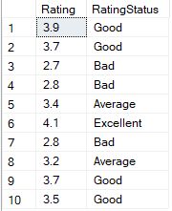

**Task-4 MSSQL Query:**

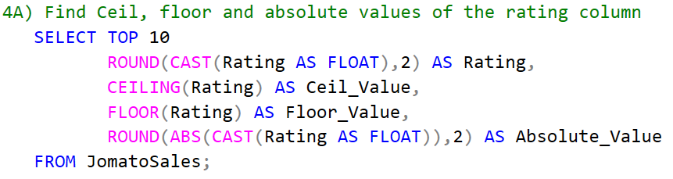

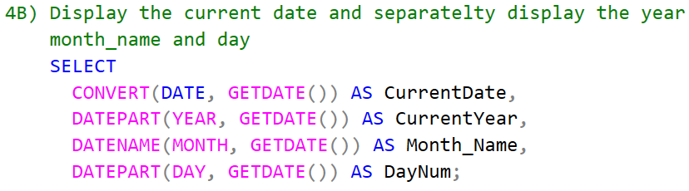

**Task-4 Result:**

Answer of 4A)

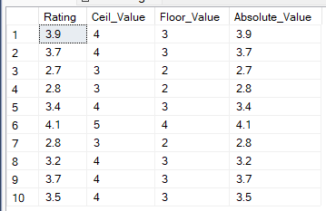

Answer of 4B)



**Task-5 MSSQL Query:**

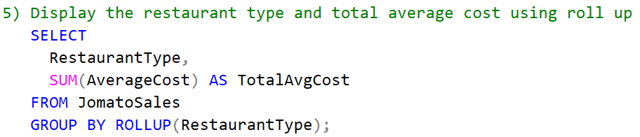

**Task-5 Result:**

