**ANIKET CHAKRABORTY ASSIGNMENT 3 ANSWER COPY**

**MSSQL Query – 1**

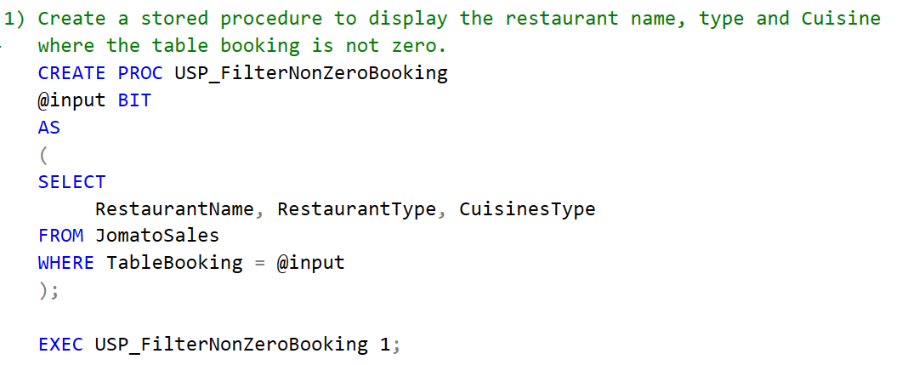

**Answer – 1**

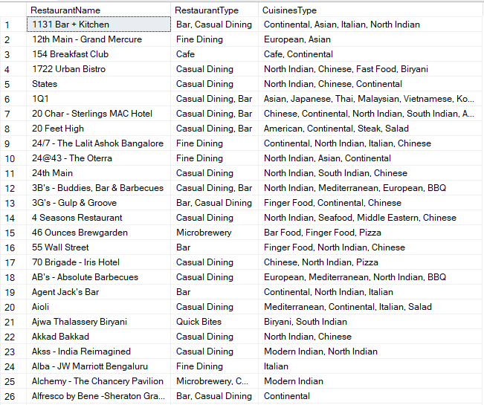

**MSSQL Query – 2**

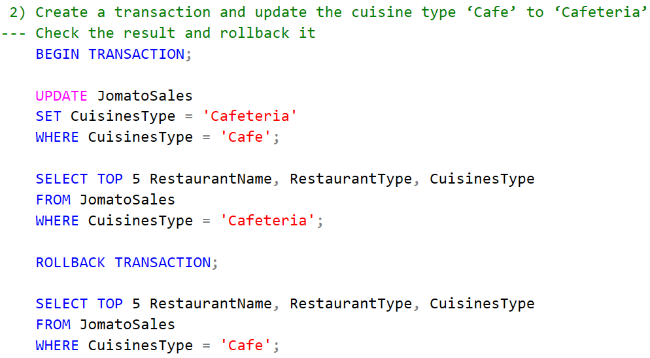

**Answer – 2**

Before Rollback

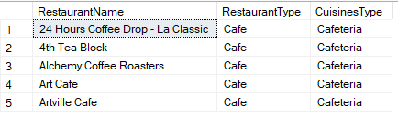

After Rollback

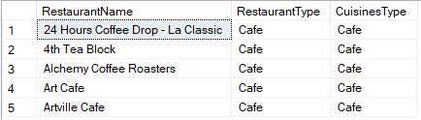

**MSSQL Query – 3**

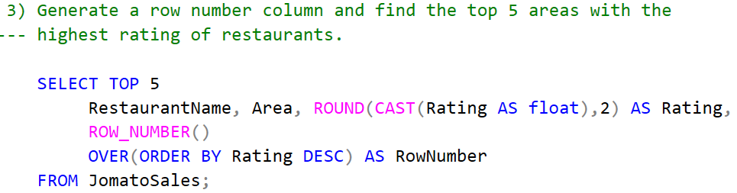

**Answer – 3**

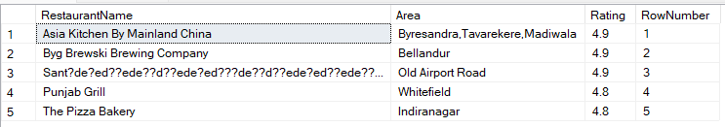

**MSSQL Query – 4**

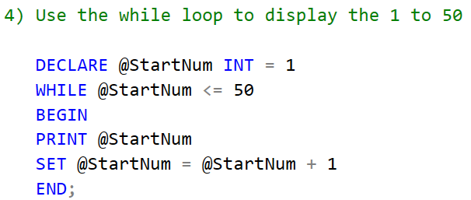

**Answer – 4**

1 2 3 4 5 6 7 8 9 10 11 12 13 14 15 16 17 18 19 20 21 22 23 24 25 26 27 28 29 30 31 32 33 34 35 36 37 38 39 40 41 42 43 44 45 46 47 48 49 50

**MSSQL Query – 5**

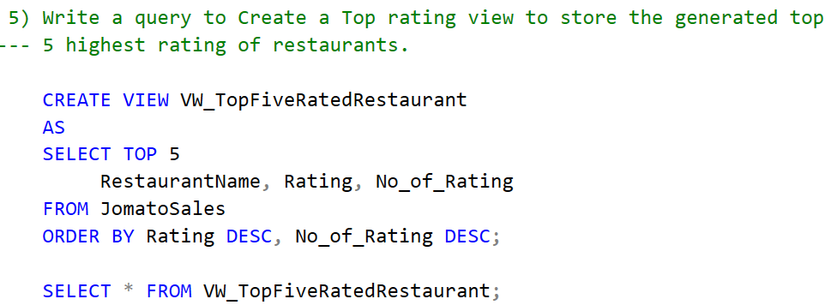

**Answer – 5**

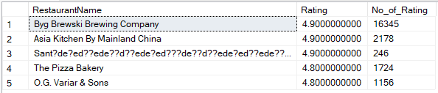

**MSSQL Query – 6**

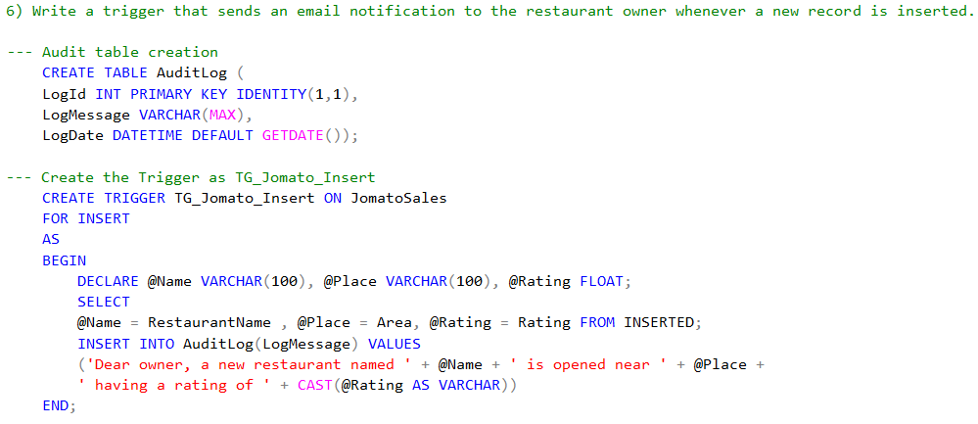

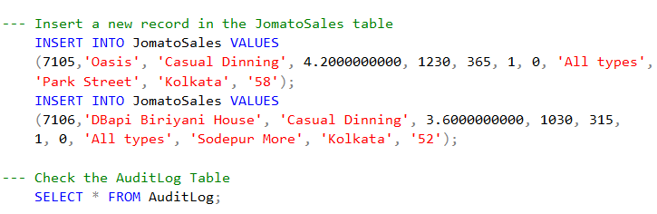

**Answer – 6**

