**ANIKET CHAKRABORTY CAST STUDY-1 ANSWER SHEET**

**Query – 1:**

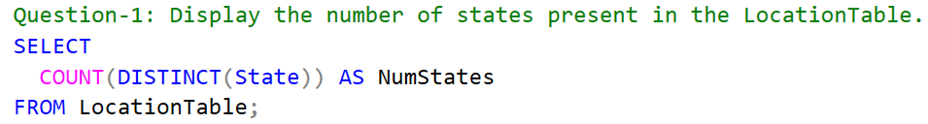

**Answer – 1:**



**Query – 2:**

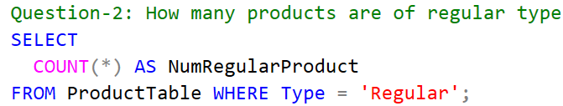

**Answer – 2:**



**Query – 3:**

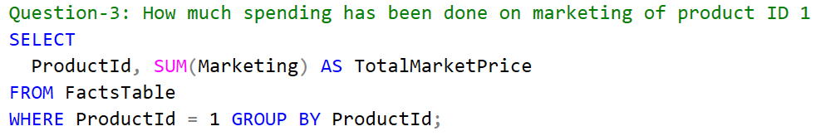

**Answer – 3:**



**Query – 4:**

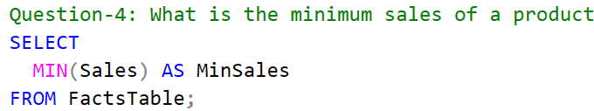

**Answer – 4:**



**Query – 5:**

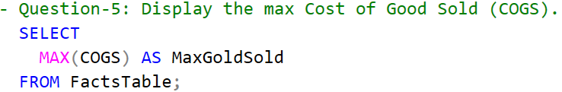

**Answer – 5:**



**Query – 6:**

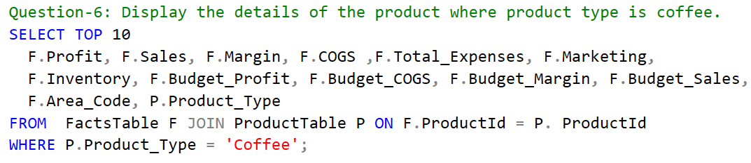

**Answer – 6:**

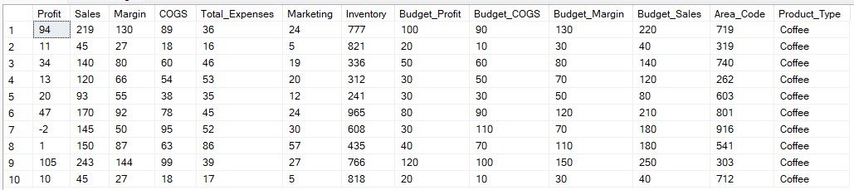

**Query – 7:**

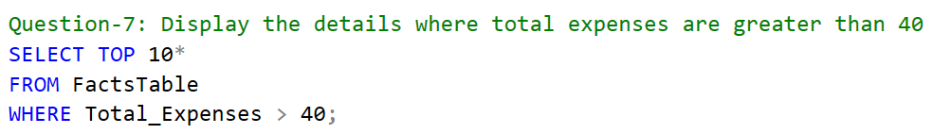

**Answer – 7:**

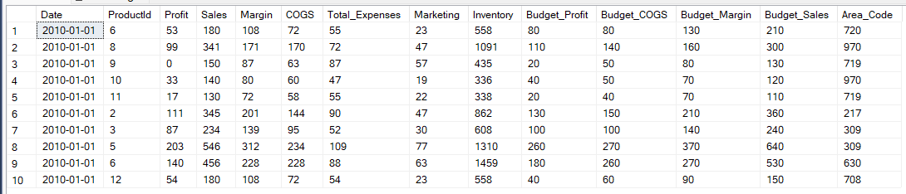

**Query – 8:**

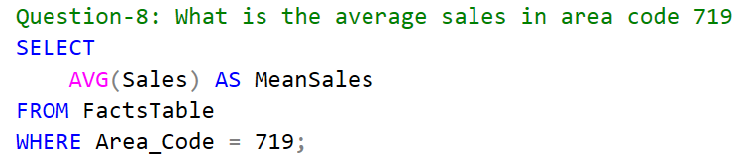

**Answer – 8:**



**Query – 9:**

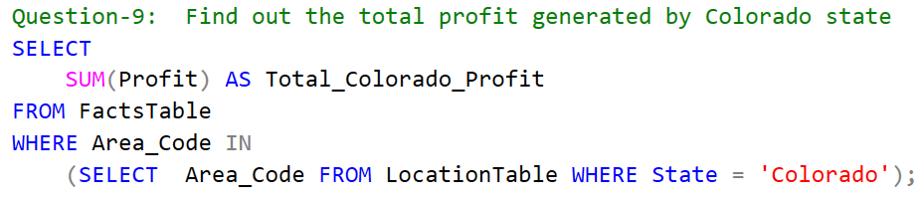

**Answer – 9:**



**Query – 10:**

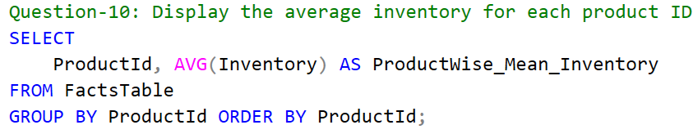

**Answer – 10:**

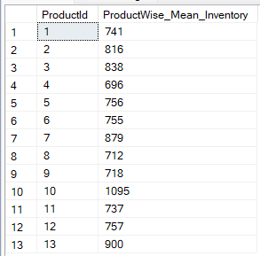

**Query – 11:**

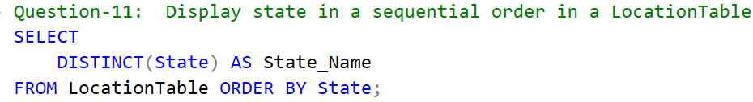

**Answer – 11:**

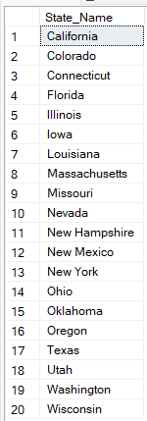

**Query – 12:**

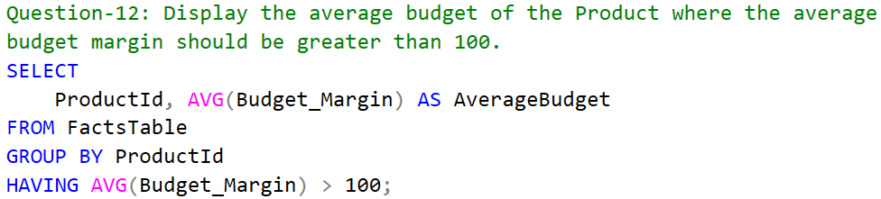

**Answer – 12:**

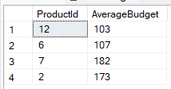

**Query – 13:**

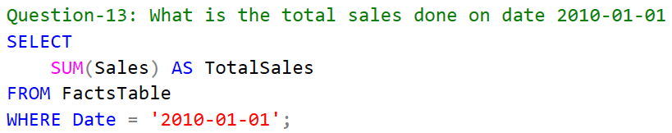

**Answer – 13:**



**Query – 14:**

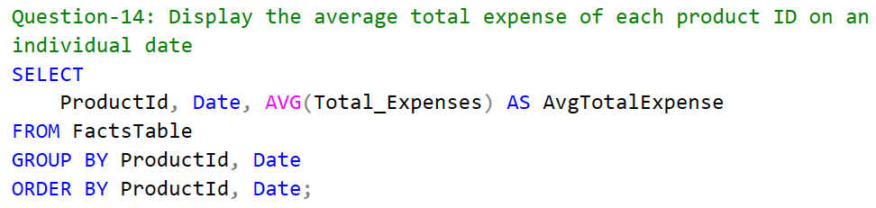

**Answer – 14:**

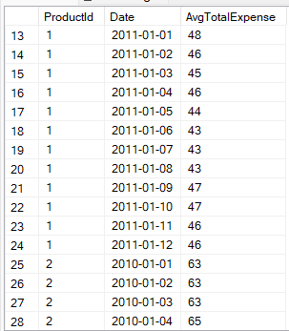

**Query – 15:**

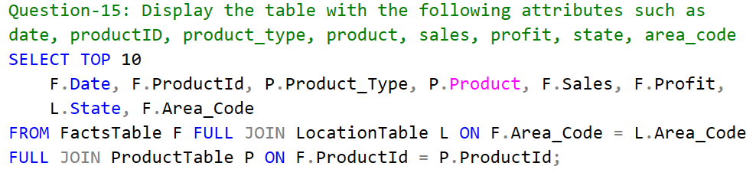

**Answer – 15:**

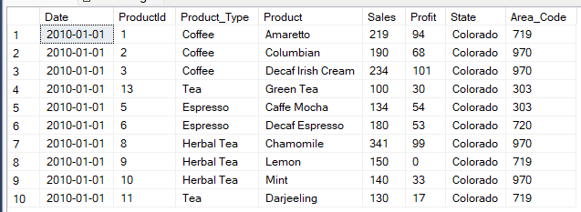

**Query – 16:**

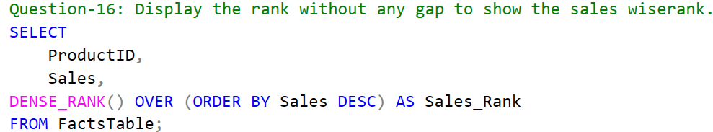

**Answer – 16:**

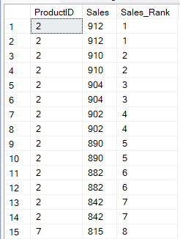

**Query – 17:**

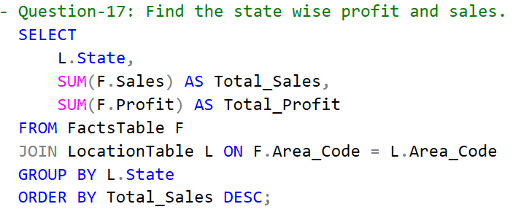

**Answer – 17:**

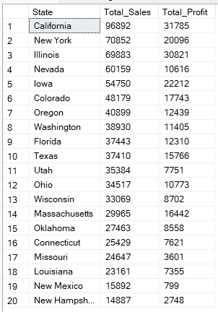

**Query – 18:**

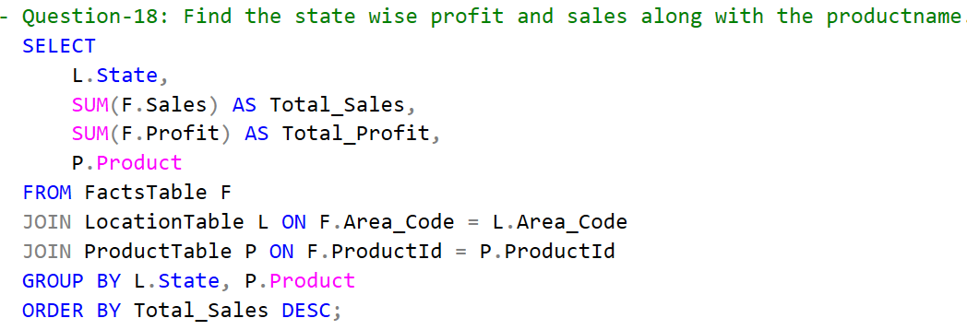

**Answer – 18:**

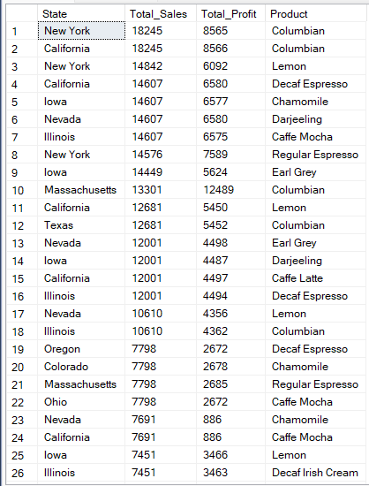

**Query – 19:**

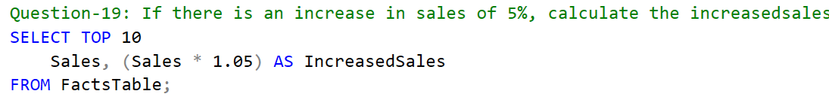

**Answer – 19:**

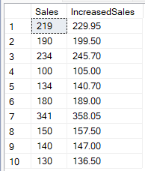

**Query – 20:**

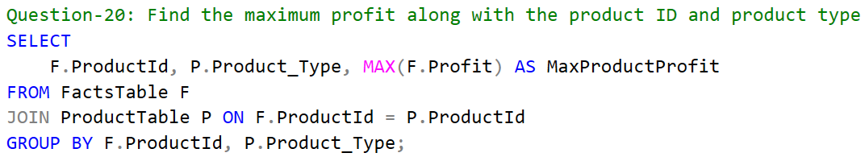

**Answer – 20:**

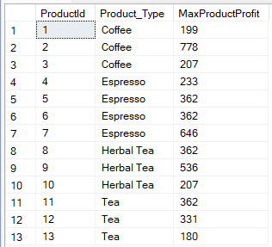

**Query – 21:**

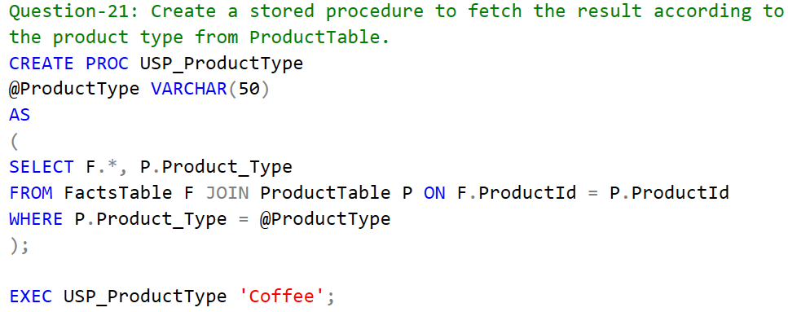

**Answer – 21:**

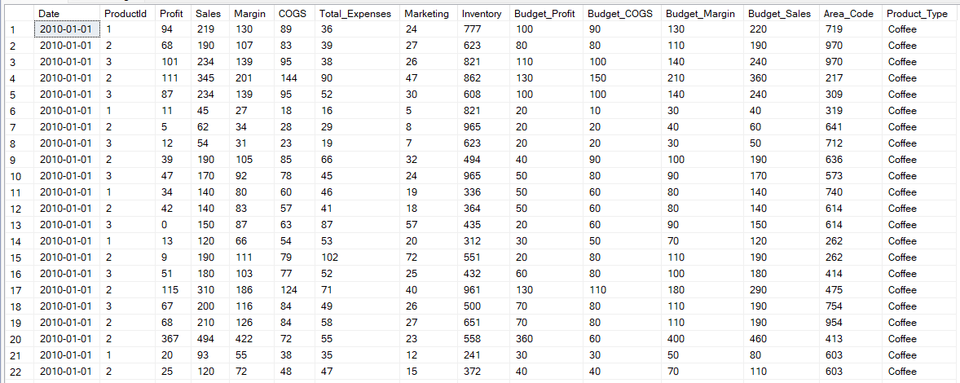

**Query – 22:**

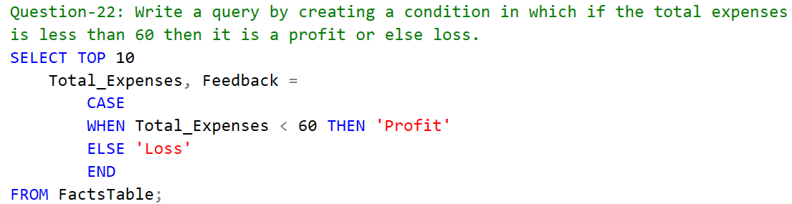

**Answer – 22:**

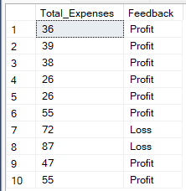

**Query – 23:**

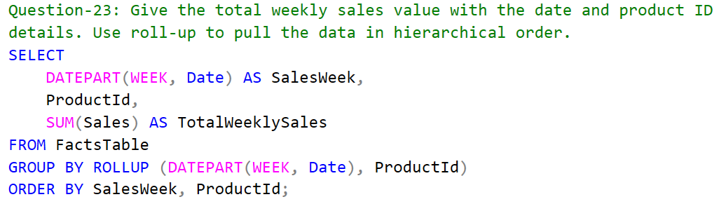

**Answer – 23:**

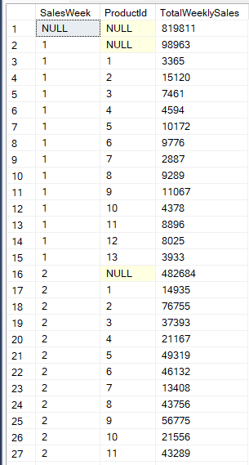

**Answer – 24:**

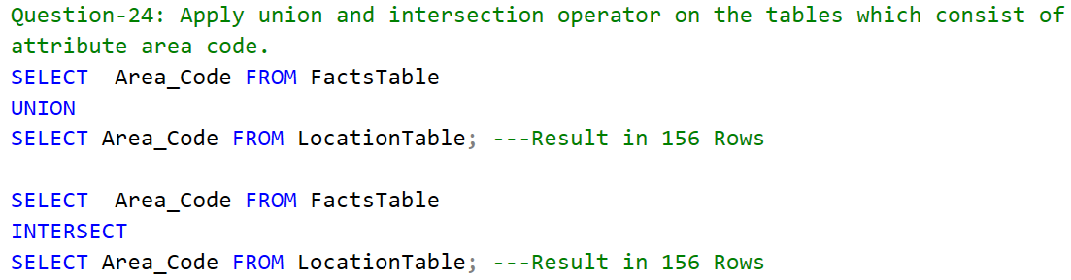

**Query – 24:**

Since, number of distinct area codes in ‘FactsTable’ and ‘LocationTable’ are same as 156, so the UNION and the INTERSECT operators returns 156 rows in result.

**Query – 25:**

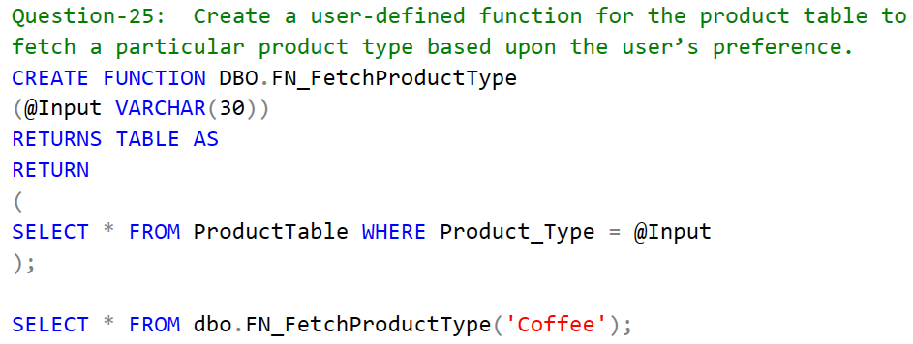

**Answer – 25:**

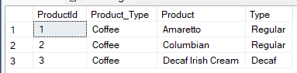

**Query – 26:**

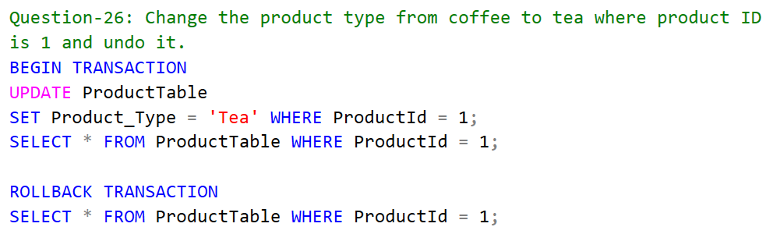

**Answer – 26:**



Before Roll back transaction After Roll back transaction

**Query – 27:**

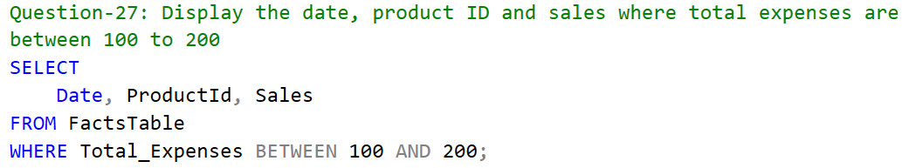

**Answer – 27:**

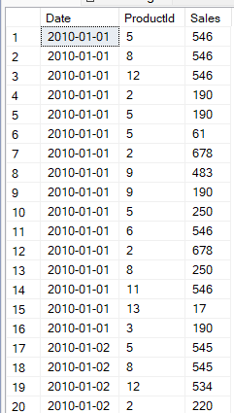

**Query – 28:**

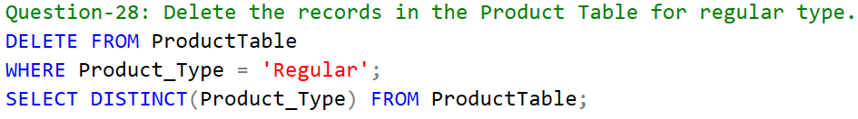

**Answer – 28:**

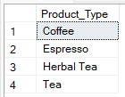

**Query – 29:**

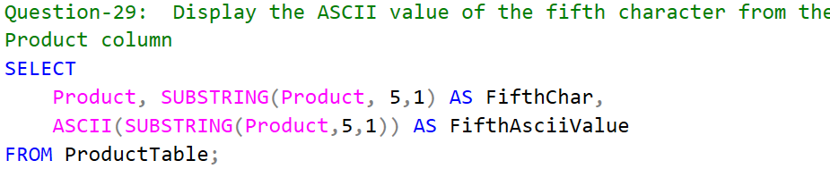

**Answer – 29:**

