**ANIKET CHAKRABORTY CASE STUDY-2 ANSWERS**

**Simple Queries Section**

**Query – 1:**

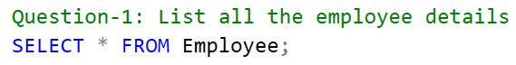

**Answer – 1:**

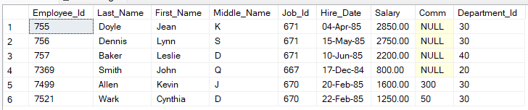

**Query – 2:**



**Answer – 2:**

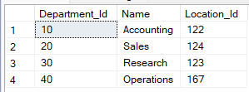

**Query – 3:**



**Answer – 3:**

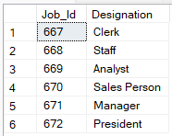

**Query – 4:**

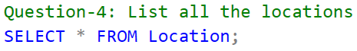

**Answer – 4:**

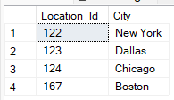

**Query – 5:**

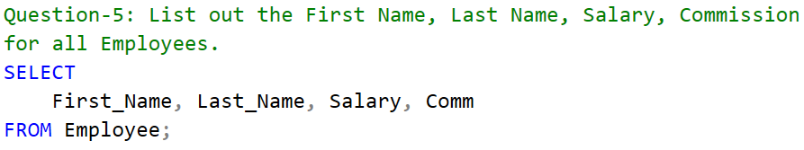

**Answer – 5:**

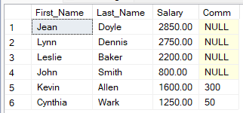

**Query – 6:**

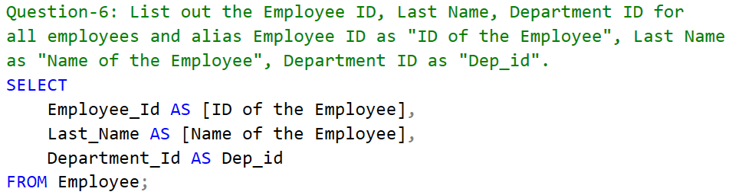

**Answer – 6:**

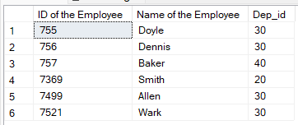

**Query – 7:**

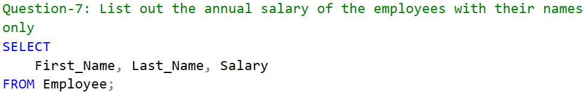

**Answer – 7:**

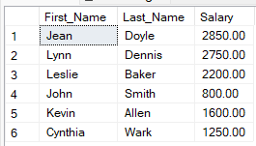

**Where Clause Section:**

**Query – 1:**

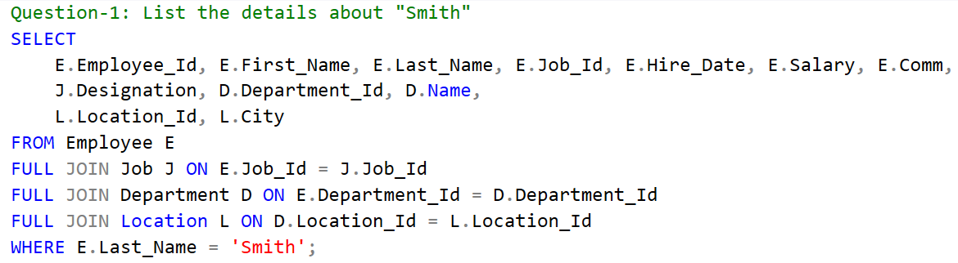

**Answer – 1:**



**Query – 2:**

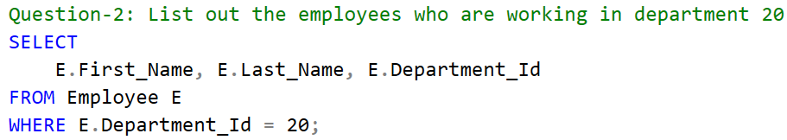

**Answer – 2:**



**Query – 3:**

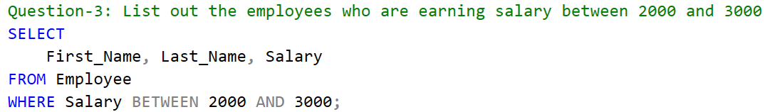

**Answer – 3:**

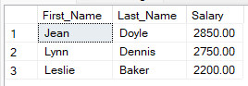

**Query – 4:**

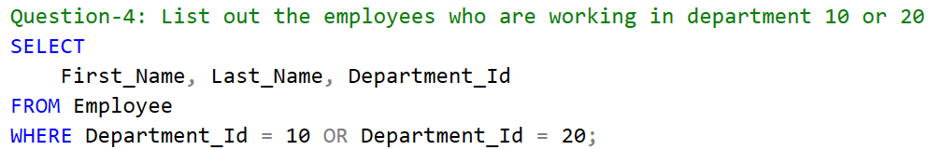

**Answer – 4:**



**Query – 5:**

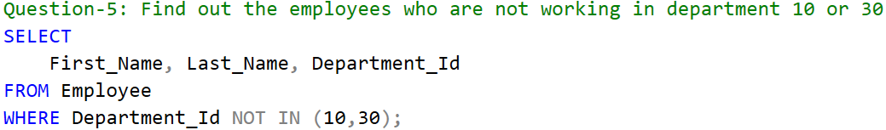

**Answer – 5:**

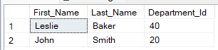

**Query – 6:**

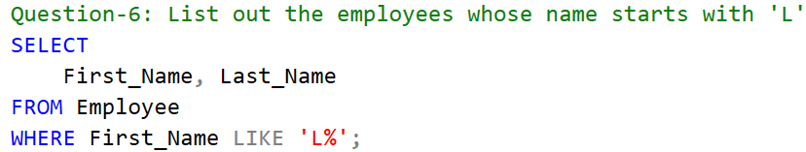

**Answer – 6:**

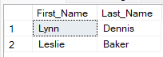

**Query – 7:**

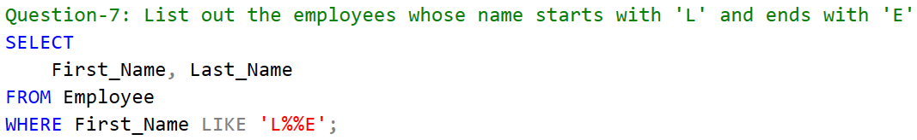

**Answer – 7:**



**Query – 8:**

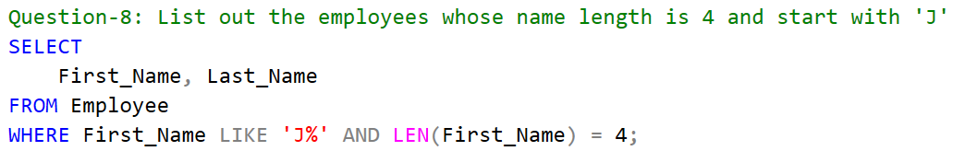

**Answer – 8:**

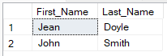

**Query – 9:**

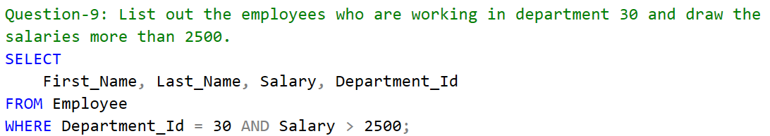

**Answer – 9:**

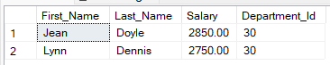

**Query – 10:**

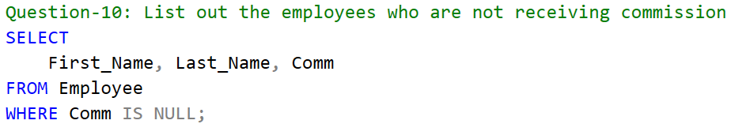

**Answer – 10:**

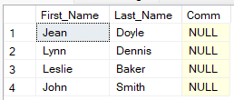

**Order By Clause section:**

**Query – 1:**

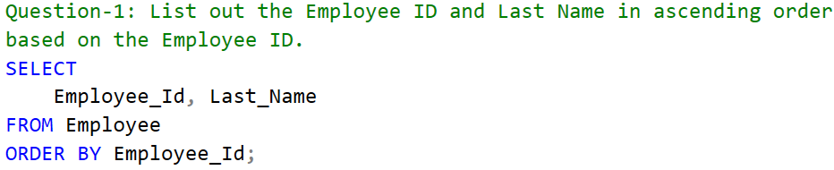

**Answer – 1:**

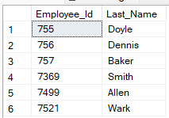

**Query – 2:**

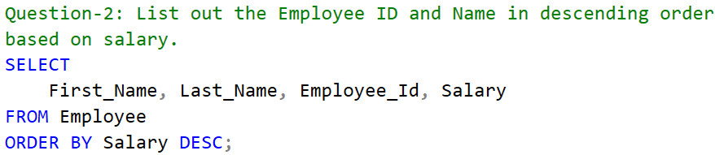

**Answer – 2:**

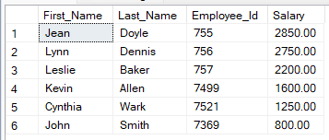

**Query – 3:**

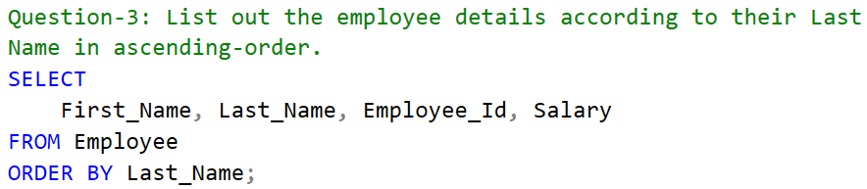

**Answer – 3:**

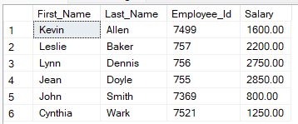

**Query – 4:**

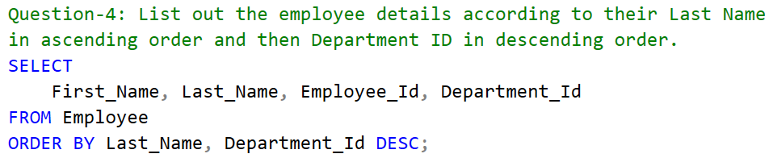

**Answer – 4:**

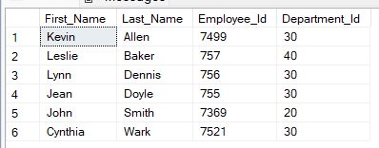

**Group By & Having Clause Section:**

**Query – 1:**

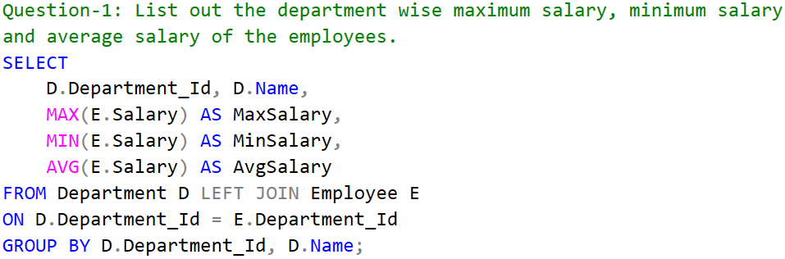

**Answer – 1:**

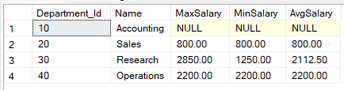

**Query – 2:**

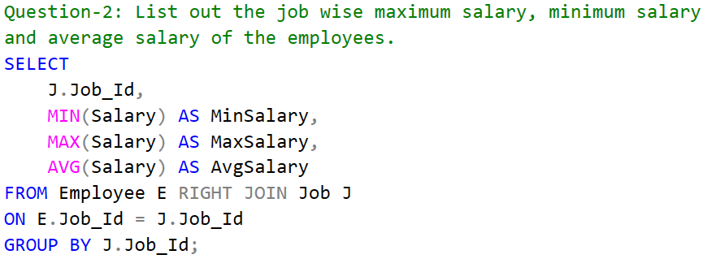

**Answer – 2:**

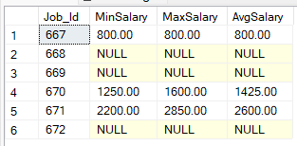

**Query – 3:**

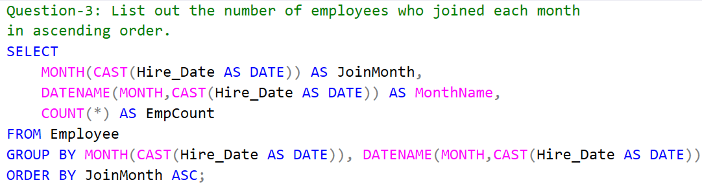

**Answer – 3:**

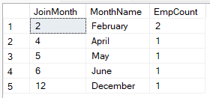

**Query – 4:**

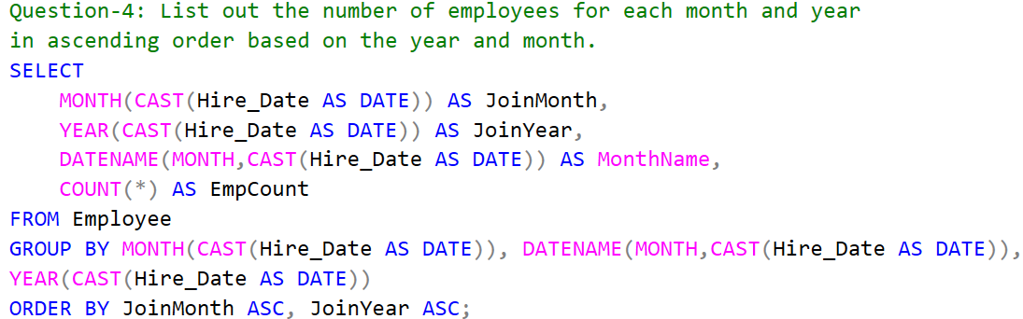

**Answer – 4:**

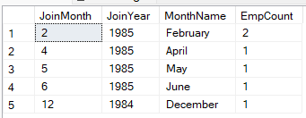

**Query – 5:**

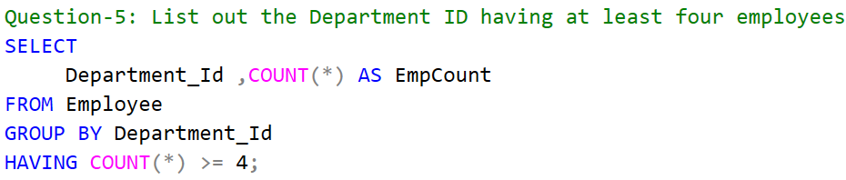

**Answer – 5:**



**Query – 6:**

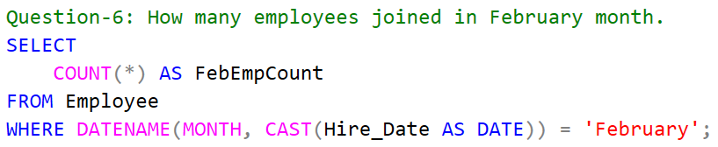

**Answer – 6:**



**Query – 7:**

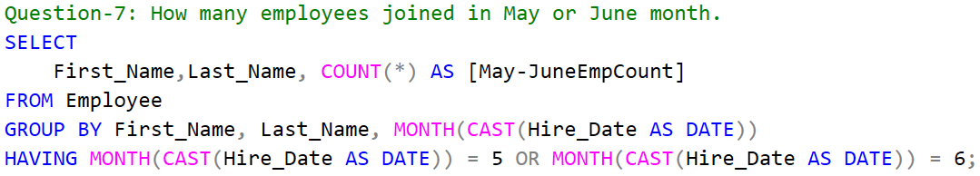

**Answer – 7:**

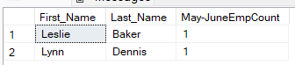

**Query – 8:**

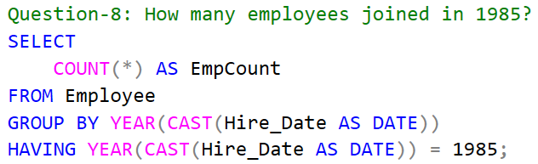

**Answer – 8:**



**Query – 9:**

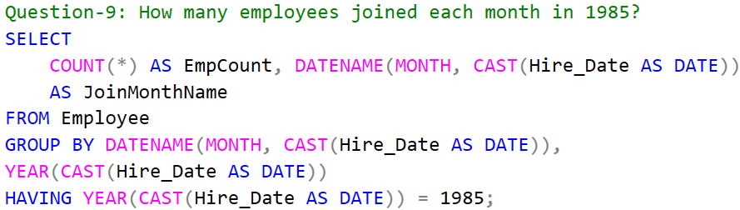

**Answer – 9:**

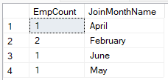

**Query – 10:**

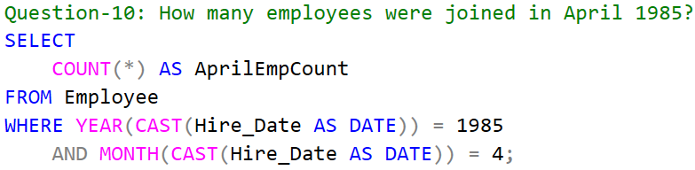

**Answer – 10:**



**Query – 11:**

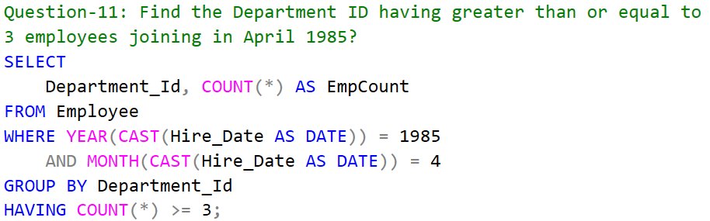

**Answer – 11:**



**Joins Clause/Operator Section:**

**Query – 1:**

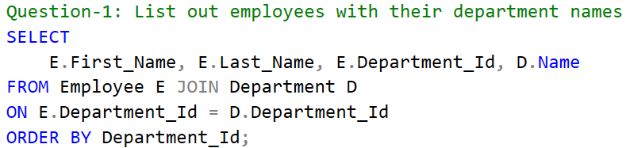

**Answer – 1:**

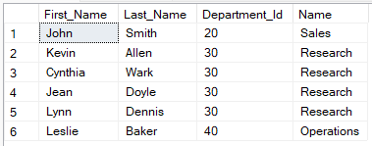

**Query – 2:**

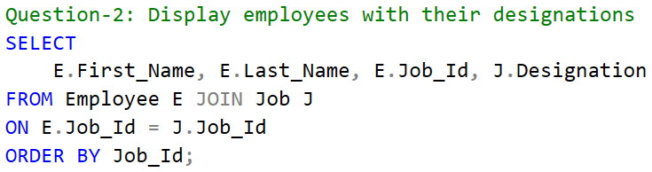

**Answer – 2:**

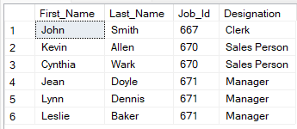

**Query – 3:**

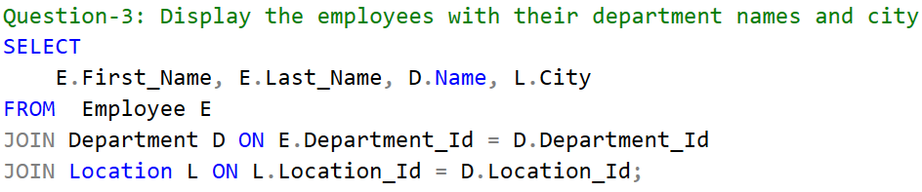

**Answer – 3:**

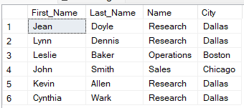

**Query – 4:**

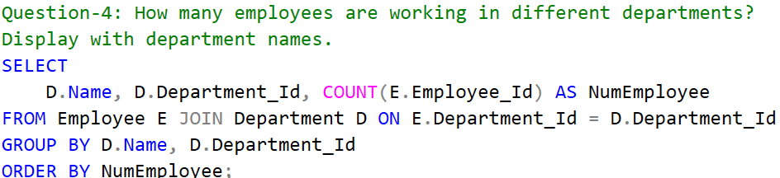

**Answer – 4:**

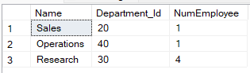

**Query – 5:**

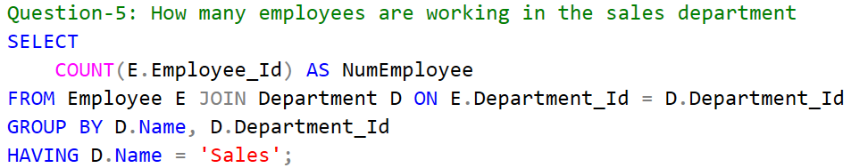

**Answer – 5:**



**Query – 6:**

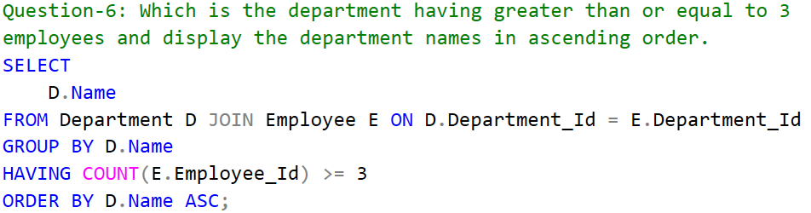

**Answer – 6:**



**Query – 7:**

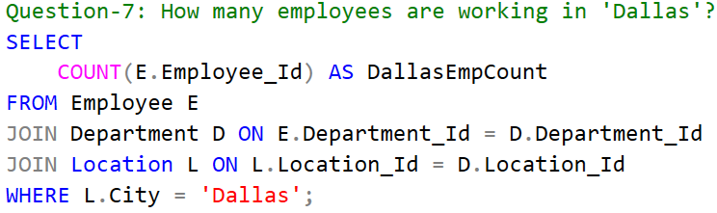

**Answer – 7:**



**Query – 8:**

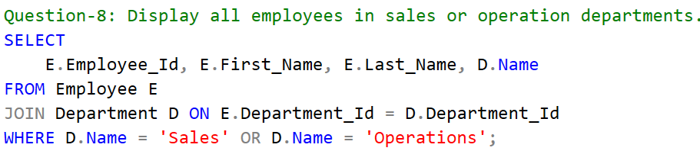

**Answer – 8:**

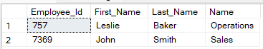

**Conditional Statements Execution Section:**

**Query – 1:**

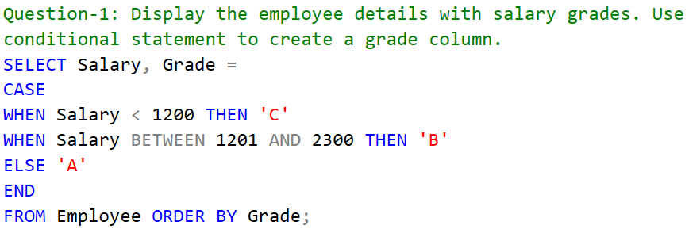

**Answer – 1:**

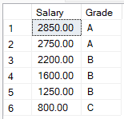

**Query – 2:**

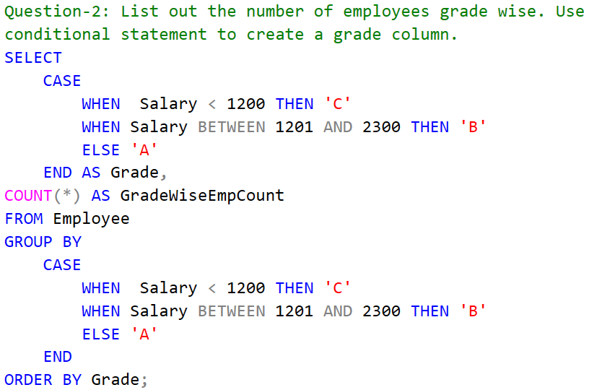

**Answer – 2:**

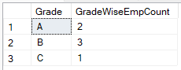

**Query – 3:**

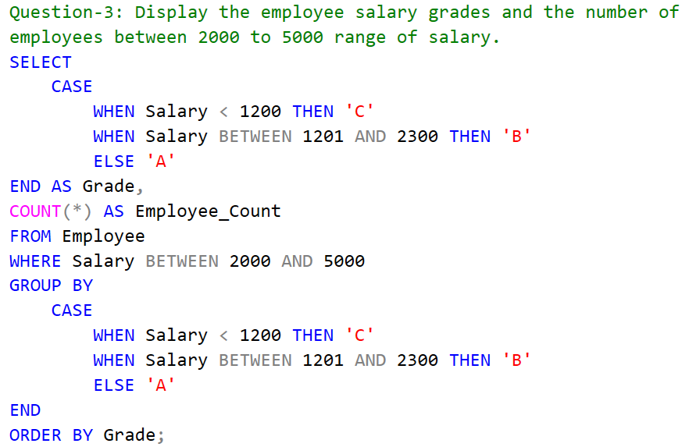

**Answer – 3:**

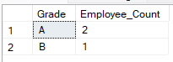

**Sub-queries Section:**

**Query – 1:**

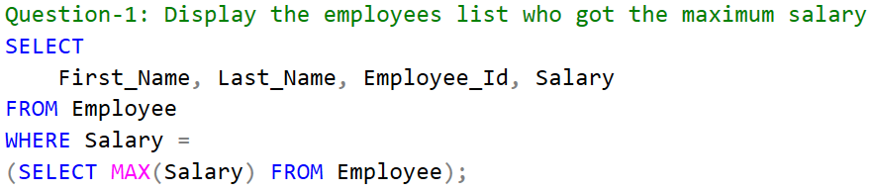

**Answer – 1:**



**Query – 2:**

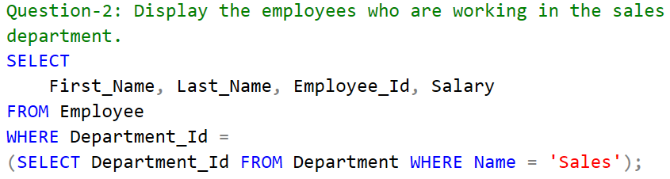

**Answer – 2:**



**Query – 3:**

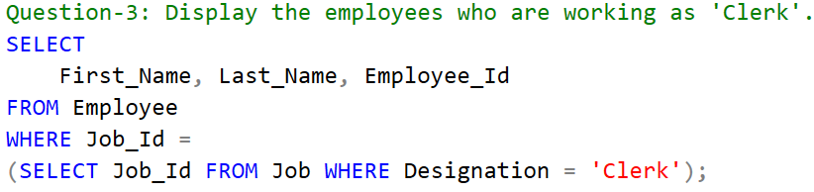

**Answer – 3:**



**Query – 4:**

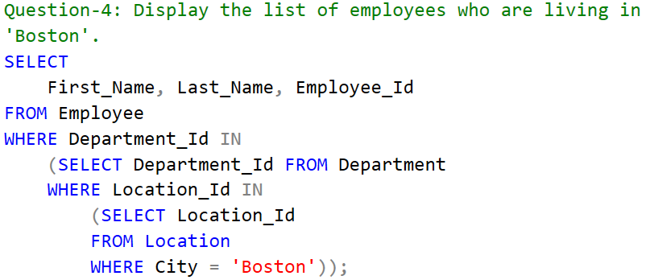

**Answer – 4:**



**Query – 5:**

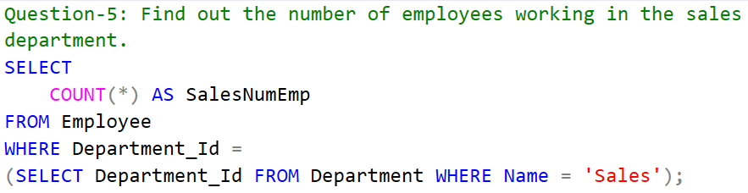

**Answer – 5:**



**Query – 6:**

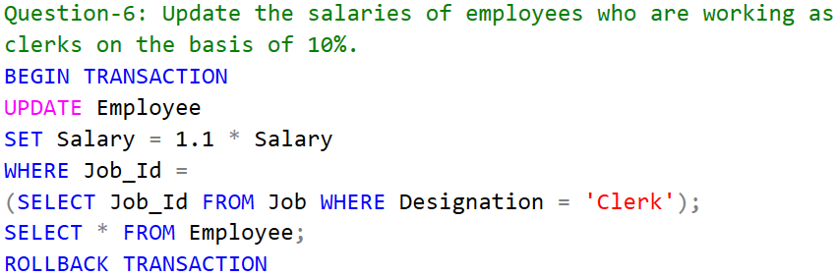

**Answer – 6:**

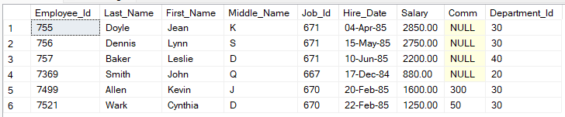

**Query – 7:**

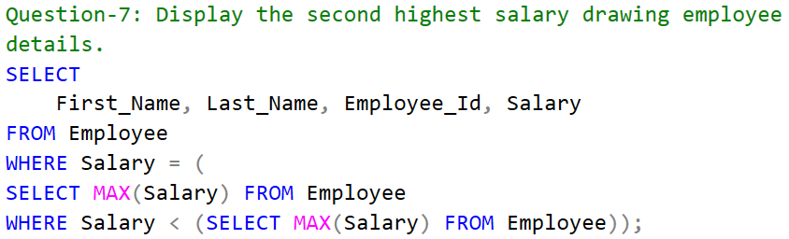

**Answer – 7:**



**Query – 8:**

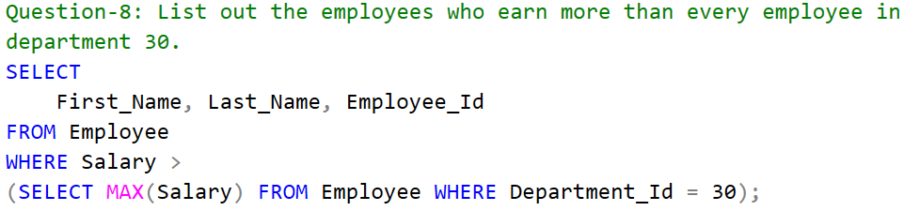

**Answer – 8:**



**Query – 9:**

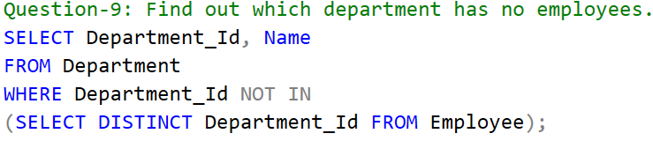

**Answer – 9:**



**Query – 10:**

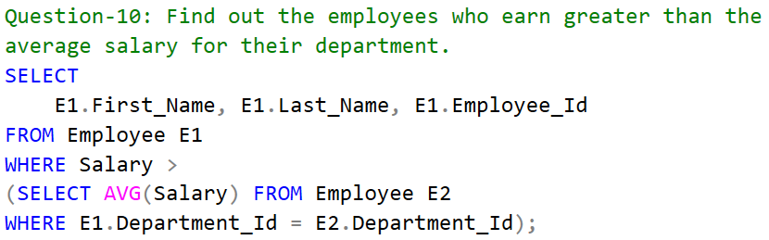

**Answer – 10:**

