**Assignment No: 9**

**Aim: Creating an Application in SalesForce.com using Apex Programming Language**

**Step 1: Log into Salesforce Developer account.**

<https://login.salesforce.com/?locale=in>

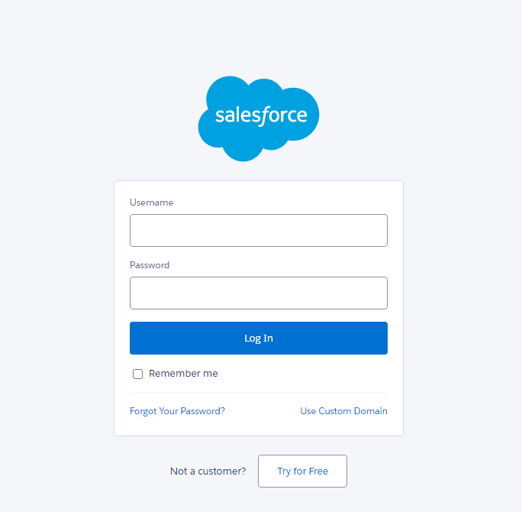

**Step 2: Click on Setup option (Upper Right Corner) and select Developer Console**

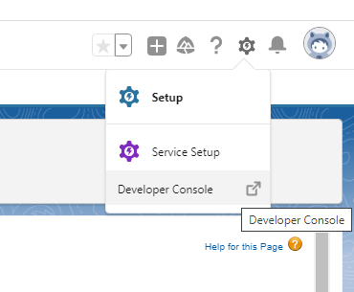

**Step 3: Click on File Menu-🡪 New🡪Apex Class**

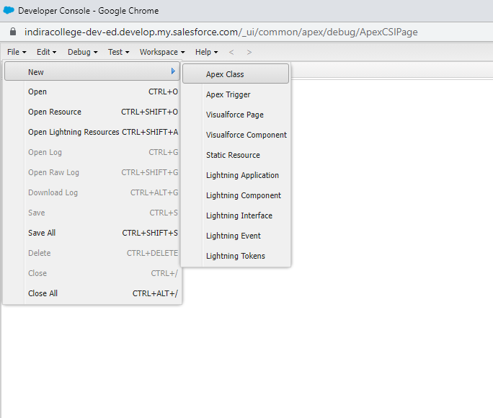

**Enter Class Name: Calc_class**

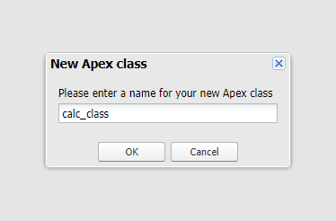

**Step 4: Write Apex class for Calculator Functionality**

public class calc_class

{

public Double val1 {get;set;}

public Double val2 {get;set;}

public Double result {get;set;}

public String func {get;set;}

public calc_class ()

{

}

public void find ()

{

if (func == 'add')

{

result = val1 + val2;

}

else if (func == 'sub')

{

result = val1 - val2;

}

else if (func == 'div')

{

result = val1 / val2;

}

else

{

Integer temp = math.mod(Integer.valueOf(val1), Integer.valueOf(val2));

result = Double.valueOf(temp);

}

}

}

**Save Apex class: Click on Save or Ctrl + s 🡪 Close Window**

Note: If program having error it will be displayed in problems tab.

**Step 5: Click on Home Menu 🡪 below home menu in the search option write visualforce and select visualforce pages option**

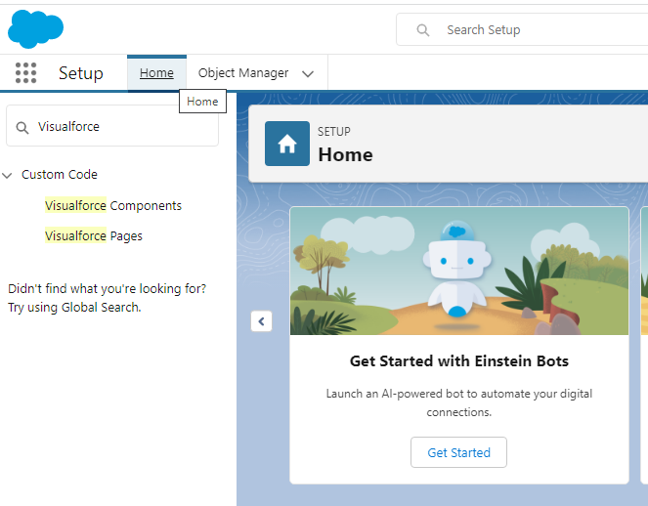

**Click on New option**

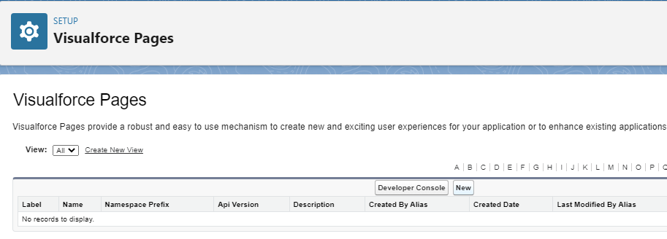

**Step 6: Give Label Name: calc_app and hit tab button**

**Write Visualforce Markup code and click on save button**

***Note: Sample is Apex class name in Markup code

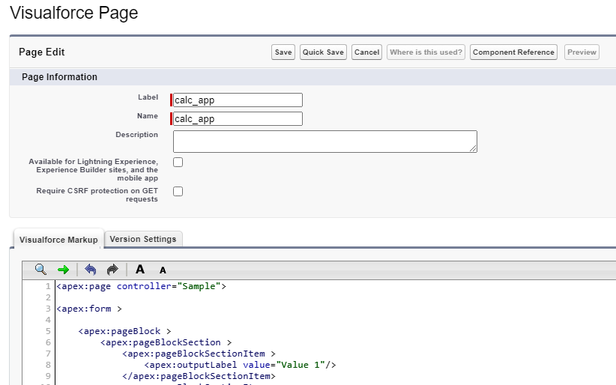

<apex:page controller=" calc_class ">

<apex:form >

<apex:pageBlock >

<apex:pageBlockSection >

<apex:pageBlockSectionItem >

<apex:outputLabel value="Value 1"/>

</apex:pageBlockSectionItem>

<apex:pageBlockSectionItem >

<apex:inputText value="{!val1}"/>

</apex:pageBlockSectionItem>

<apex:pageBlockSectionItem >

<apex:outputLabel value="Value 2"/>

</apex:pageBlockSectionItem>

<apex:pageBlockSectionItem >

<apex:inputText value="{!val2}"/>

</apex:pageBlockSectionItem>

<apex:pageBlockSectionItem >

<apex:selectRadio value="{!func}" layout="pageDirection">

<apex:selectOption itemValue="add" itemLabel="Add"/>

<apex:selectOption itemValue="sub" itemLabel="Subtract"/>

<apex:selectOption itemValue="div" itemLabel="Division"/>

<apex:selectOption itemValue="mod" itemLabel="Modulo Division"/>

</apex:selectRadio>

</apex:pageBlockSectionItem>

<apex:pageBlockSectionItem >

</apex:pageBlockSectionItem>

<apex:pageBlockSectionItem >

<apex:outputLabel value="Result"/>

</apex:pageBlockSectionItem>

<apex:pageBlockSectionItem >

<apex:inputText value="{!result}" id="res"/><apex:actionStatus id="sts" startText="Finding..."/>

</apex:pageBlockSectionItem>

</apex:pageBlockSection>

<apex:pageBlockButtons >

<apex:commandButton value="Find" action="{!find}" reRender="res" status="sts"/>

</apex:pageBlockButtons>

</apex:pageBlock>

</apex:form>

</apex:page>

**Save and Preview output will be displayed**

