**Report**

**Assumptions:**

* To select 100 products from api I have queries Edmodo api with following query terms :

math, mitosis, fractions, history, arts , holidays , cooking , dance , drama , music , graphical arts , programming , web design , game design , phonics ,reading , poetry , writing , Chinese , German , English , Latin , French , Arabic , Spanish , Italian , calculus , decimals , statistics , geometry , religion , coaching , arithmetic.

* Total Products got using these queries : 108

**Implementation details:**

* I have used MVC framework in Django.
* Database used MySQL.
* I have created project ‘Edmodo’ and app ‘searchEngine’ in project.
* The schema for table has been defined in Model.py file. This allows to modify columns or modify database in minimal changes in code base.
* <http://localhost:8080/search/> is landing page for searchEngine.
* Each time page loads, internally it checks whether MySQL database table has entries. If not, it will execute the ‘scraper’ which will call Edmodo api, fetch data and push into database table.
* If database table already has data, then it proceed further to business logic.
* Business logic i.e. searching of products, has been implemented using ‘Django-Haystack’ and ‘Whoosh’ .
* I have used ‘title’ and ‘long_desc’ for indexing the data.
* Generated index can be found at ‘Whoosh’ folder in project .
* At front-end, I have used ‘Bootstrap’ framework.
* Communication with Django view has been managed by ‘AJAX’.

**Results:**

Please find the screenshots of execution.

1. **Landing Page :**

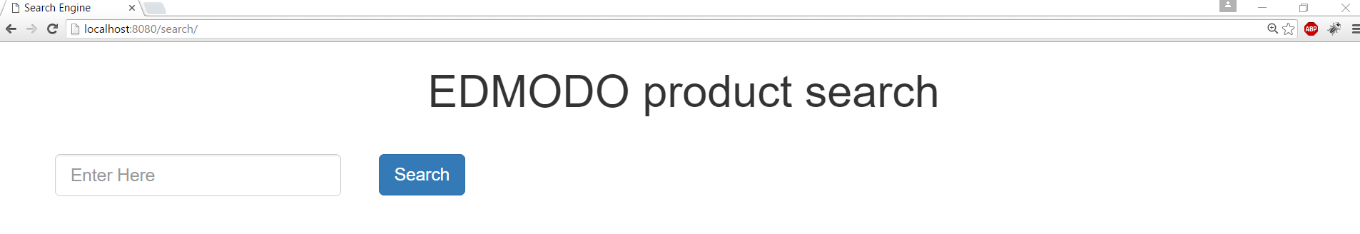

1. **Searching :**

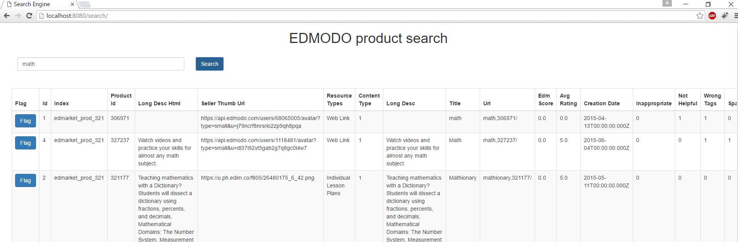

1. **On click Flag :**

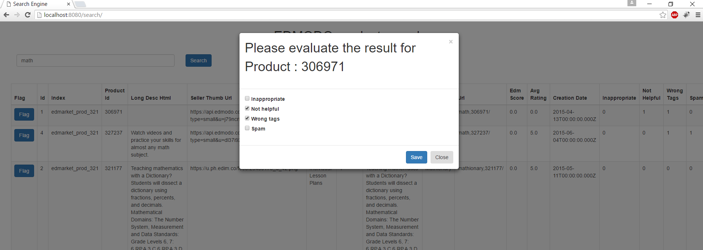

Note: Here, if database has already set some flags, like in this case for product_id 306971, someone has already set flags ‘Not Helpful’ and ‘Wrong Flags’. So those checkbox will be checked. Now, if you think that it’s actually helpful and but ‘inappropriate’ then, just uncheck ‘Not helpful’ and check ‘inappropriate’.

1. **Setting new flags :**

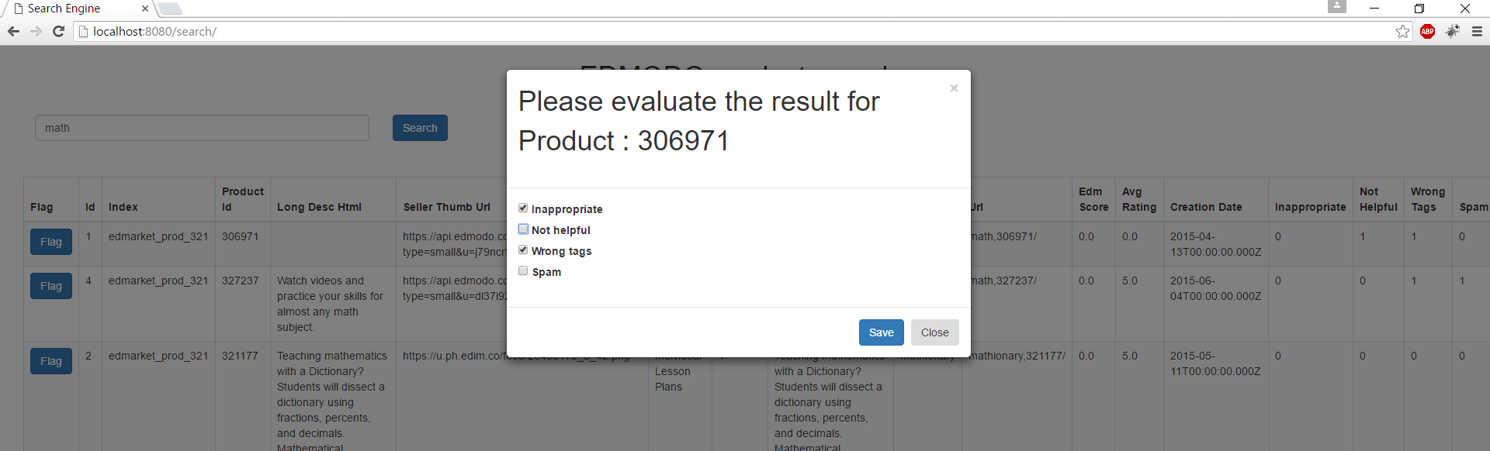

1. **Reflection of changes (Show flagged products ) :**

Once you close the modal window, your changes will reflect in backend table and also can be observed in backend screen.

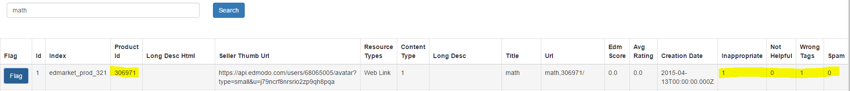

1. **Last Four columns indicate flags :**

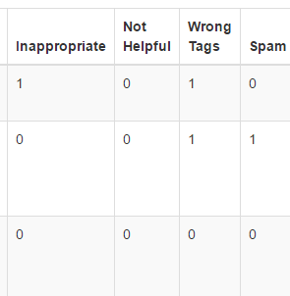

Here 0 indicate not set and 1 indicate set.

**Execution:**

* create MySQL database with following credentials :

host="localhost"

user="root"

passwd="qwerty"

db="edmodo"

Note : If you give another password please update password in 'Settings.py' file

* Extract Edmodo.zip in folder **"C:\Python27\"**
* Install python packages :

Django==1.9.4

django-haystack==2.4.1

ipdb==0.9.0

jsonschema==2.5.1

MySQL-python==1.2.4b4

requests==2.9.1

simplejson==3.8.1

urllib3==1.14

Whoosh==2.7.3

* To start server **first run migrate_server.bat** and then **run restart_EDMODOv2_server.bat**
* Launch **http://localhost:8080/search/** in chrome.
* **NOTE :**

The First execution will take time as application will pull data from Edmodo API online (This will need internet connection. For future execution there is no need for internet). For future execution, it won’t call API, so execution will be faster.