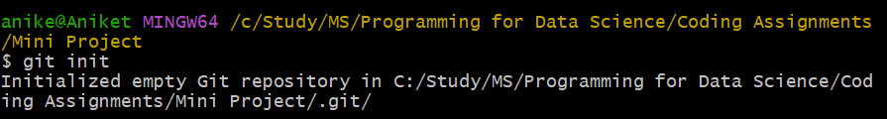



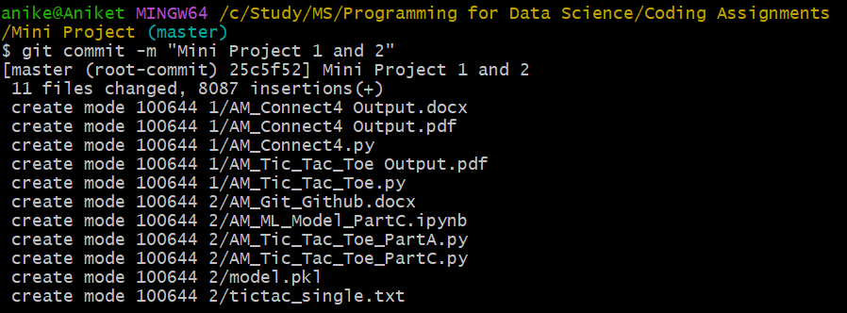

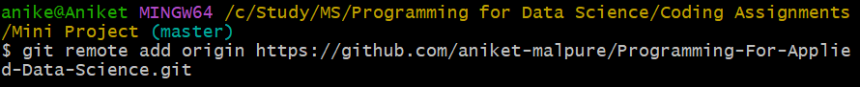

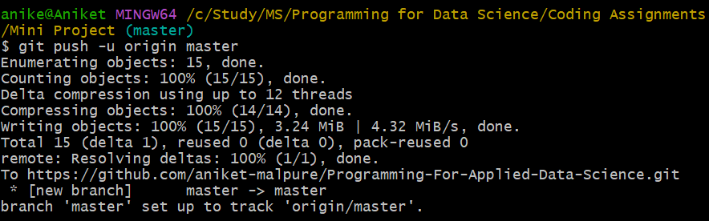

This is stored in a private repository and added [rui.guo@ufl.edu](mailto:rui.guo@ufl.edu) as collaborator for the same:

<https://github.com/aniket-malpure/Programming-For-Applied-Data-Science>

