System Modules

Module 1 – User Management
Responsible for:
- User Registration
- User Login
- Role Management
- Profile Management
- Password Management

Module 2 – Product Management
Responsible for:
- Add Product
- Update Product
- Delete Product
- Search Products
- View Product Details

Module 3 – Category Management
Responsible for:
- Add Category
- Update Category
- Delete Category
- Assign Categories to Products

Module 4 – Supplier Management
Responsible for:
- Add Supplier
- Update Supplier
- Delete Supplier
- View Supplier Information

Module 5 – Inventory Management
Responsible for:
- Stock In
- Stock Out
- Stock Adjustment
- Inventory History
- Current Stock Monitoring

Module 6 – Purchase Management
Responsible for:
- Create Purchase Orders
- Update Purchase Orders
- View Purchase History
- Order Status Tracking

Module 7 – Sales Management
Responsible for:
- Record Sales
- Update Sales Records
- View Sales History
- Generate Sales Invoice

Module 8 – Report Management
Responsible for:
- Inventory Reports
- Purchase Reports
- Sales Reports
- Low Stock Reports

Module 9 – Dashboard
Responsible for:
- Inventory Summary
- Product Statistics
- Recent Purchases
- Recent Sales
- Low Stock Alerts

Entities and Relationships

Entities
- User
- Category
- Product
- Supplier
- Purchase
- Purchase Item
- Sale
- Sale Item
- Relationships
Parent Entity | Relationship | Child Entity
Category | One-to-Many | Product
Supplier | One-to-Many | Purchase
User | One-to-Many | Purchase
User | One-to-Many | Sale
Purchase | One-to-Many | Purchase Item
Product | One-to-Many | Purchase Item
Sale | One-to-Many | Sale Item
Product | One-to-Many | Sale Item

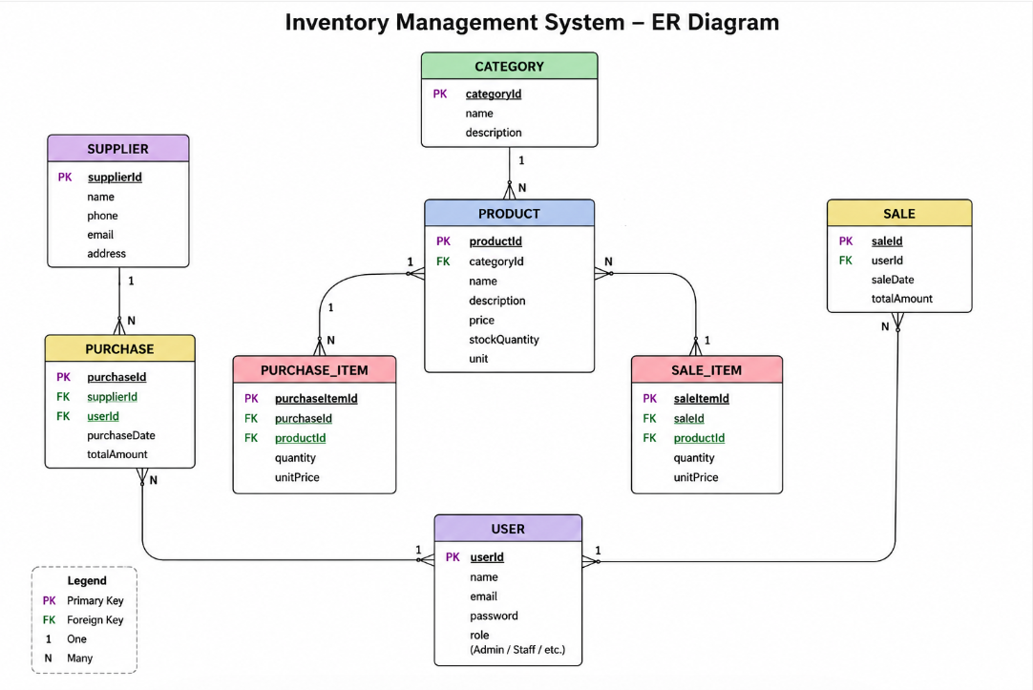

Primary Keys (PK)
- userId
- categoryId
- productId
- supplierId
- purchaseId
- purchaseItemId
- saleId
- saleItemId

Foreign Keys (FK)
- categoryId → Product
- supplierId → Purchase
- userId → Purchase
- userId → Sale
- purchaseId → Purchase Item
- productId → Purchase Item
- saleId → Sale Item
- productId → Sale Item

Collection Details

1. Users
Purpose: Stores login credentials and user roles.
Fields:
- _id
- name
- email
- password
- role
- phone
- createdAt

2. Categories
Purpose: Stores product categories.
Fields:
- _id
- categoryName
- description

3. Products
Purpose: Stores product information and inventory.
Fields:
- _id
- productName
- categoryId
- description
- price
- stockQuantity
- unit
- createdAt

4. Suppliers
Purpose: Stores supplier details.
Fields:
- _id
- supplierName
- contactPerson
- phone
- email
- address

5. Purchases
Purpose: Stores purchase orders.
Fields:
- _id
- supplierId
- userId
- purchaseDate
- totalAmount
- status

6. PurchaseItems
Purpose: Stores products purchased in each purchase order.
Fields:
- _id
- purchaseId
- productId
- quantity
- unitPrice

7. Sales
Purpose: Stores sales transactions.
Fields:
- _id
- userId
- saleDate
- totalAmount
- paymentMethod

8. SaleItems
Purpose: Stores products sold in each sales transaction.
Fields:
- _id
- saleId
- productId
- quantity
- unitPrice

Collection Relationships
Collection | References
Products | Categories
Purchases | Suppliers, Users
PurchaseItems | Purchases, Products
Sales | Users
SaleItems | Sales, Products

Navigation Flow for Each User Role

1. Administrator (Business Owner)
