Knowledge Launch Version, Permissions, and User Acceptance Test Report

1. scope

This note sets out the following:

* 1. the scope of version 1.0 of Mattersmith Knowledge and Review, i.e. the **launch version**;
  2. the features to be available for each of the following user-profiles, which will apply to *all* instances of Knowledge:
     1. Viewer Read Only;
     2. Viewer Editor;
     3. Admin; and
  3. the results of my testing of the SuperAdmin function and the test instance of Knowledge.

1. Launch Version

Functionality and content

* + 1. The launch version will be dedicated to supporting the review of non-disclosure agreements and data processor agreements under the new general data protection regulation. The application will be launched in English. (Mark we should discuss the possibility of creating versions in French and German in due course.)
    2. The actions in relation to *legal and linguistic* content are as follows:
       1. AS to complete the generic playbooks and models; and
       2. AS and MP to agree and implement:
          1. structure of Concept Library - there are some Concepts within the library we’re created for NDAs which could be applied to other legal documents, such as indemnity;
          2. common naming across Review Concepts and their Knowledge Playbook equivalents.
    3. Linking feature between Knowledge and Review is not required for launch.

Instances and log-on

* + 1. There will be one instance of Knowledge and one instance of Review.
    2. Users and Admin Users must log on to both separately. There will be no Viewer Editor accounts created for the launch version of Knowledge.

Architecture

* + 1. This note attaches MP’s deck on the server architecture, which I don’t believe we have implemented yet, or have we?
    2. Are the SuperAdmin features to be associated with each instance of Knowledge and Review, or is there to be one SuperAdmin feature for each of Knowledge and Review which applies to *all* instances Knowledge and Review? If the latter, then the current feature needs to have added the ability to link the accounts to an instance of Knowledge and Review. I assume, however, that the former is the case, i.e. whenever a new instance of Knowledge or Review is created, that instance will have a SuperAdmin feature associated with it to create accounts to access that instance.
    3. As a general point, we need to group users by reference to the client. I believe this requires an additional field to be included in the SuperAdmin Add/Edit User table.
    4. For launch, we do not require the ability to upgrade each instance of Knowledge or Review from a master version. However, I believe this will be required – at least in respect of Knowledge – soon.

1. knowledge user-profiles

As Action

* + 1. I have been asked to describe the features of Knowledge that are to be made available to each of the user-types which are to be reinforce in the back-end of the application. These are set out below.
    2. The initial solution developed by MHN provides for two logon options – viewer and admin. There is no difference in the available functionality except that the editing features which appear on the screen when Knowledge is used in Admin mode are hidden from view in Viewer mode.

Admin

The Admin user is to have no ability to view or edit the Knowledge graphs, however, they should have the ability to give themselves a Viewer or Viewer-Editor account.

Viewer Editor

* + 1. To be able to use *all* features currently available to the “Admin” user of the graph, including:
       1. create, edit, delete instances from the Schema;
       2. save and cancel changes;
       3. upload documents lined to instance;
       4. download documents held in the graph;
       5. create and delete edges according to the existing associations and rules reflected in the application;
       6. view and use the features of the graph whilst in admin mode; and
       7. switch between Viewer Read Only and Viewer Editor modes.
    2. For practical illustrations, please use the sandbox in Admin mode **but without deleting or editing any of the current instances**.
    3. If and when we develop the ability to create new classes, we will need to consider whether additional controls are required.

Viewer Read Only

The ability to view and use the features of the graph. None of the editorial features on the screen are to be visible. For practical illustrations, please use the sandbox in Viewer mode.

1. AS UAT Results
   1. I can now view the accounts created.
   2. When I logged on to Knowledge using the Viewed Editor account I created, neither the Schema nor Topics would load (see screen shot 1).
   3. The Viewer Editor account I created was AndrewDScott. This was listed and I had to log on as AndrewDScott-viewer. This is confusing. Is there any particular reason for the “-viewer” text? If it is necessary, then I think it should be “-viewer” for Viewer Read Only and “-editor” for Viewer Editors.
   4. As noted above, we need an additional field to capture the name of the client.
   5. When I accessed in Viewer Editor mode, the screen appeared to be Viewer Read Only (see screen shot 1). Is this because in the test environment everyone logs onto the same instance?
   6. I still can’t log on using Chrome (see screen shot 2).
   7. The red line above “Law matters…” appear at the end of the line in every instance I could see (see screen shots 3 and 4).
   8. Editorial content to follow. I will need to include a privacy policy for data protection purposes. Cookies will not be installed on the user’s machine.
   9. I have not yet tested:
      1. the functionality of Knowledge or Review;
      2. the Admin feature to create accounts;
      3. reset password.
   10. Testing is needed on different browsers.

Andrew Scott

Principal

Screen Shot 1

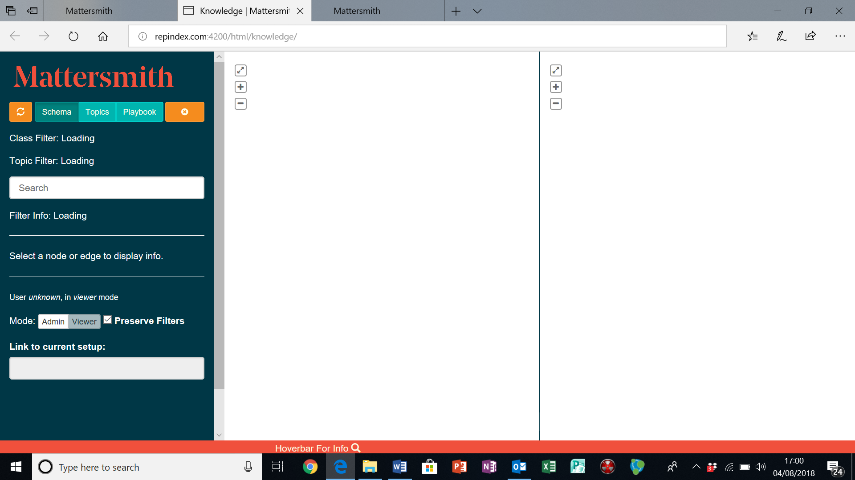

Screen shot 2

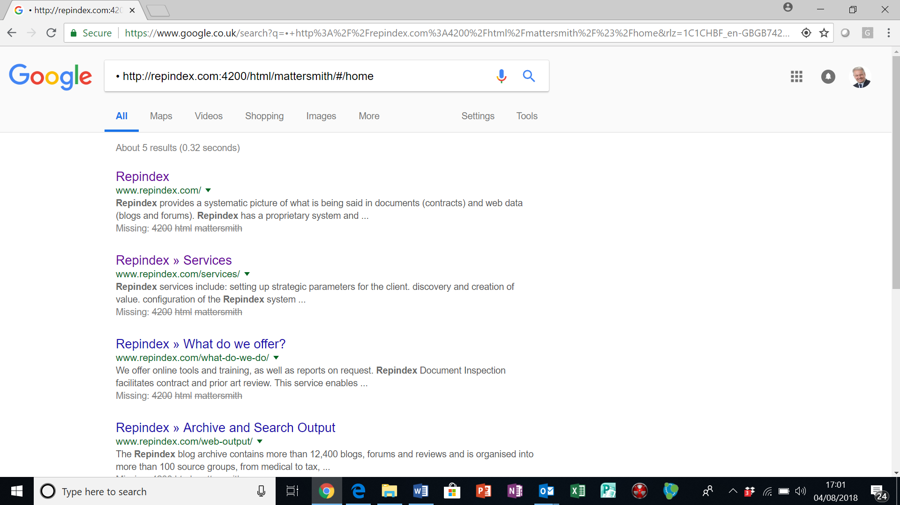

Screen shot 3

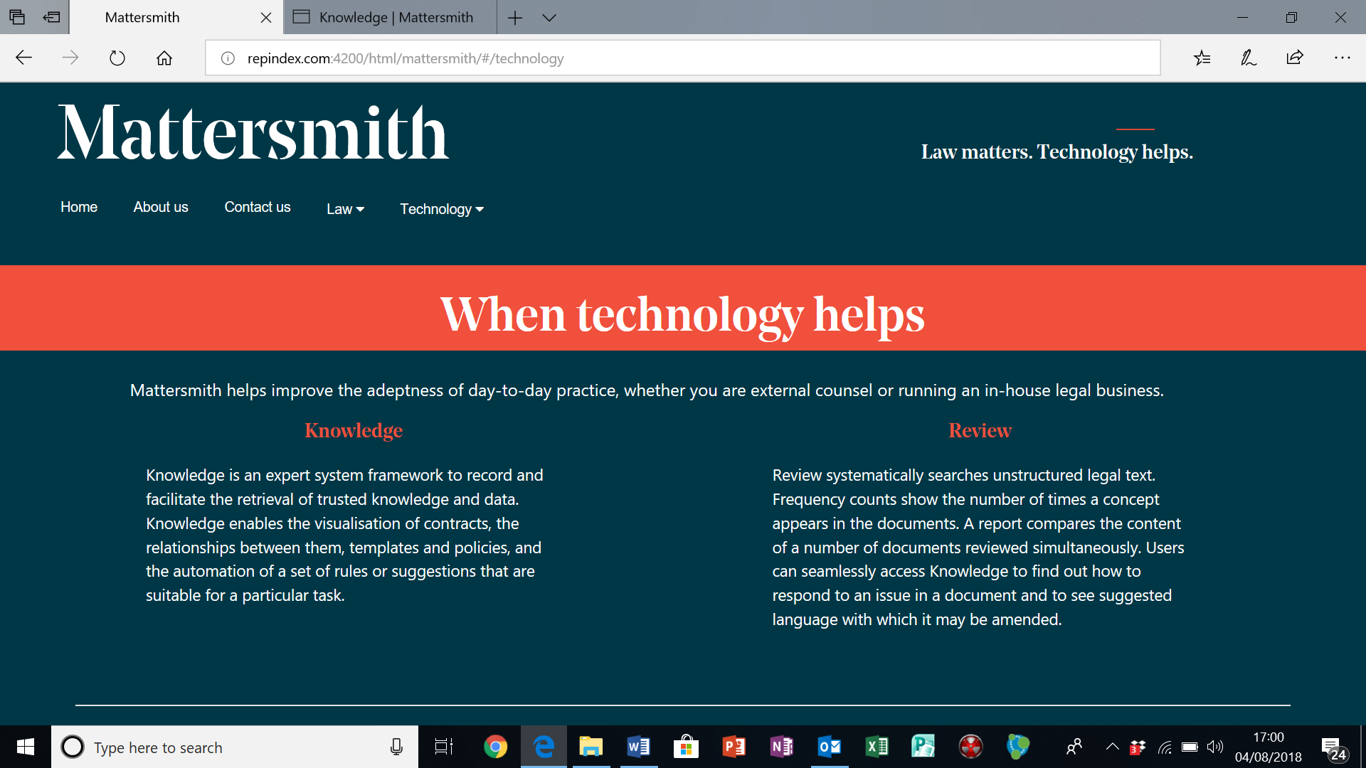

Screen shot 4

