Answer 1:

No. | STIRLING FACTORIAL | EXACT FACTORIAL | ABSOLUTE ERROR | RELATIVE ERROR
1 | 0.921904 | 1 | 0.0780961 | 0.0780961
2 | 1.91852 | 2 | 0.0814796 | 0.0407398
3 | 5.83474 | 6 | 0.165258 | 0.027543
4 | 23.5003 | 24 | 0.499721 | 0.0208217
5 | 117.99 | 120 | 2.01035 | 0.016753
6 | 709.901 | 720 | 10.099 | 0.0140263
7 | 4979.16 | 5040 | 60.8433 | 0.0120721
8 | 39892.5 | 40320 | 427.506 | 0.0106028
9 | 359448 | 362880 | 3432.1 | 0.00945794
10 | 3597813 | 3628800 | 30992.5 | 0.0085407

OBSERVATION: we can see that the Relative error is less than Absolute error, and as number is increasing the difference between Absolute error and relavtive error increases rapidly.So I should use Relative error in this case as this error is small compare to Absolute error.

Answer 2:
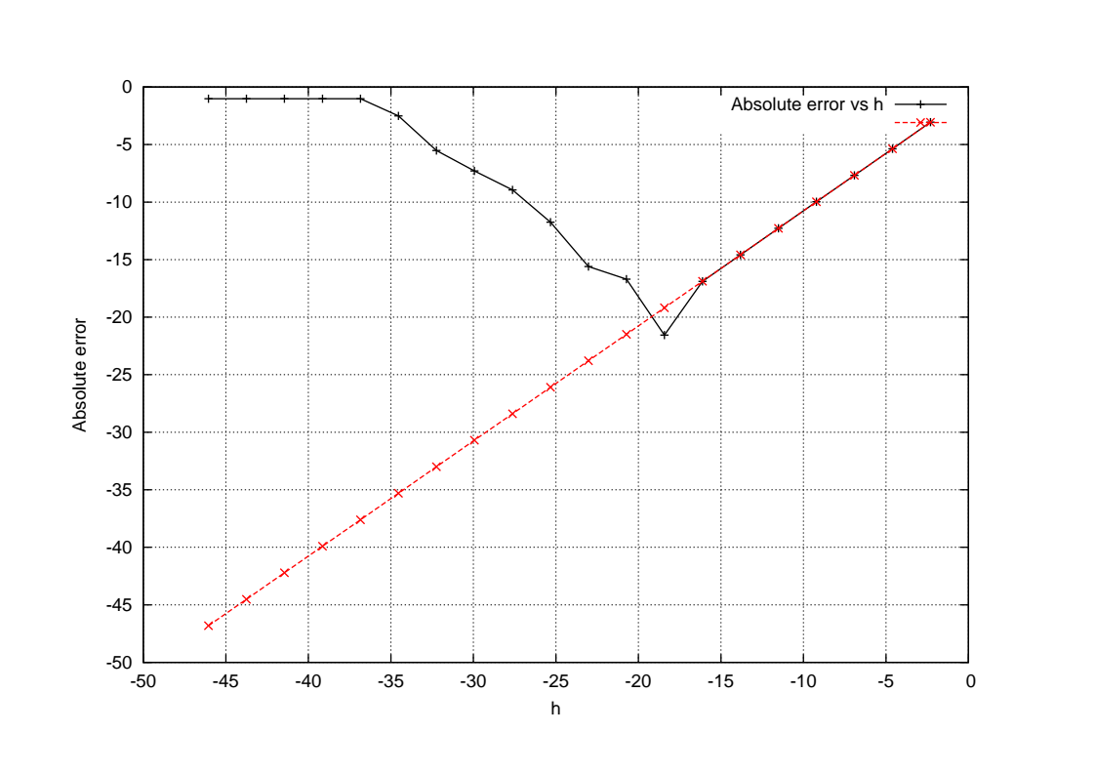
Answer 2 (continue....):

When we decrease crease h drastically the computer’s absolute error will deviate from absolute actual error as computer’s absolute error uses roundoff error while in case of an absolute actual error we use only discretization error without roundoff error. The deviation may increases as we decrease h and it will become constant at some value of h(depends upon the system).

Answer 3:

