1. Write query that counts all orders for October 3.

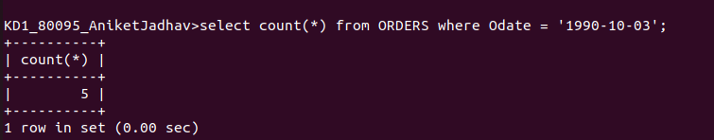

2. Write a query that counts the number of different non NULL city values in the Customers table.

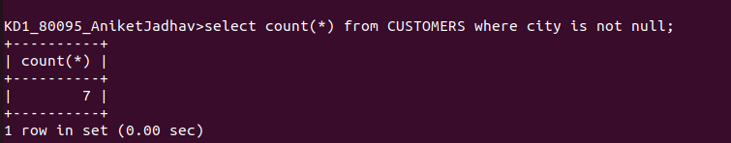

3. Write a query that selects each customers smallest order.

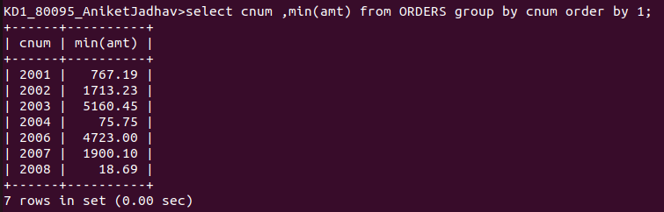
.

4.Write a query that selects the first customer, in alphabetical order, whose name begins with G.

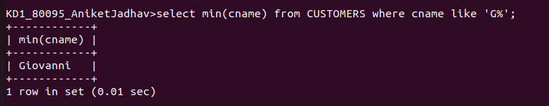

5. Write a query that selects the highest rating in each city.

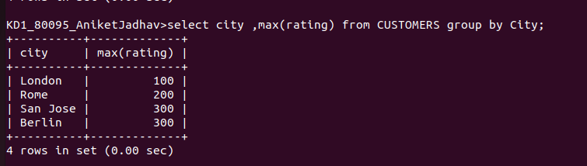
.

6. Write a query that counts the number of salespeople registering orders for each day.

