1. Write two different queries that would produce all orders taken on 3rd or 4th 1990.

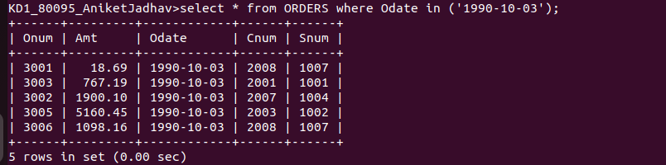

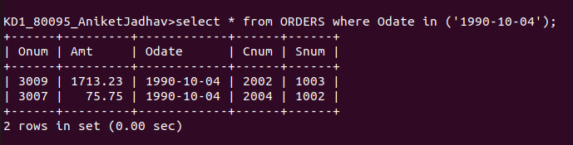

2. Write query that selects all of the customers serviced by Peel Or Motika .

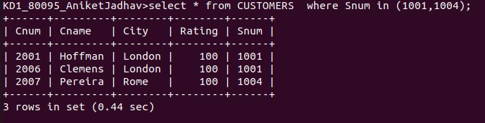
3. Write a query that will produce all the customers whose names begin with a letter from ‘A’ to ‘G’.

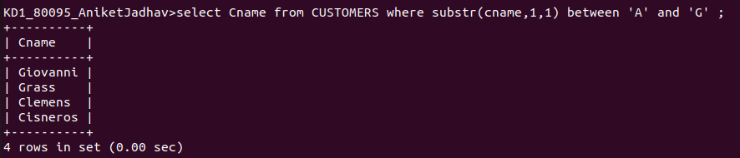
1

4. Write a query that selects all customers whoes names begin with letter ‘C’.

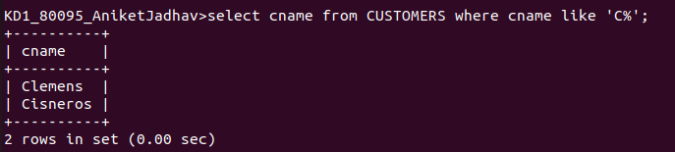

5. Write query that selects all orders except those with zeroes or NULLs in the amt field.

