1. Write query that lists each order number followed by the name of the customer who made the order.

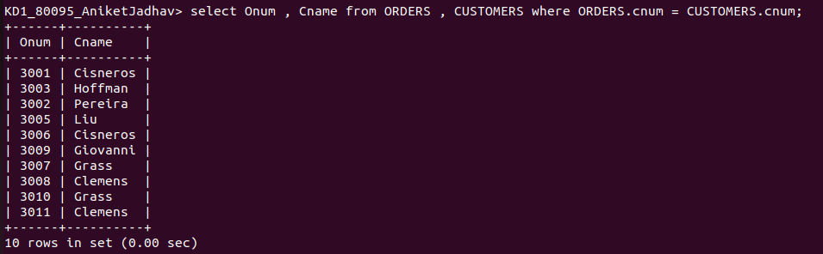
.

2. Write the query that gives the names of both the salesperson and the customer for each order along with order number

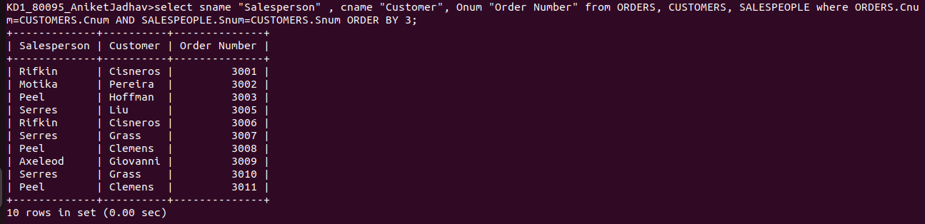
.

3. Write a query that produces all customers serviced by salespeople with a commission above 12%.Output the customers name, salesperson name , and salesperson rate of commission.

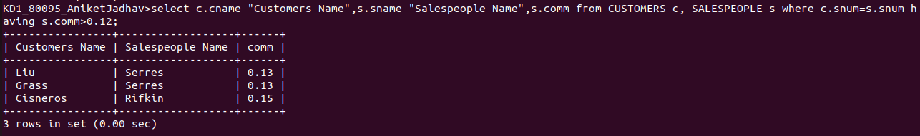
.

4. Write a query that calculates the amount of salesperson commission on each order by a customer with a rating above 100.

