1. Write query taht will give you all orders more than RS 1000.

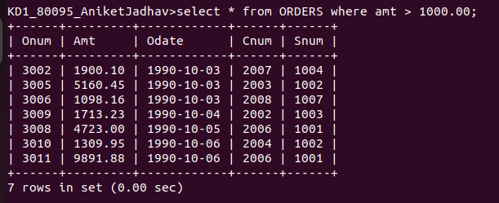

2. Write query that will give you the names and cities of all salespeople in london with a commission above 0.10

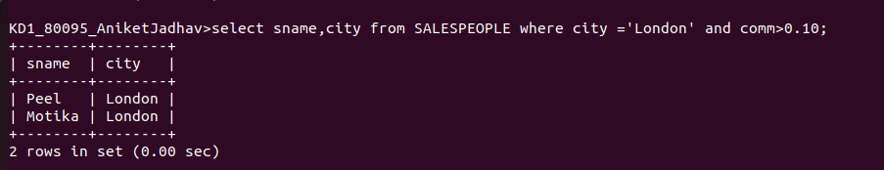

3.Write query on customers table whose output will exclude all customers with rating <= 100,unless they are located in rome.

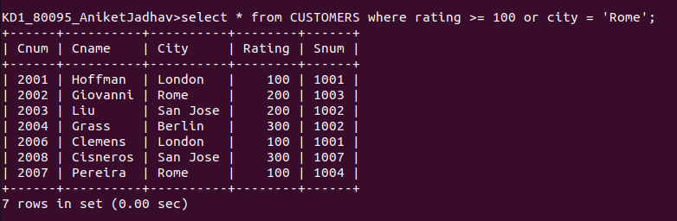
4.
What will be output from the folloing query

Select * from ORDERS where (amt <1000 OR NOT (Odate = '1990-10-03' AND cnum >2003));

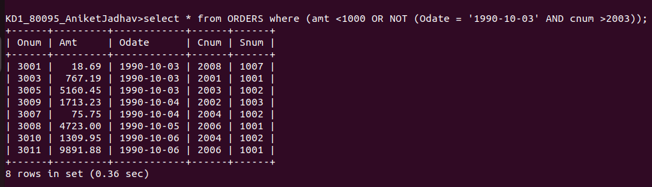

5. What will be output from the folloing query
select * from ORDERS where not ((odate = ‘1990-10-03’ OR snum > 1006) AND amt>= 1500);

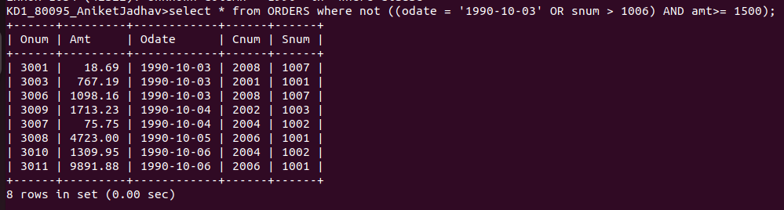

6. What is simple way to write the query?

Simpler Way =

