1. Assume each salesperson has a 12% commission. Write a query on the orders table that will produce order number, salesperson number and amount of salesperson commision for that order.

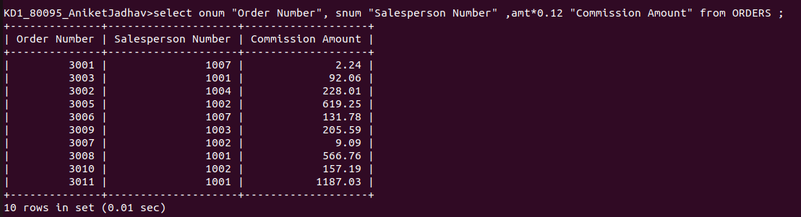

2. Write a query on customers table that will find the highest rating in each city .

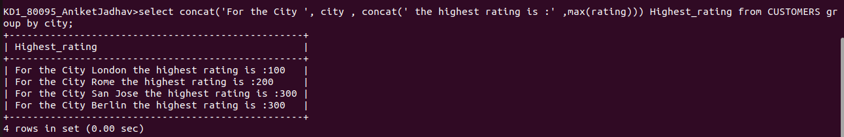

3. Write a query that lists customers in descending order of rating. Output the rating field first followed by customers name and number.

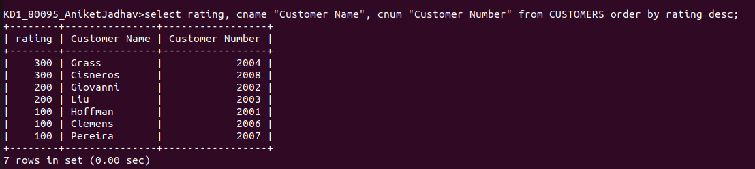

4. Write a query that totals orders for each day and places the results in descending order.

