1. Write a query that uses a subquery to obtain all orders for customer named Cisneros. Assume you do not know his customer number (cnum).

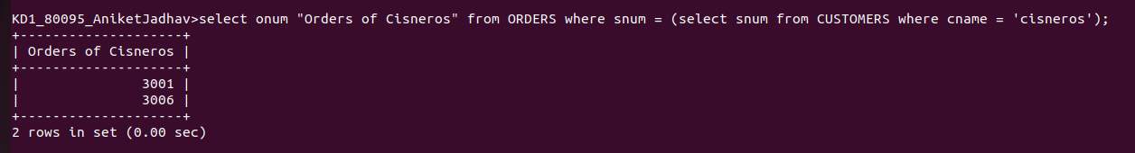

2.Write a query that produces the names and ratings of all customers who have above average orders.

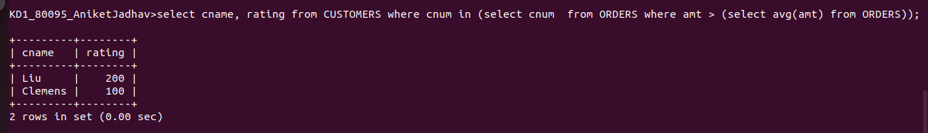

3.Write a query that selects the total amout in orders for each salesperson fro whom this total is greater than the amount of the largest order in table.



