1. Write a select command that produces the order number, amount, and date for all rows in orders table.

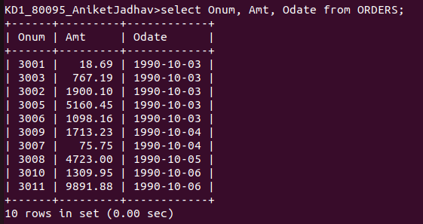

2.Write a query that produces all rows from Customers table for which the salespersons number is 1001.

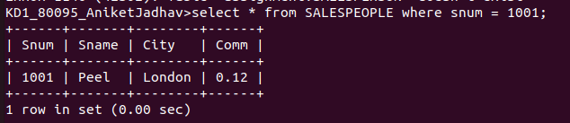
3. Write a query that displays the Salespeople table with columns in the following order:
city, sname,snum,comm.

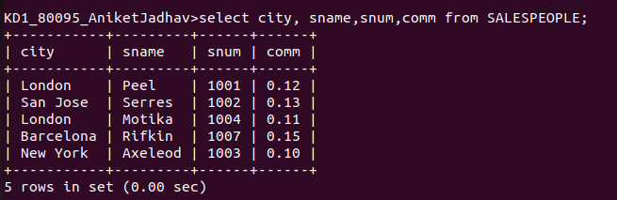

4.Write a select command that produces the rating followed by the name of each customer in San Jose.

