1. Write a query that produces all pairs of salespeople who are living in the same city. Excludes combinations of salespeople with themselves as well as duplicate rows with the order reversed.

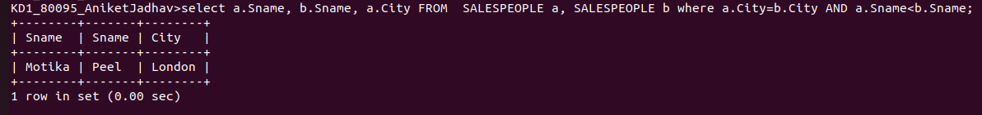
.

2. Write a query that produces names and cities of all customers with the same rating as Hoffman.

