WORLD LIFE EXPECTANCY

World Life Expectancy Project ( Data Cleaning)
SELECT *
FROM worldlifeexpectancy;
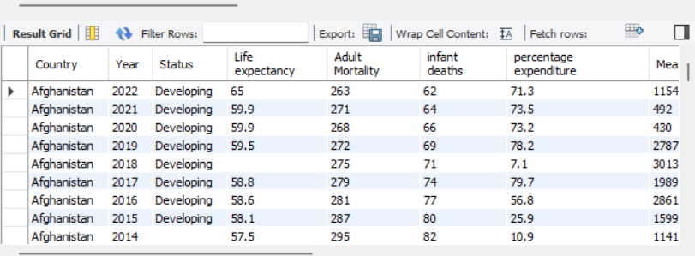

Identifying Duplicates
SELECT Country, Year , CONCAT(Country,Year) , COUNT(CONCAT(Country,Year))
FROM worldlifeexpectancy
GROUP BY Country, Year , CONCAT(Country,Year)
HAVING COUNT(CONCAT(Country,Year)) > 1;
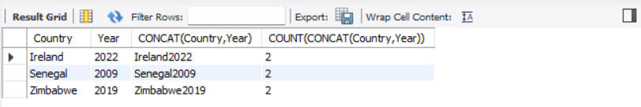
RemovingSELECT *
FROM
(SELECT Row_ID , CONCAT(Country,Year) ,
ROW_NUMBER() OVER(PARTITION BY CONCAT(Country,Year) ORDER BY CONCAT(Country,Year)) AS row_num
FROM worldlifeexpectancy) AS rowww
WHERE row_num >1; Duplicates
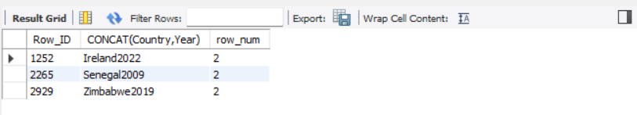

DELETE FROM worldlifeexpectancy
WHERE Row_ID IN (
SELECT Row_ID
FROM
(SELECT Row_ID , CONCAT(Country,Year) ,
ROW_NUMBER() OVER(PARTITION BY CONCAT(Country,Year) ORDER BY CONCAT(Country,Year)) AS row_num
FROM worldlifeexpectancy) AS rowww
WHERE row_num >1
);

Check for blanks
SELECT *
FROM worldlifeexpectancy
WHERE status = '';
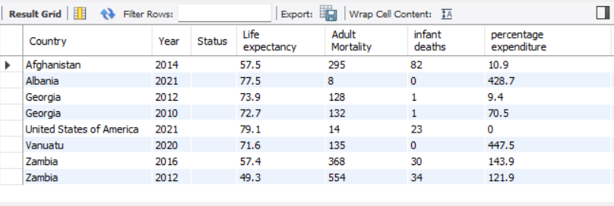
Filling blanks
UPDATE worldlifeexpectancy t1
JOIN worldlifeexpectancy t2
ON t1.Country = t2.Country
SET t1.Status = 'Developing'
WHERE t1.Status = ''
AND t2.Status <> ''
AND t2.Status = 'Developing';

SELECT *
FROM worldlifeexpectancy
WHERE Status = '';
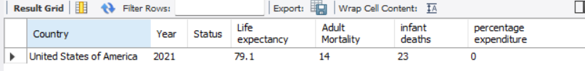

SELECT *
FROM worldlifeexpectancy
WHERE Country = 'United States of America' ;
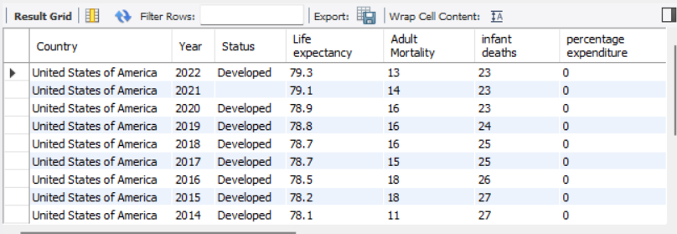

UPDATE worldlifeexpectancy t1
JOIN worldlifeexpectancy t2
ON t1.Country = t2.Country
SET t1.Status = 'Developed'
WHERE t1.Status = ''
AND t2.Status <> ''
AND t2.Status = 'Developed';

SELECT *
FROM worldlifeexpectancy;
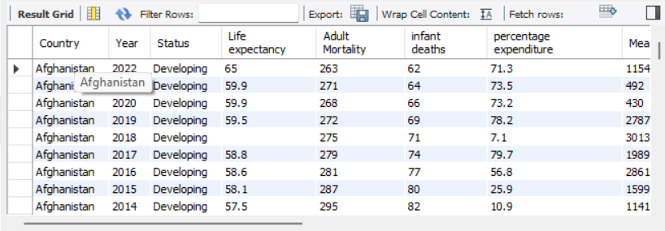

SELECT *
FROM worldlifeexpectancy
WHERE `Life expectancy` = '';
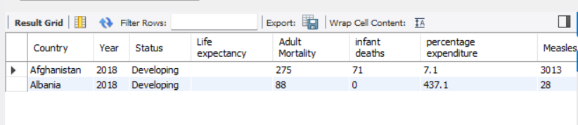
SELECT t1.Country, t1.Year, t1.`Life expectancy`, t2.Country, t2.Year, t2.`Life expectancy`, t3.Country, t3.Year, t3.`Life expectancy`,
ROUND((t2.`Life expectancy` + t3.`Life expectancy`)/2,1)
FROM worldlifeexpectancy t1
JOIN worldlifeexpectancy t2
ON t1.Country = t2.Country
AND t1.Year = t2.Year - 1
JOIN worldlifeexpectancy t3
ON t1.Country = t3.Country
AND t1.Year = t3.Year + 1
WHERE t1. `Life expectancy` = '';
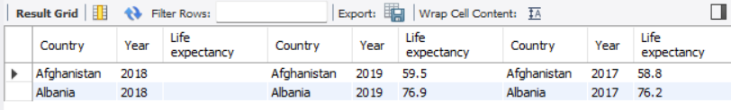

-- World Life Expectancy Project (Exploratory Data Analysis)

SELECT Country , MIN(`Life expectancy`), MAX(`Life expectancy`),
ROUND(MAX(`Life expectancy`)-MIN(`Life expectancy`),1) AS Life_increse_15_years
FROM worldlifeexpectancy
GROUP BY Country
HAVING MIN(`Life expectancy`) <> 0
AND MAX(`Life expectancy`) <> 0
ORDER BY Life_increse_15_years DESC;
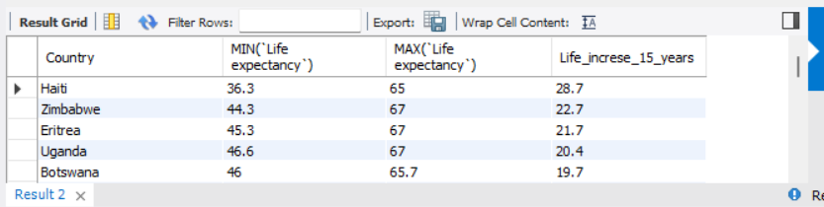

SELECT Year, ROUND(AVG(`Life expectancy`),2)
FROM world_life_expectancy
WHERE `Life expectancy` <> 0
GROUP BY Year
ORDER BY Year;

