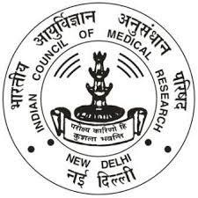

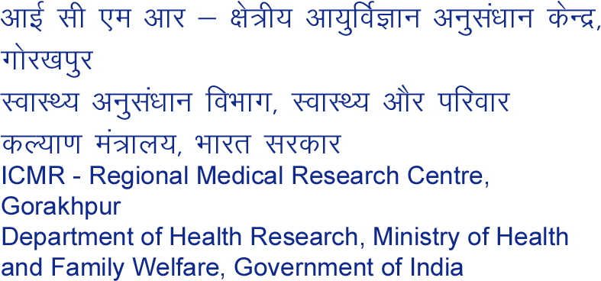

Covid-19 Test (RT-PCR) Report

|  |  |
| --- | --- |
| **Date and Time of Reporting (DD/MM/YYYY): 12 hour format** | **27-12-2021 10:30 PM** |
| **Address of the referring facility/Hospital** | RMRC Gorakhpur |
| **SPECIMEN DETAILS** | |
| **Date & Time of Sample Collection** | **27-12-2021** |
| **Date & Time of receipt of specimen at VRDL** | **27-12-2021** |
| **Date of sample testing** | **27-12-2021** |
| **Condition of Specimen Received/Quality on arrival** | As per standards |

|  |  |  |  |  |  |  |
| --- | --- | --- | --- | --- | --- | --- |
| **Sr No.** | **Sample ID** | **Patient Name** | **Age** | **Sex** | **Result** | |
| **2019- nCOV** | **Other Resp.**  **viruses** |
| 1 | RMRCGKPCOV-5409 | Arapana lal | 17 | F | Negative | - |

***Prepared by: Checked and Approved by***

*Note: The results relate only to the specimens tested and should be correlated with clinical findings.* Interpretation guidance: -

* *Testing of referred clinical specimens was considered on the basis of request / referral received from / through State Surveillance Officer (SSO) of concerned State Integrated Disease Surveillance Programme (IDSP)/ any other health care facility affirming requirements of the case definition/s.*
* *A single negative test result, particularly if this is from an upper respiratory tract specimen, does not exclude infection\**
* *A positive test result is only tentative, and will be reconfirmed by retesting.*
* *Repeat sampling and testing of lower respiratory specimen is strongly recommended in severe or progressive disease. The repeat specimens may be considered after a gap of 2 – 4 days after the collection of the first specimen for additional testing if required. \**
* *A positive alternate pathogen does not necessarily rule out either, as little is yet known about the role of coinfections.*
* *Please note that these results are not to be used for any thesis or presentations or for Publication in any Journal without the prior permission of the Director General, ICMR*