

CASE STUDY

ON

Cyber Retaliation, Hybrid Warfare, and India’s Defensive Resilience On India by Pakistan linked hacker groups

Submitted to: Submitted by:

Mr. Santanu Sasmal Aniket Dayal

202210101180009

& Ujjwal Srivastava

202210101180002

(B.Tech CSE Cyber Security)

🛡️ Operation Sindoor –

DDoS Attacks (2025)

A Strategic case study on Cyber Retaliation, Hybrid Warfare, and India’s Defensive Resilience
Date of Issue: November 17, 2025
Timeframe of Analysis: April 22, 2025 – May 31, 2025

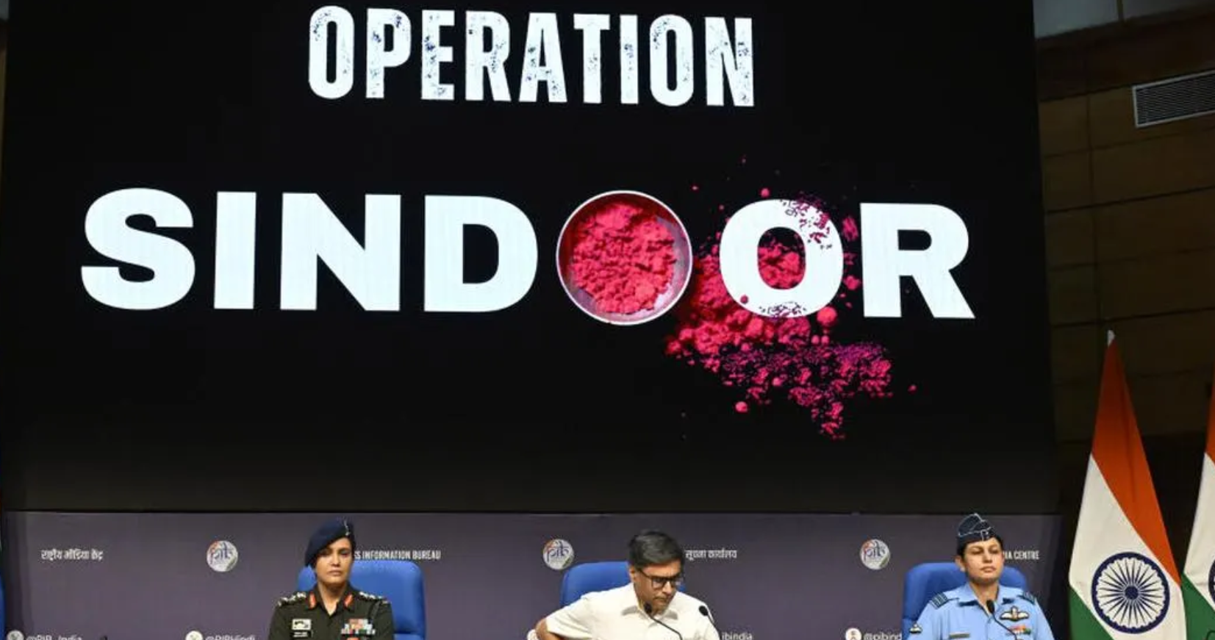

Executive Summary
Operation Sindoor (May 7, 2025), India's calibrated military response to the preceding Pahalgam terror attack, marked a definitive moment where geopolitical conflict immediately and intensely escalated into cyberspace. This report focuses specifically on the Distributed Denial of Service (DDoS) campaigns—the primary form of publicly claimed, large-scale cyber-retaliation launched by pro-Pakistani and allied hacktivist groups in the campaign codenamed #OpIndia.

Key Findings:
- Immediate and Coordinated Escalation: Within hours of the kinetic strikes, DDoS attack claims surged, peaking at 9:30 PM IST on May 7th, with up to seven claims reported per hour. This speed and intensity indicate significant pre-positioning and coordination among hacktivist groups.
- Target Priority: The attacks were overwhelmingly focused on Government and Public Services, accounting for over 75% of all claimed DDoS activity (including attacks on the PMO, GeM, and central ministries). The goal was symbolic disruption and psychological warfare, not systemic destruction.
- Hybrid Attack Sophistication: Threat actors, including the dominant RipperSec group (30%+ of claims), employed Hybrid DDoS strategies. This involved high-volume Volumetric Floods (e.g., DNS/UDP amplification) to exhaust bandwidth, coupled with sophisticated, encrypted Application-Layer (L7) Floods (e.g., HTTPS-based attacks) that bypassed traditional perimeter defenses.
- Cyber Resilience Triumphs over Claims: Despite the high volume, the campaign demonstrated an abysmal success rate of 0.01%, with over 1.5 million cyber incidents recorded by Maharashtra Cyber, but only a minimal number resulting in verifiable, sustained downtime. Critical infrastructure (Power, major Finance) maintained operational continuity due to robust cloud-based and multi-layered defenses.
- Multi-Domain Warfare: The DDoS operations were systematically amplified by a highly coordinated Disinformation Campaign (Operation Bunyan Marsoos) on social media, blurring the lines between cyber disruption and information warfare to manipulate public perception and sow panic. Furthermore, the persistence of the state-linked APT-36 (Transparent Tribe) deploying the Crimson RAT for espionage ran parallel to the hacktivist disruption.

Strategic Implications:
Operation Sindoor confirmed that the next major conflict will be multi-domain, multi-vector, and instant in cyberspace. India must immediately transition from a reactive defense posture to a unified, AI-driven Zero-Trust architecture across all government entities to proactively detect and mitigate sophisticated, low-volume attacks that traditional network defenses miss. Sustained investment in threat intelligence and indigenous security solutions is critical to counter the globally networked, politically-motivated nature of modern hacktivism.

Introduction and Context
- 1.1. Background: Operation Sindoor (May 7, 2025): The report begins by establishing the context, tracing the cyber response back to the kinetic trigger: the Pahalgam Terror Attack (April 22, 2025). This necessitated India's retaliatory precision strikes, codenamed Operation Sindoor, on nine specific terrorist infrastructure locations across the Line of Control. This section defines the crisis as the first coordinated cyber-kinetic conflict for the region, where digital retaliation was an immediate strategic complement to physical action.
- 1.2. Report Scope and Methodology: Focuses strictly on the Distributed Denial of Service (DDoS) attacks and associated hacktivist claims that occurred between April 22, 2025, and May 31, 2025. Data sources include real-time threat intelligence from global firms (Radware, CloudSEK), official government reports (Maharashtra Cyber's "Road of Sindoor"), and Open-Source Intelligence (OSINT) from hacktivist Telegram channels and social media.
- 1.3. Definition of Terms: Key terms are clearly defined, including Hacktivism (politically/ideologically motivated cyber attacks), Volumetric DDoS (Layer 3/4 network saturation), Application-Layer DDoS (Layer 7 resource exhaustion), and APT (Advanced Persistent Threat) to distinguish sophisticated state-linked espionage from hacktivist disruption.

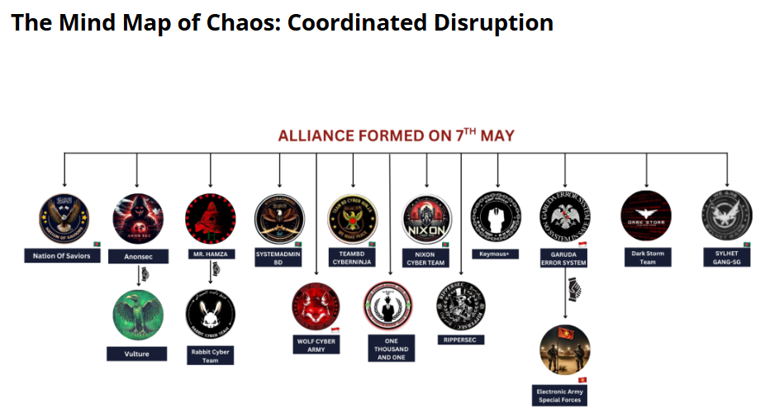

The Pre-Operation Cyber Landscape
- 2.1. Baseline Hacktivist Activity in Early 2025: Establishes the normal state of cyber tension. Before Operation Sindoor, India was already a frequent target, recording 256 claimed DDoS attacks by 26 distinct groups in 2025 (Jan-April). The dominant threat groups like RipperSec and AnonSec were consistently targeting government and education sectors.
- 2.2. Threat Actor Prepositioning: Highlights the strategic shift before the strikes. The Pakistan-linked APT-36 (Transparent Tribe) intensified its campaign, deploying the Crimson Remote Access Trojan (RAT) through spear-phishing emails and fake documents themed around the Pahalgam attack to compromise Indian defence and government officials—a clear example of parallel cyber espionage preceding open conflict.
- 2.3. India’s Cyber Security Posture: Reviews the readiness of Indian cyber defenses, noting the issuance of high-alert advisories by CERT-In and the relatively robust cloud-based and scrubbing center defenses employed by Critical Information Infrastructure (CII) entities like the Power Grid and major financial institutions, which were crucial in mitigating the subsequent wave of attacks.

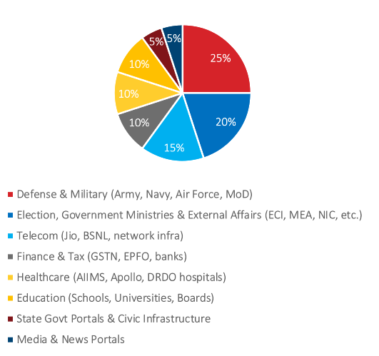

Anatomy of the Post-Sindoor DDoS Campaign
This chapter provides a technical breakdown of the attacks, quantifying the severity and detailing the sophisticated tactics employed by the threat actors.

3.1. Attack Timeline and Intensity
The response was instantaneous and reached peak intensity within hours of the kinetic strikes.
Date/Time (IST) | Event | Activity Profile
May 7, 01:05 – 01:30 | Operation Sindoor: Missile Strikes | Kinetic Trigger
May 7, 08:00 – 12:00 | Initial Hacktivist Response | Website defacements and minor DDoS claims. Groups like AnonSec and Sylhet Gang issue threats.
May 7, 21:30 (9:30 PM) | DDoS Peak Tsunami | Up to seven claimed attacks per hour worldwide. The most aggressive surge of the year.
May 8 – May 10 | Sustained High Activity | Over 40 groups involved in coordinated DDoS and data leak claims.
May 11 onwards | Normalization of Claims | Activity begins to taper, focusing on defacements and disinformation.
The peak on May 7th was characterized by massive volumetric saturation, quickly followed by a sustained application-layer campaign designed to prolong disruption even after the initial flood was scrubbed.

3.2. Targeted Sectors and Organizations
The targeting was primarily symbolic and disruptive, focused on maximum public visibility rather than core infrastructure damage.
- Government & Public Services (Over 75% of Attacks):
  - Targets: High-visibility portals like the Prime Minister’s Office (PMO), Ministry of External Affairs, National Informatics Centre (NIC), and various state e-governance platforms.
  - Goal: To embarrass the government, undermine administrative continuity, and generate media headlines claiming a 'national cyber failure'.
- Financial Sector (8.5%):
  - Targets: Stock Exchanges (NSE/BSE), major public sector banks (IOB, Bank of Baroda), and payment gateways.
  - Mitigation: Major financial entities swiftly enforced precautionary blocks (e.g., restricting foreign access), ensuring market stability.
- Telecommunications (6.4%) and Education:
  - Targets: BSNL portals, National Testing Agency (NTA), and university websites.
  - Goal: To target public utility services and disrupt critical examination periods, maximizing public inconvenience.

3.3. Tactics, Techniques, and Procedures (TTPs)
The campaign was defined by the sophisticated use of Hybrid DDoS tactics:
- Volumetric Attacks (Layer 3/4):
  - Method: Reflection and Amplification attacks (DNS, NTP, CLDAP) were used to flood target networks with massive, high-bandwidth traffic. These attacks were characterized by high bits-per-second (Bps) rates, designed to overwhelm scrubbing centres and network links.
  - Tooling: Utilized rented Internet of Things (IoT) botnets and publicly available attack scripts.
- Application-Layer Attacks (Layer 7):
  - Method: These are the most difficult to mitigate. Hacktivists used encrypted HTTPS Floods and HTTP POST/GET Floods (like the RUDY attack) that mimic legitimate user behavior. By consuming application resources (CPU, memory, database connections), these low-volume, high-Request-Per-Second (RPS) attacks cause service degradation or crash the application server without triggering volumetric network alarms.
  - Tooling: The widely shared MegaMedusa (a Node.js-based DDoS tool) used by RipperSec, and other commercial/open-source DDoS platforms. The availability of such user-friendly tools allowed a massive, low-skilled volunteer force to participate in the attack.
- Obfuscation:
  - Analysis confirmed that a significant volume of attacks was routed through proxy infrastructure in Bangladesh, Indonesia, and Morocco, among others. This strategy was designed to obfuscate the primary origin in Pakistan, complicating immediate attribution and making counter-measures based on simple geo-blocking ineffective.

Key Threat Actor Analysis and Coordination
- 4.1. Primary Hacktivist Groups and Claims: The campaign was a coalition effort involving over 40 groups. RipperSec was the most prolific (30%+ of claims), followed by AnonSec, Keymous+, Sylhet Gang, and Mr Hamza. Many of these groups operate from Bangladesh and other Southeast Asian regions. The report verifies that many claims (e.g., alleged leaks of 247GB from NIC) were frequently exaggerated or involved repackaged, publicly available data, confirming the psychological warfare element.
- 4.2. Ideological and Geographic Alignment: A critical finding is the unprecedented level of coordination among groups with varied ideological leanings (e.g., pro-Palestine, religious fundamentalist, political nationalist). The conflict served as a unifying banner, forging a temporary "Cyber Alliance" against India, demonstrated by the inclusion of the Iranian group Vulture and the increased activity of groups from Indonesia and Morocco.
- 4.3. Disinformation and Narrative Warfare: The cyberattacks were inextricably linked to massive Disinformation Campaigns (e.g., Operation Bunyan Marsoos). Social media handles associated with groups like P@kistanCyberForce and CyberLegendX amplified false claims of power grid failures, satellite jamming, and military breaches. This created a strategic "fog of war" in the digital domain, attempting to delegitimize Operation Sindoor and spread domestic panic. The Indian government responded by successfully requesting platforms like X (formerly Twitter) to withhold over 8,000 such accounts.

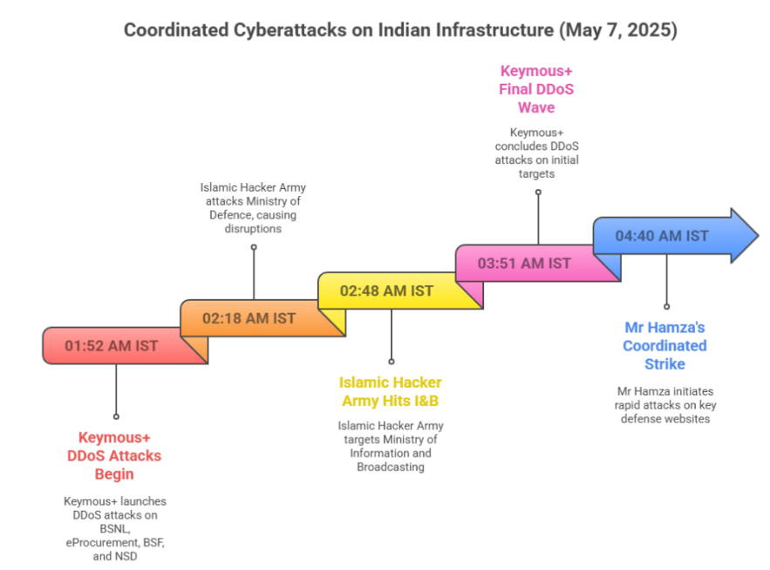

Impact Assessment and Lessons Learned
This chapter moves beyond the TTPs to assess the actual damage inflicted and the effectiveness of India's response, identifying both successes and critical vulnerabilities.

5.1. Operational and Service Disruption Impact
The quantitative impact of the DDoS campaign was low in terms of systemic damage but high in terms of public perception.
- Quantitative Success Rate: The "Road of Sindoor" report by Maharashtra Cyber confirmed over 1.5 million cyber incidents (DDoS, malware, defacements) were launched against Indian infrastructure. Of these, only 150 resulted in a successful breach or verifiable defacement/outage. This translates to an abysmal success rate of less than $0.01\%$.
- Sustained Downtime: Downtime was largely confined to less-hardened, non-critical government and state-level public portals, which lacked the multi-layered scrubbing solutions used by CII. Verifiable, sustained outages on major national critical infrastructure were prevented.
- Qualitative Impact: Despite the low technical success, the reputational damage and public anxiety were significant. The sensationalized headlines generated by the amplified claims achieved the hacktivists' secondary objective of undermining public confidence and creating a psychological strain on security agencies.

5.2. Cyber Defence Effectiveness and Challenges
The response was a mixed success, revealing critical dependencies and institutional gaps.

✅ Successes:
- CII Resilience: Entities utilizing large, centralized DDoS scrubbing services (cloud-based or domestic), such as major financial exchanges and telecom backbone providers, demonstrated immediate and effective automated mitigation against the high-volume volumetric attacks.
- Rapid Inter-Agency Response: The coordinated advisories from CERT-In and the rapid mobilization of state cyber forces (like Maharashtra Cyber) to debunk false claims and isolate affected non-critical systems were highly effective in containing the spread of disruption and panic.
- Strategic Blocks: Precautionary measures, such as temporarily restricting foreign access to sensitive platforms (e.g., payment systems, financial portals), proved invaluable in the peak hours.

❌ Challenges and Vulnerabilities:
- Application-Layer Blind Spot: Existing perimeter defenses struggled to accurately differentiate sophisticated, encrypted Layer 7 (HTTPS) attacks from legitimate, heavy user traffic. This meant many L7 floods had a longer dwell time before effective behavioral-based mitigations kicked in, leading to temporary service degradation.
- Legacy System Exposure: Numerous legacy IT systems and state/municipal portals were not integrated into centralized national security architectures, making them soft targets for easy defacement and disruption.
- Foreign Dependency: The reliance on predominantly foreign-based DDoS mitigation and Content Delivery Network (CDN) providers remains a strategic vulnerability, raising concerns about data sovereignty and swift, customized response capabilities during a geopolitical conflict.

5.3. Cyber-Kinetic Linkage
Operation Sindoor cemented the reality of integrated multi-domain conflict. The cyber theatre was not a separate event, but a simultaneous projection of force and a tool for digital signaling. The DDoS attacks and the parallel APT espionage campaigns demonstrated that disruption and intelligence gathering are executed concurrently with—and in immediate response to—physical military actions.

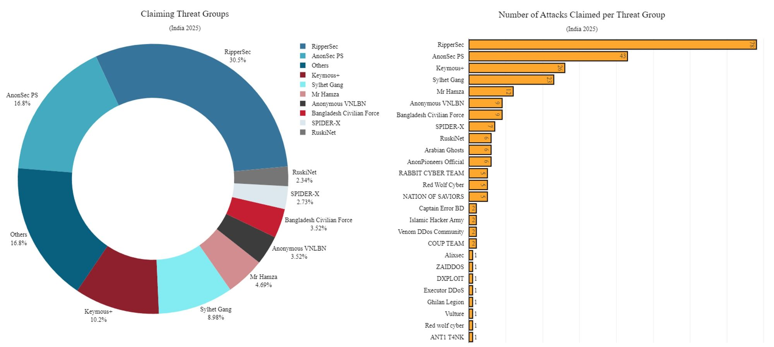

Recommendations and Future Outlook
- 6.1. Strategic Cybersecurity Imperatives: Recommends a national mandate for implementing a Zero-Trust Architecture (ZTA) across all government and CII entities. This shifts focus from perimeter defense to internal micro-segmentation, limiting the lateral movement potential of any successful breach (including APT intrusions). It also stresses the need for Unified Cyber Command, integrating the intelligence, analysis, and response capabilities of CERT-In, NCIIPC, and the Defence Cyber Agency.
- 6.2. Technical and Operational Recommendations:
  - AI-Enabled Mitigation: Immediate investment in Artificial Intelligence and Machine Learning (AI/ML)-based solutions for Layer 7 traffic analysis, capable of distinguishing subtle bot behavior from human traffic in real-time.
  - Indigenous Solutions: Strategic prioritization and funding for indigenous development of DDoS scrubbing centers and secure hosting solutions to enhance digital sovereignty and tailor defenses to regional threat vectors.
  - Attack Surface Reduction: Mandatory, continuous vulnerability assessments and a 'patch-or-perish' policy for all public-facing services, moving all legacy and un-hardened systems offline or behind centralized WAF/DDoS protection.
- 6.3. Legislative and Capacity Building: Urges the modernization of IT security laws to specifically address hacktivist alliances, data breach amplification, and disinformation campaigns. Simultaneously, a national program for cybersecurity skill augmentation is required to staff the complex ZTA and AI-driven defense systems across the public sector.
- 6.4. Conclusion: Vigilance as the New Normal: Operation Sindoor was a low-cost, high-impact lesson. The future of conflict is now permanently hybrid. India’s success in maintaining operational integrity was not due to luck, but to existing layered defenses. However, the next wave of attacks will be more destructive. Continuous, proactive investment in sophisticated defense and threat intelligence is the only guarantee of national digital security.

Appendices and References
- Appendix A: Detailed List of Confirmed DDoS Targets and Groups (May 7-10, 2025)
- Appendix B: Technical Analysis of the MegaMedusa DDoS Tool and Crimson RAT Malware
- Bibliography: List of Public Reports, Advisories, and Threat Intelligence Sources.

