TEAM HEART

INDIAN EMERGENCY NOTIFY SYSTEM

SIH2020

Design our project/application:

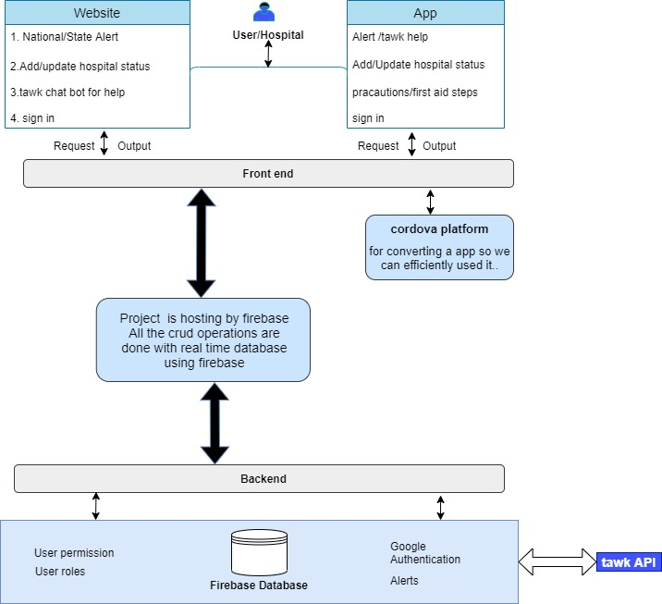

We are using module view controller architecture.

Technologies we are using in our project/application

1. We are using Google **Firebase No Squeal Database** to store system data just like big JSON object ,Also to add information to **Users’s Node** to make our system **more interactive**.
2. Our system use **Spa based** on **angular JS Framework** to enhance more user connectivity with (IENS) app

1. To build an app in efficient way we using **apache cordova.**
2. In future scope we plan to manage and **connect large Database of Real time**
3. **Weather forecast** information from satellites ,radar and other Weather Monitoring technologies , **IENS** works with several Disaster management API to monitor uncertain situation and with Government to get information about man made disasters .

Platforms we are using in our project/application:

1.Website:For frontend we are using **angular js** which is structural framework for **dynamic web** apps.

2.Server/Database:we use **Firebase** here. It is a mobile database and we can easily access.

3.Application: for app we use **cordva** to develop an app in efficient way.