**NAME :- ANIKET SANJAYKUMAR BIYANI**

**DATA ENGINEERING BATCH -1**

**PYSPARK DAY-16 ASSIGNMENT**

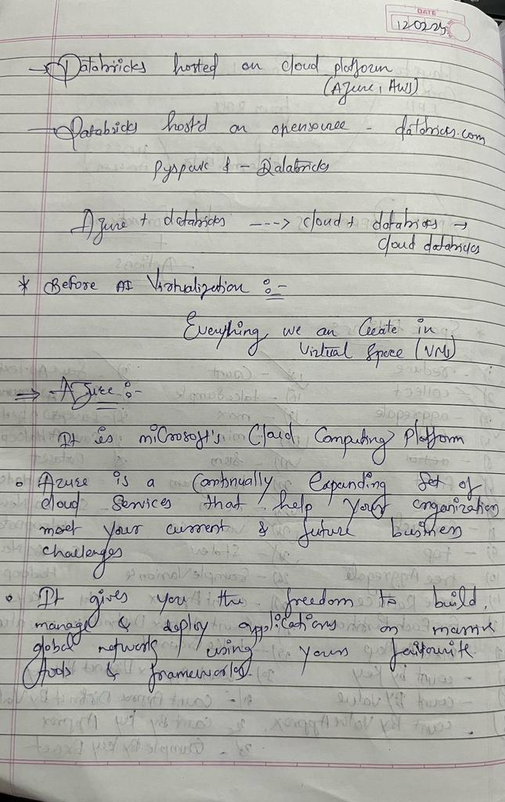

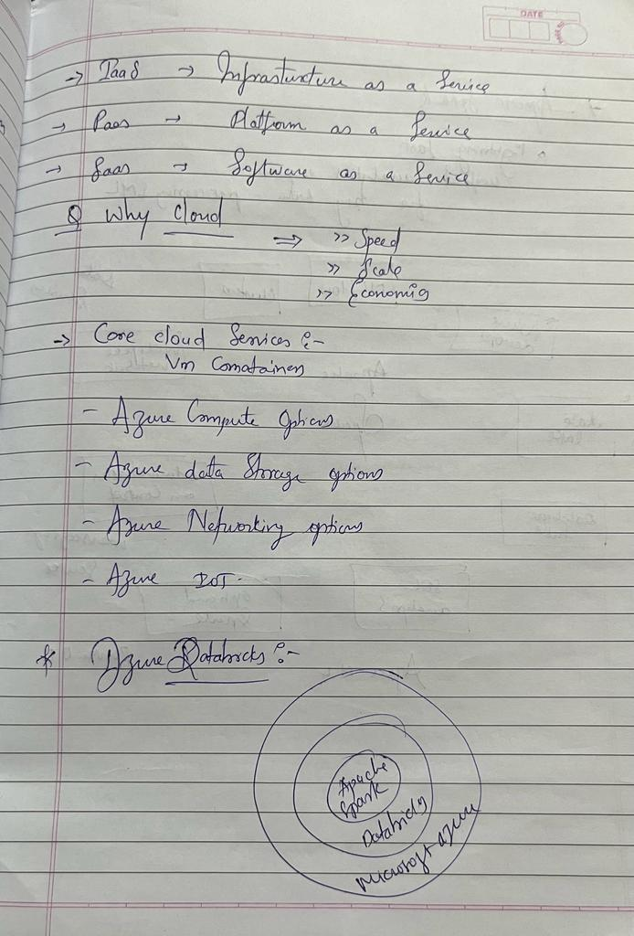

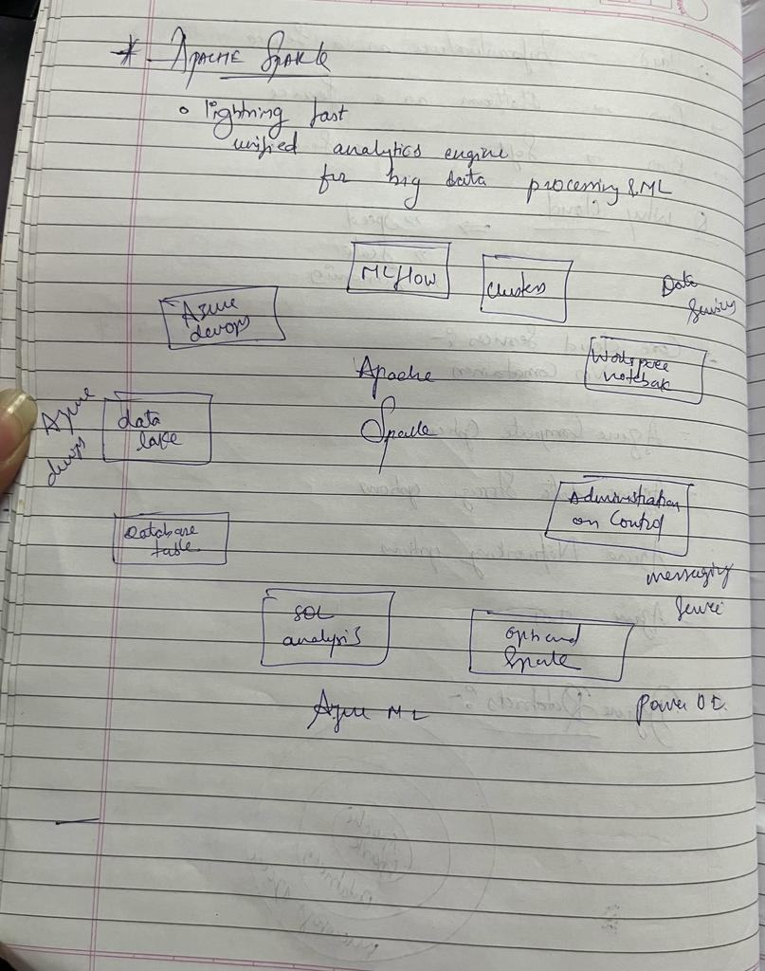

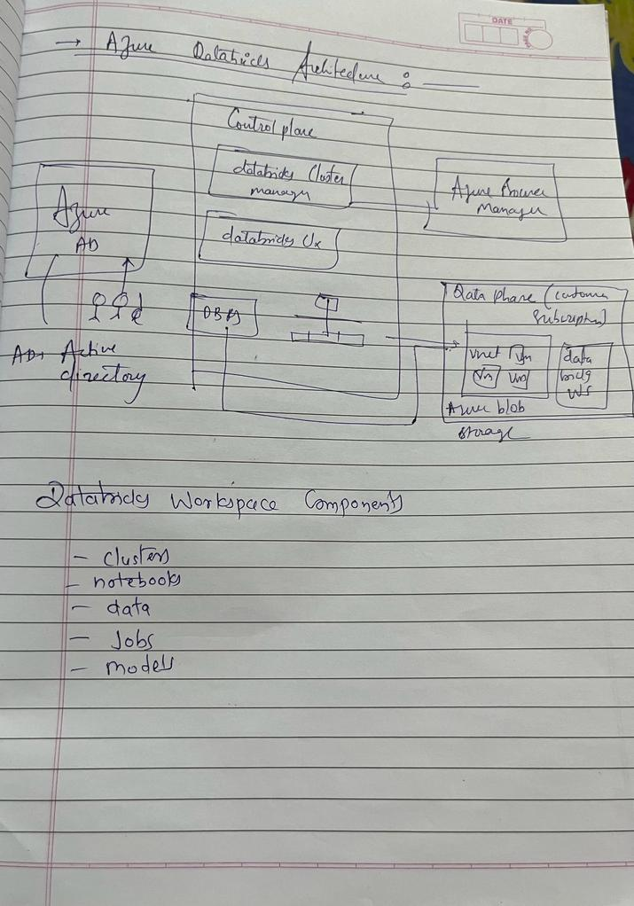

**Setting up Azure Lab :**

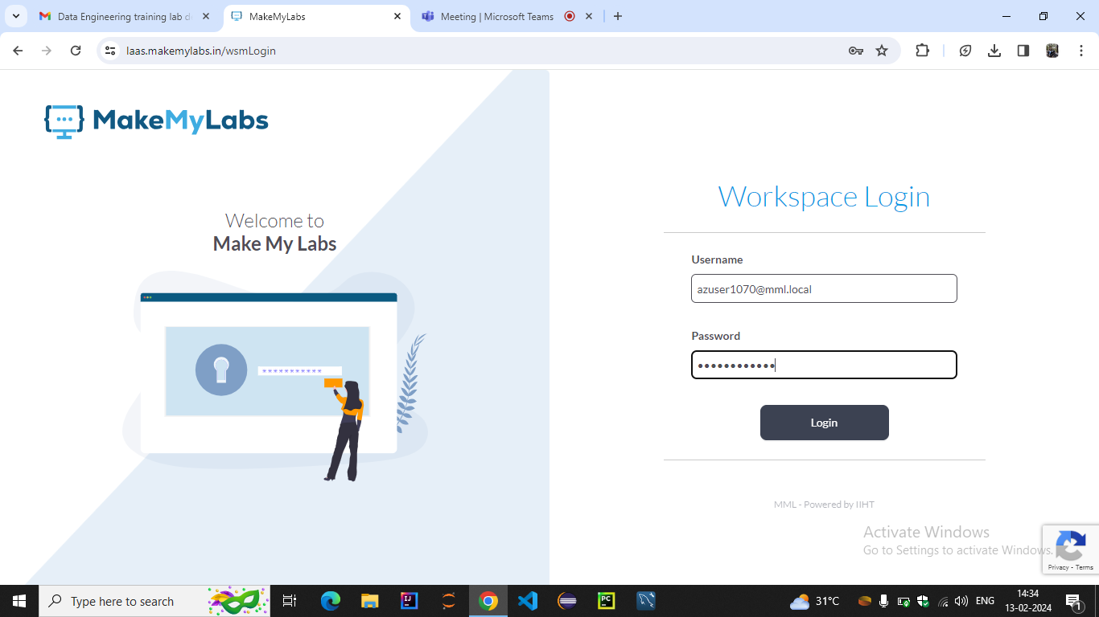

**Homepage preview where we need to add mail address and password to login.**

**Workspace Dashboard :**

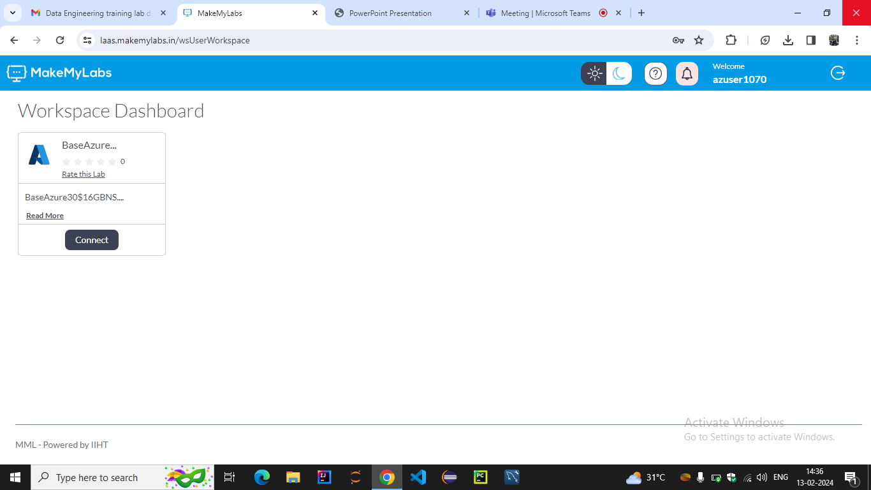

**Once login you will be redirected to this page, Click on the connect option**

**Lab creation page :**

**This is the lab dashboard where all the lab details are available. Click on generate link.**

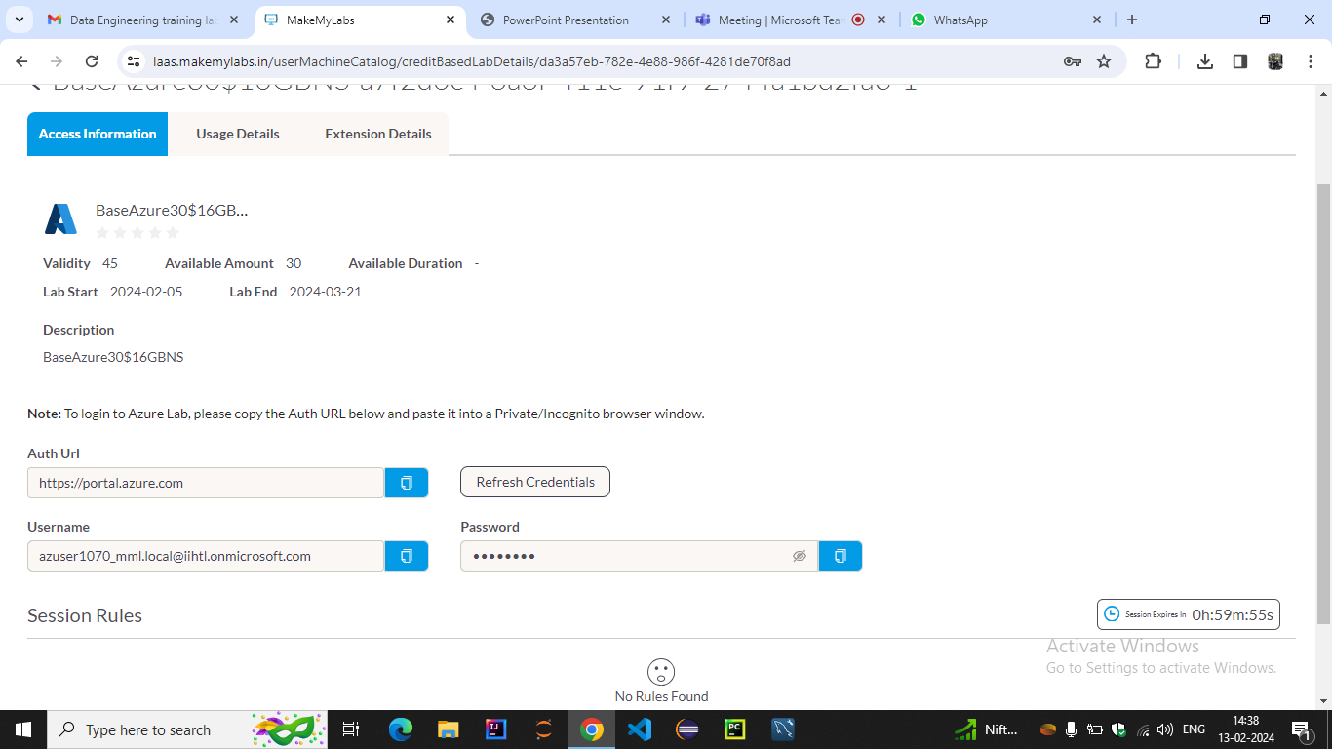

**Once you click on Generate Link the login details will be shown like above**

**After clicking on connect we get this page where Authentication URL mail id and temporary password is provided .**

**If we log in to the session it will be only valid for 60 mins after that we need to generate a new password and login again**

**MICROSOFT LOGIN PAGE**

**Copy the details from previous page then open a new tab and login to Azure Portal.**

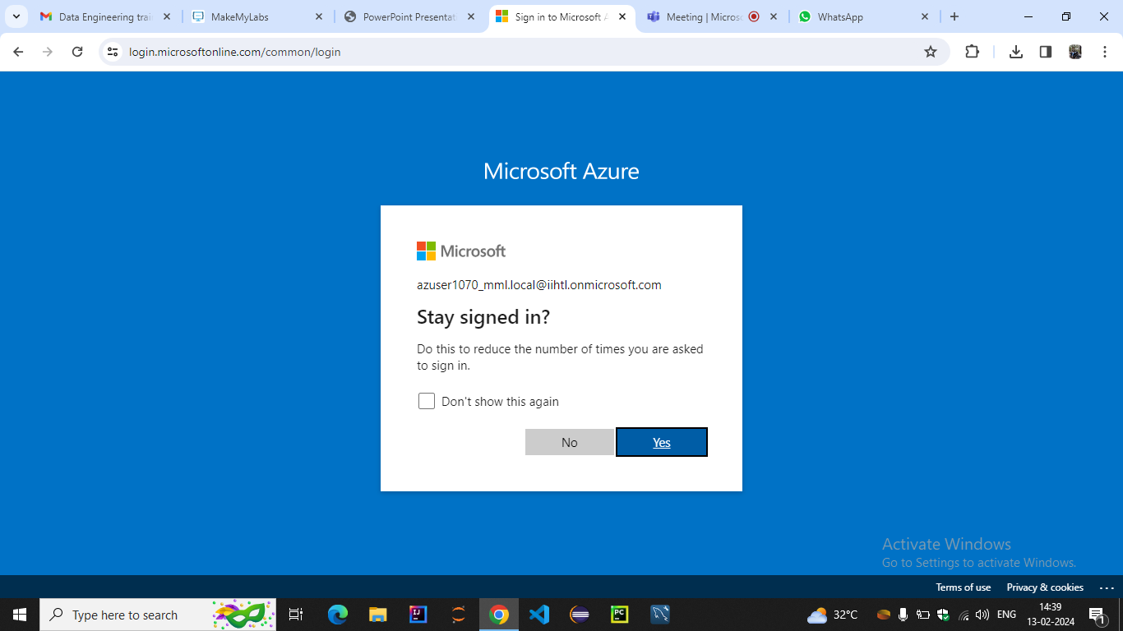

**Creating Workspace for Azure Databricks :**

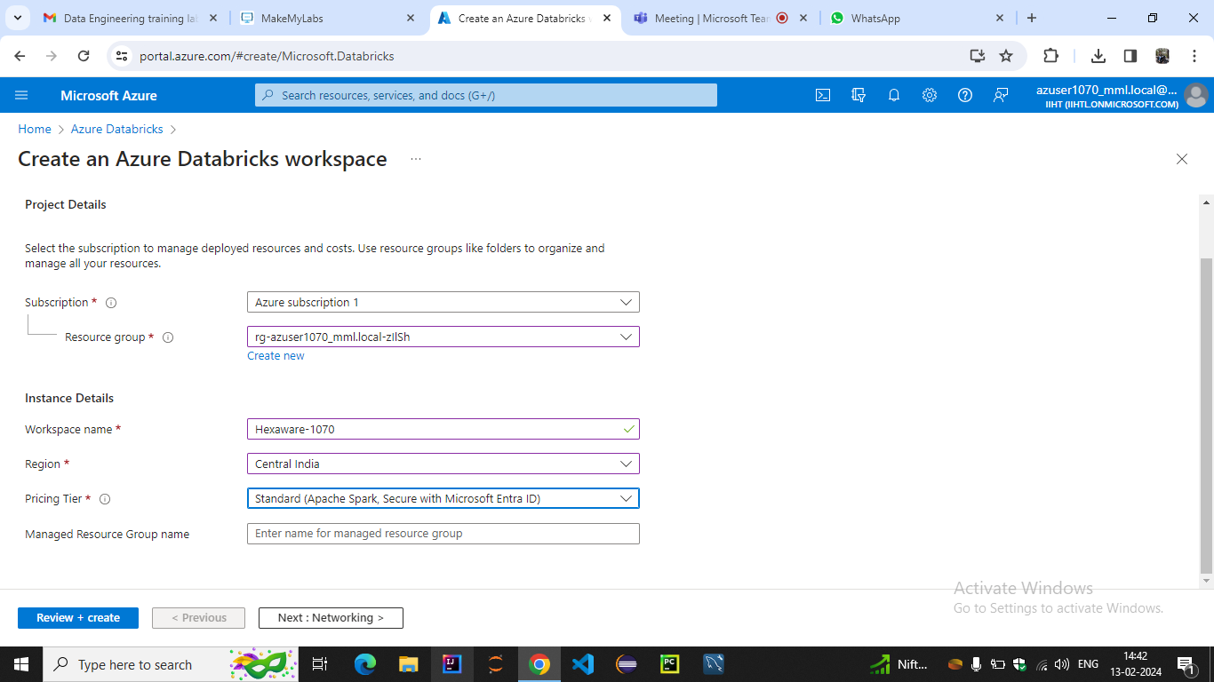

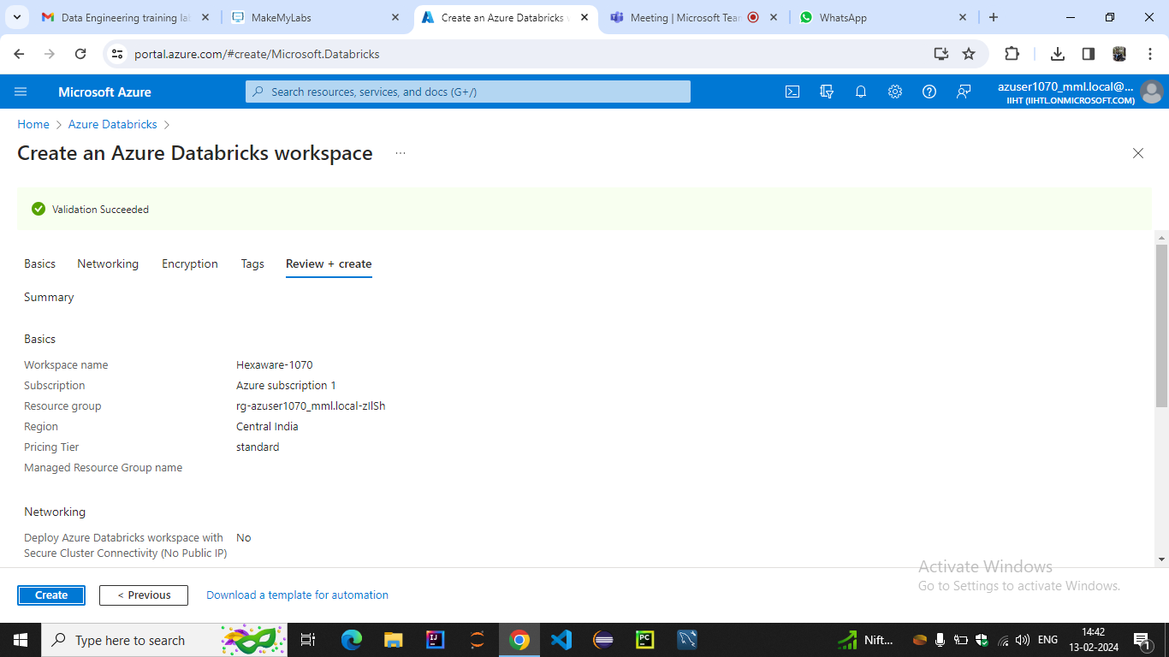

**Above image shows the workspace that we created for using Azure Data Bricks as we click on Launch Workspace the following databricks UI will be opened in a new tab**

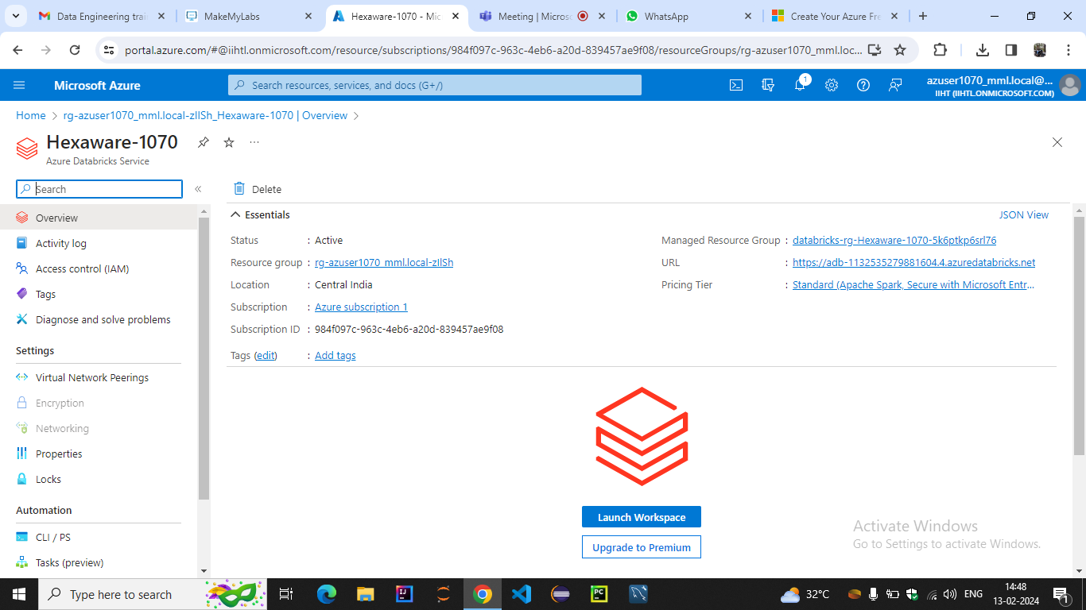

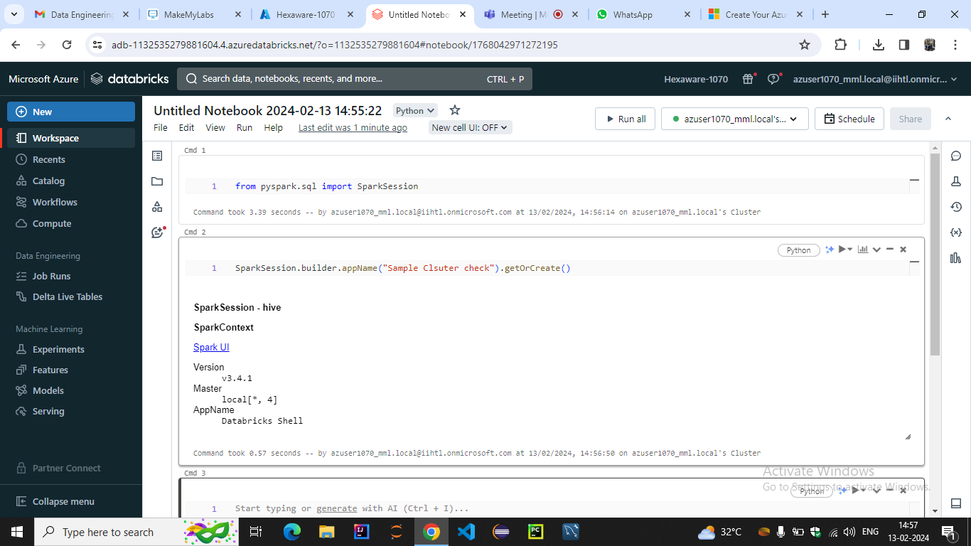

**Once you are done with the lab, Sign-out from the Azure portal**

**Click on the Arrow mark ( Shown above) to logout from the Lab portal**