**NAME :- ANIKET SANJAYKUMAR BIYANI**

**DATA ENGINEERING BATCH -1**

**AZURE DAY2- ASSIGNMENT**

**Visualizations in Databricks notebooks**

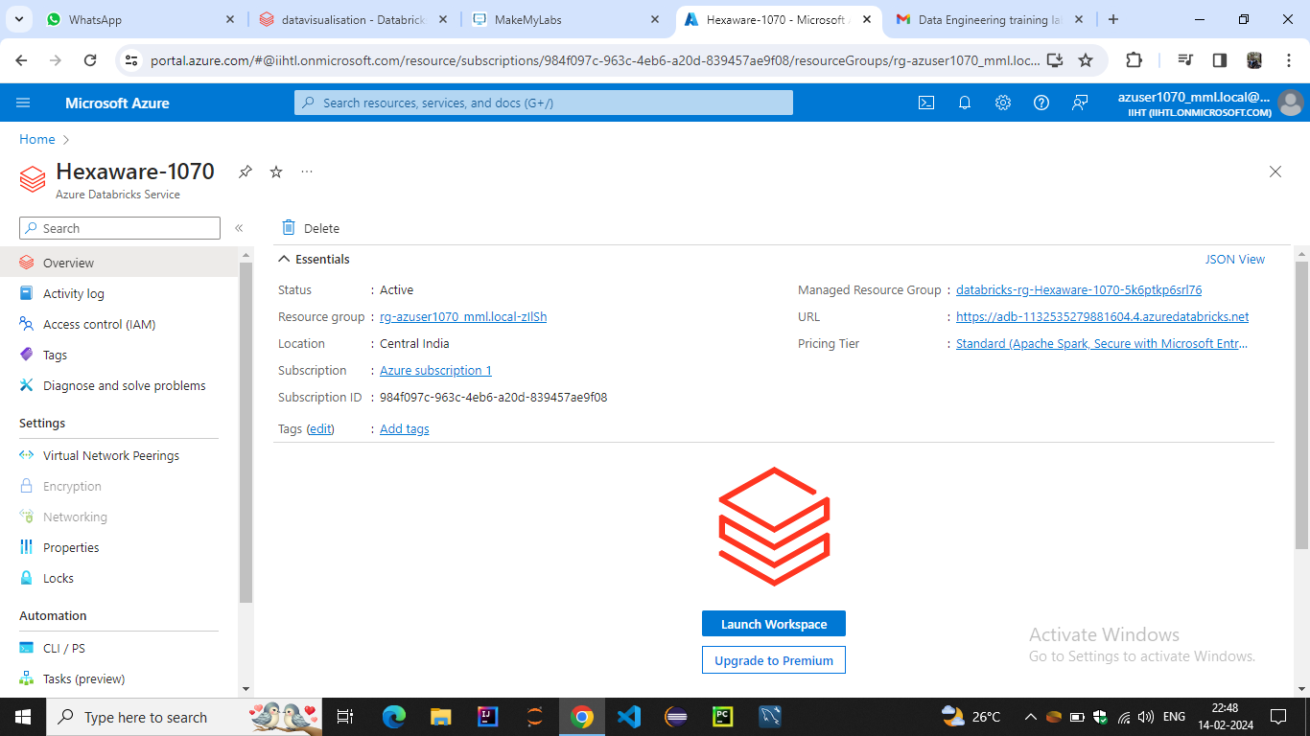

## LAUNCH WORKSPACE

## Create a new visualization

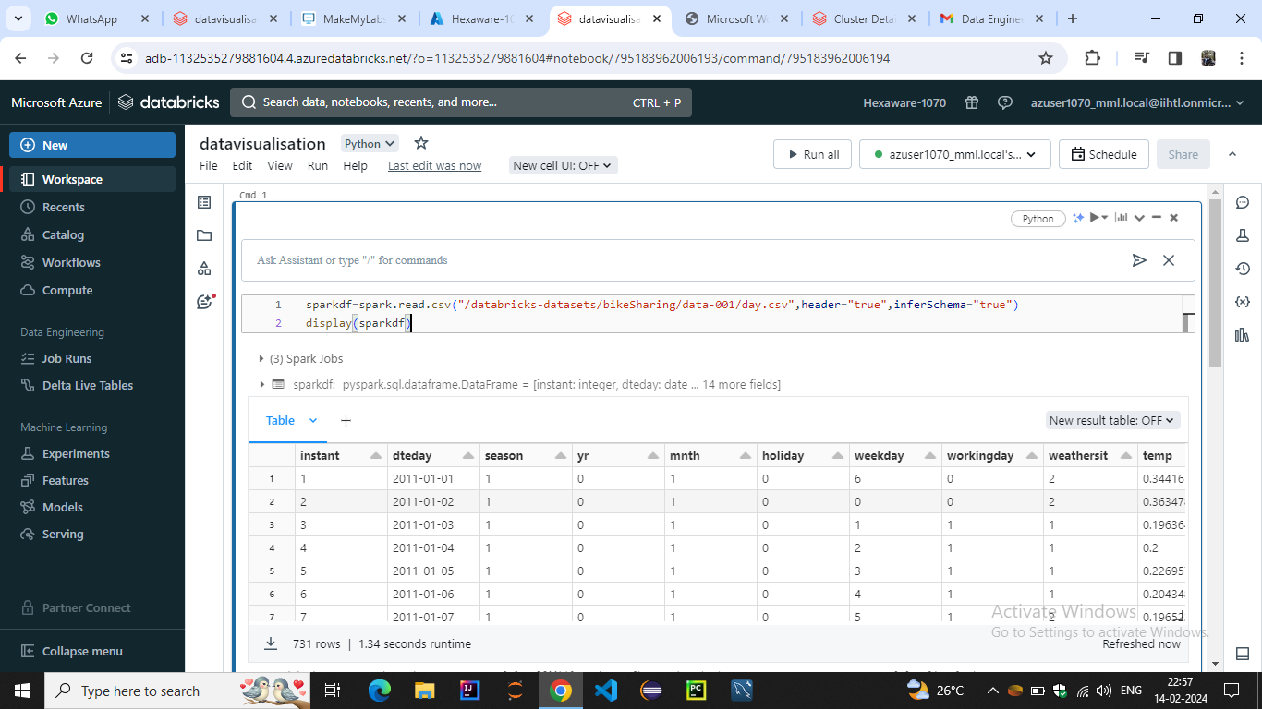

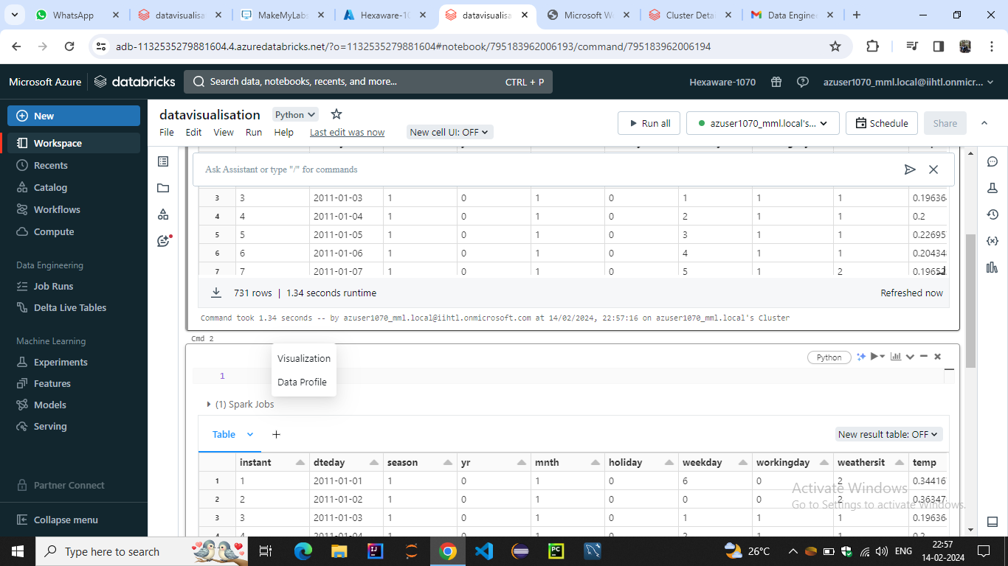

In the **Visualization Type** drop-down, choose a type.

1. Select the data to appear in the visualization. The fields available depend on the selected type.
2. Click **Save**

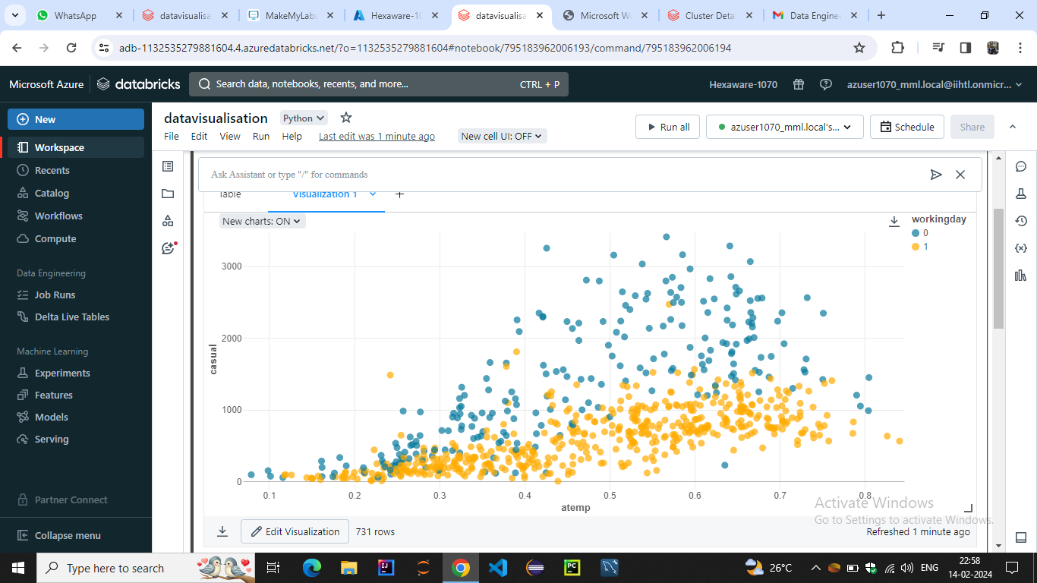

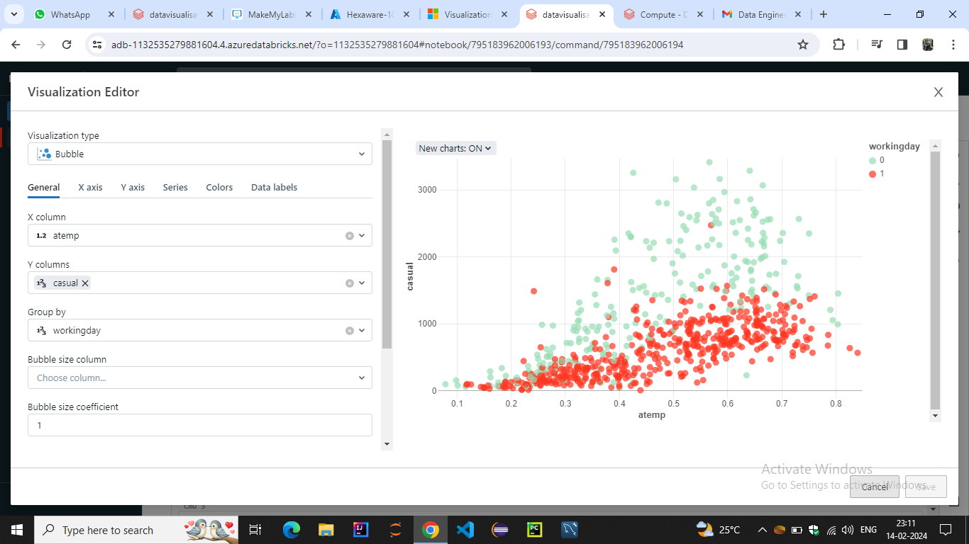

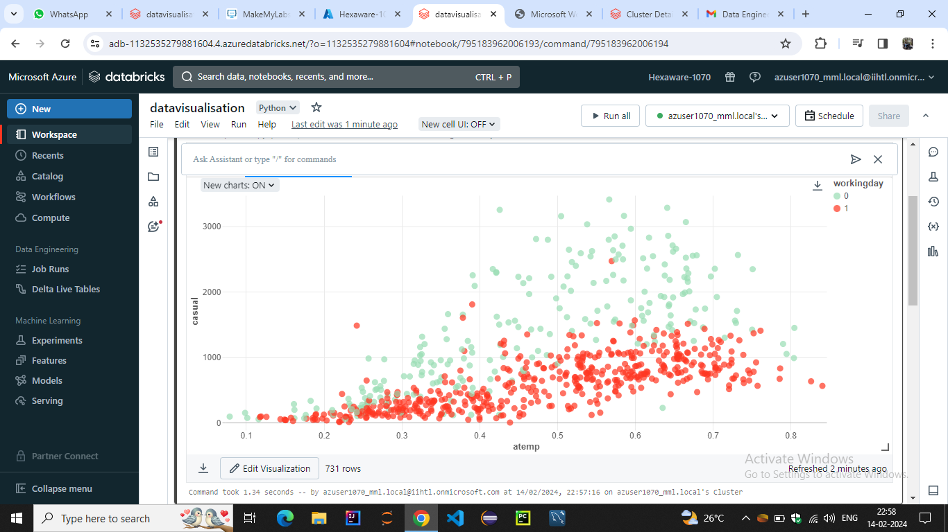

## Create a new data profile

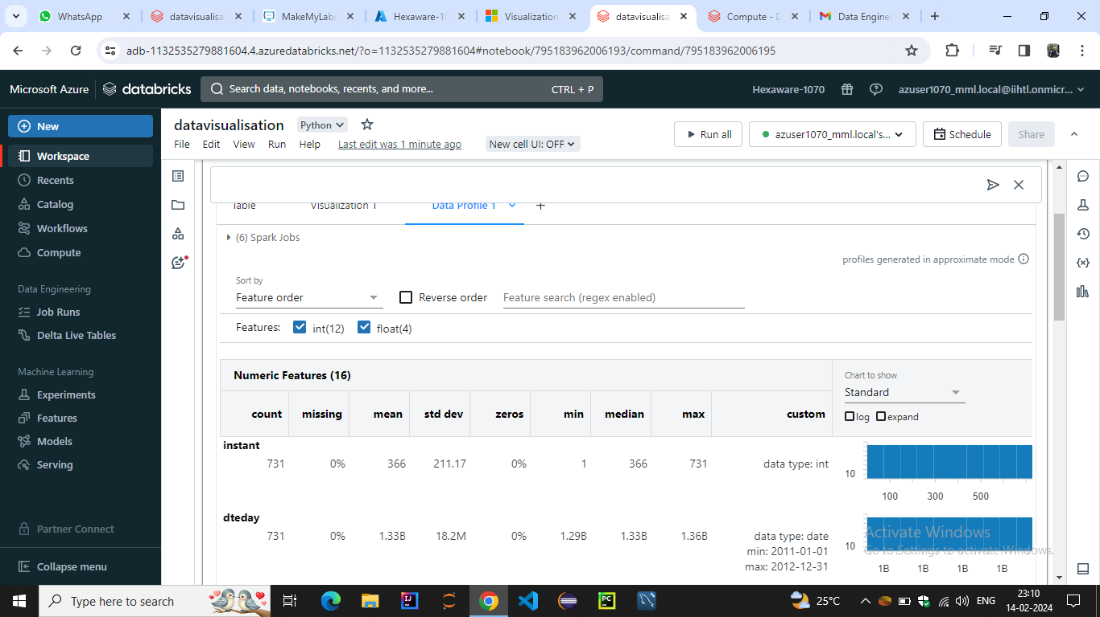

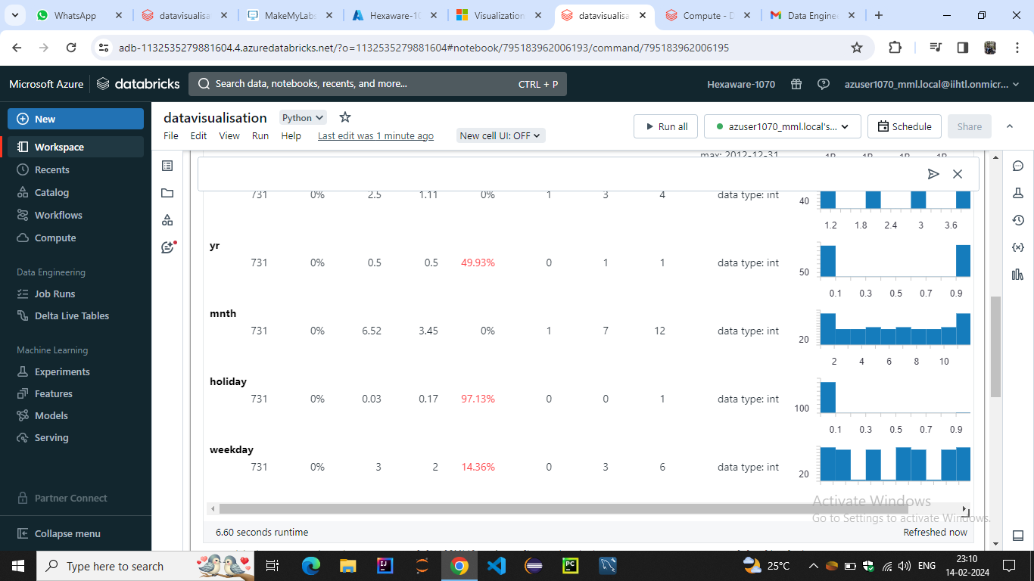

### Rename, duplicate, or remove a visualization or data profile

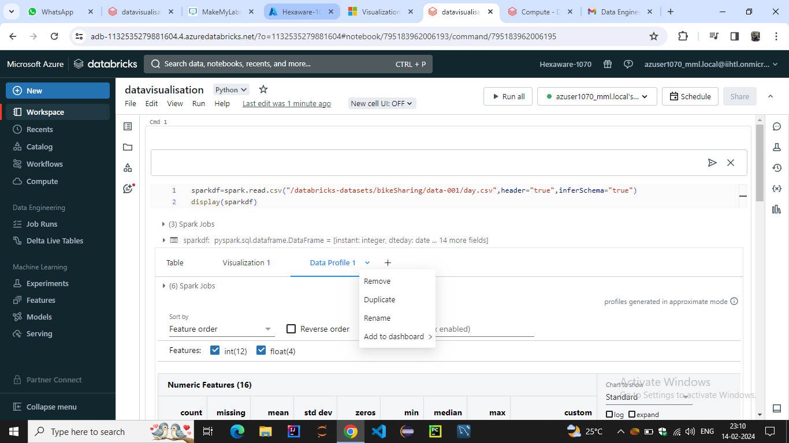

### Download a visualization

To download a visualization in .png format, click the camera icon camera iconin the notebook cell or in the visualization editor.