**NAME :- ANIKET SANJAYKUMAR BIYANI**

**DATA ENGINEERING BATCH -1**

**AZURE DEVOPS DAY 2- ASSIGNMENT 23-02-2024**

**Hands-on Exercise: Creating a DevOps repository**

**Git strategies for data engineering projects**

* **Navigate to Repositories**: Once your project is created, navigate to the "Repos" tab from the project dashboard. This is where you'll manage your Git repositories.
* **Create a New Repository**: Click on the "New repository" button to create a new Git repository for your project. Give your repository a meaningful name and, if needed, provide a description.
* **Initialize the Repository**: Decide whether you want to initialize the repository with a README file or not. If you're starting from scratch, initializing with a README can be helpful for providing initial documentation.

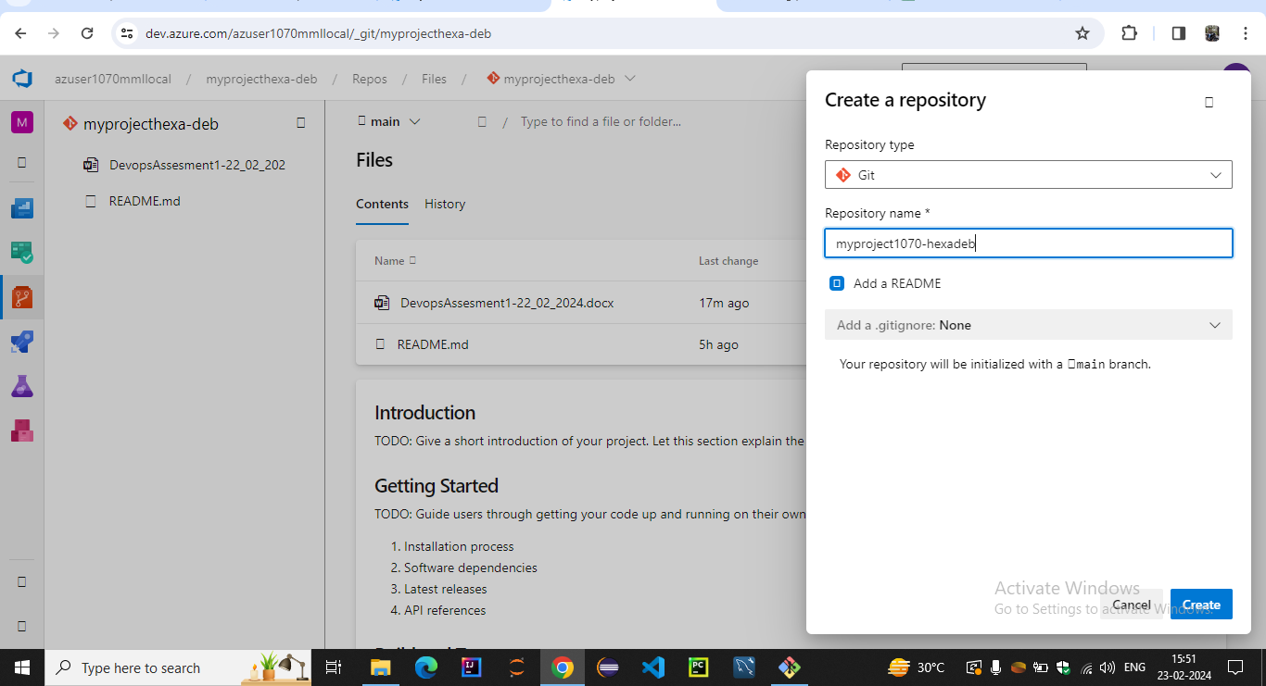

**Set Up Git**: If you haven't already configured Git on your local machine, make sure to set it up with your name and email address.

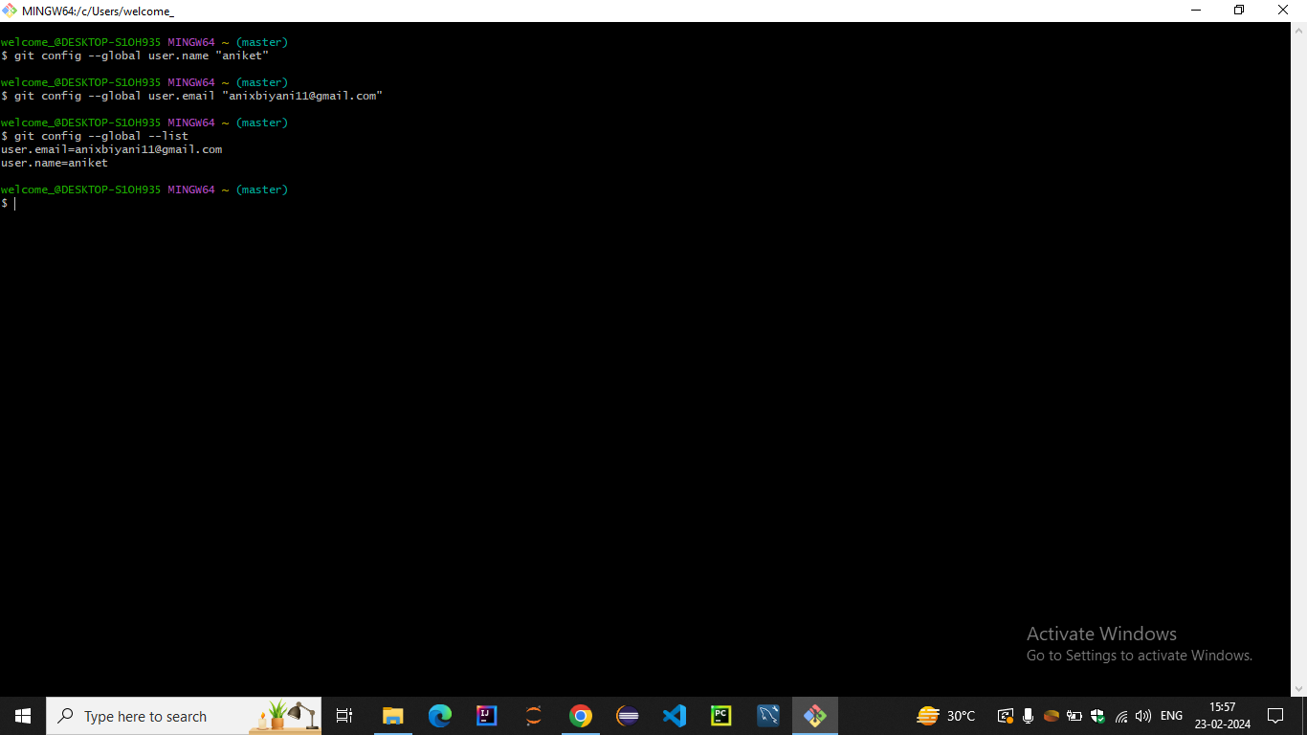

**Clone the Repository**: After creating the repository, clone it to your local machine using Git. You can find the repository URL on the repository's overview page

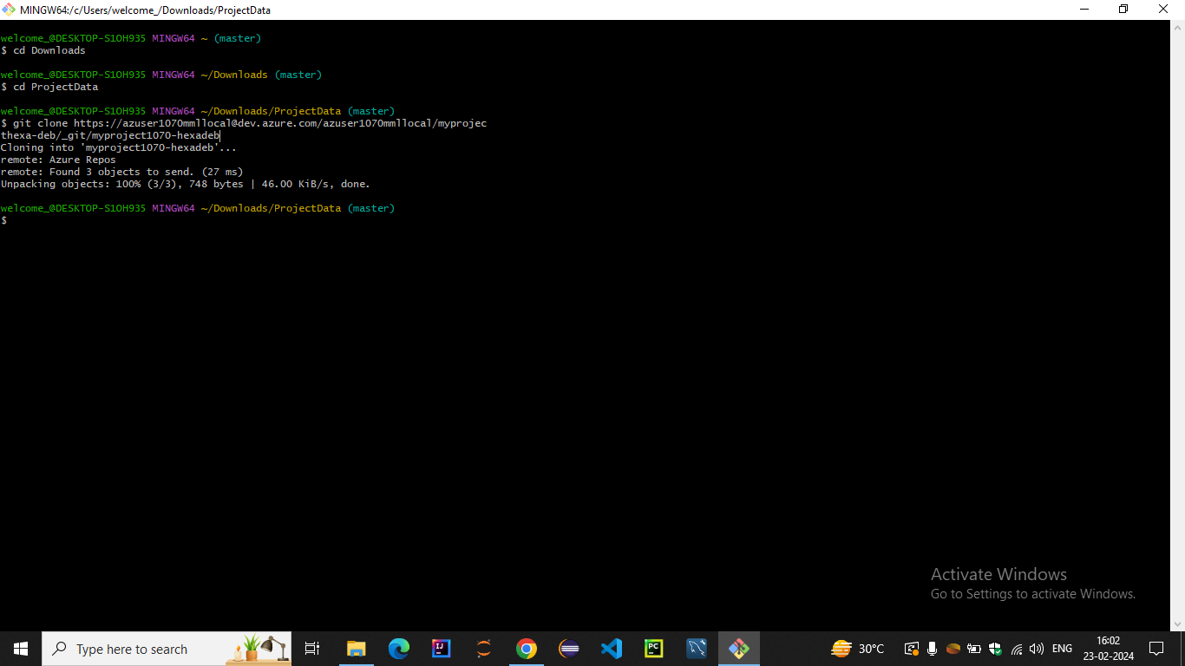

**After cloning in the specified directory the project folder will be created**

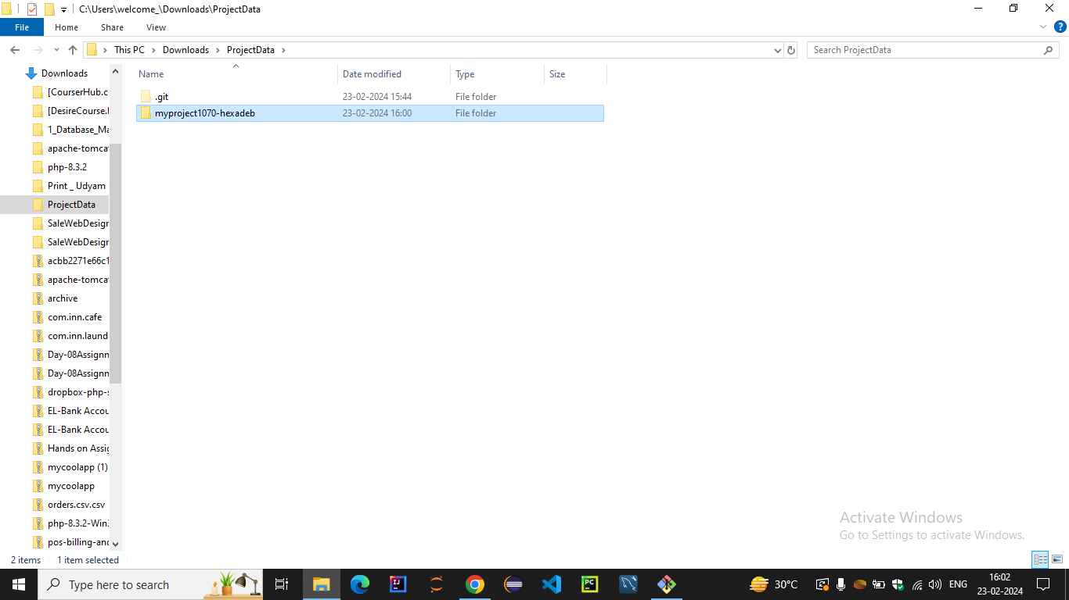

**Add Your Project Files**: Add your data engineering project files to the local repository directory on your machine.

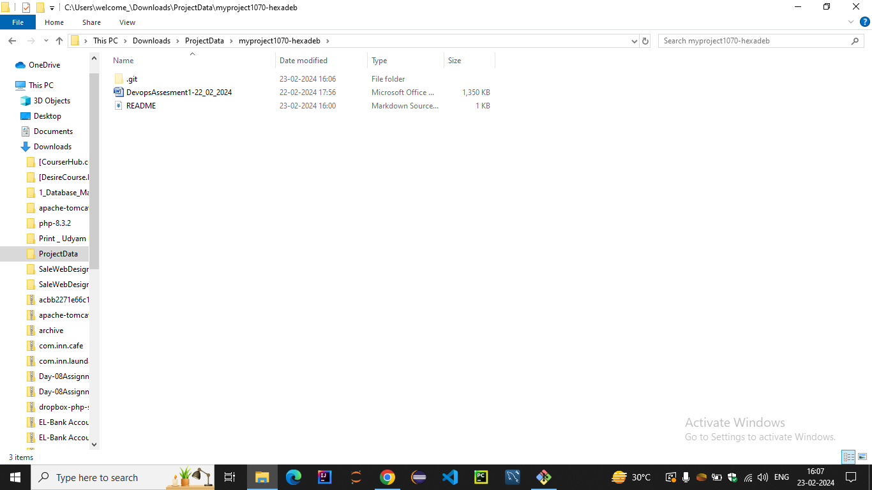

**Commit Your Changes**: Use Git commands (e.g., **git add .** to stage changes and **git commit -m "Initial commit"** to commit them) to commit your project files to the local repository.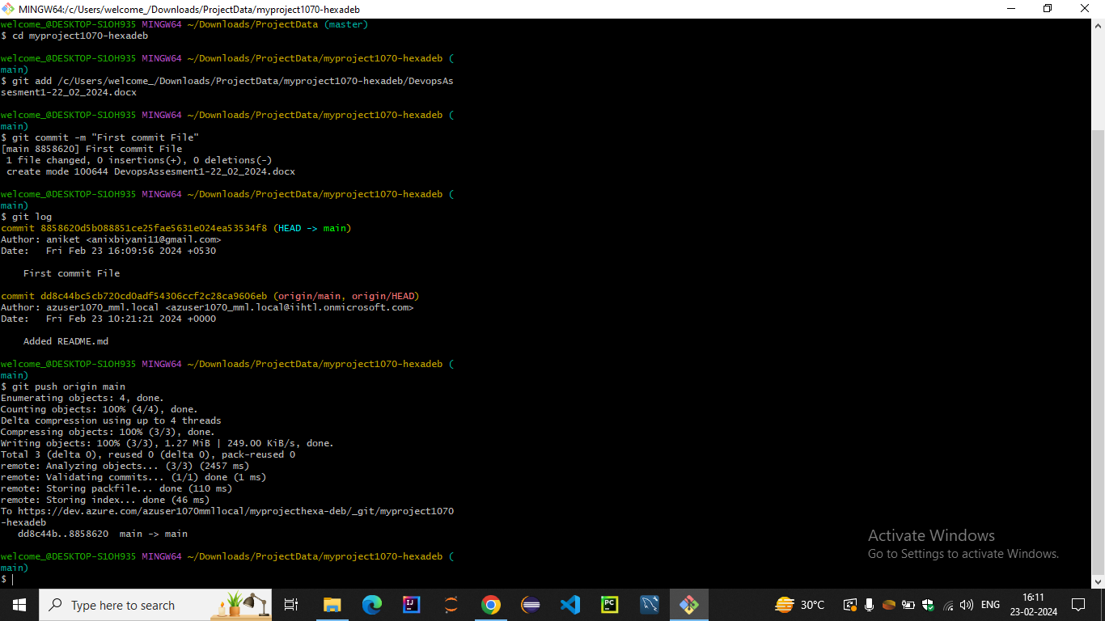

**Push Changes to Azure DevOps**: Once you've committed your changes locally, push them to the Azure DevOps repository using **git push**.

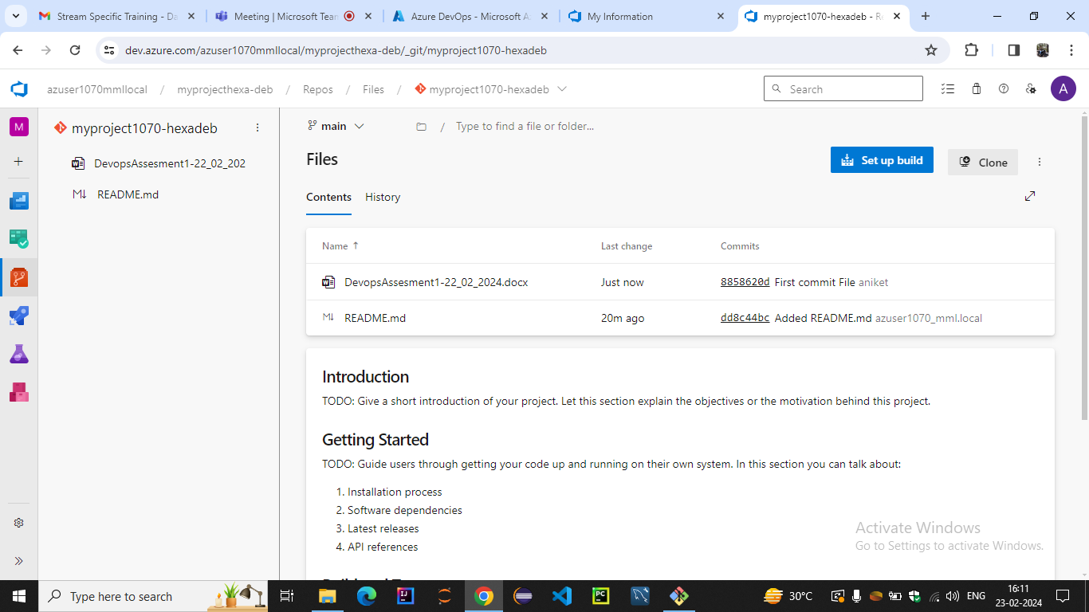

OTHER GIT COMMANDS

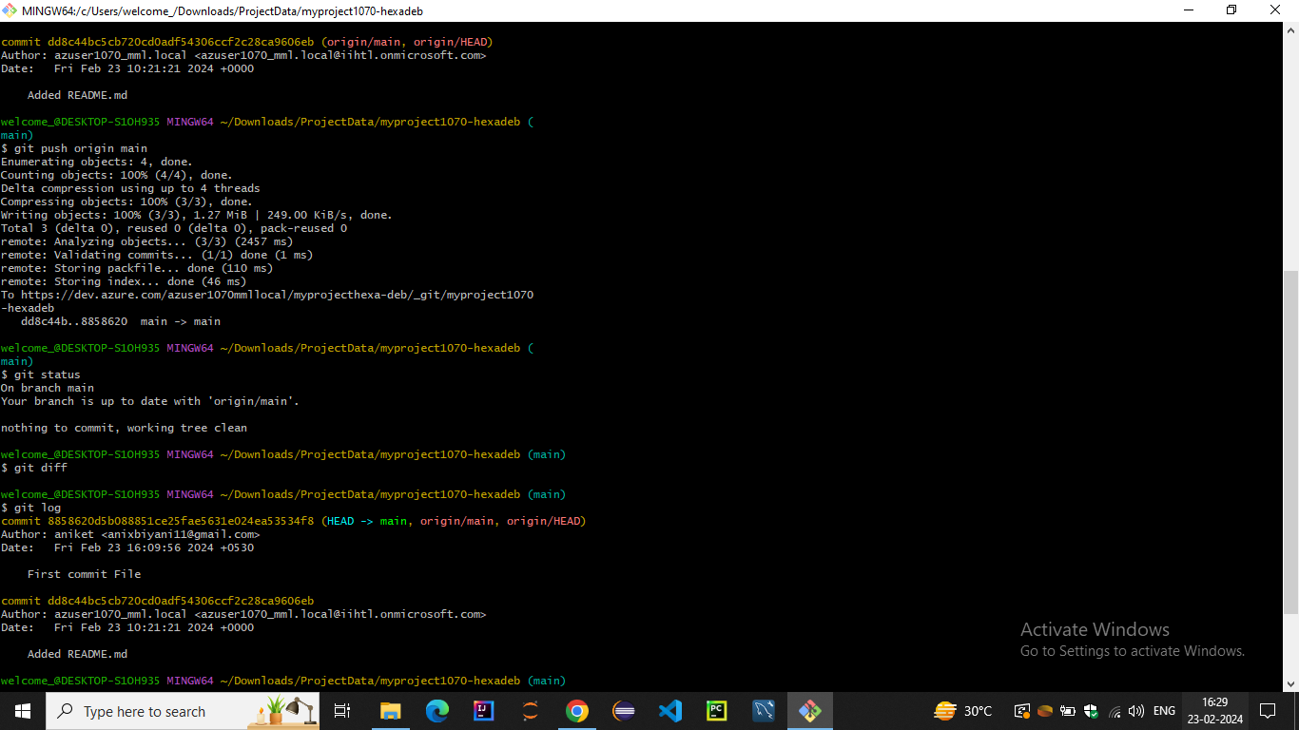

UPLOADING FILES IN DEVOPS AND PULL REQUEST INTO LOCAL

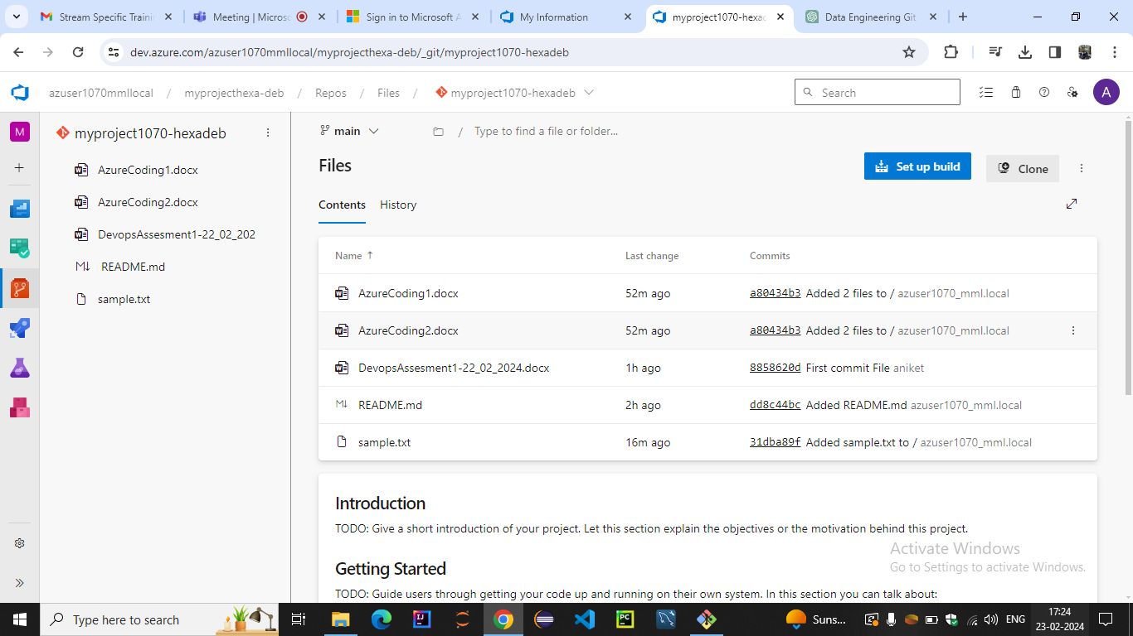

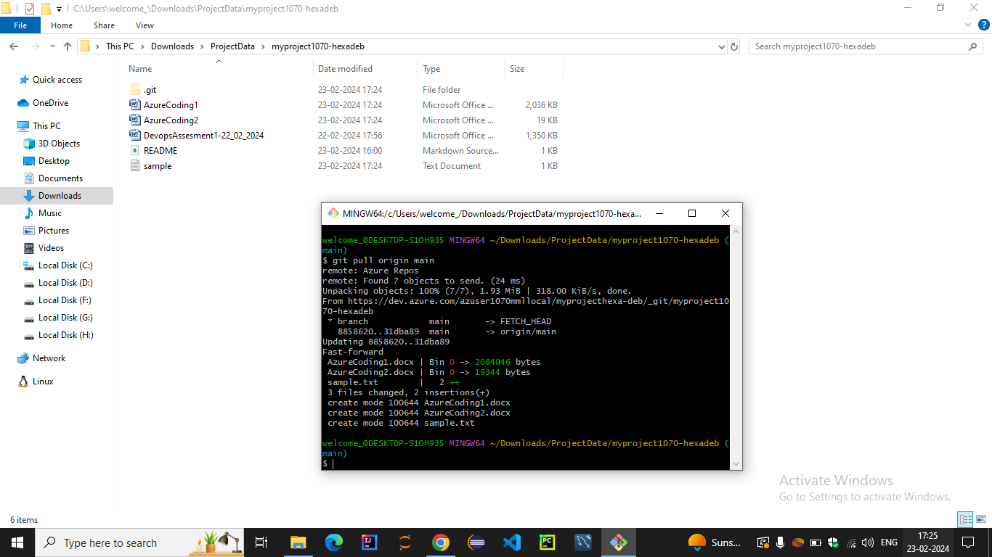

READING FILE

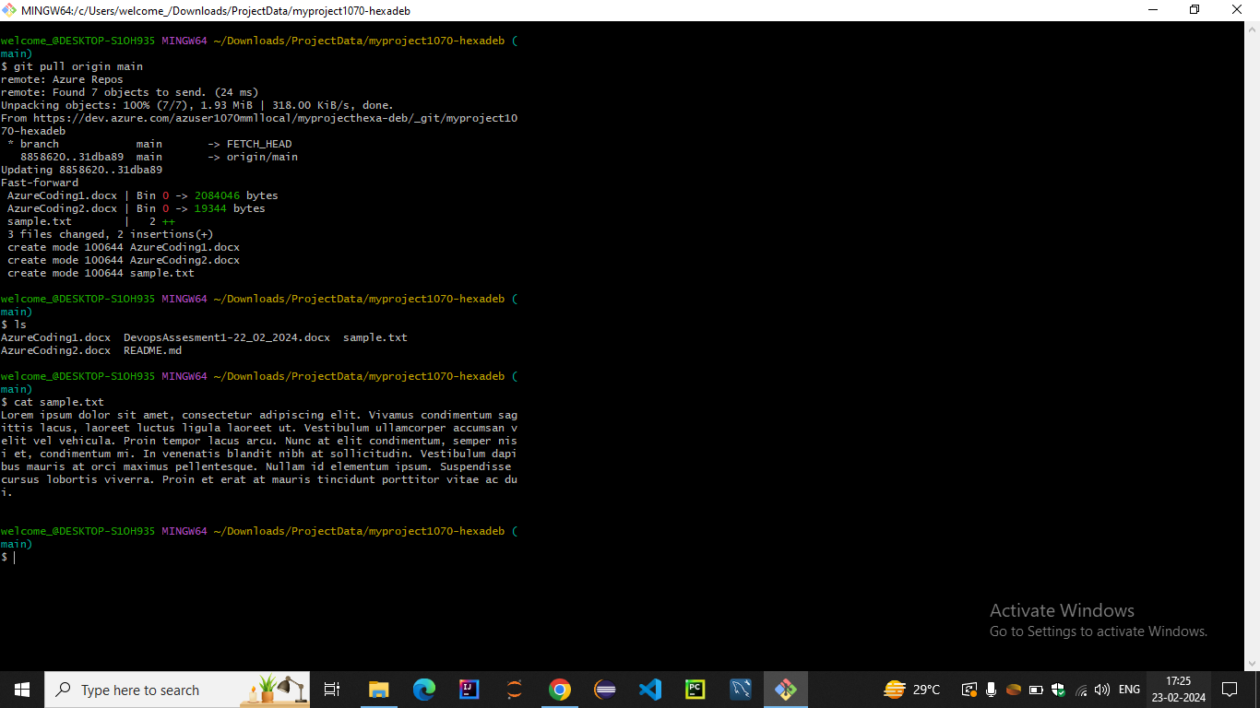

Creating CI/CD pipelines for data engineering projects

