NAME :- ANIKET SANJAYKUMAR BIYANI

DATA ENGINEERING BATCH -1

AZURE DEVOPS DAY 2- ASSIGNMENT 24-02-2024

# AzureDevOpsCI/CD:

Azure DevOps is a comprehensive set of development tools provided by Microsoft that facilitates the entire software development lifecycle, including planning, coding, building, testing, and deploying applications. It offers a wide range of services and features to support continuous integration (CI) and continuous deployment (CD) processes for data engineering projects. Below, I'llprovidedetailedinformationfocusingontheCI/CDpartfordataengineering in Azure DevOps:

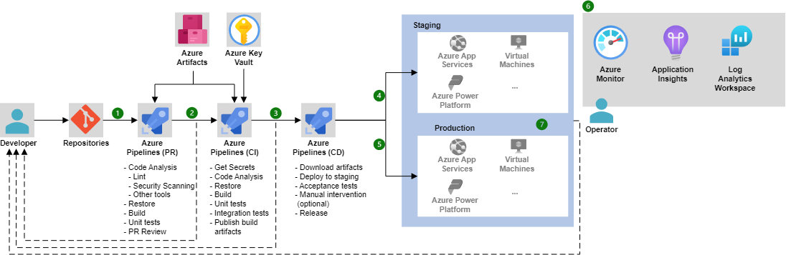

# AzureDevOpsServices:

* + AzureDevOpsServicesisacloud-basedplatformthatprovidesasuiteof services for managing the software development lifecycle.
  + It includes services such as Azure Repos (for version control), Azure Pipelines(forCI/CD),AzureBoards(forprojectmanagement),AzureTest Plans (for testing), and Azure Artifacts (for package management).

# ContinuousIntegration(CI):

* + ContinuousIntegrationisthepracticeoffrequentlyintegratingcode changes into a shared repository.
  + InAzureDevOps,AzurePipelinesfacilitatesCIbyautomaticallybuilding and testing code every time a change is committed to the repository.
  + Fordataengineeringprojects,CIinvolvestaskssuchascompilingcode, running unit tests, validating data pipelines, and performing static code analysis.

# ContinuousDeployment(CD):

* + ContinuousDeploymentisthepracticeofautomaticallydeployingcode changestoproductionorotherenvironmentsafterpassingtheCIprocess.
  + AzureDevOpssupportsCDthroughAzurePipelines,enablingautomated deployment of data engineering artifacts, such as ETL jobs, SQL scripts, or machine learning models.
  + CD pipelines in Azure DevOps can deploy to various environments, includingdevelopment,testing,staging,andproduction,withcustomizable release strategies and approval workflows.

# AzurePipelines:

* + AzurePipelinesisacloud-basedserviceforbuilding,testing,and deploying code across different platforms and languages.
  + ItsupportsbothCIandCDworkflowsandallowsyoutodefinepipelines using YAML or the visual designer.
  + Pipelinescanincludemultiplestages,jobs,andtaskstoautomatevarious aspects of the development process, including data engineering tasks like data validation, transformation, and deployment to target data stores.

# KeyConceptsinAzurePipelines:

* + Pipeline:DefinestheentireCI/CDprocess,includingstages,jobs,and tasks.
  + Stage:Representsalogicalboundarywithinthepipeline,suchasBuild, Test, or Deploy.
  + Job:Definesasetoftasksthatrunsequentiallyorinparallelwithina stage.
  + Task:Representsasingleactionwithinajob,suchasexecutingascript, running a test suite, or deploying an artifact.

# IntegrationwithDataEngineeringTools:

* + AzurePipelinesintegratesseamlesslywithvariousdataengineeringtools and technologies commonly used in Azure ecosystem, such as Azure Data Factory, Azure Databricks, Azure Synapse Analytics, and Azure SQL Database.
  + Integrationmayinvolverunningscripts,executingcommands,deploying packages, or triggering workflows in these services as part of the CI/CD process.

# MonitoringandReporting:

* + AzureDevOpsprovidesmonitoringandreportingcapabilitiestotrackthe progress and health of CI/CD pipelines.
  + Youcanmonitorpipelineruns,viewbuildandreleaselogs,analyzetest results, and generate reports to identify issues and optimize performance.

# SecurityandCompliance:

* + AzureDevOpsincludesfeaturesforensuringsecurityandcompliancein CI/CD processes, such as role-based access control (RBAC), encryption, audit logs, and compliance certifications (e.g., SOC, ISO).
  + ItalsosupportsintegrationwithAzureKeyVaultforsecurelymanaging secrets and credentials used in pipelines.

By leveraging Azure DevOps for CI/CD in data engineering projects, teams canautomatethedeploymentofdatapipelines,maintainconsistencyacross environments, and accelerate the delivery of data-driven solutions while ensuring reliability and quality.