Name:Aniket Biyani

DataEngineering Batch-1

Azure Devops Day4 26_02_2024

AzureSynapseAnalytics,formerlyknownasAzureSQLDataWarehouse,is a cloud-based analytics service provided by Microsoft Azure. It's a unified analytics platform that integrates enterprise data warehousing and big data analytics. Azure Synapse aims to streamline the process of ingesting, preparing, managing, and serving data for immediate business intelligence and machine learning needs.

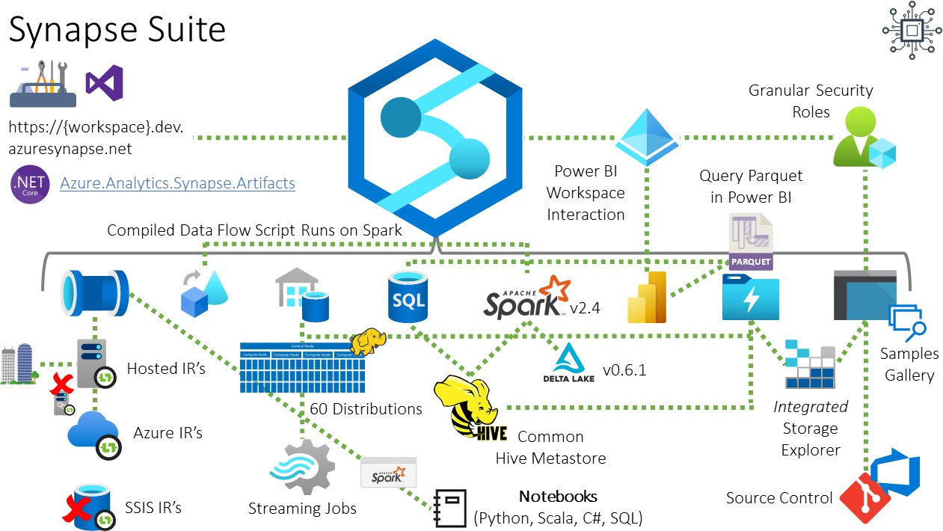

1. **Unified Analytics:** Azure Synapse provides a unified experience for data engineers, data scientists, and business analysts. It integrates big data and datawarehousingcapabilitiesintoasingleservice,enablinguserstoanalyze both structured and unstructured data.
2. **Data Integration:** It offers built-in integration with various data sources, including Azure Blob Storage, Azure Data Lake Storage, Azure SQL Database,AzureCosmosDB,andmore.Thisallowsuserstoingestdatafrom different sources easily.
3. **Data Warehousing:** Azure Synapse provides a fully managed, scalable data warehousing solution capable of handling petabytes of data. It uses massivelyparallelprocessing(MPP)architecturetoexecutecomplexqueries quickly and efficiently.
4. **BigDataAnalytics:**WithsupportforApacheSparkandbuilt-inconnectors for popular big data frameworks like Apache Hadoop and Apache Kafka, Azure Synapse allows users to analyze and process large volumes of data using familiar tools and languages.
5. **DataExplorationandVisualization:**Itincludesintegrateddataexploration and visualization tools, such as Power BI and Azure Synapse Studio, to help users gain insights from their data and create interactive reports and dashboards.
6. **SecurityandCompliance:**AzureSynapseoffersrobustsecurityfeatures, including encryption at rest and in transit, role-based access control (RBAC), anddynamicdatamasking.Italsohelpsorganizationscomplywithregulatory requirements such as GDPR, HIPAA, and SOC.
7. **ServerlessSQLPool:**AzureSynapseoffersaserverlessSQLpooloption, allowing users to run on-demand analytics queries without the need to provision or manage dedicated resources.
8. **IntegrationwithAzureServices:**ItintegratesseamlesslywithotherAzure services like Azure Machine Learning, Azure Data Factory, Azure Databricks, and Azure Active Directory, enabling users to build end-to-end analytics solutions.

Overall, Azure Synapse Analytics provides a comprehensive platform for organizations to analyze and derive insights from their data, whether it's structuredorunstructured,inreal-timeorbatchprocessingscenarios.Itoffers scalability, performance, and flexibility to meet the evolving needs of modern data-driven businesses.

**HandwrittenNotes:**



