**Name :- Aniket Sanjaykumar Biyani**

**Data Engineering Batch-1**

**Devops Coding Challenge-1**

**Q 1.** **Create Azure Devops Environment and configuring Azure Devops Git Repository ,configure on your local git to implement this upload few test files on same.**

* **Creating an environment in Azure DevOps** involves several steps, including setting up the necessary infrastructure, defining deployment targets, configuring security, and managing resources

1. Sign in to your Azure DevOps organization

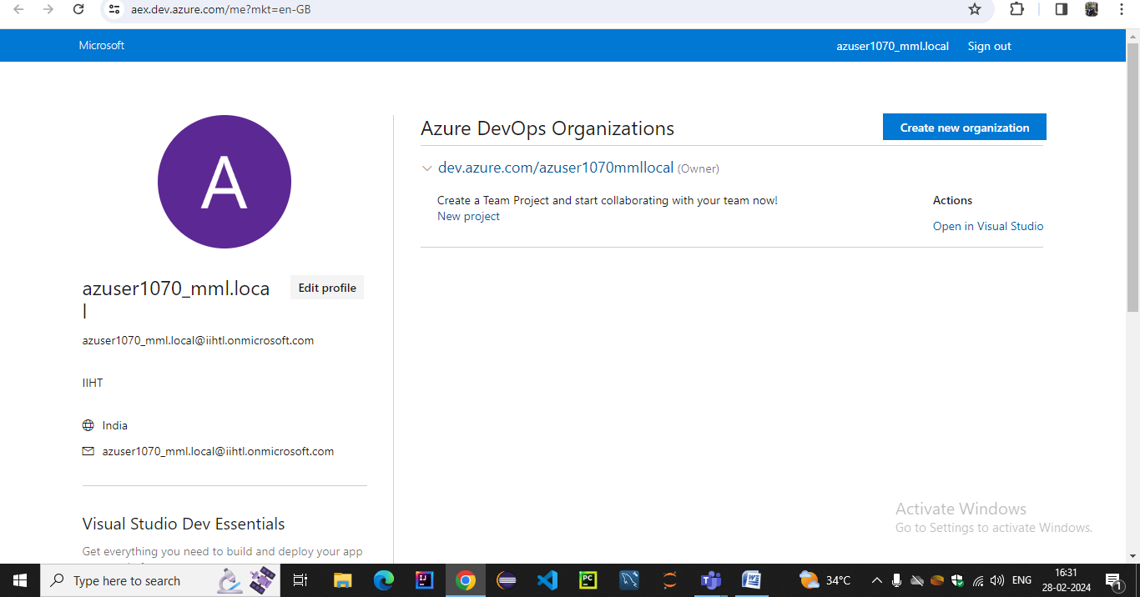

1. Create a new project or browse to existing project if any

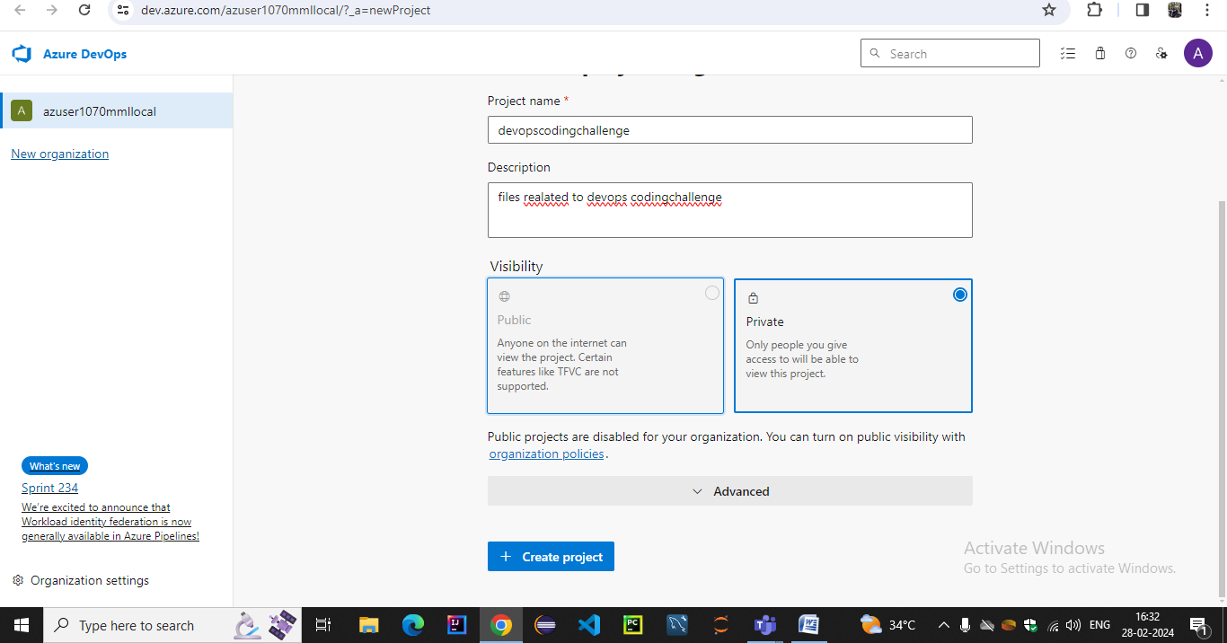

### 3. Navigate to Environments:

Once logged in, navigate to your project and select "Pipelines" from the left-hand menu. click on "Environments" under the "Pipelines" section.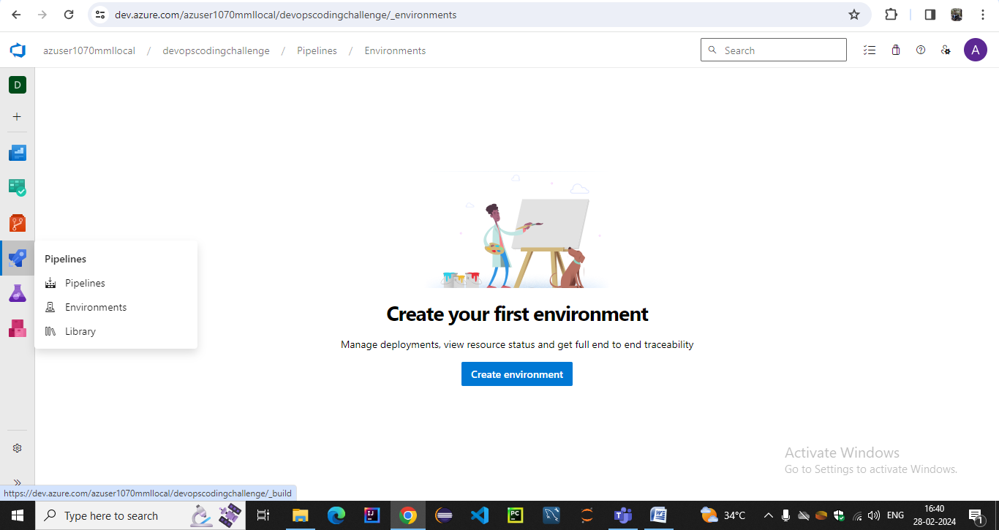

4. Fill in the necessary details like environment name, resource group, region, etc.Configure security, approvals, deployment targets, and other settings as needed. Save the environment.

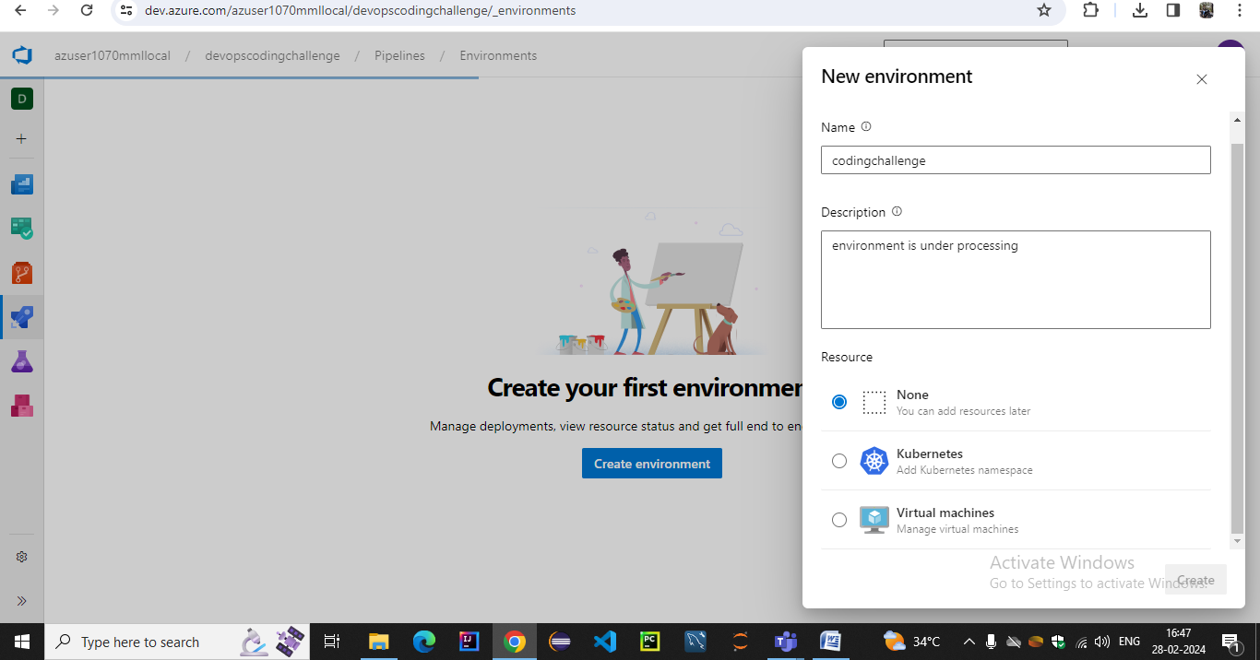

5. Once the environment is created, you can manage it by editing configurations, adding or removing resources, configuring security settings, and monitoring deployment status.

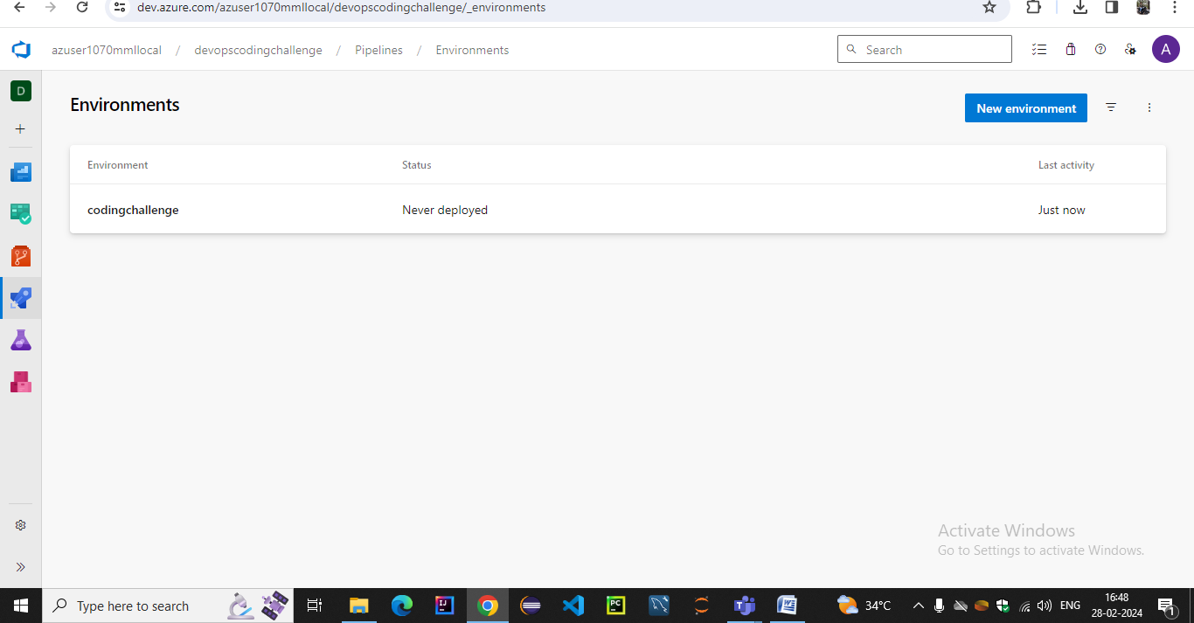

* **Configuring Azure Devops Git Repository**

1.In your Azure DevOps project, go to the "Repos" section.

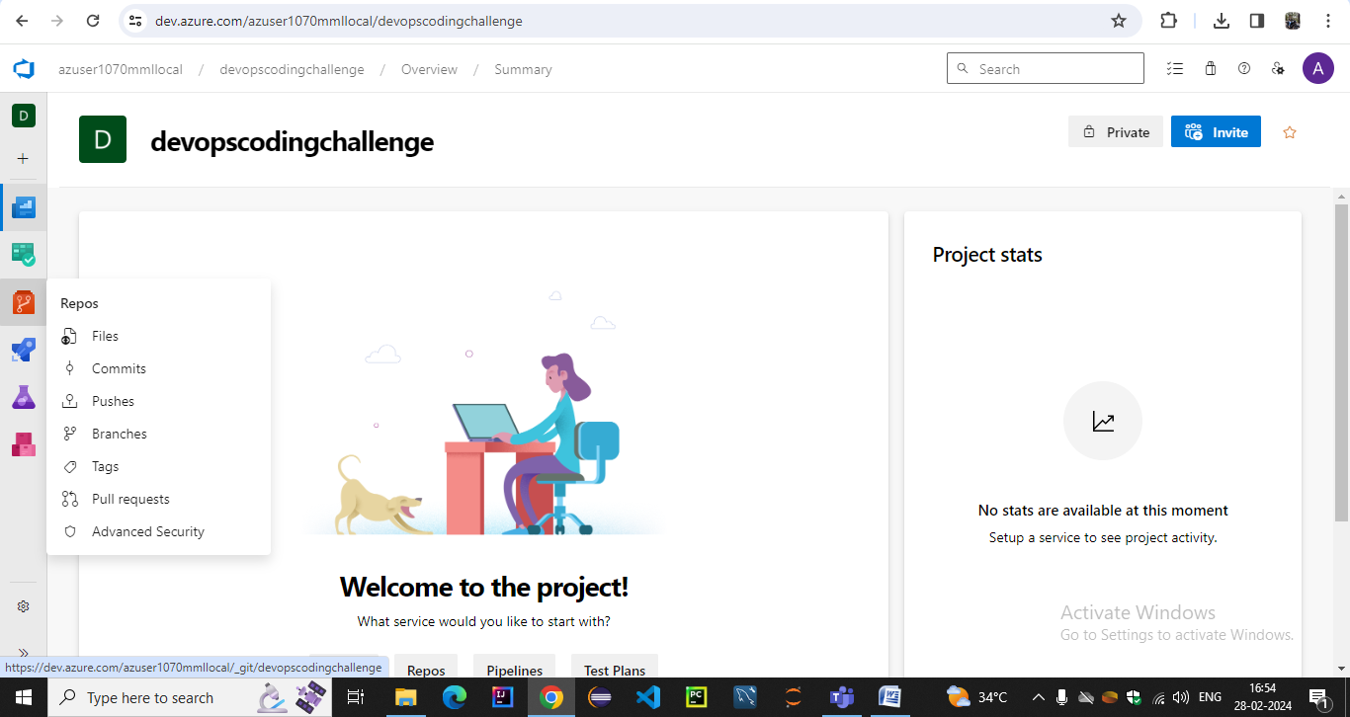

2.Click on "New repository" Provide a name and description for the repository.Choose the visibility (public or private) of the repository. Add a readme file .Click on "Create" to create the repository.

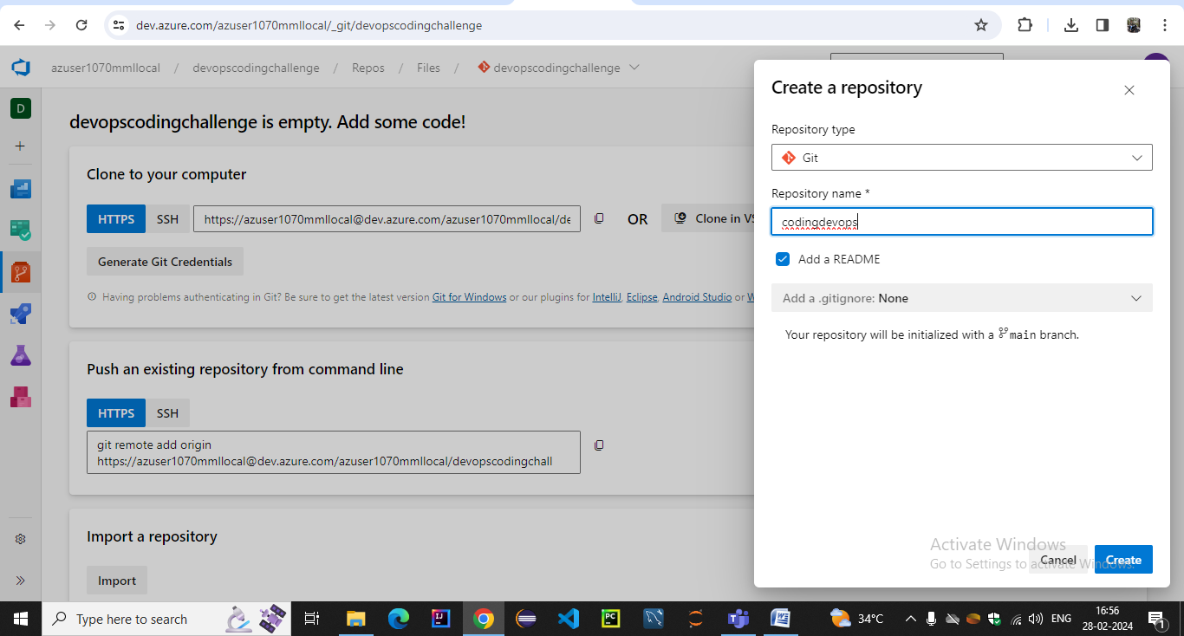

1. We can upload files into the repository from machine

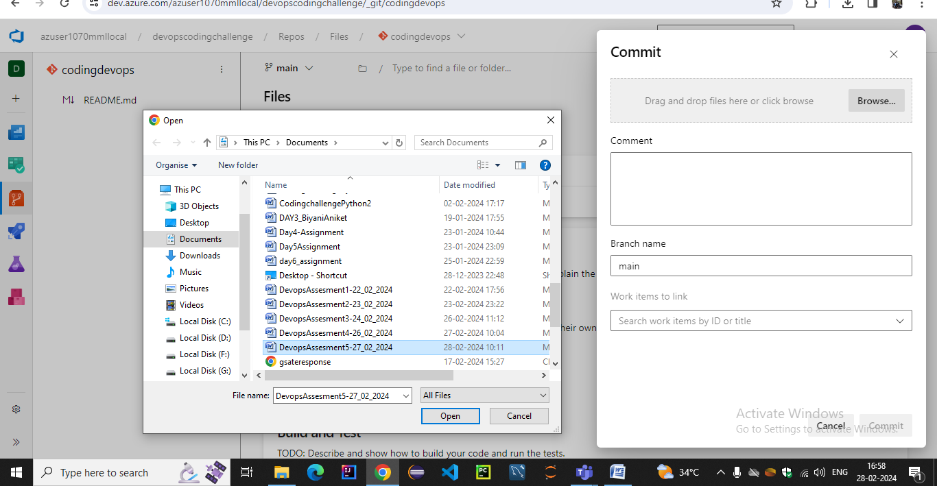

1. We can see uploaded file in the contents

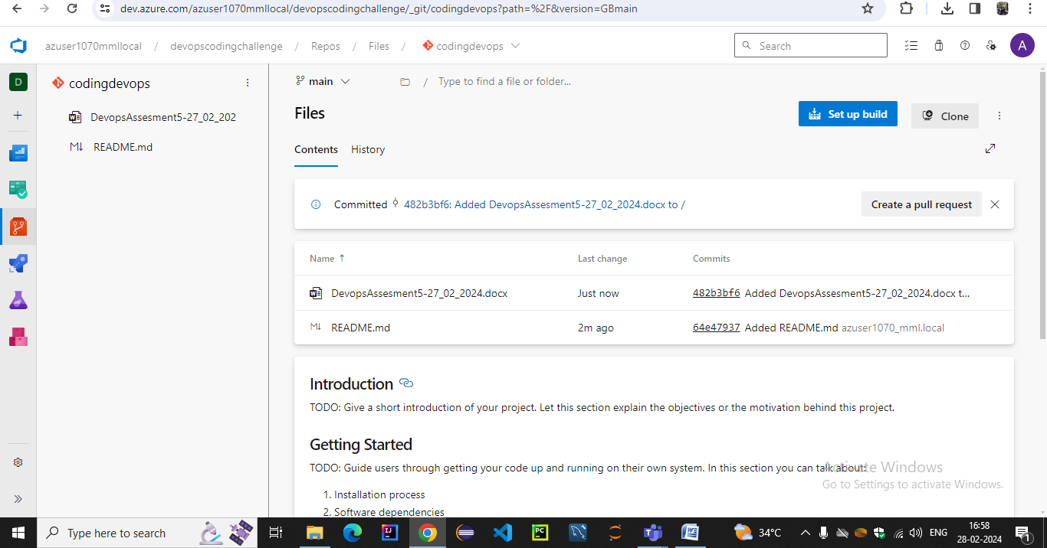

### Configure Local Git Repository:

1. Install Git on your local machine if you haven't already.
2. Open a terminal or command prompt.
3. Navigate to the directory where you want to clone the Azure DevOps Git repository.

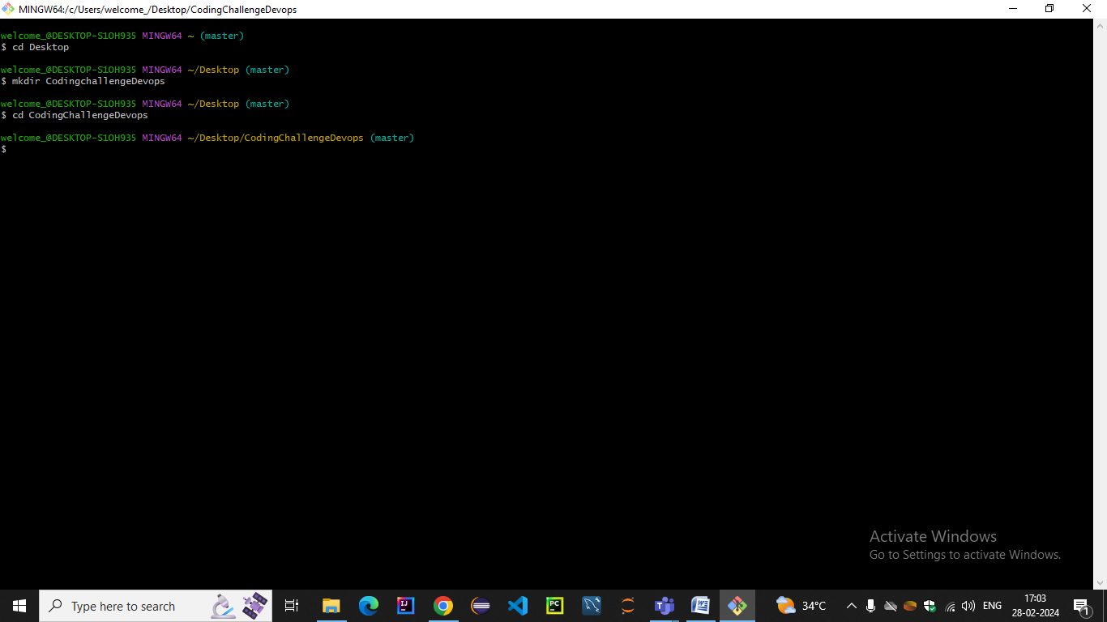

### Clone the repository in the given specified directory

### Url of the clone can be obtained from devops repos section

### C:\Users\welcome_\Pictures\Screenshots\Screenshot (1180).png

### 5.After running command we get the .git in the specified directory

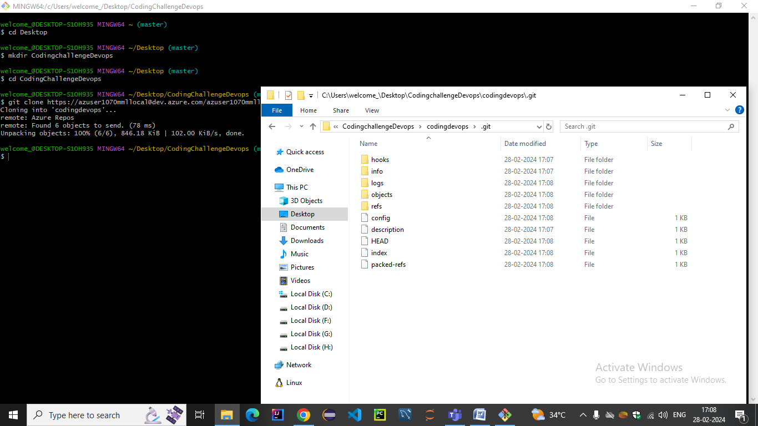

6.Configure your Git user name and email using the following commands: set up Git credentials caching or use SSH for authentication.for new user

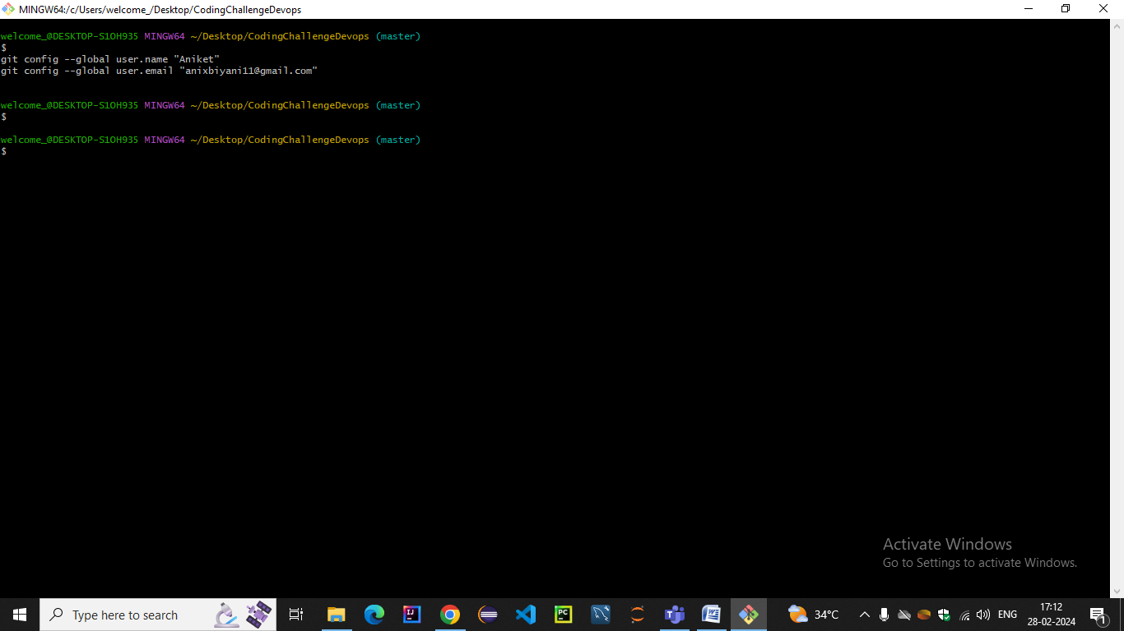

7. **Add Your Project Files**: Add your data engineering project files to the local repository directory on your machine.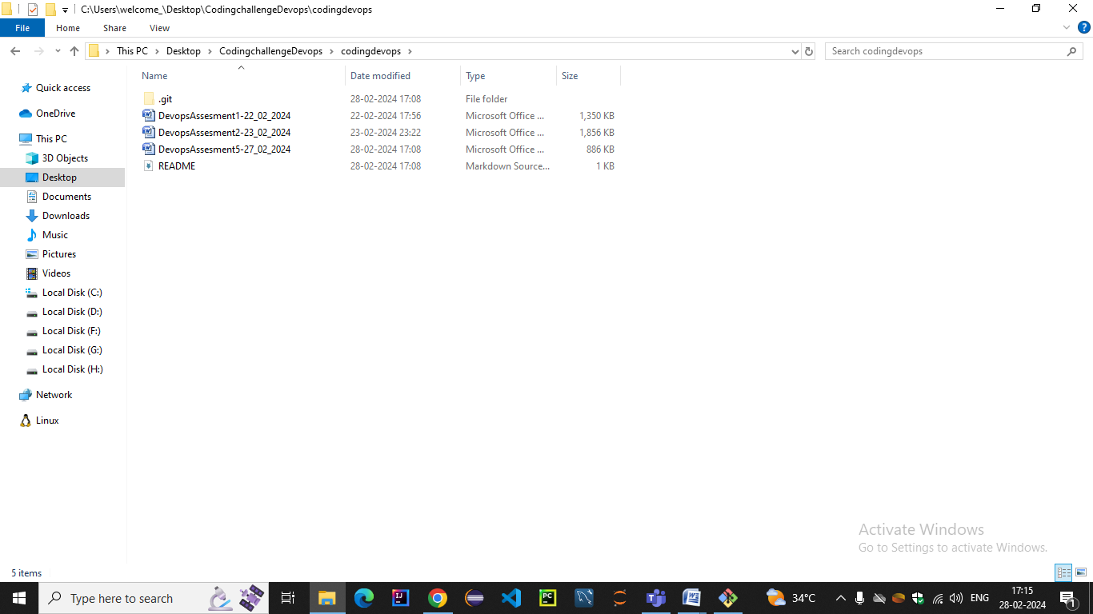

**Commit Your Changes**: Use Git commands (e.g., git add . to stage changes and git commit -m "Initial commit" to commit them) to commit your project files to the local repository

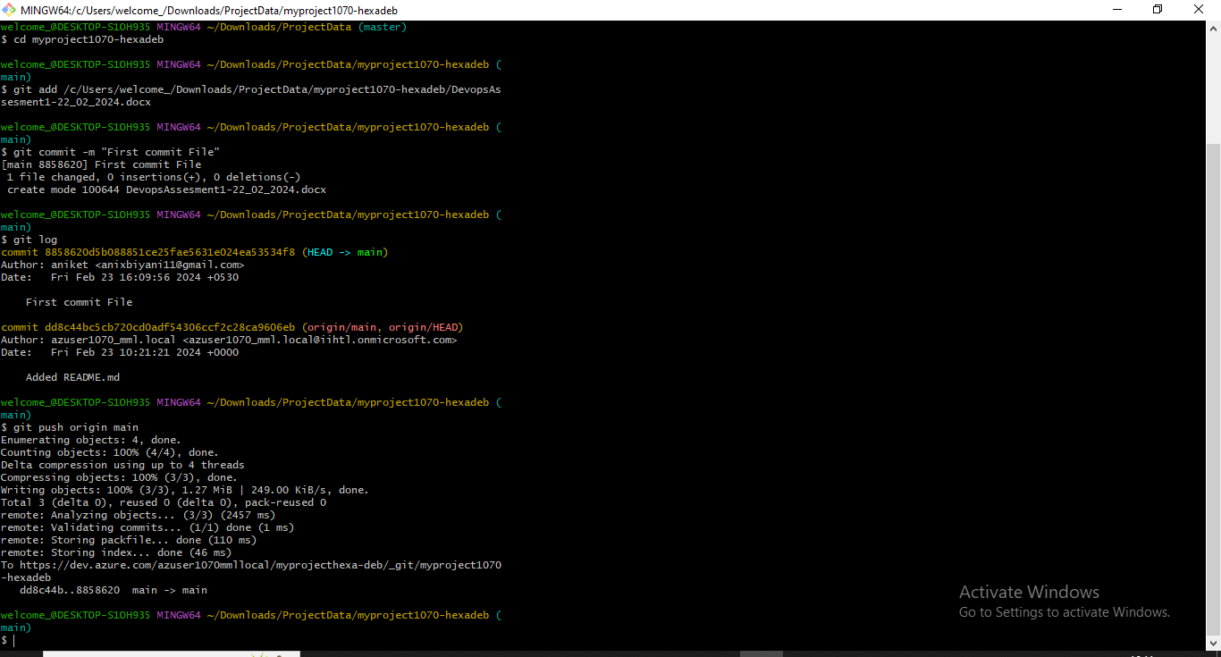

**Push Changes to Azure DevOps**: Once you've committed your changes locally, push them to the Azure DevOps repository using git push

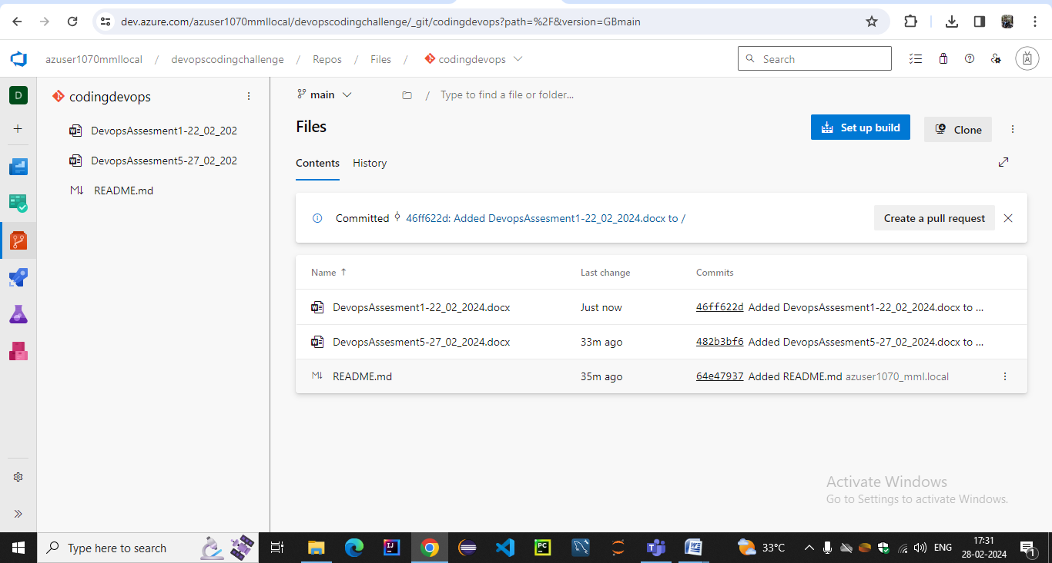

Hence i n these way files will be pushed back to git repos