**Name :- Aniket Sanjaykumar Biyani**

**Data Engineering Batch-1**

**Devops Coding Challenge-2**

**Q2.LeveragethepractisesofCICDUsingAzureDataEngineering and explain the architecture of the Azure synapse .**

# CI/CDPracticesforAzureDataEngineering:

ContinuousIntegration(CI)andContinuousDelivery(CD)practicesare crucial for Azure Data Engineering projects to ensure efficiency, reliability, and scalability. Here's how you can leverage CI/CD in Azure Data Engineering:

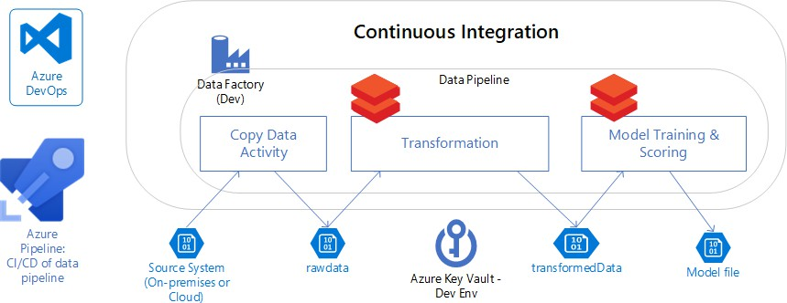

1. Version Control: Utilize version control systems like Git to manage yourcodeandconfigurations.Storeyourdataengineeringartifacts,such as SQL scripts, notebooks, and ETL pipelines, in a version-controlled repository.
2. Automated Builds: Set up automated build pipelines using Azure DevOpsorAzurePipelines.Thesepipelinesshouldautomaticallybuild your data engineering artifacts whenever changes are pushed to the repository.
3. Automated Testing: Implement automated testing for your data engineeringpipelinestovalidatedataquality,integrity,andperformance.

Thisensuresthatyourpipelinesproduceaccurateresultsandmeet business requirements.

1. ContinuousDeployment:Implementcontinuousdeploymentpipelines to automate the deployment of your data engineering solutions to production environments. This involves deploying data pipelines, data warehouses, and analytics solutions seamlessly across different Azure services.
2. Infrastructure as Code (IaC): Use Infrastructure as Code tools like AzureResourceManager(ARM)templatesorAzureBiceptodefineand manage your Azure infrastructure. This allows you to provision, configure, and manage resources consistently and reproducibly.
3. Monitoring and Logging: Implement monitoring and logging solutions totracktheperformance,health,andreliabilityofyourdataengineering pipelinesandinfrastructure.AzureMonitorandAzureLogAnalyticsare commonly used for this purpose.
4. Feedback Loop: Establish a feedback loop to gather insights and feedbackfromstakeholders,end-users,andmonitoringsystems.Use this feedback to continuously improve and iterate on your data engineering solutions.

ByincorporatingtheseCI/CDpracticesintoyourAzureDataEngineering projects, you can streamline development processes, increase productivity, and ensure the reliability and scalability of your solutions.

# AzureSynapseArchitecture:

Azure Synapse Analytics is an integrated analytics service that combinesenterprisedatawarehousing,bigdataanalytics,anddata integration. Its architecture consists of several key components:

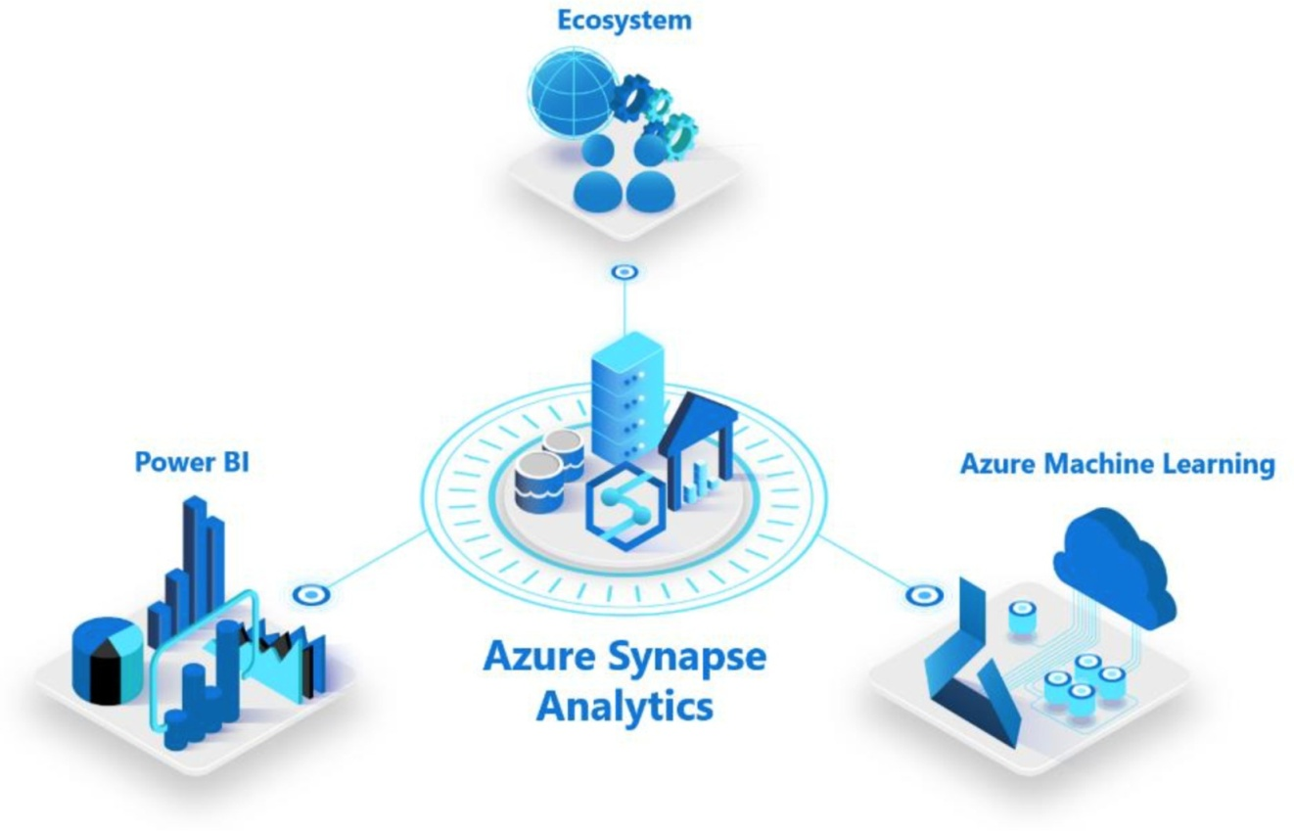

1. **SQL Pools:** Azure Synapse provides dedicated SQL pools (formerly knownasSQLDataWarehouses)forrunninganalyticalqueriesonlarge datasets. These pools are MPP (Massively Parallel Processing) architectures that distribute and process data across multiple nodes for high performance.
2. **SparkPools:**AzureSynapsealsooffersApacheSparkpoolsforbig data processing and machine learning tasks. Spark pools provide distributedprocessingcapabilitiesandsupportvariousdataprocessing workloads.
3. **Serverless SQL Pool:** In addition to dedicated SQL pools, Azure SynapseoffersaserverlessSQLpoolforon-demandqueryprocessing

withouttheneedtoprovisionormanagededicatedresources.Itallows users to query data stored in various formats and locations without upfront infrastructure costs.

1. **IntegrationRuntimes:**AzureSynapseincludesintegrationruntimes for data integration and orchestration. These runtimes support connectingtovariousdatasources,executingETL(Extract,Transform, Load) processes, and orchestrating data workflows across hybrid and multi-cloud environments.
2. **DataLakeStorage:**AzureSynapseintegrateswithAzureDataLake Storage Gen2 for scalable, secure, and cost-effective storage of structured and unstructured data. Data Lake Storage serves as a centralized data repository for storing raw and processed data used in analytics and reporting.
3. **SecurityandGovernance:**AzureSynapseprovidesrobustsecurity and governance features, including role-based access control (RBAC), data encryption, data masking, auditing, and compliance certifications. These features ensure data protection, regulatory compliance, and governance across the analytics lifecycle.

Overall, Azure Synapse's architecture provides a comprehensive platformforbuildinganddeployingmodernanalyticssolutions,enabling organizations to derive valuable insights from their data efficiently and securely.