**NAME :- ANIKET SANJAYKUMAR BIYANI**

**DATA ENGINEERING BATCH -1**

**PYSPARK CODING ASSESMENT**

**Q2.Execute Pyspark -sparksql joins & Applying Functions in a Pandas DataFrame**

Spark SQL joins are a fundamental aspect of data processing in Apache Spark, especially when dealing with structured data. They allow you to combine data from multiple sources based on certain conditions

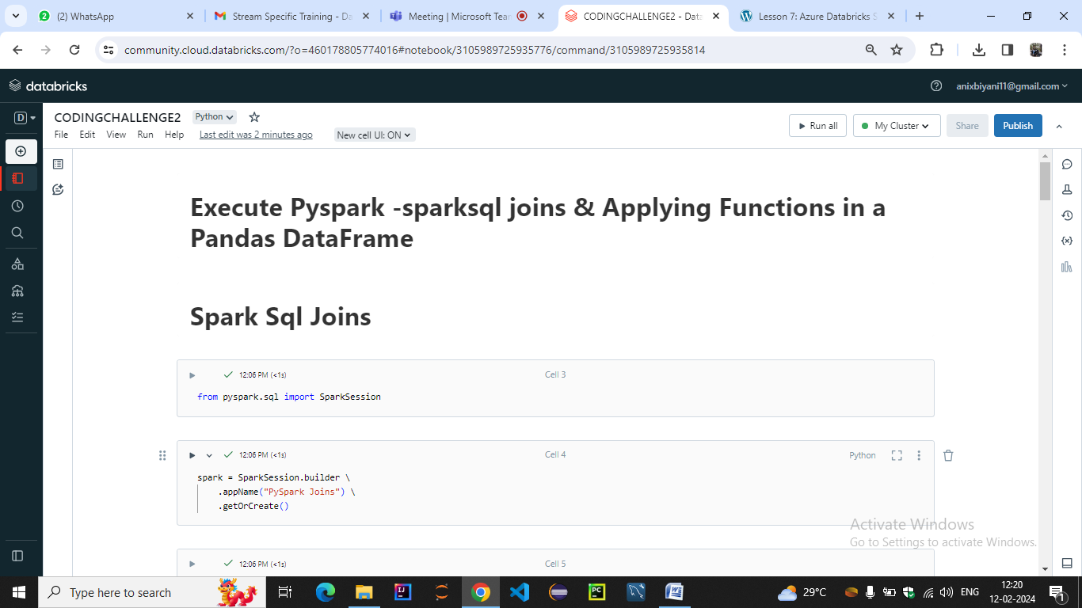

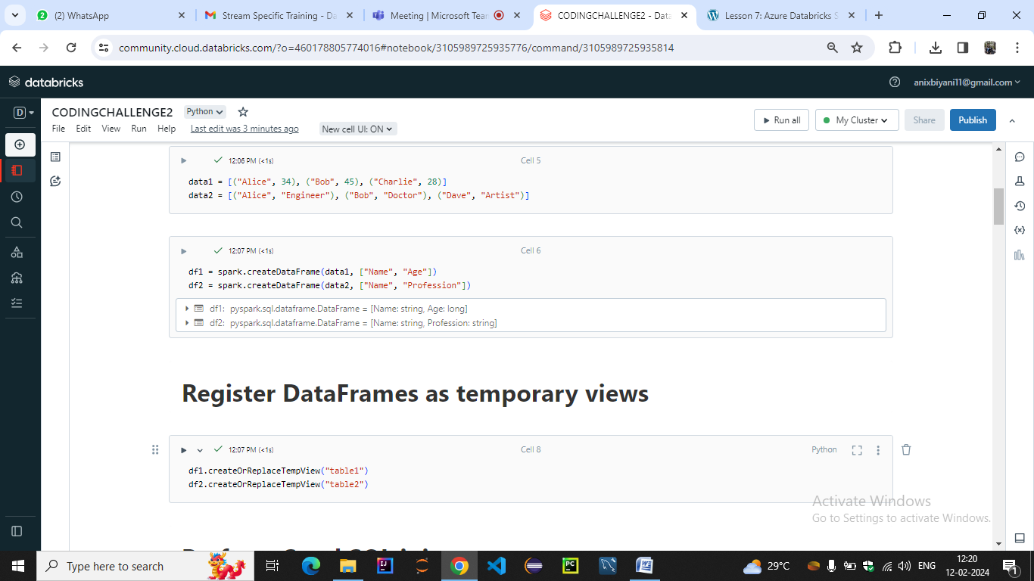

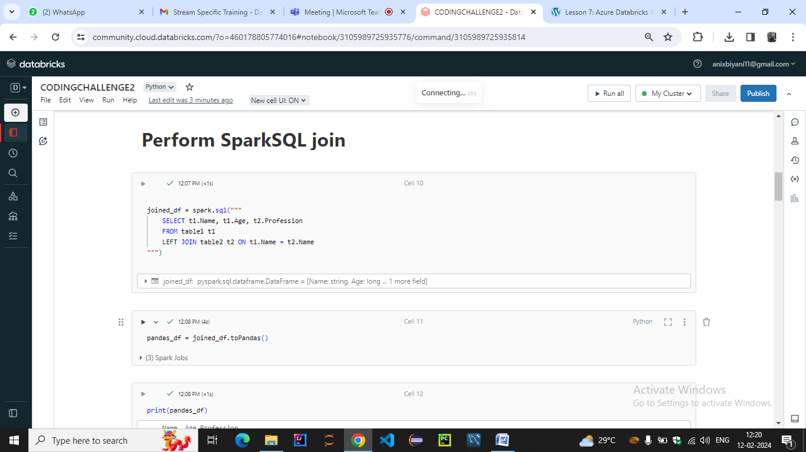

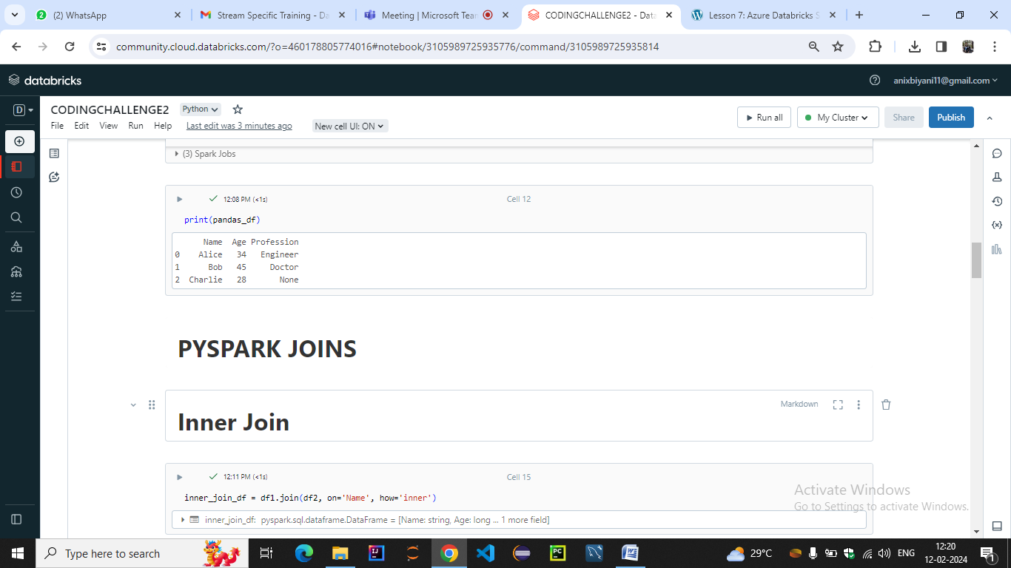

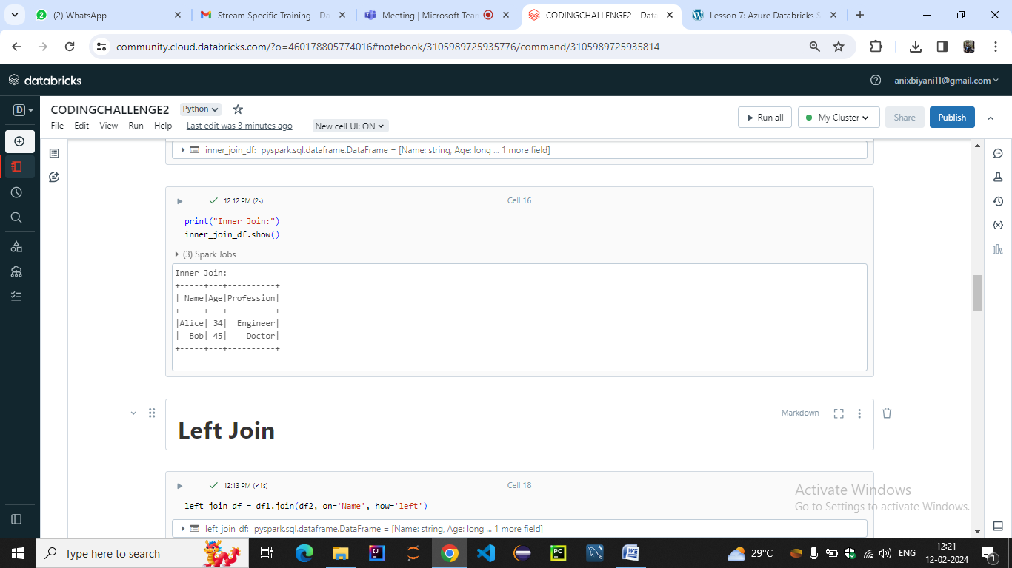

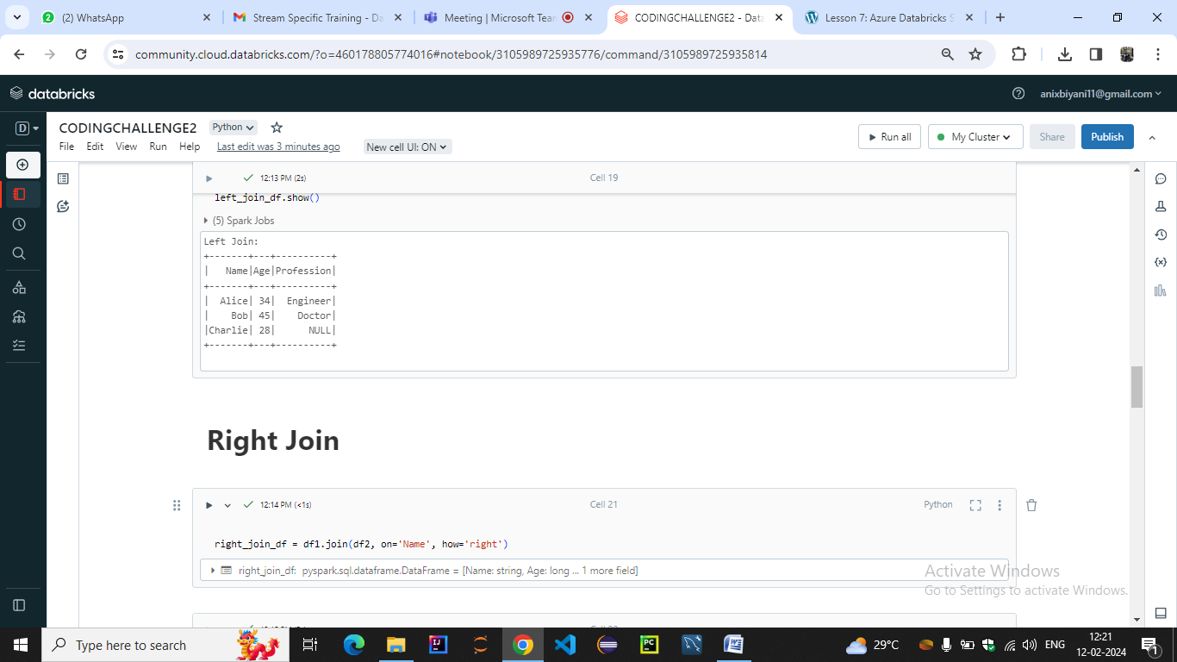

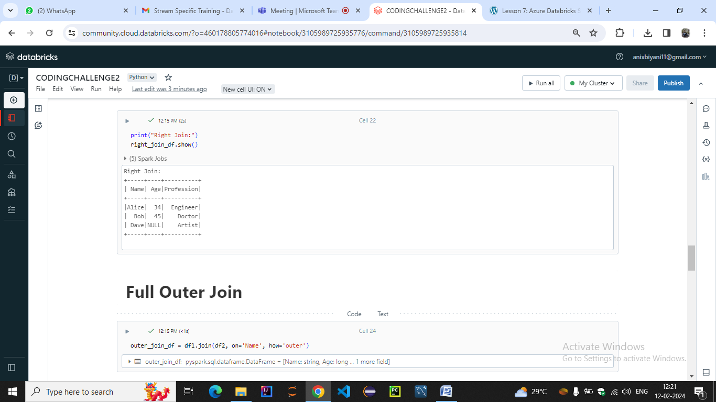

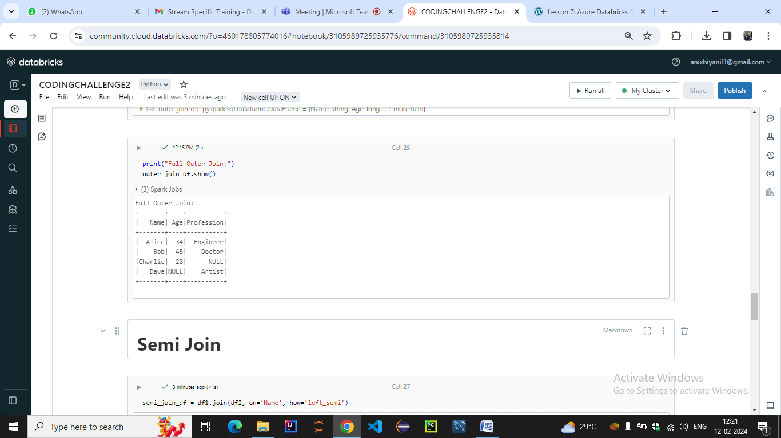

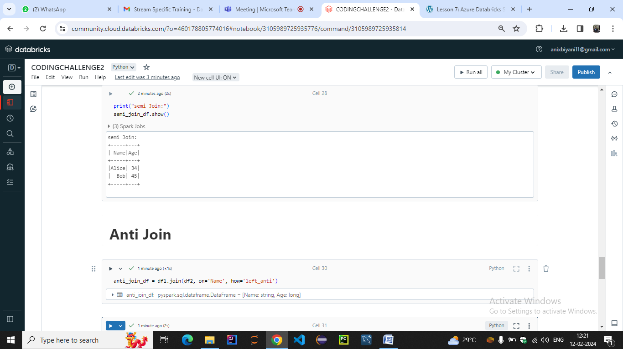

Applying functions to DataFrames in Apache Spark is a common task for transforming and manipulating data. Spark provides several ways to apply functions to DataFrames, including using built-in functions, user-defined functions (UDFs), and higher-order functions

