**NAME :- ANIKET SANJAYKUMAR BIYANI**

**DATA ENGINEERING BATCH -1**

**PYTHON DAY-08 ASSIGNMENT**

**Introduction to python**

* **Writing and Running First program**
* **Keywords** 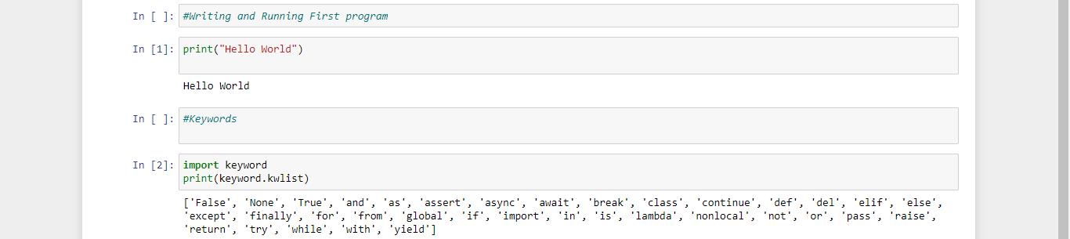
* **Operators**
* ARITHMETIC OPERATORS

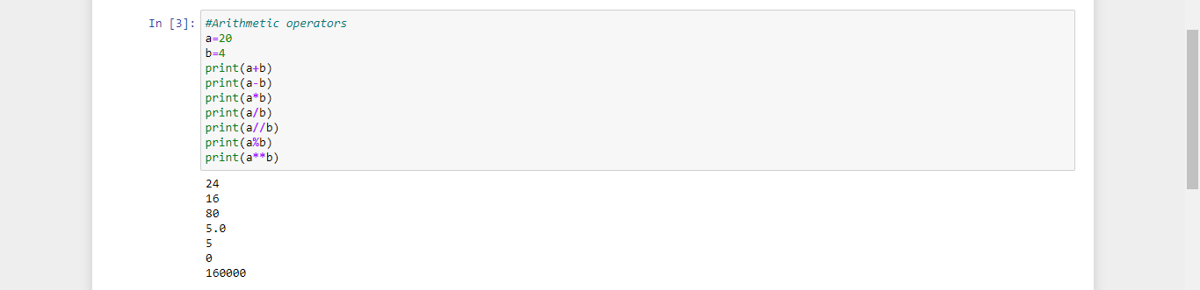

* ASSIGNMENT OPERATORS

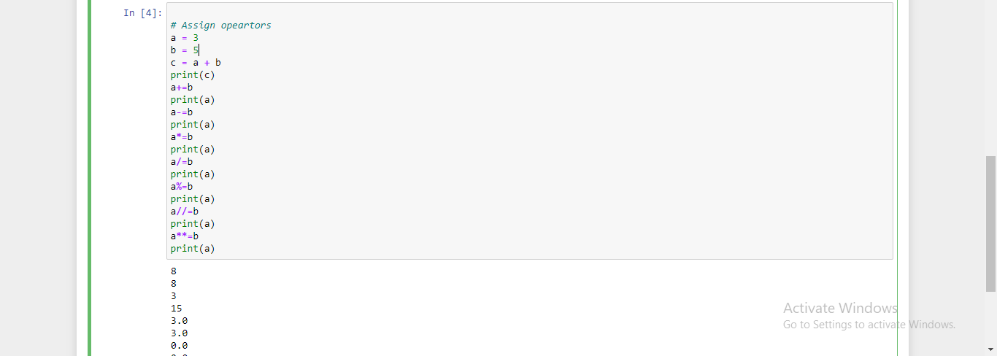

* BITWISE OPERATORS
* COMPARISION OPERATORS

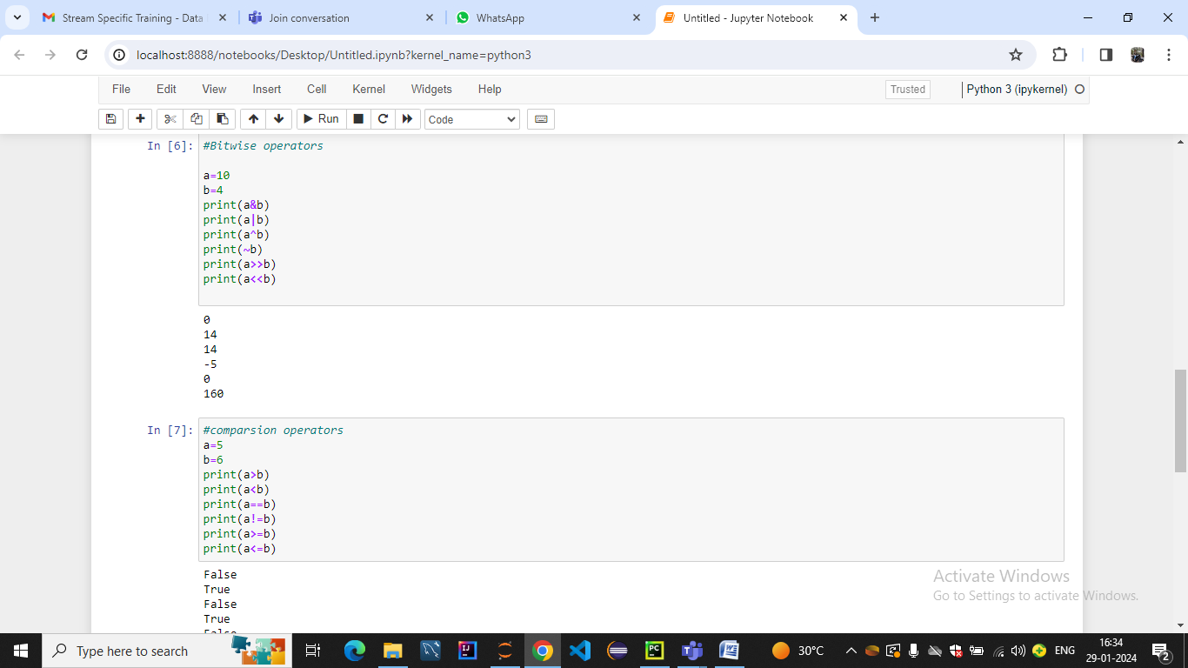

* IS IN OPERATORS
* LOGICAL OPERATORS

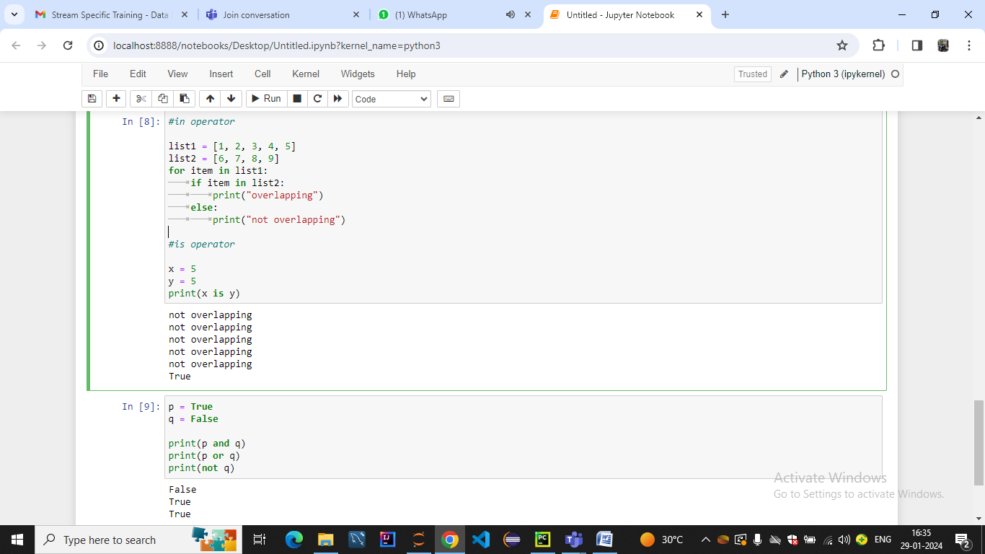

* OPERATOR FUNCTIONS

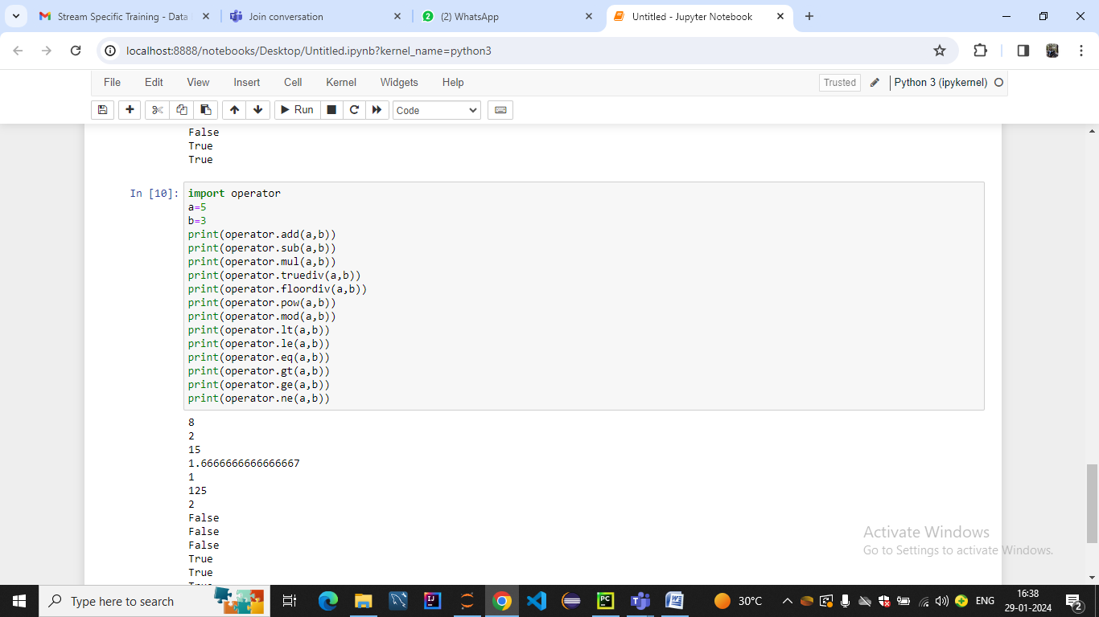

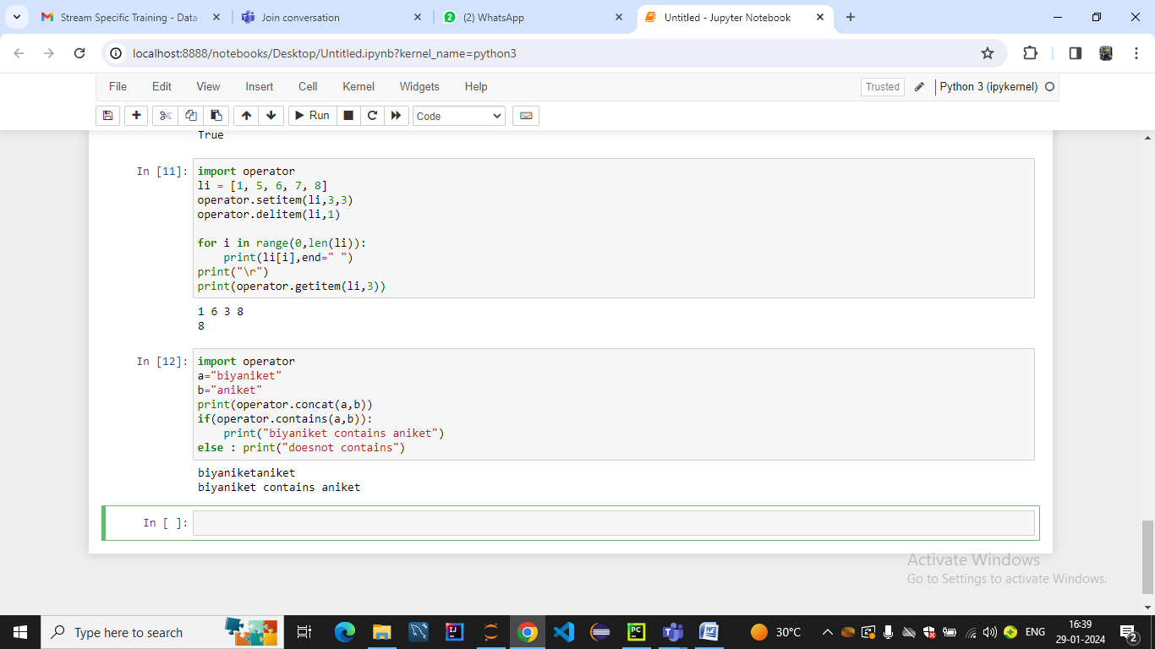

* **Data Types**
* Numeric 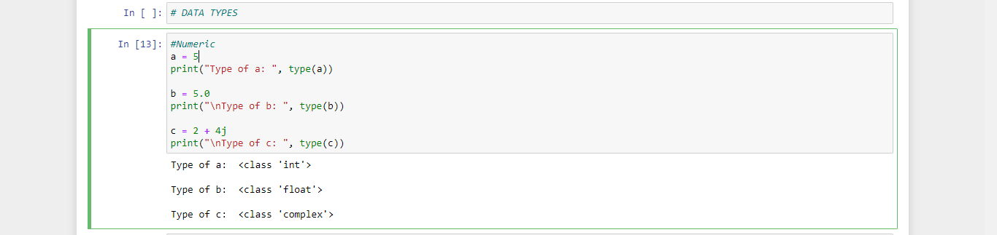
* Sequence:-
* Strings

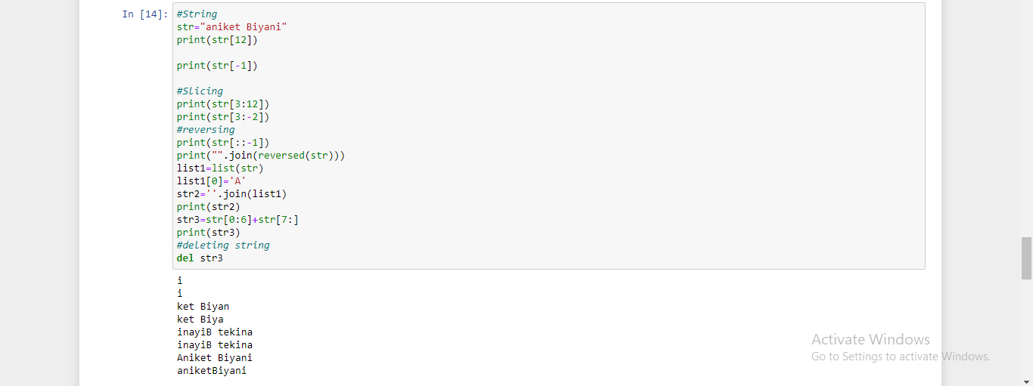

* Lists Lists,Methods and slicing

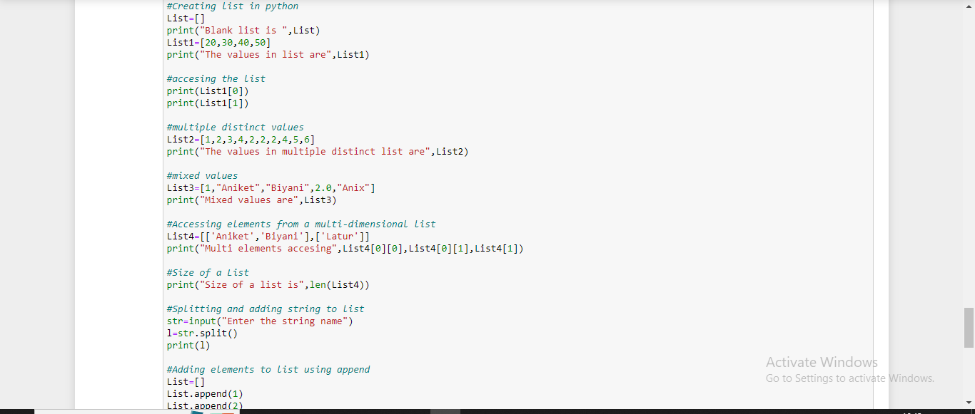

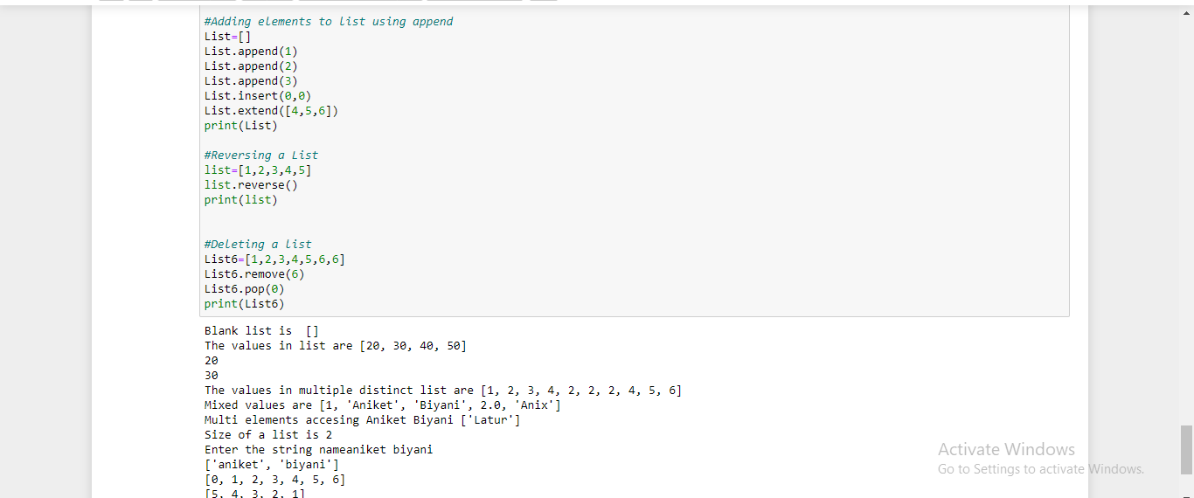

* Tuple

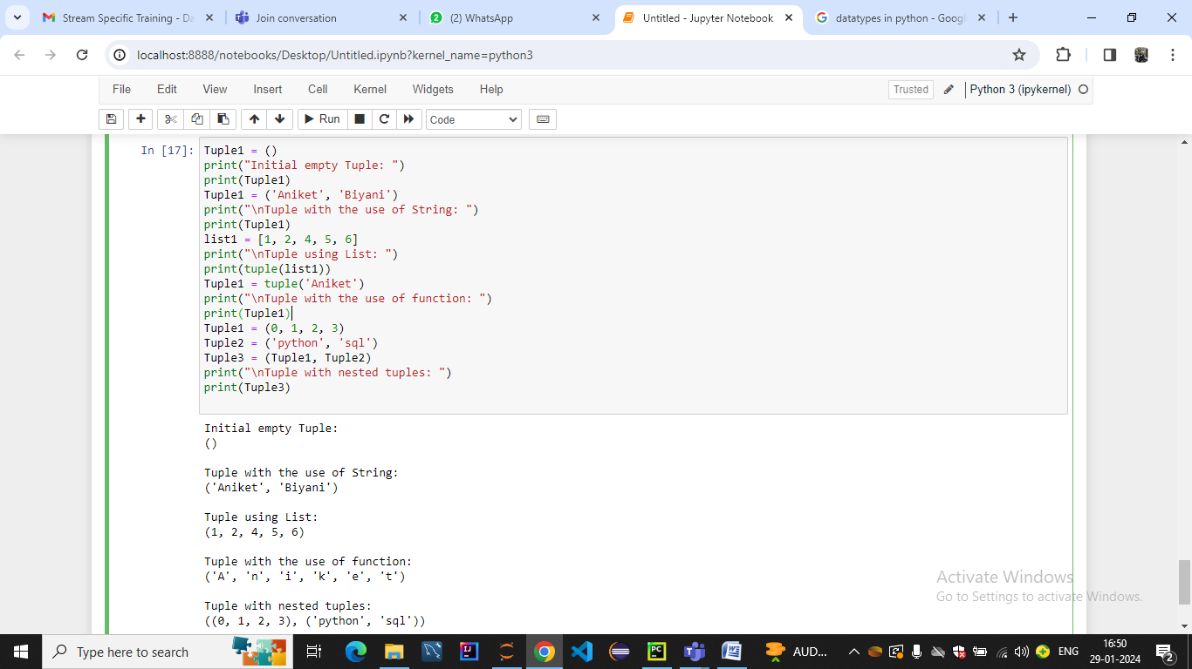

* Boolean 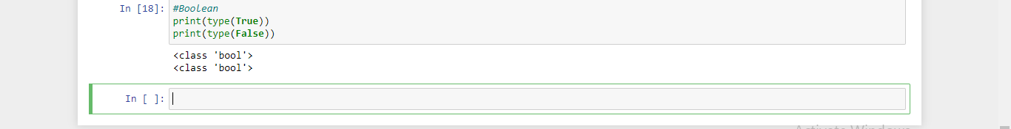
* **SET** Introduction to Set & Set Methods

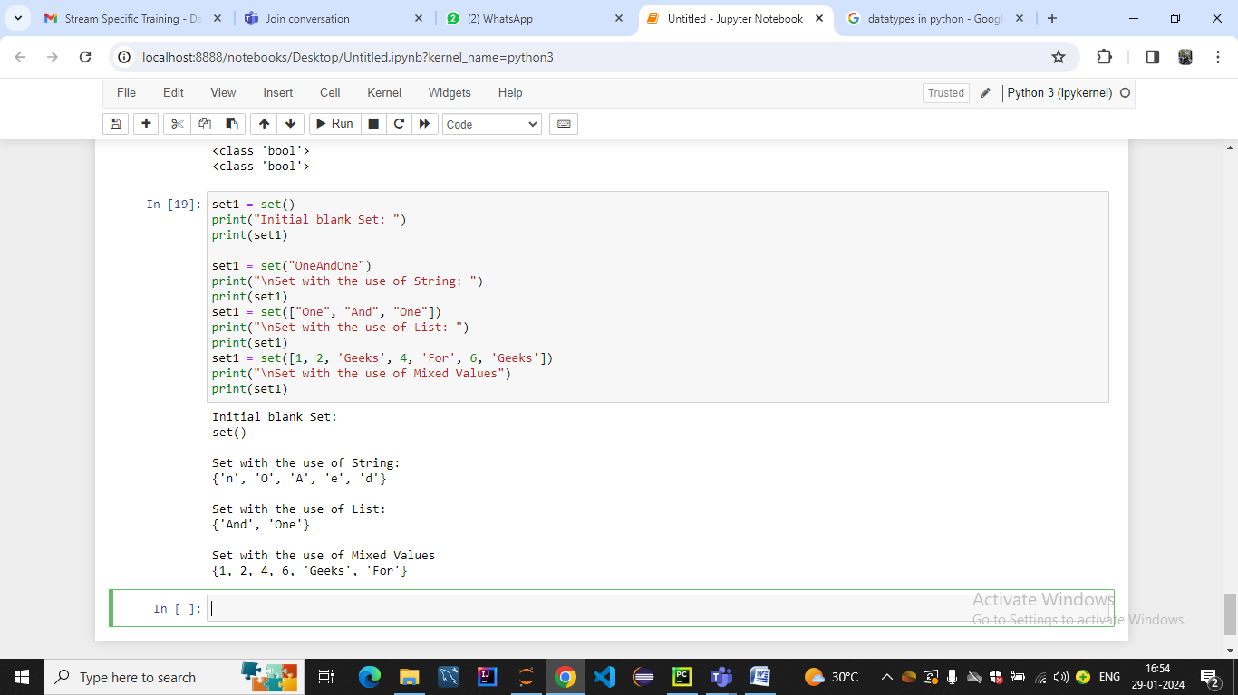

**CONTROL STRUCTURE**

* If statement
* If-else statement
* If-elif-else statement

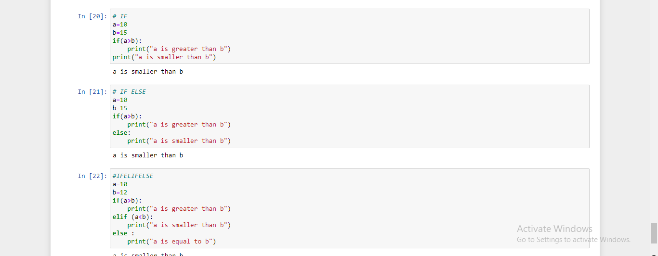

* For Loop

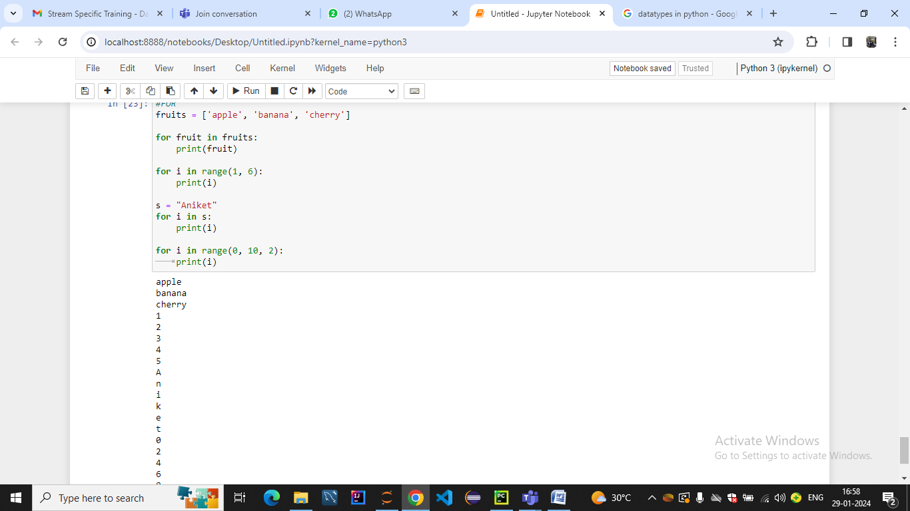

* While Loop
* Nested Loop

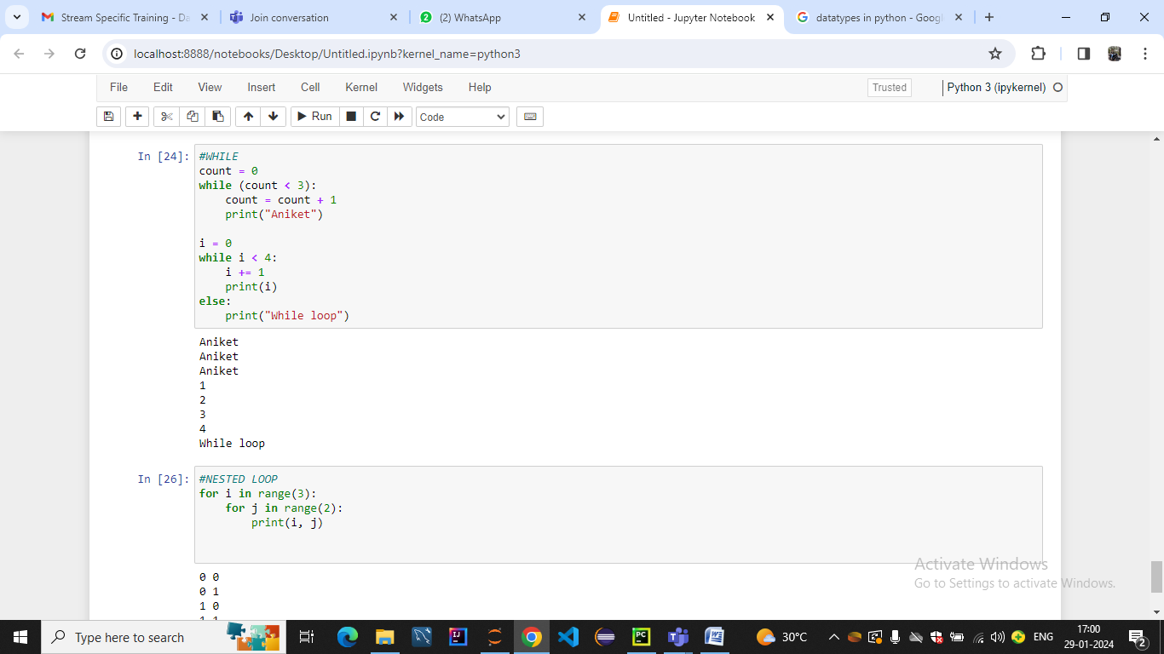

* Break, Continue & Pass

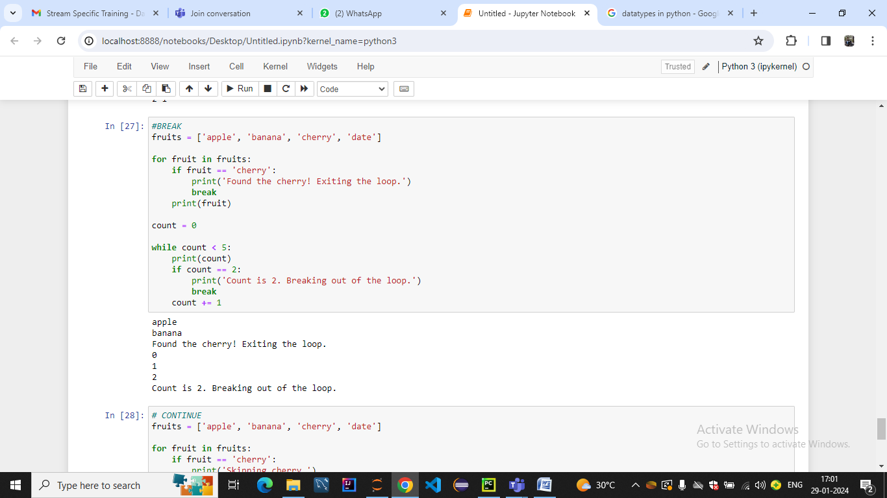

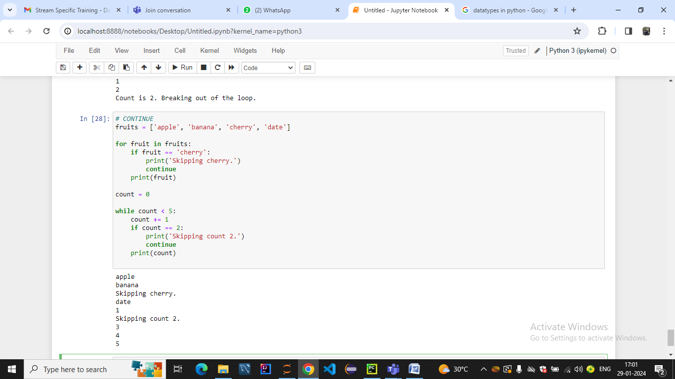

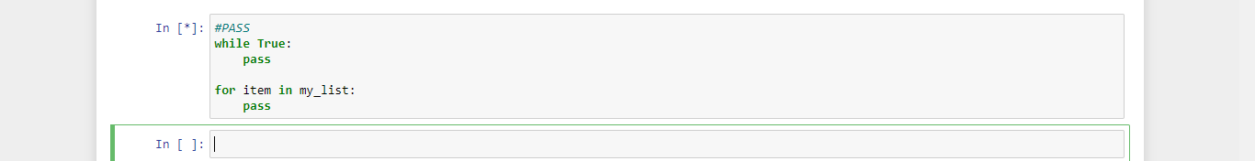

* Introduction to Dictionaries & Dictionary Methods

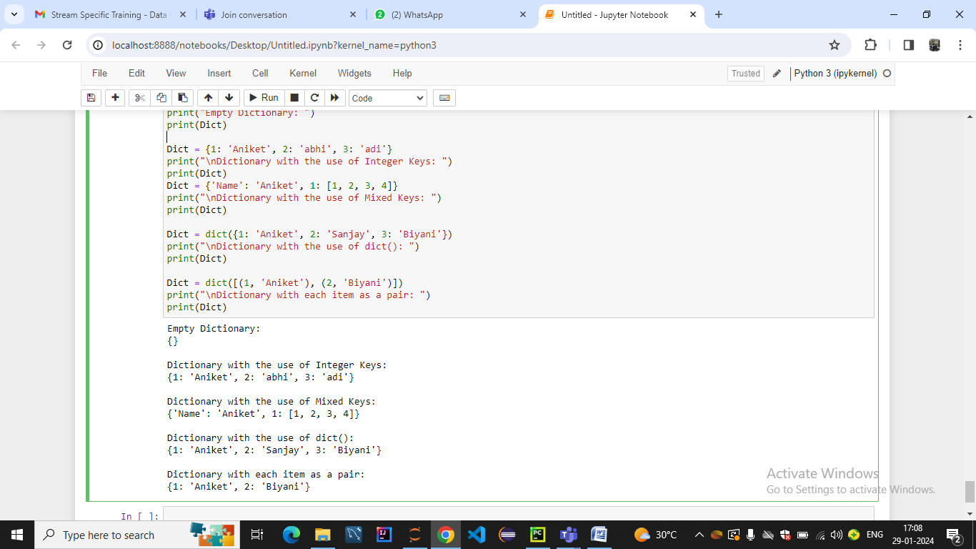

* Introduction to Map & Map Methods
* Mapping Functions

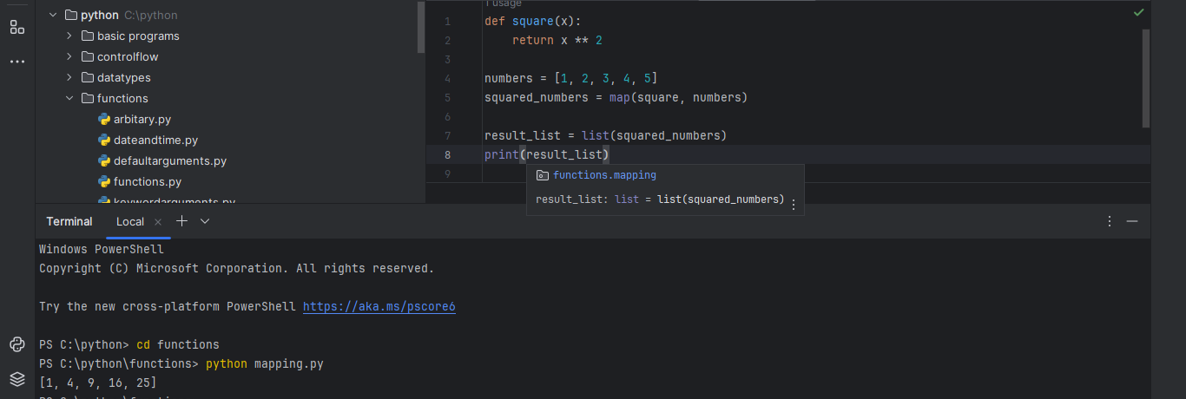

**FUNCTIONS**

* String Function

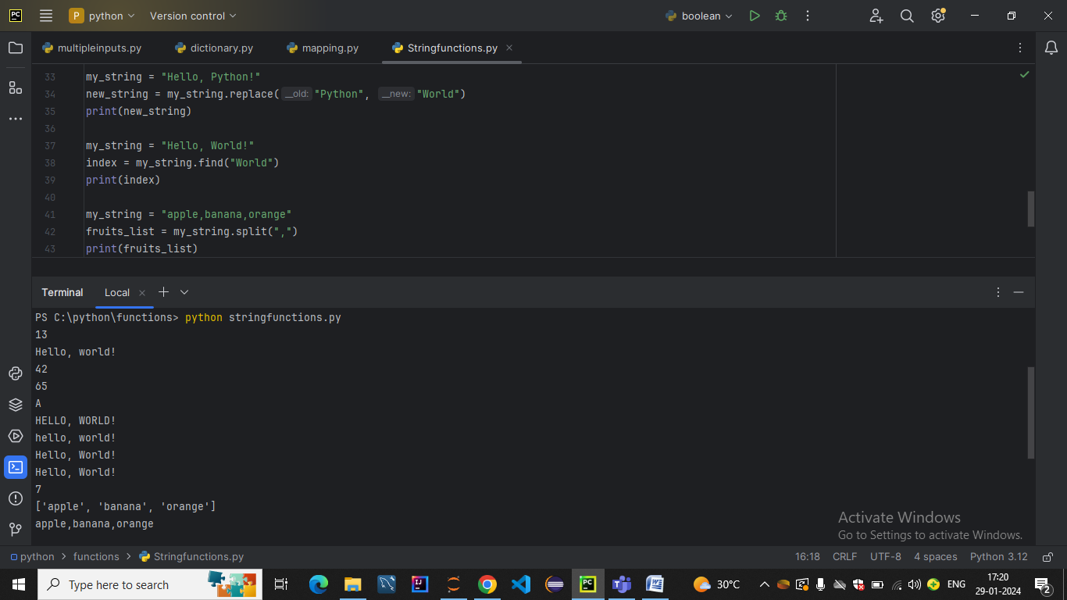

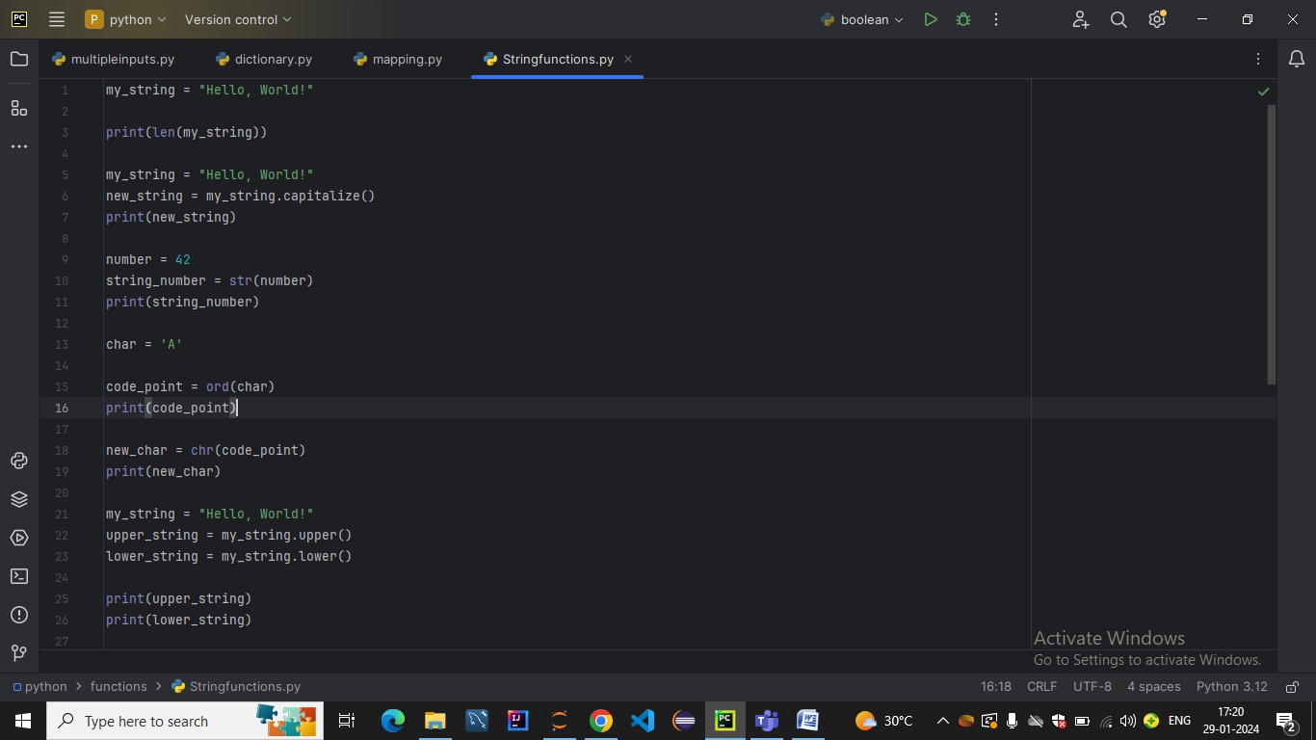



* Number Function

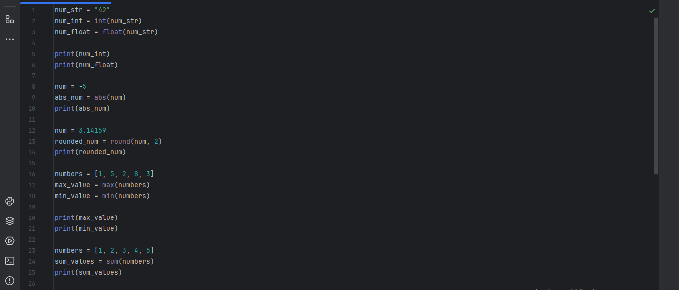

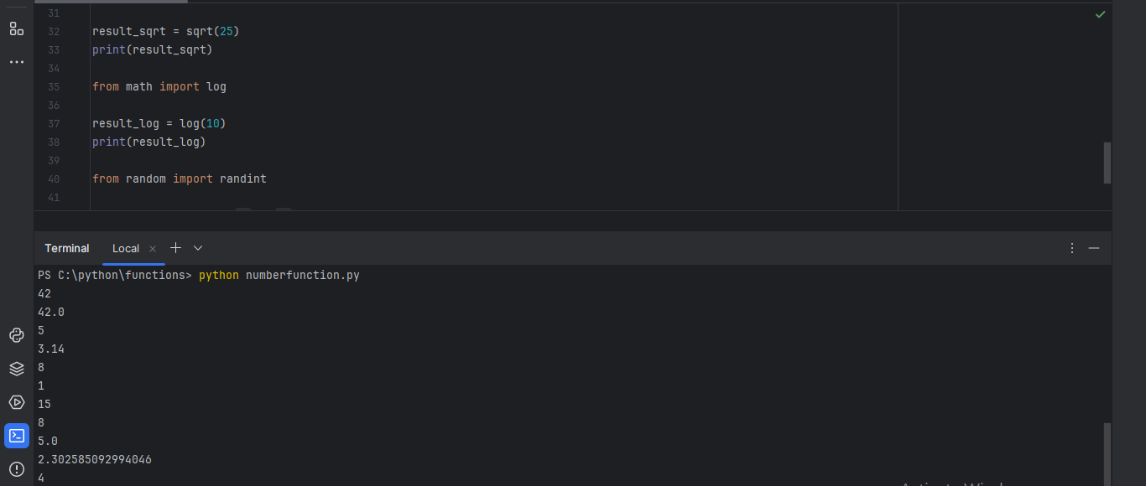

* Date and Time Function

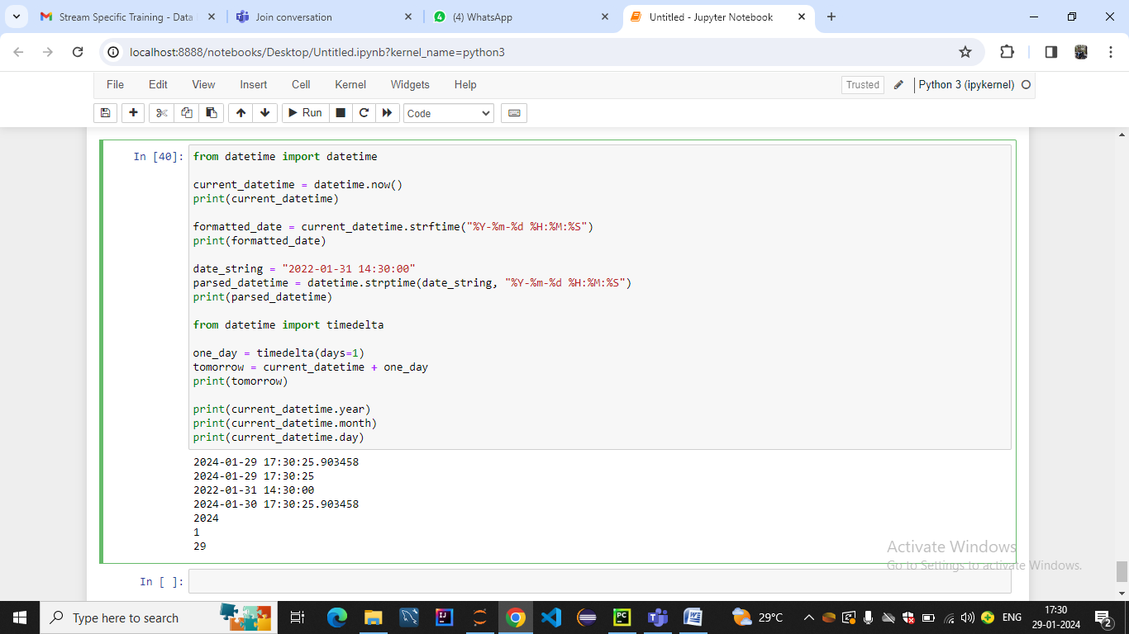

* Default Argument Values
* Keyword Arguments

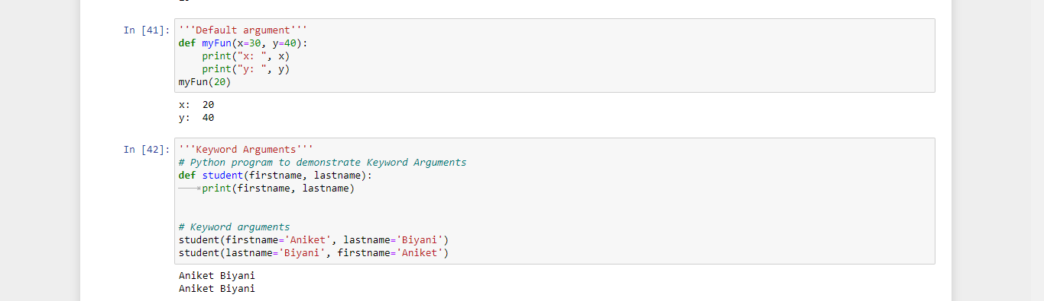

* Special parameters
* Arbitrary Argument Lists

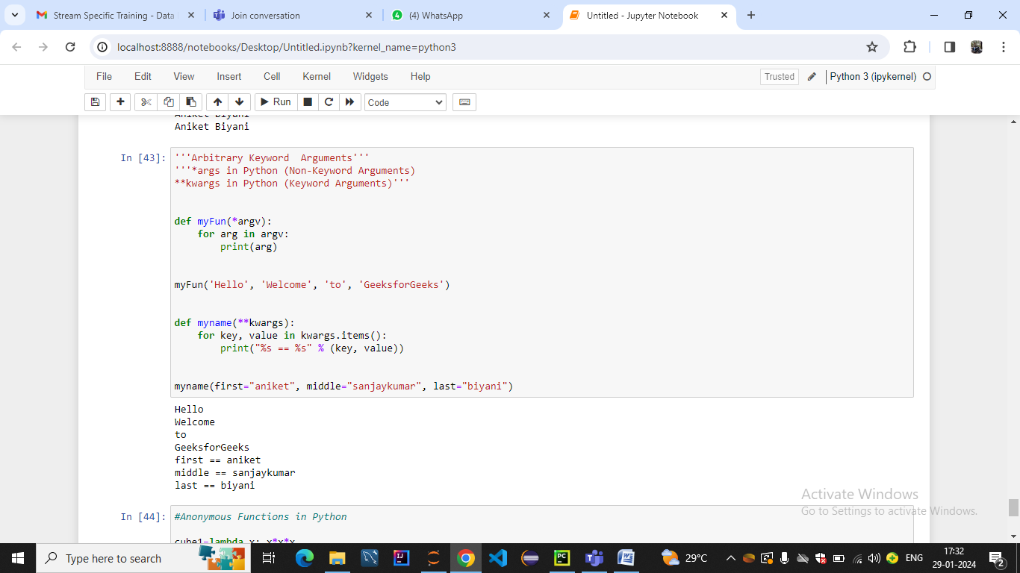

* Lambda Expressions

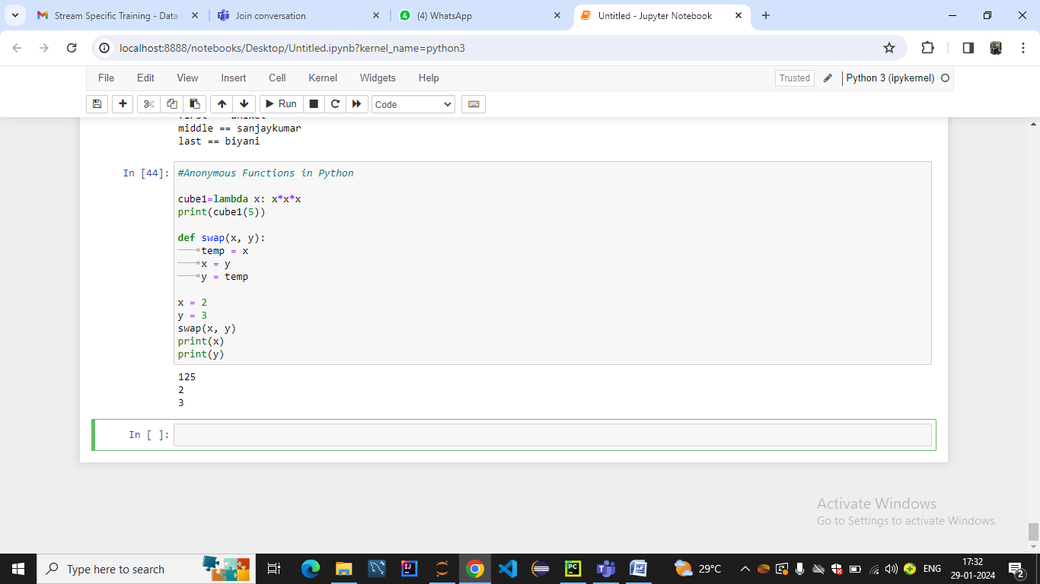

**OOPS**

* **Classes and Object**

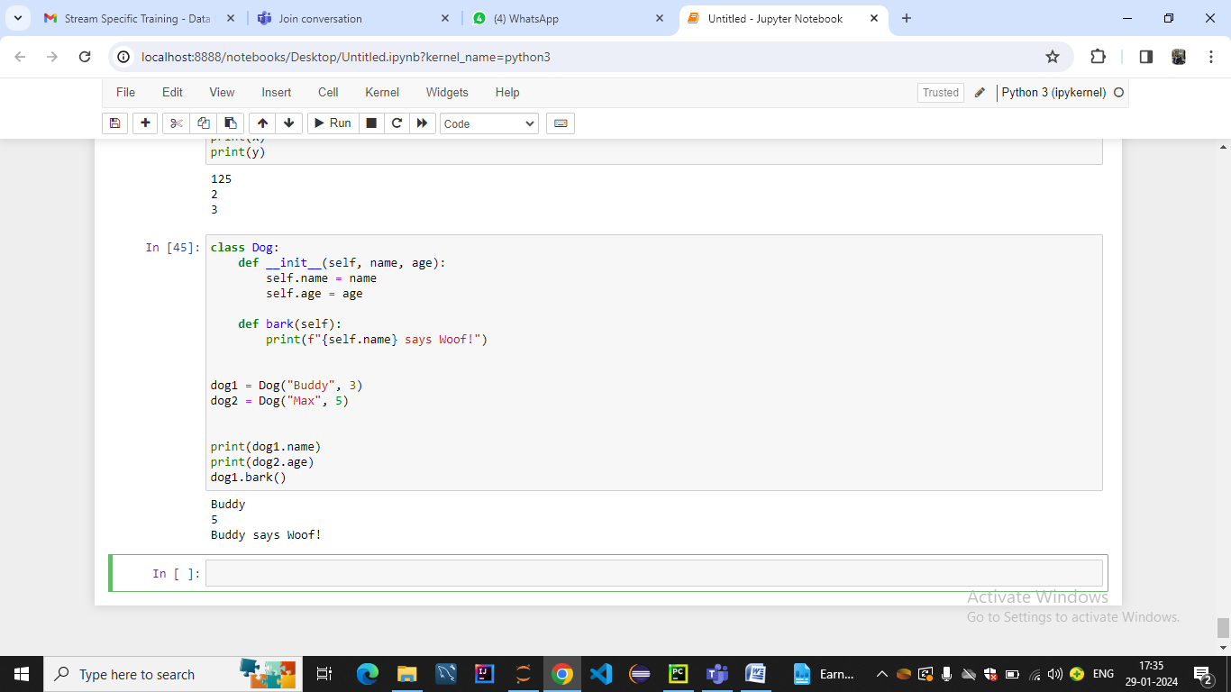

* **Inheritance**

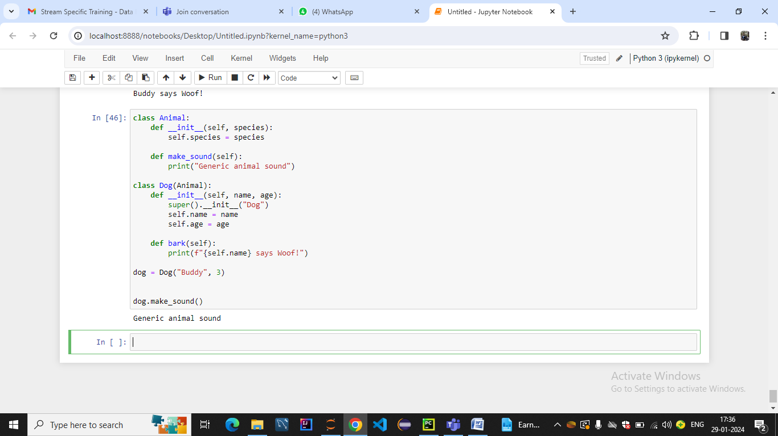

* **Encapsulation**

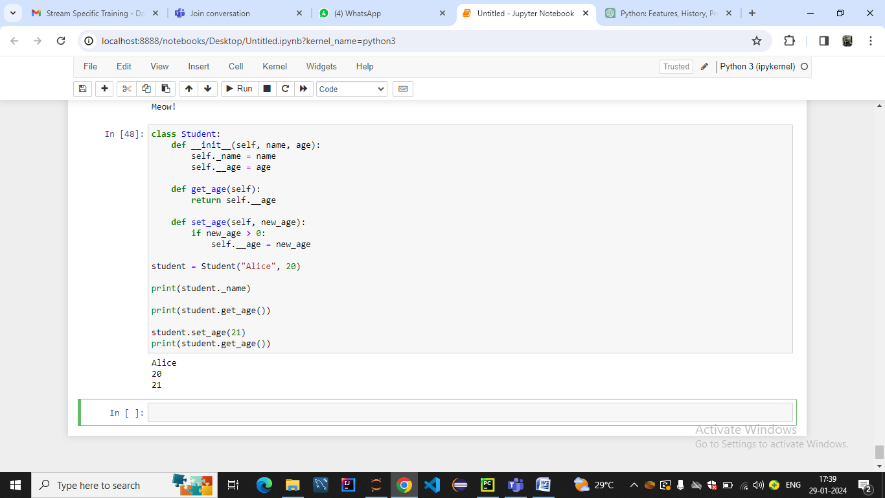

* **Method Overriding**
* 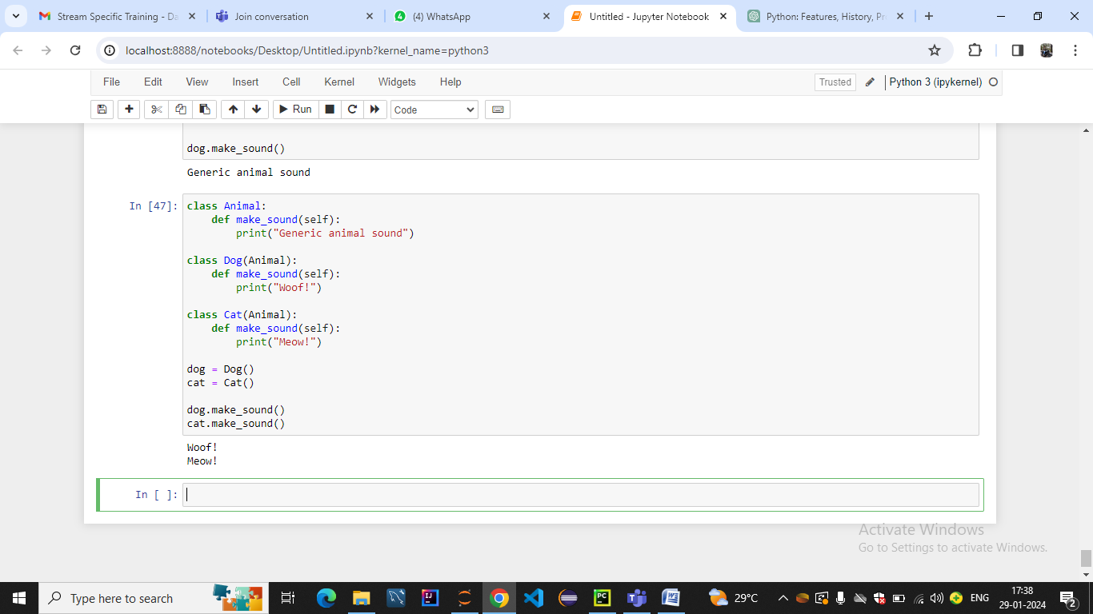
* **Exception Handling**

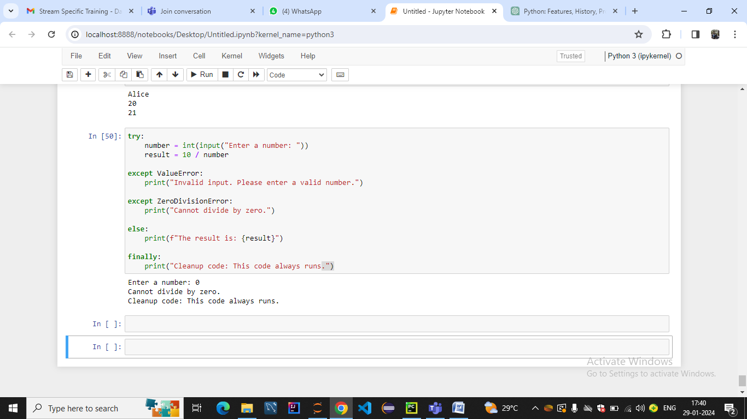

* **Modules**

