**NAME :- ANIKET SANJAYKUMAR BIYANI**

**DATA ENGINEERING BATCH -1**

**PYTHON DAY-07 ASSIGNMENT**

* File IO using Python
* File reading from file

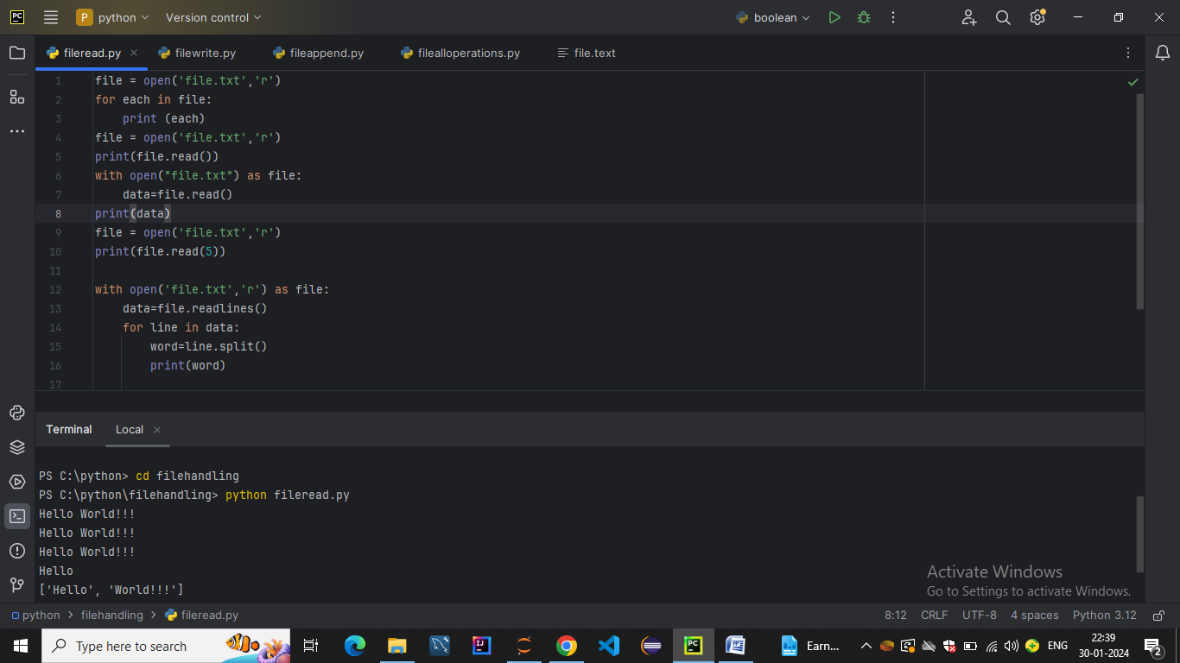

* File writing

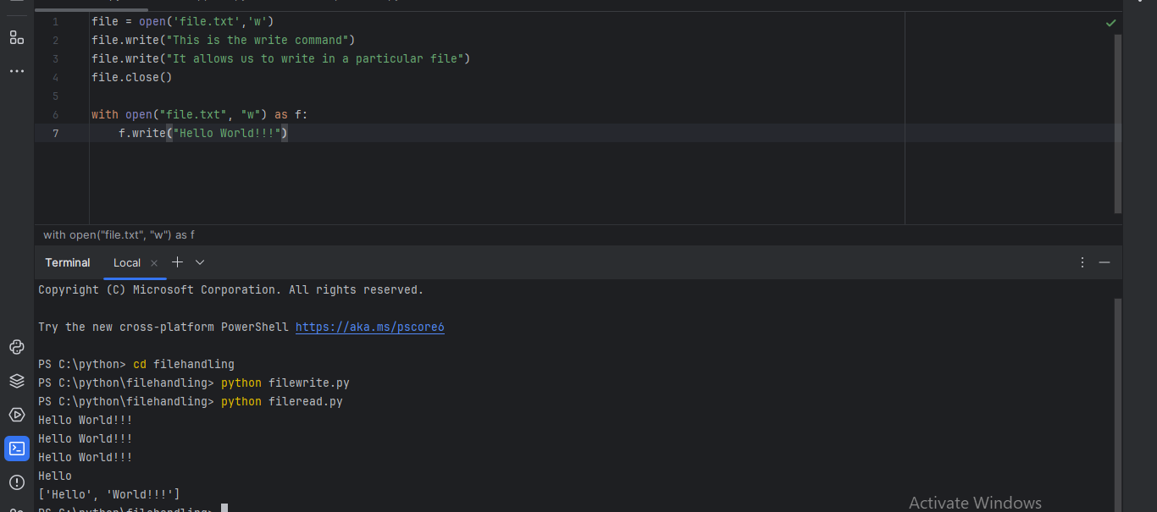

* File append

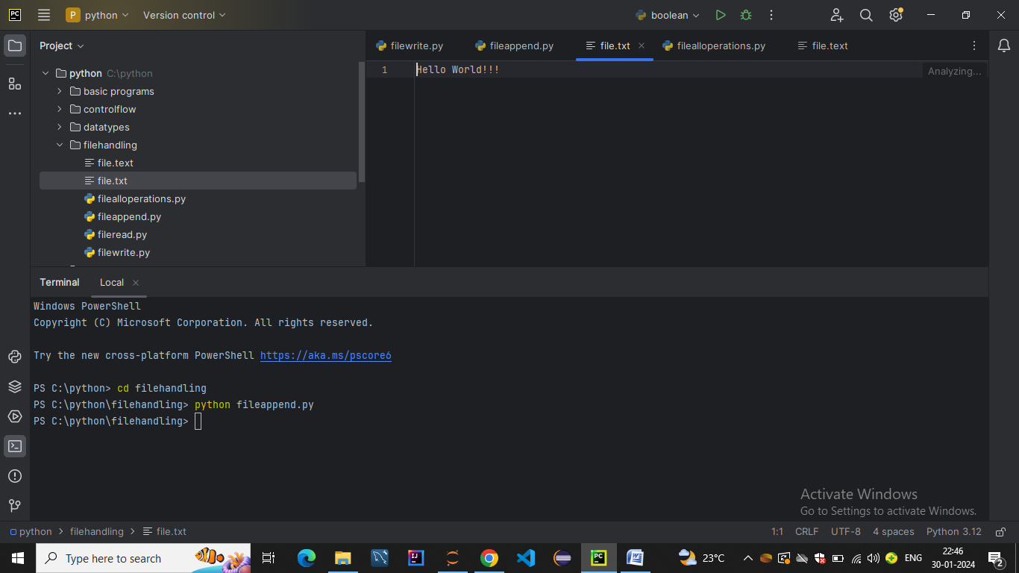

* File operations like create,read,append

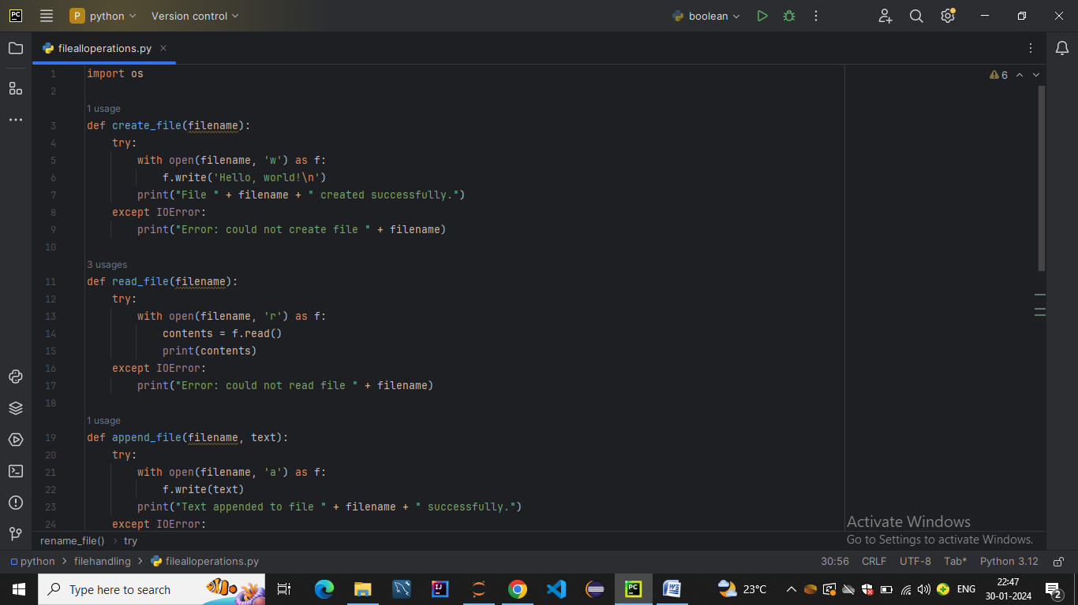

* Rename ,delete

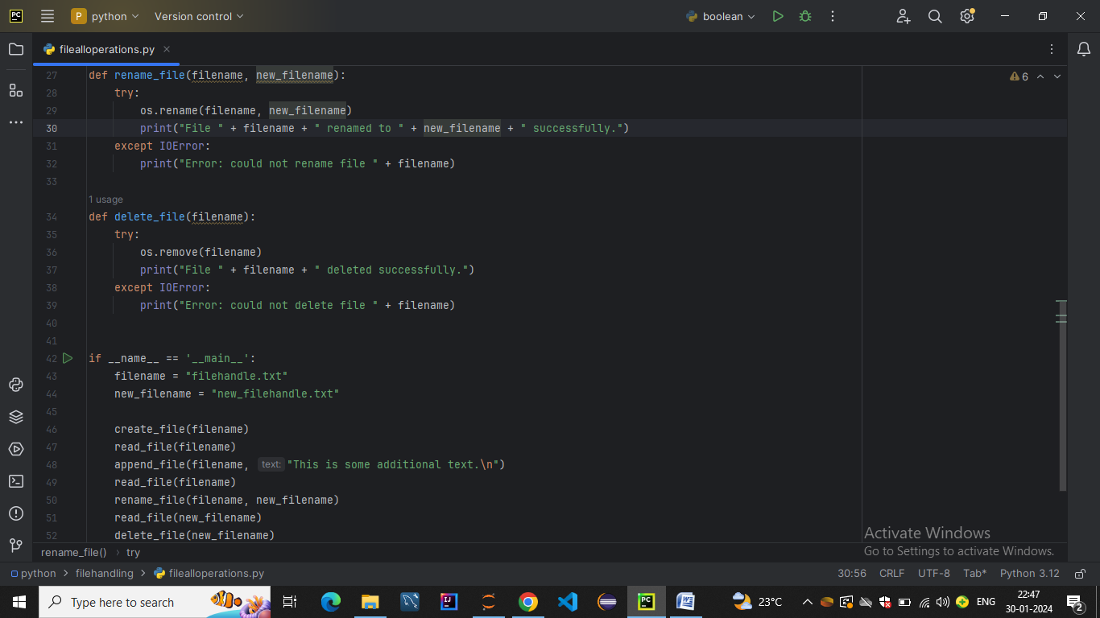

* OUTPUT:-

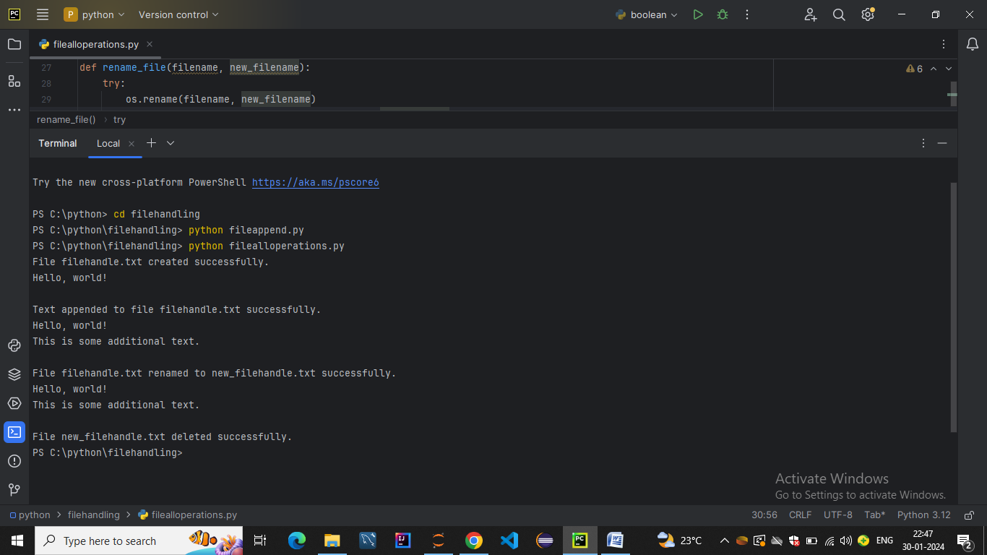

* Read Data from CSV File into Python List
* Read CSV file using csv.reader

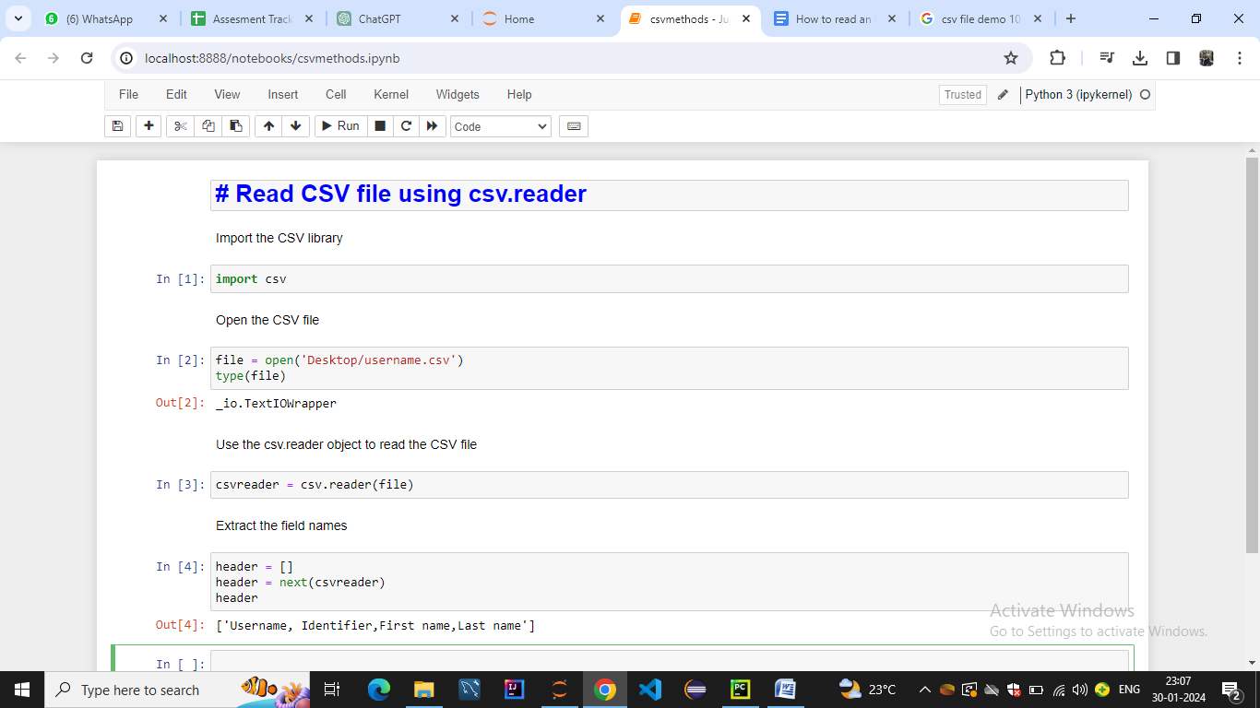

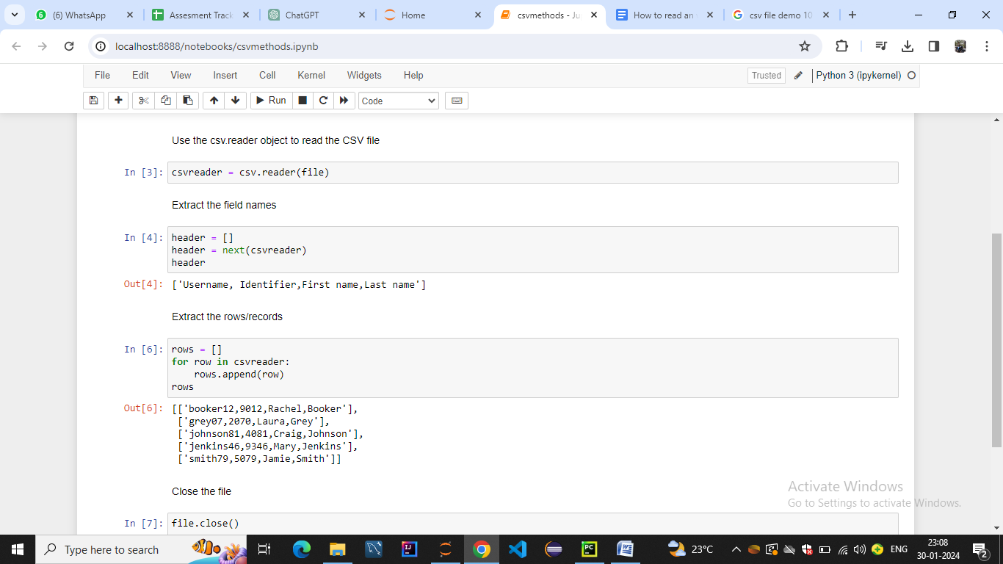

* Read CSV file using .readlines() function

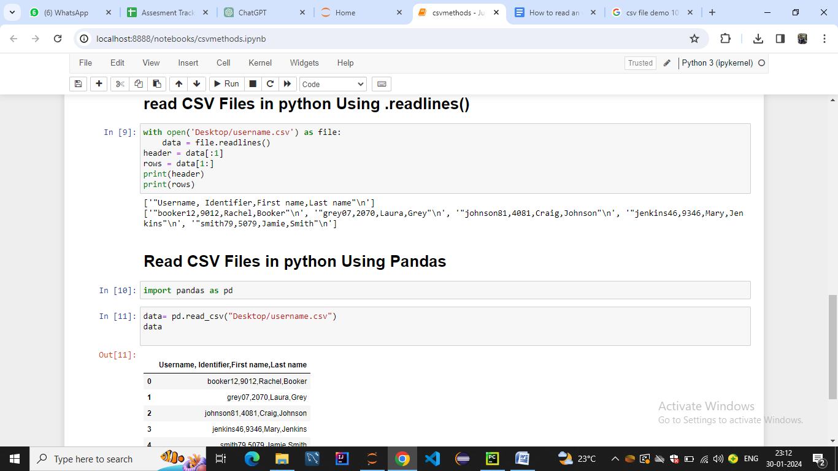

* Read CSV file using Pandas

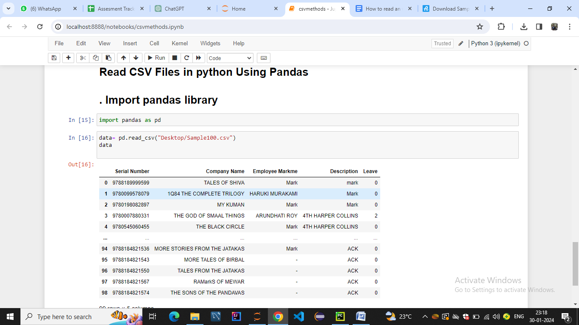

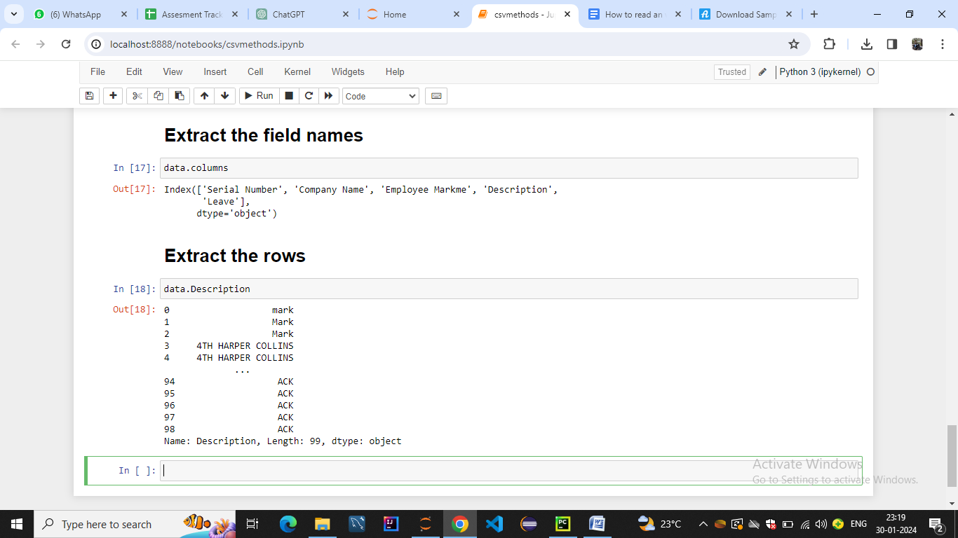

* Read CSV file using csv.DictReader

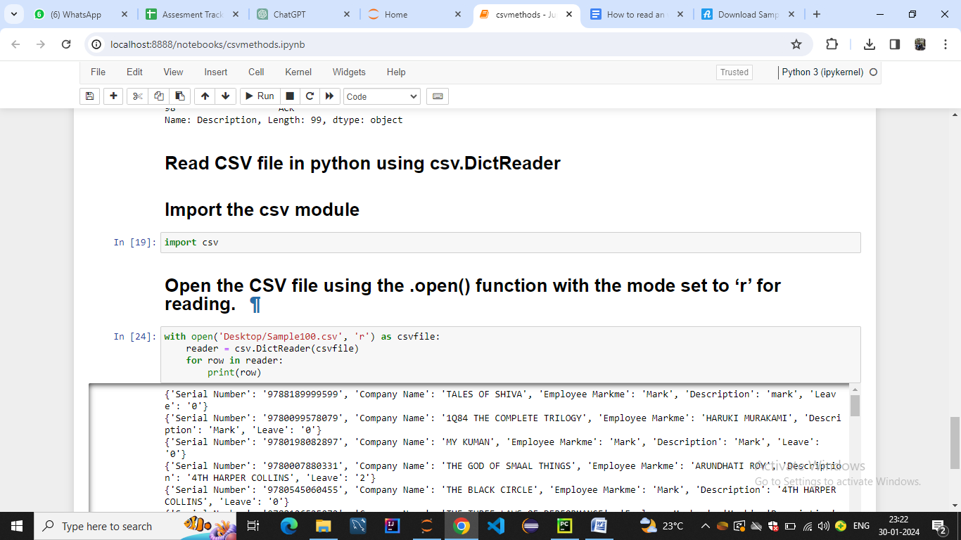

* Processing Python Lists

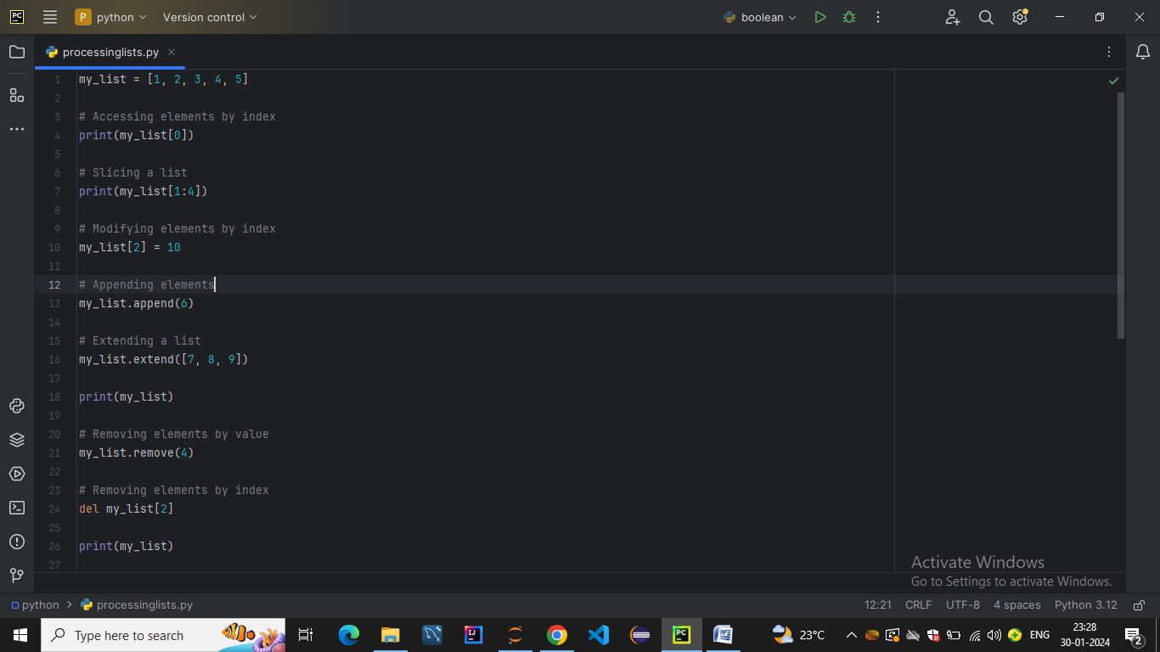

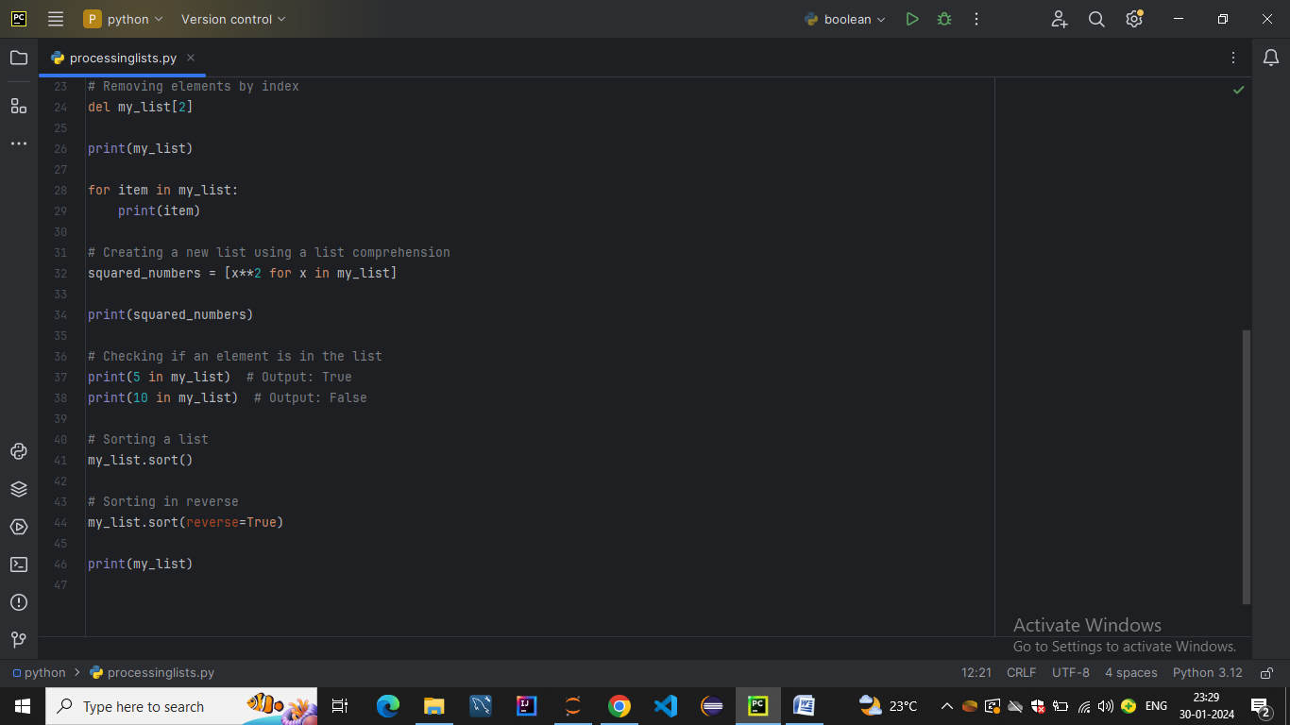

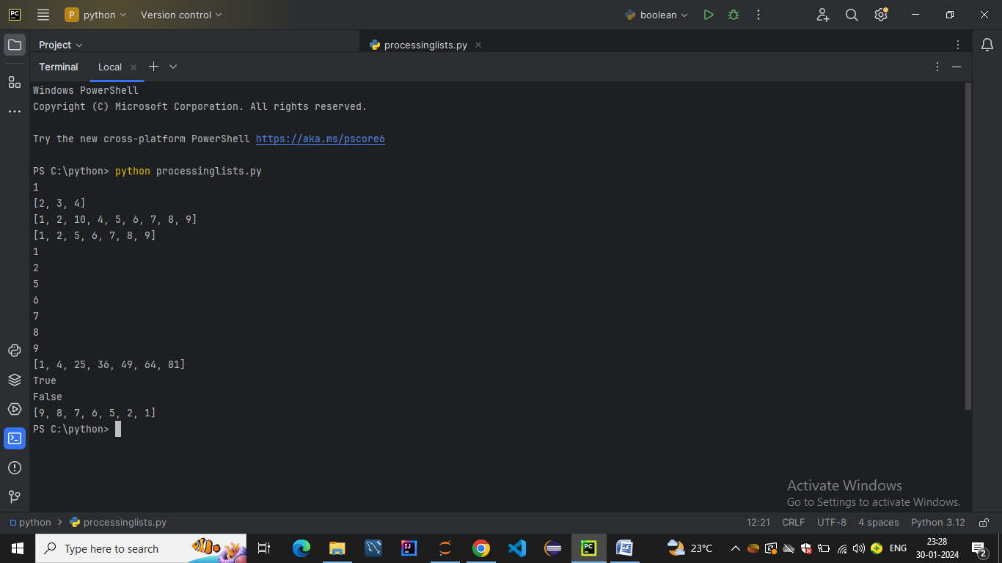

* Lambda Functions in Python
* a.Use of Lambda Function in Python
* Lambda functions in Python are anonymous functions defined using the lambda keyword. They are also known as lambda expressions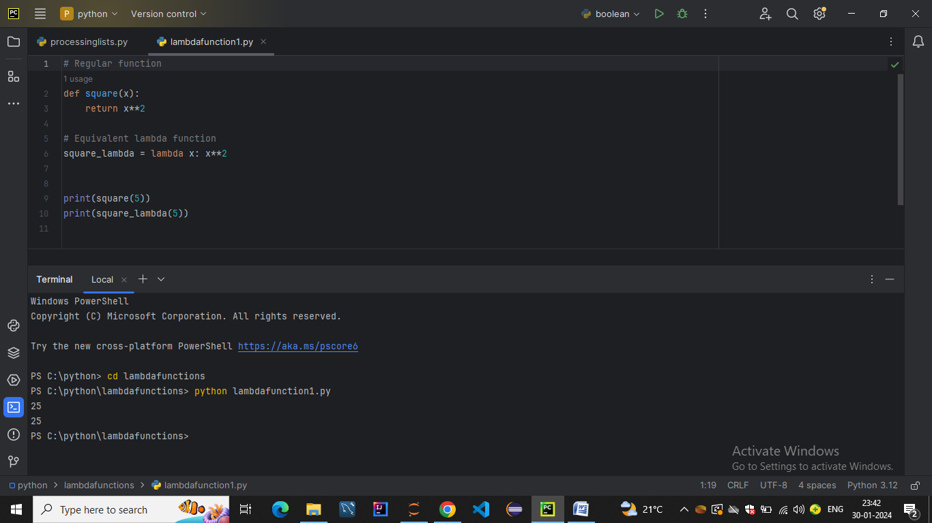
* . Unlike regular functions defined using the def keyword, lambda functions are concise and are typically used for short-term operations.
* Usage of Lambda Functions
* b.Practical Uses of Python lambda function
* Filter Data in Python Lists using filter and lambda
* Functional Arguments:

Lambda functions are often used as arguments to higher-order functions that take functions as parameters. For example, functions like map(), filter(), and sorted()

* Short-Term Use:

Lambda functions are handy when you need a quick, short-term function for a specific task. They are concise and can be defined in a single line.

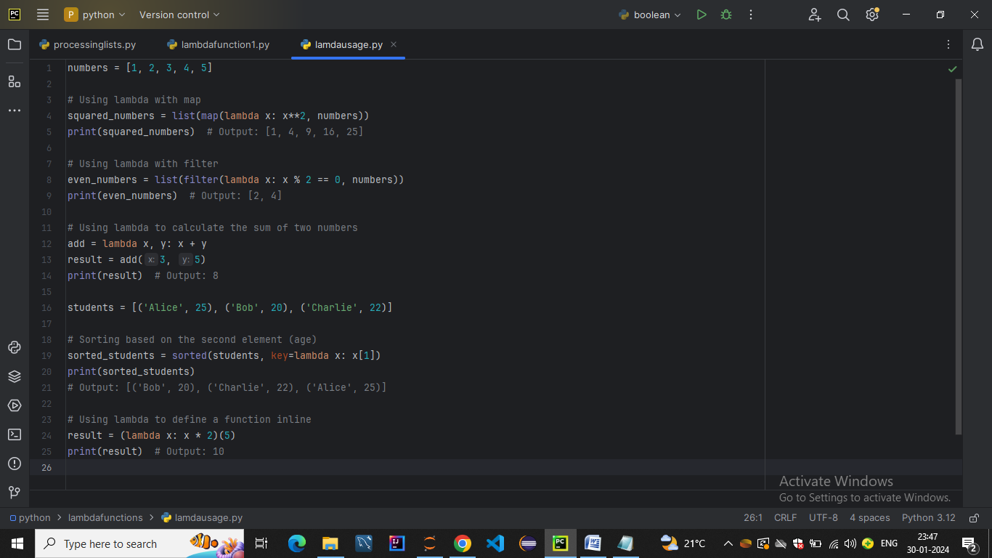

* Sorting:

Lambda functions can be used to define custom sorting criteria for functions like sorted()

* Inline Functions:

When a small, one-time function is needed, using a lambda can be more readable and avoids cluttering the code with unnecessary function definitions.

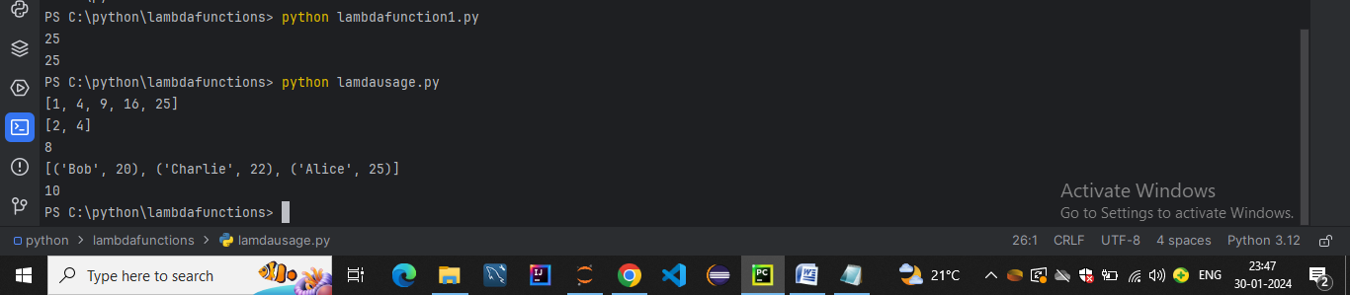

* c.Using lambda() Function with map(),filter(),reduce()

