**NAME :- ANIKET SANJAYKUMAR BIYANI**

**DATA ENGINEERING BATCH -1**

**PYTHON DAY-09 ASSIGNMENT**

* **Get unique values from list using set**

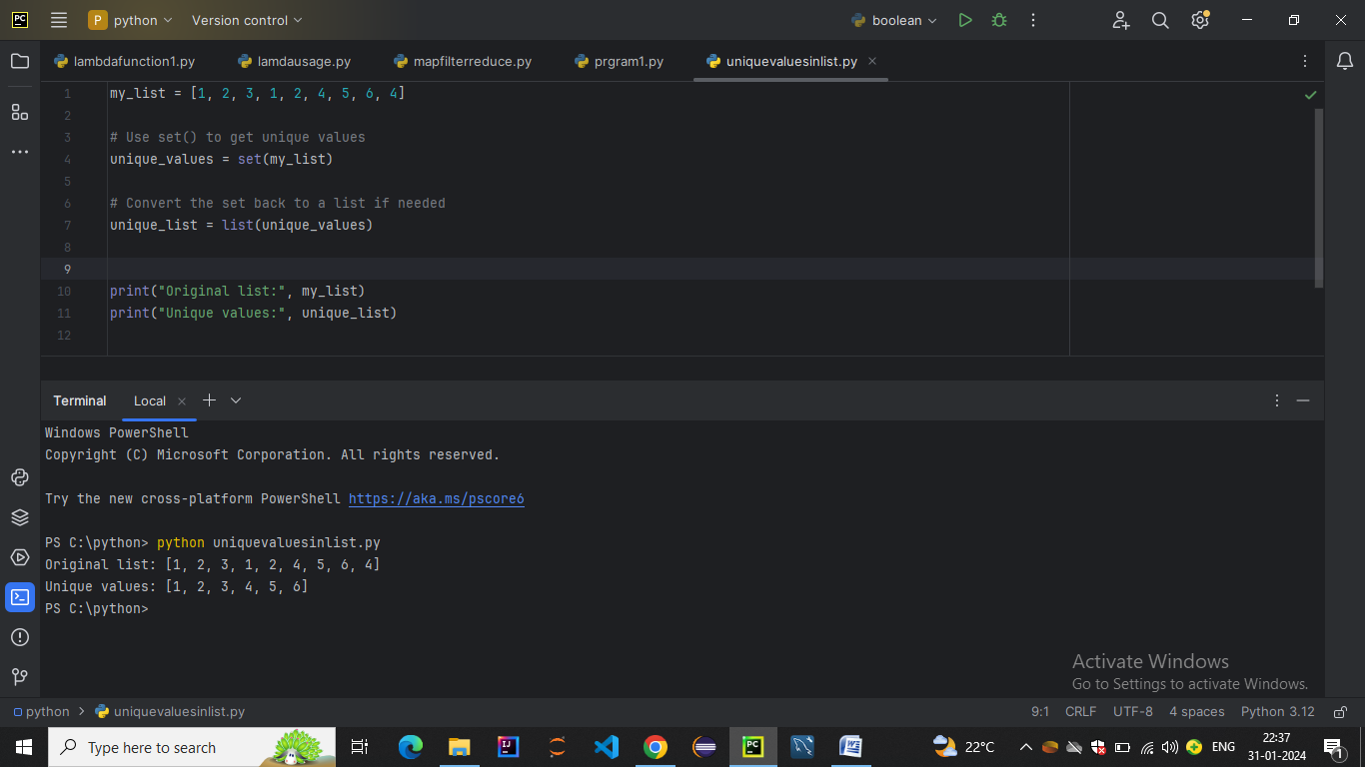

* **Get Unique Values From a List in Python Using reduce() function**

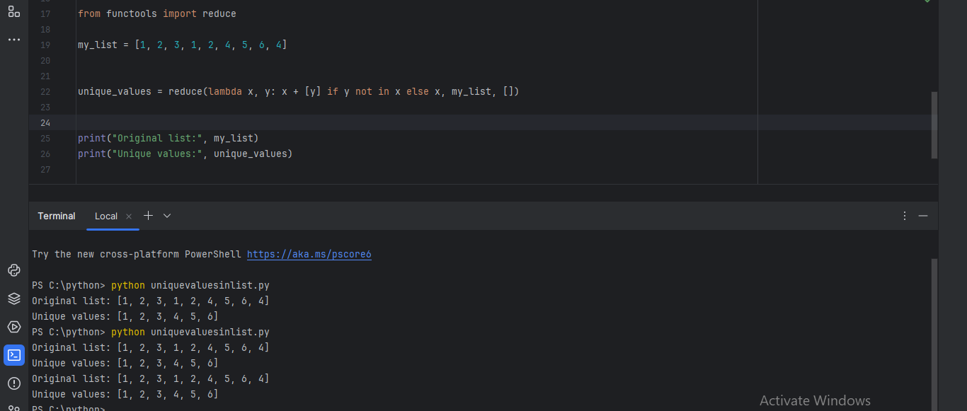

* **Get Unique Values From a List Using dict.fromkeys()**

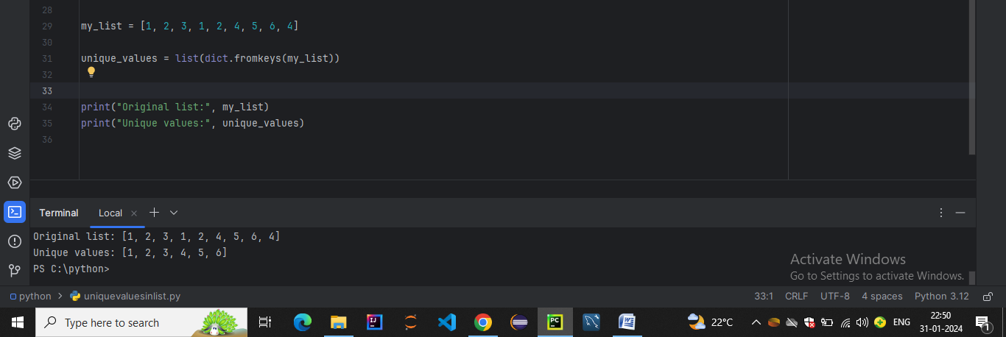

* **Get Unique Values From a List in Python Using pandas module**

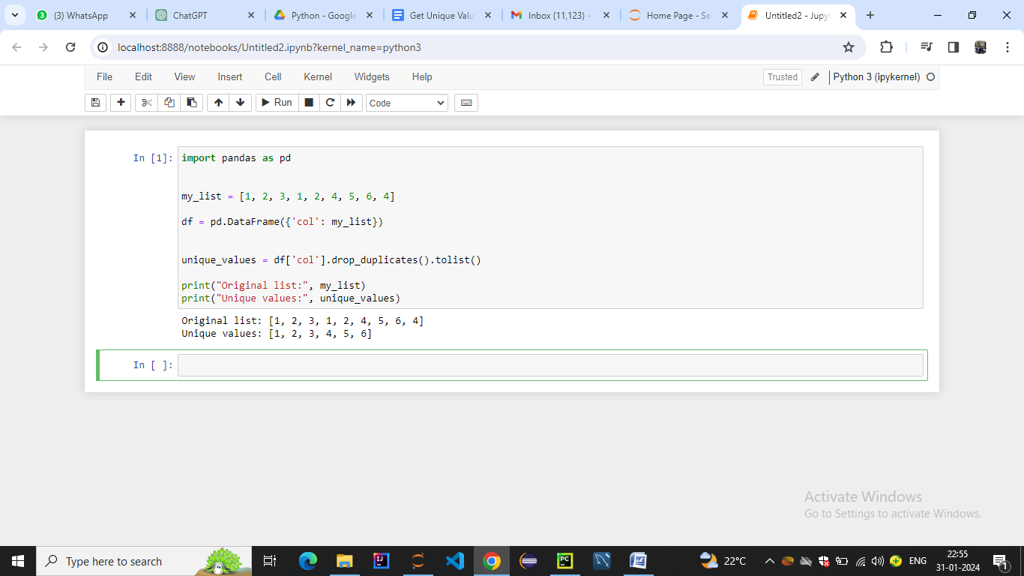

* **Get Unique Values From a List in Python Using collections.Counter()**

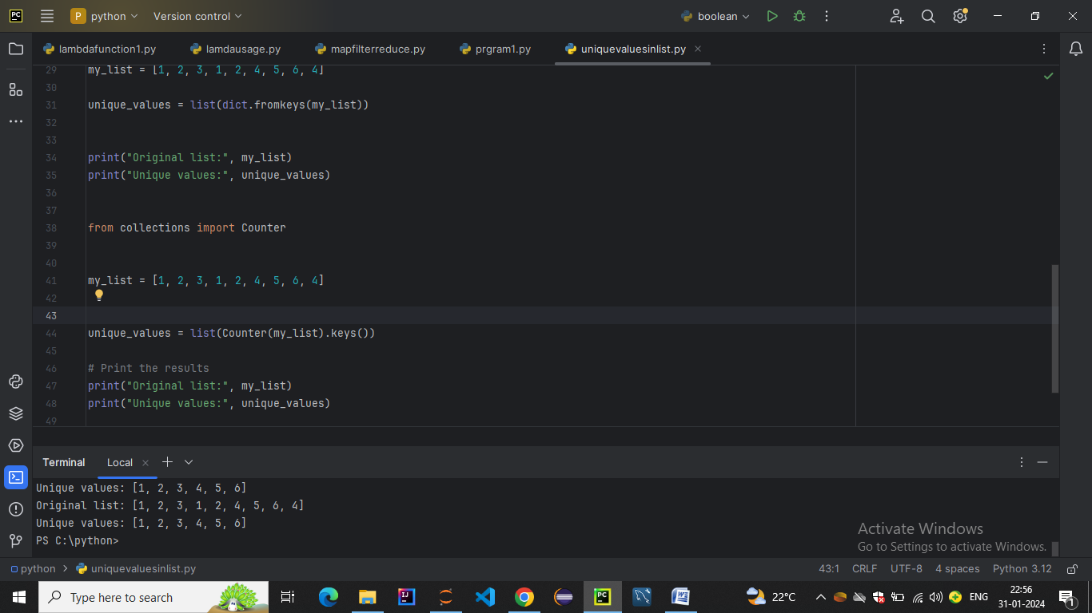

* **Get Unique Values From a List in Python Using sets and maps**

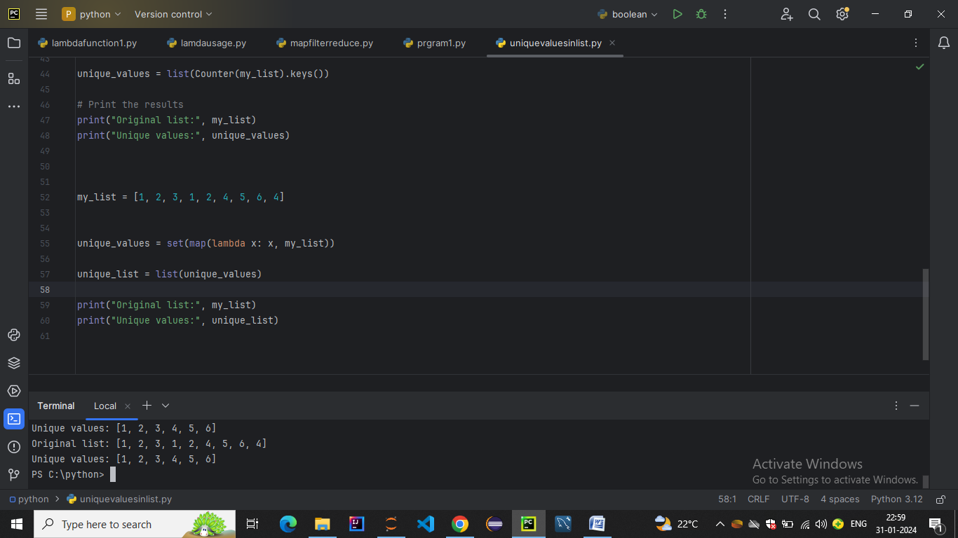

* **Sort Python lists using key**

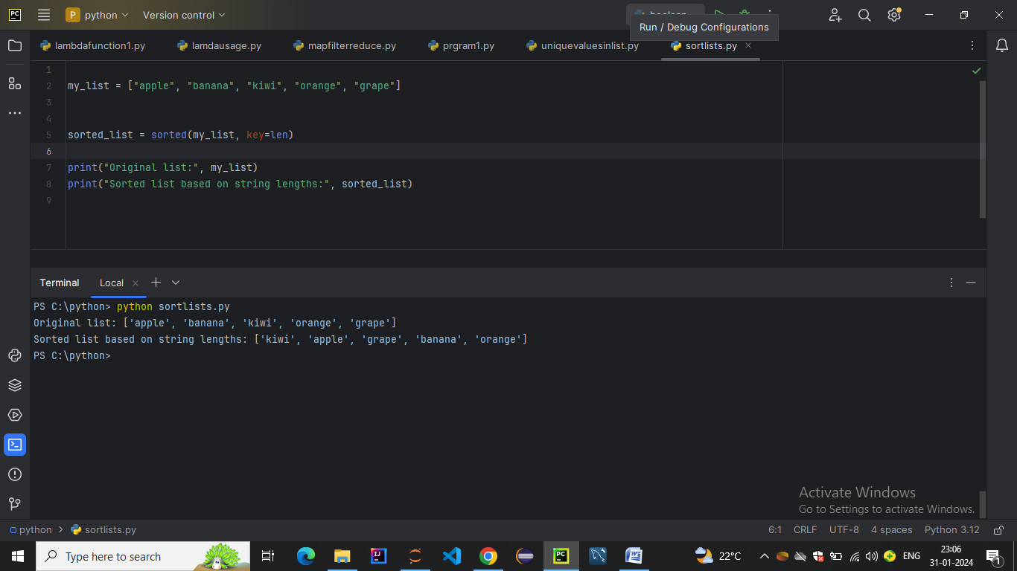

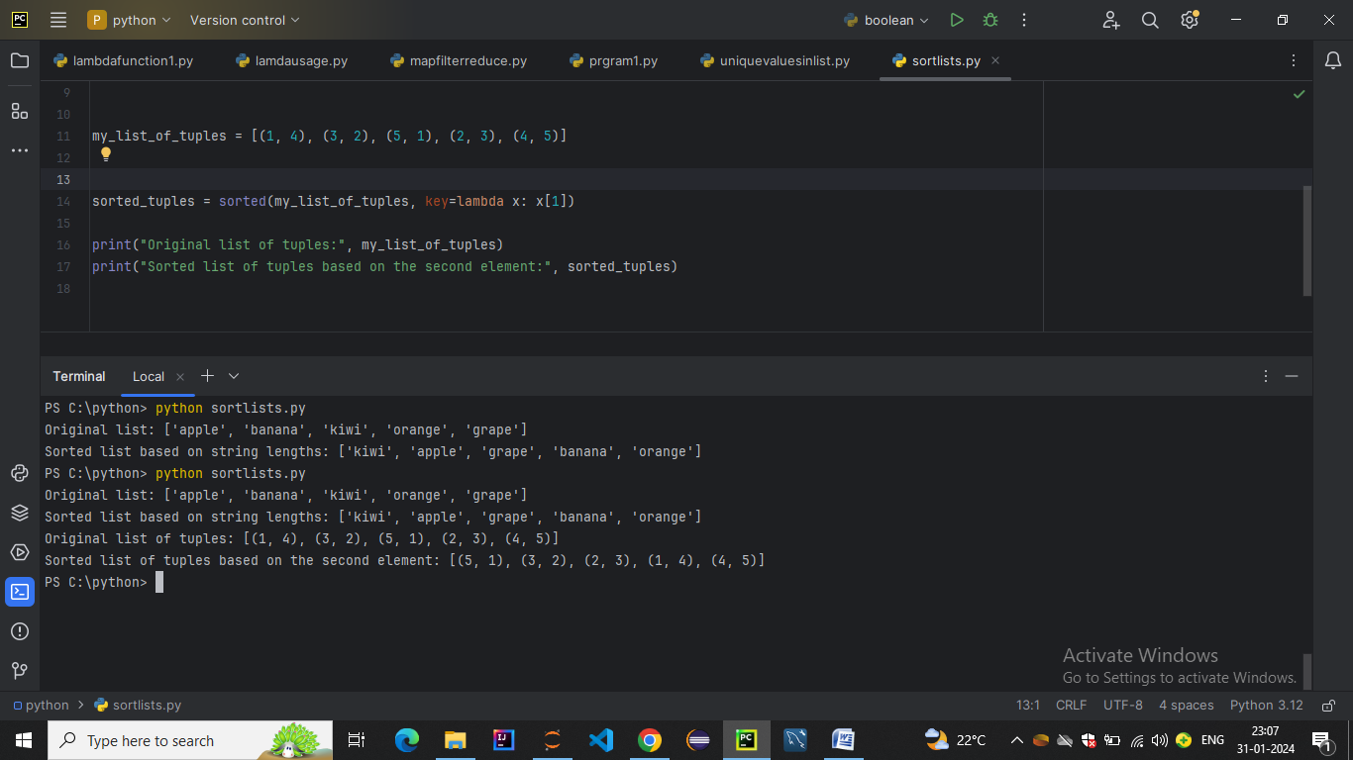

* **JSON** or **J**ava**S**cript **O**bject **N**otation
* **Convert JSON String to Dictionary Python**

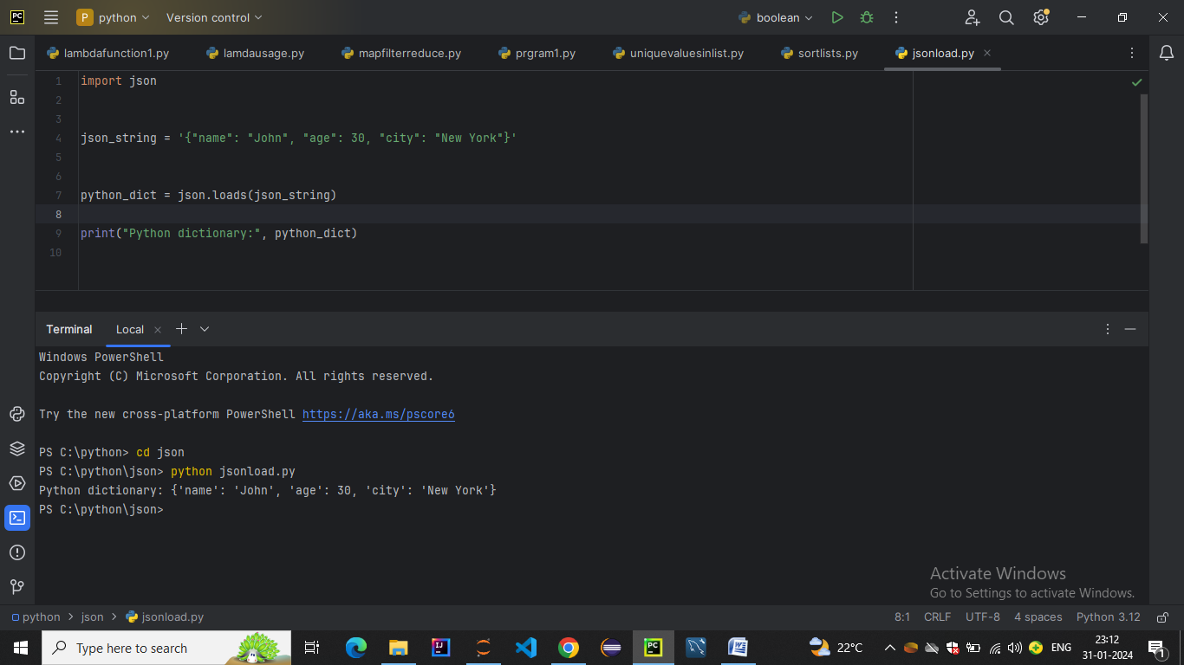

* **Convert JSON File to Python Object**

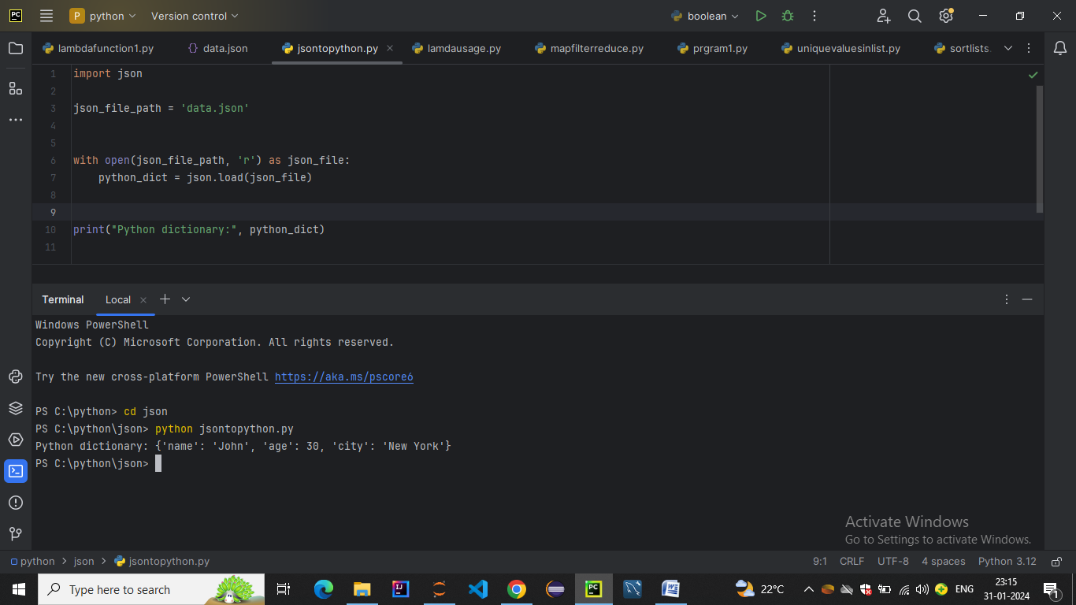

**Convert Nested JSON Object to Dictionary**

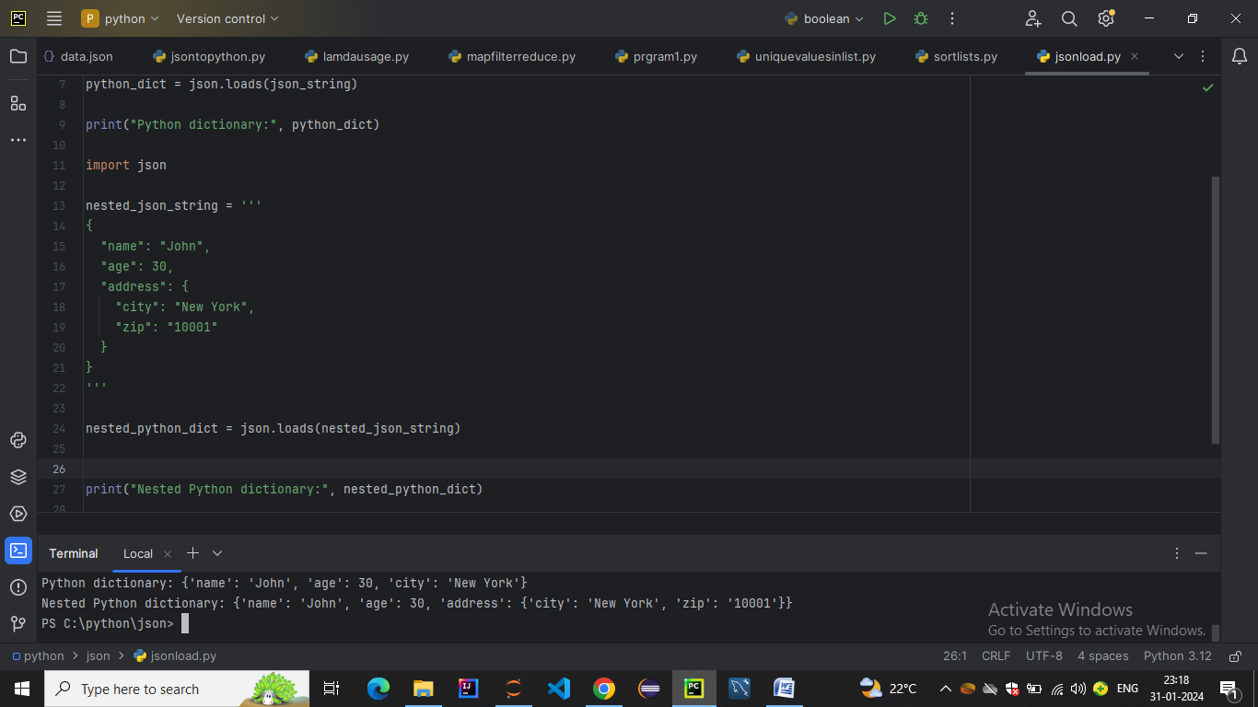

* **Convert JSON String to Dictionary in Python**

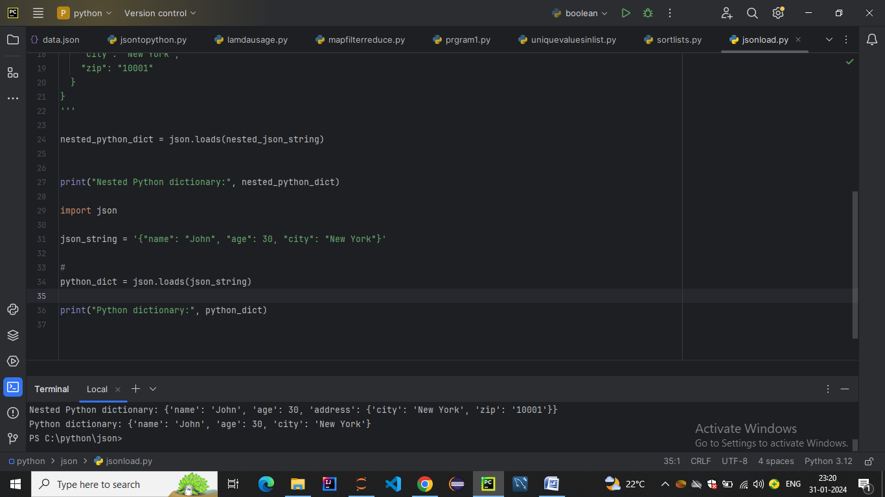

* **Convert Python Dict to JSON**

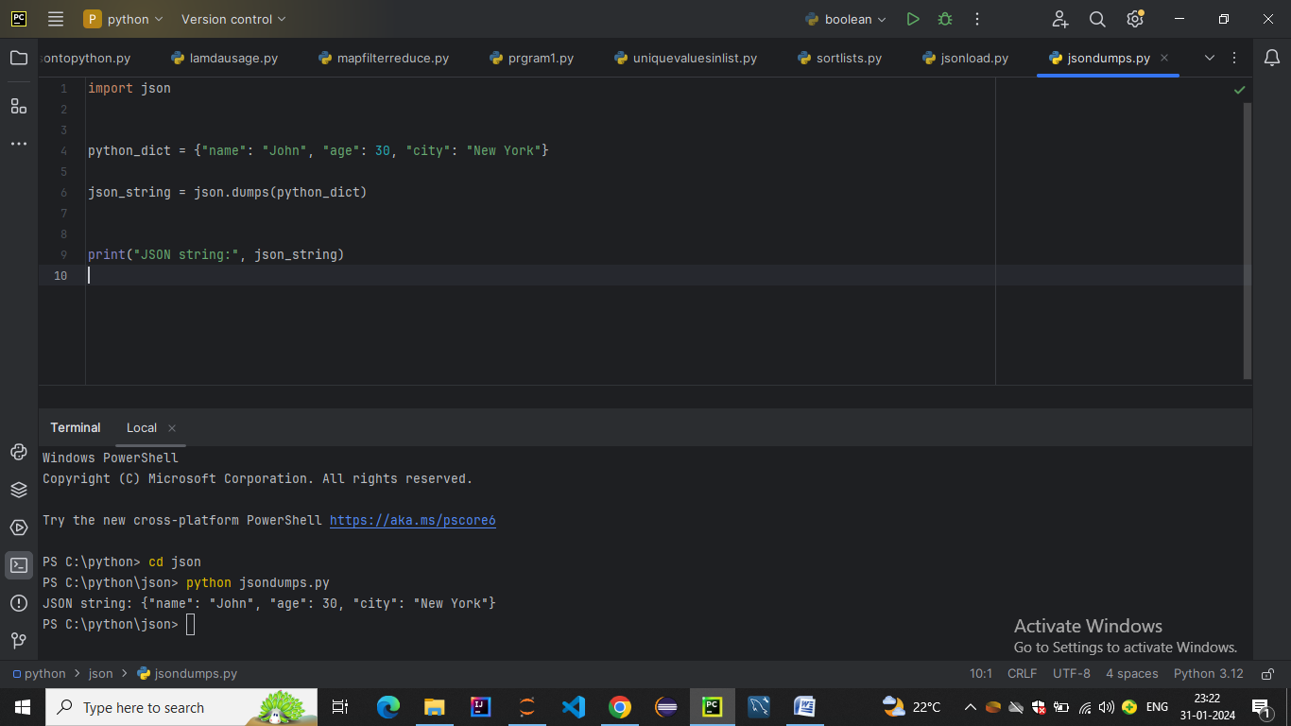

* **Writing JSON to a file in Python**

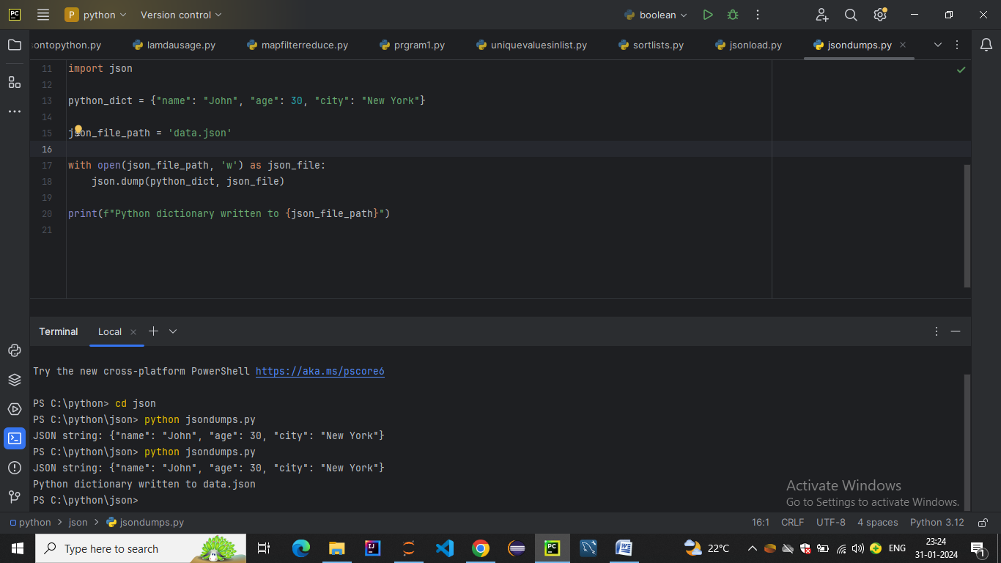

* **Python Pretty Print JSON**

