**NAME :- ANIKET SANJAYKUMAR BIYANI**

**DATA ENGINEERING BATCH -1**

**PYTHON DAY-09 ASSIGNMENT**

* **Pandas for Data Processing**
* Pandas is a Python library for data manipulation and analysis, providing versatile data structures like DataFrames.
* It excels in reading, filtering, and transforming data from various sources, such as CSV files. With powerful querying capabilities, it enables efficient data exploration.
* Pandas facilitates tasks like aggregation, sorting, and joining, offering a comprehensive toolkit for data processing. Additionally, it supports seamless data export to various formats, including CSV and JSON.
* **Reading CSV Data using Pandas**

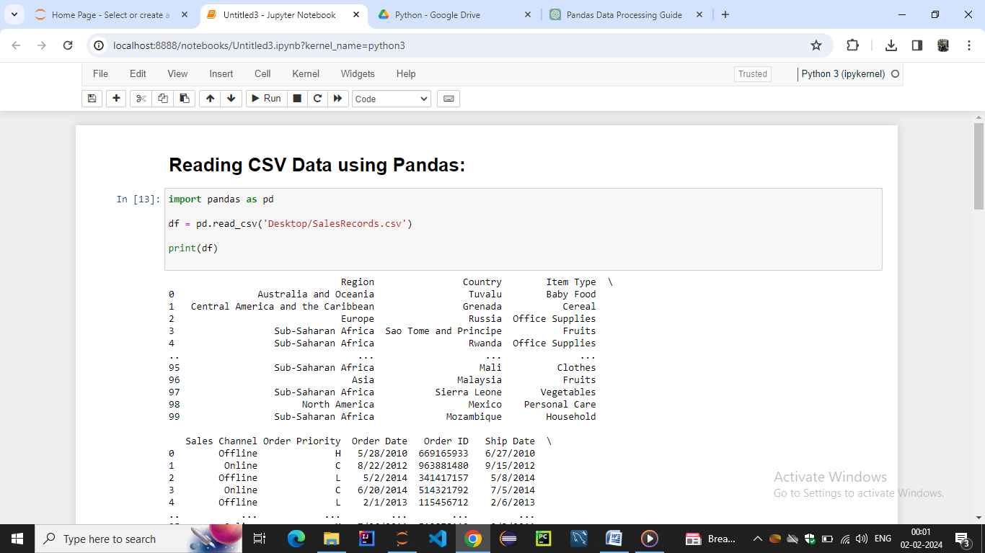

* **Read Data from CSV Files to Pandas Dataframes**

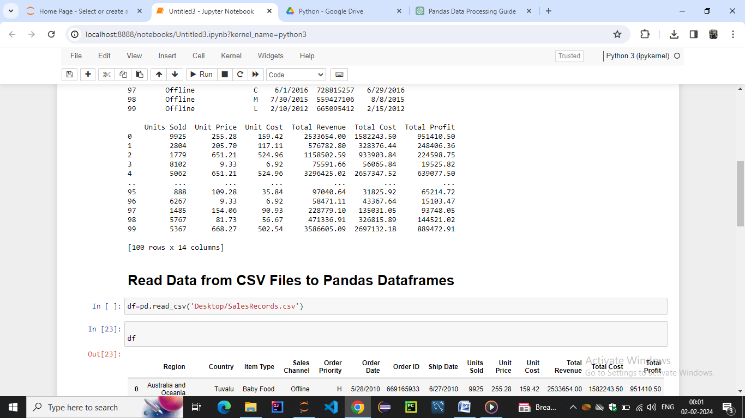

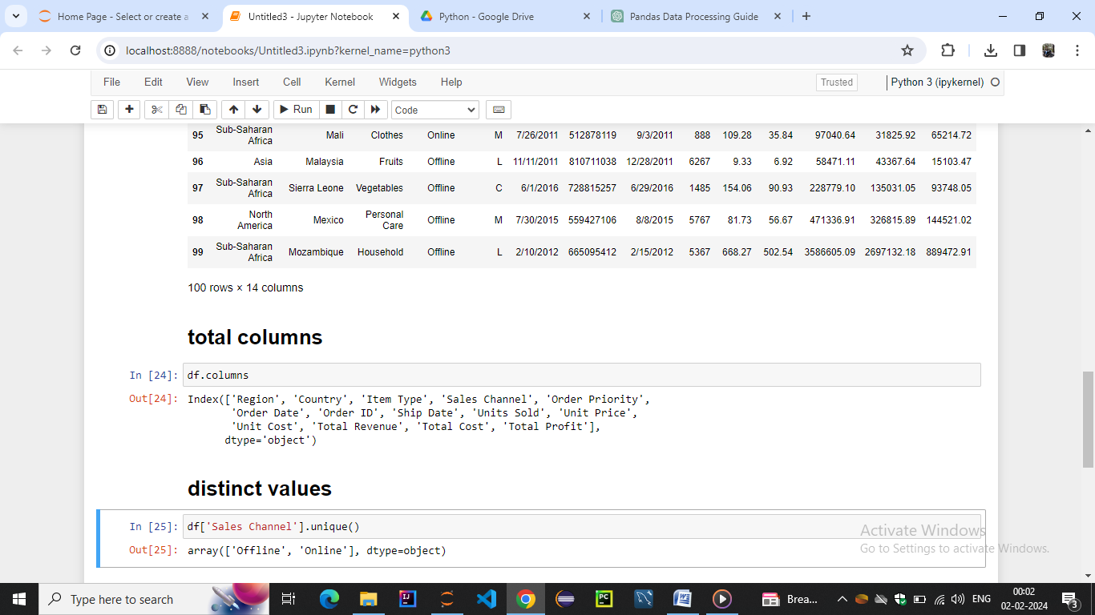

* **Filter Data in Pandas Dataframe using query**

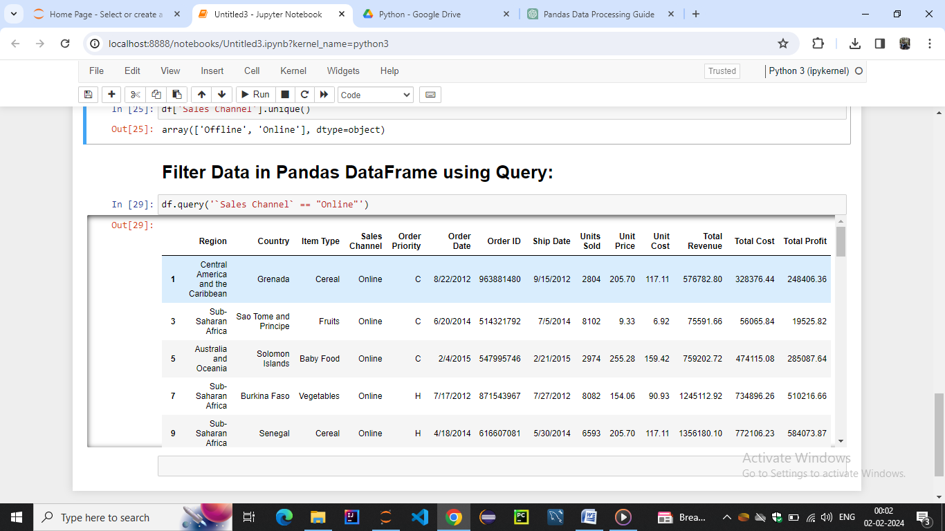

* **Get Count by Status using Pandas Dataframe APIs**

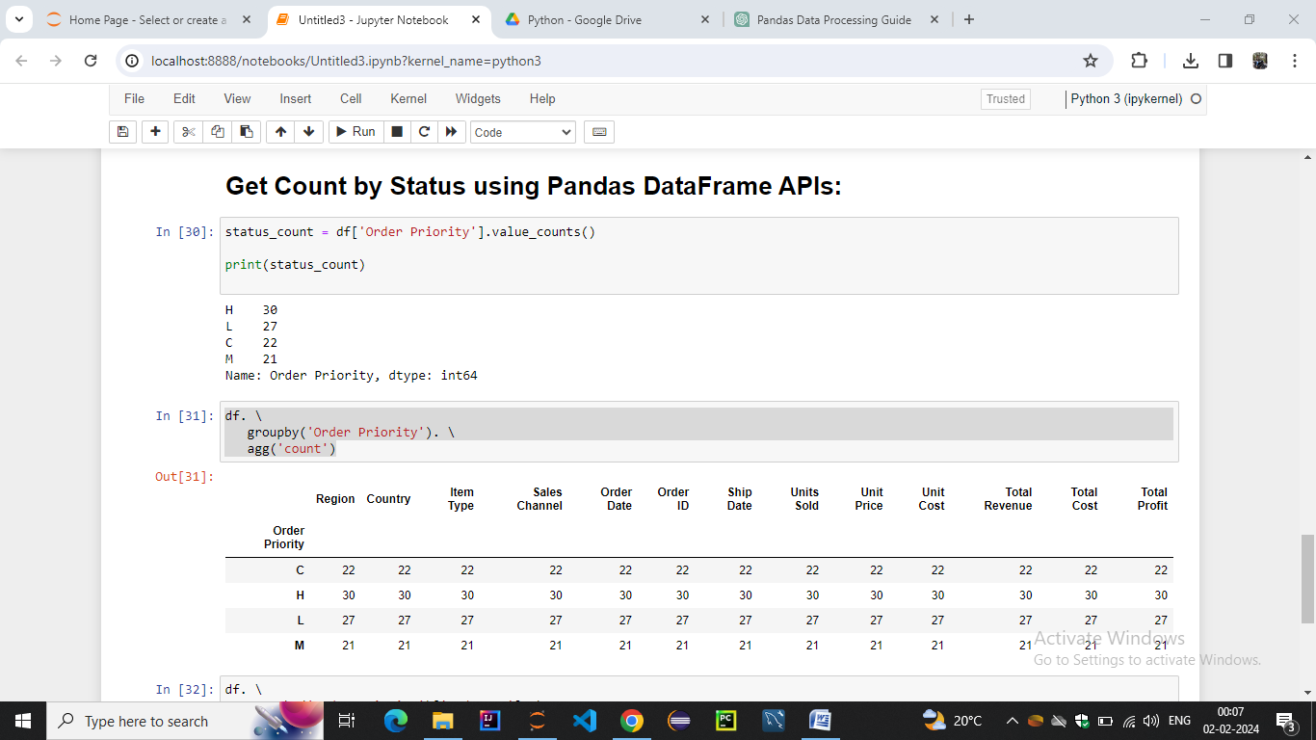

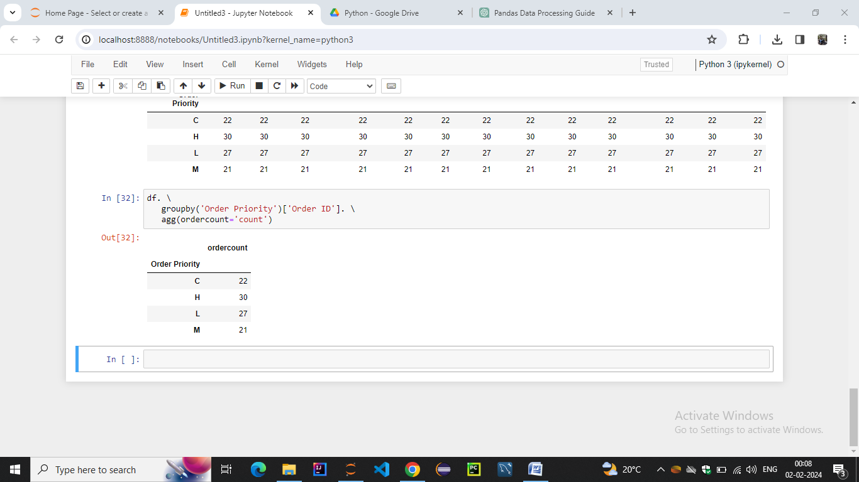

* **Get count by Month and Status using Pandas Dataframe APIs**

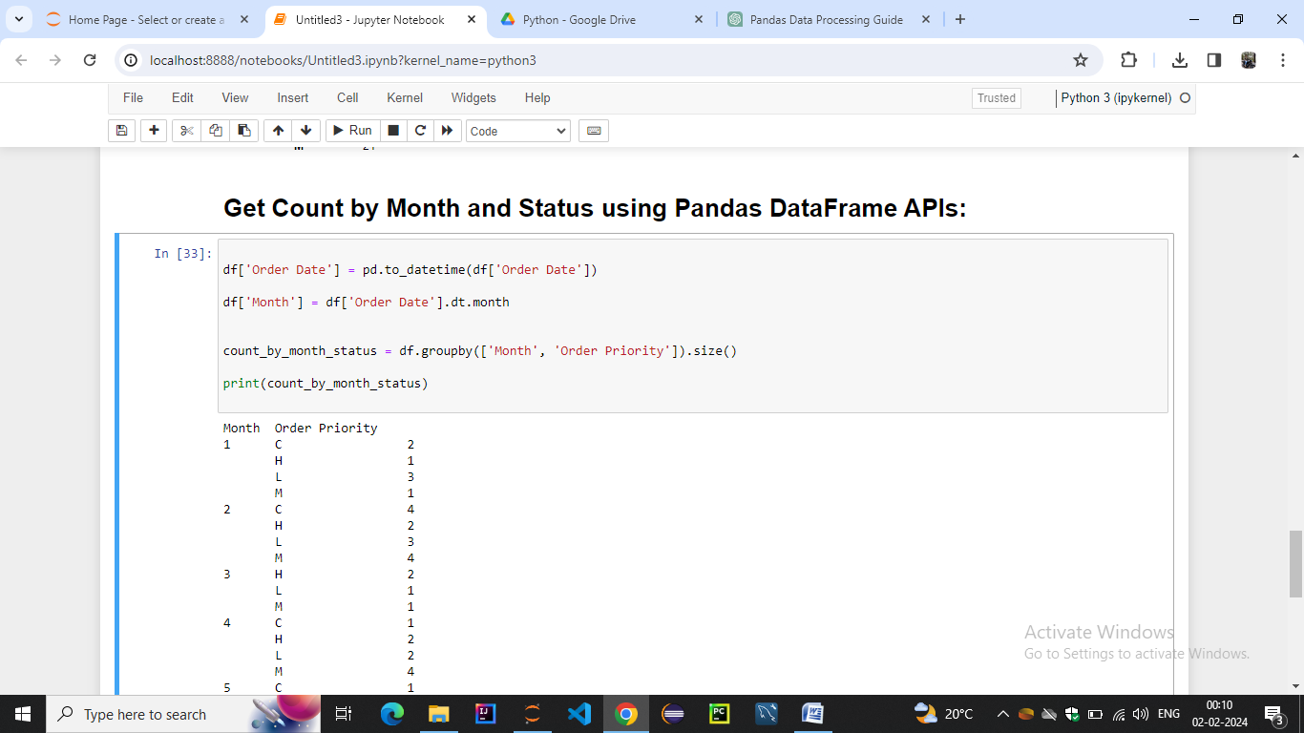

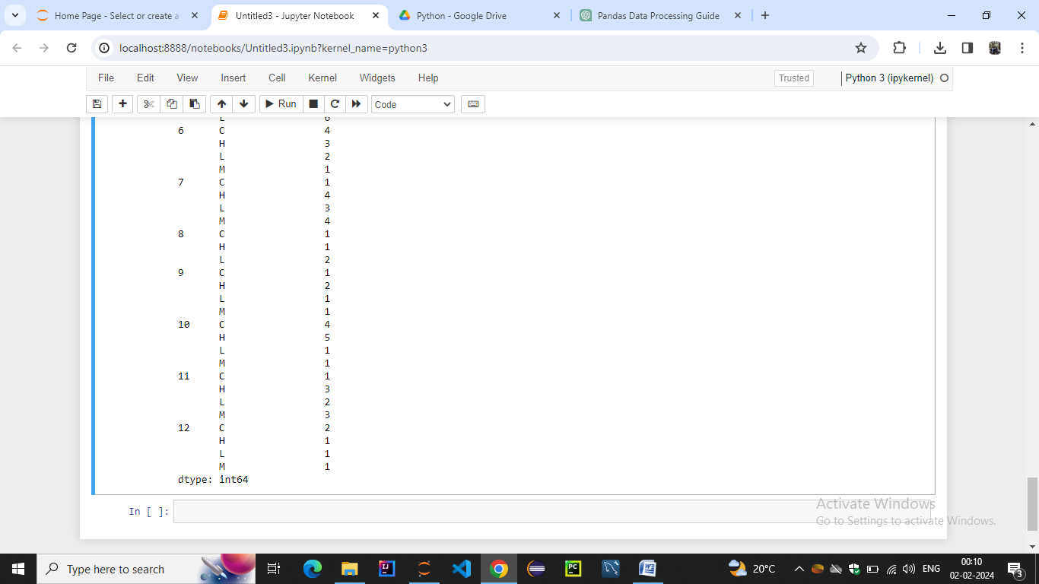

* **Create Dataframes using dynamic column list on CSV Data**

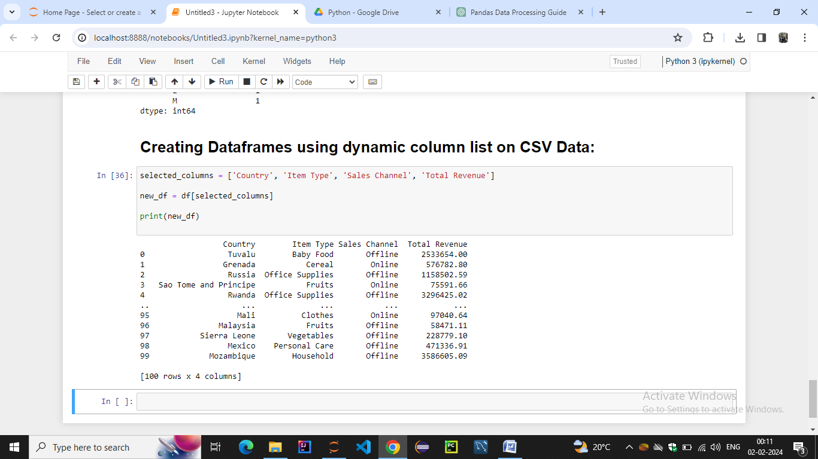

* **Performing Inner Join between Pandas Dataframes**

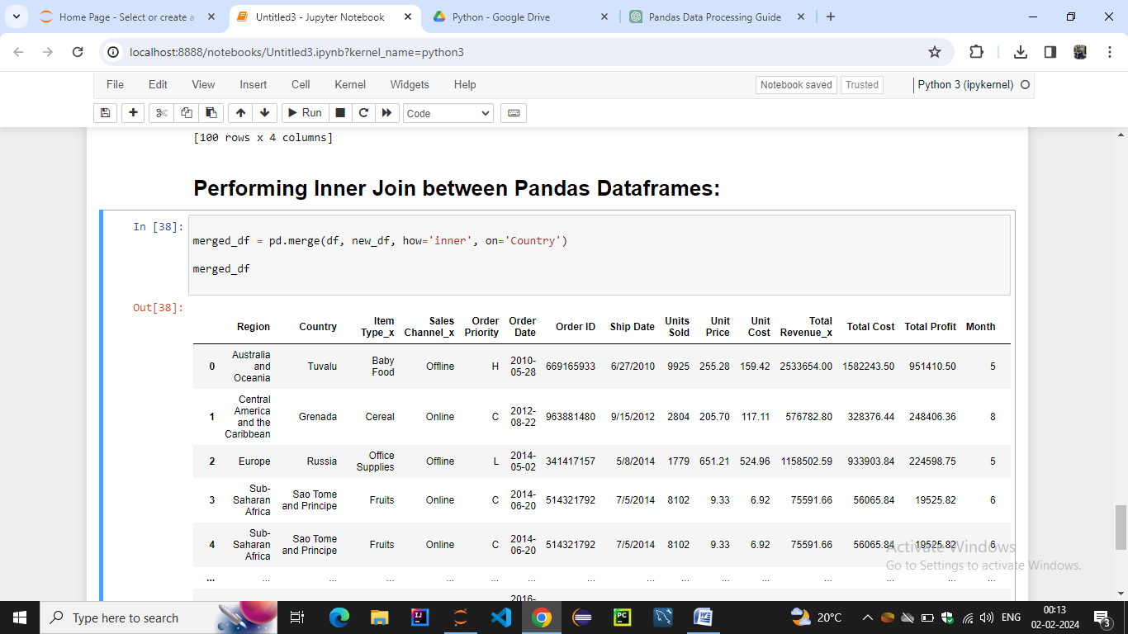

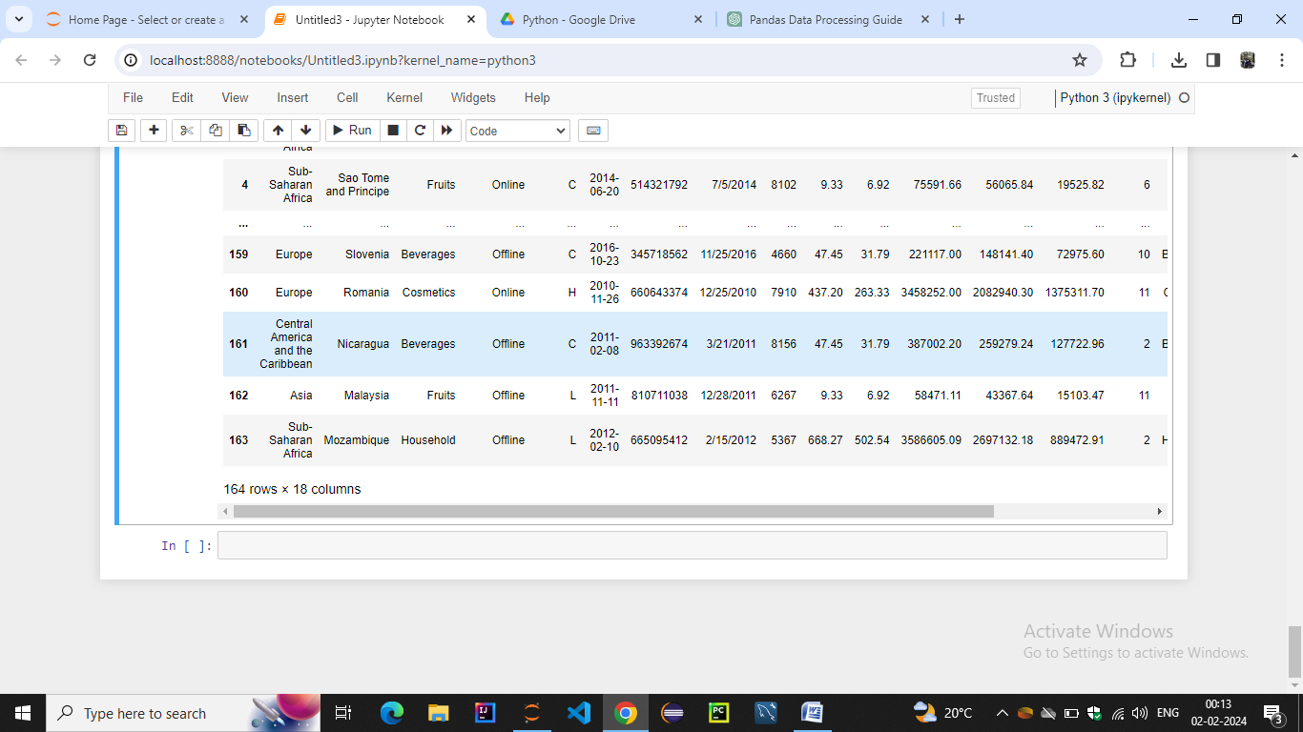

* **Perform Aggregations on Join results**

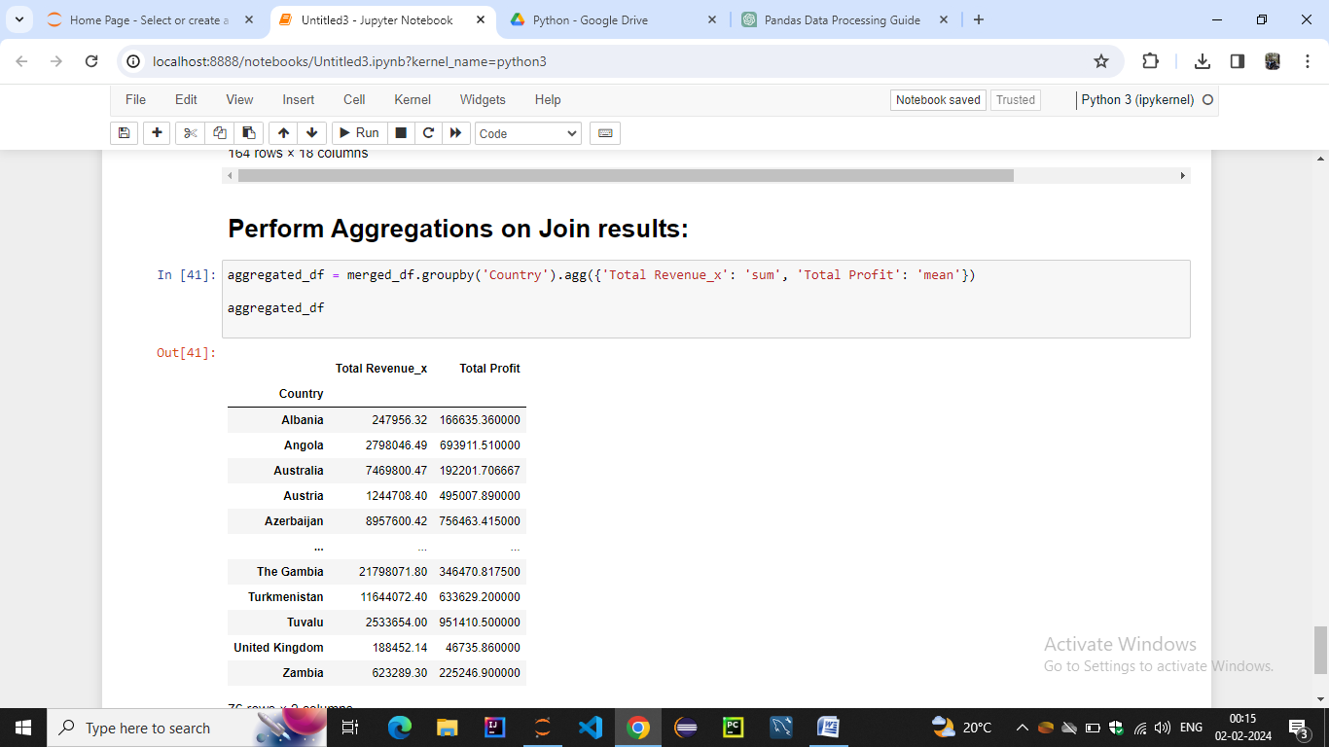

* **Sort Data in Pandas Dataframes**

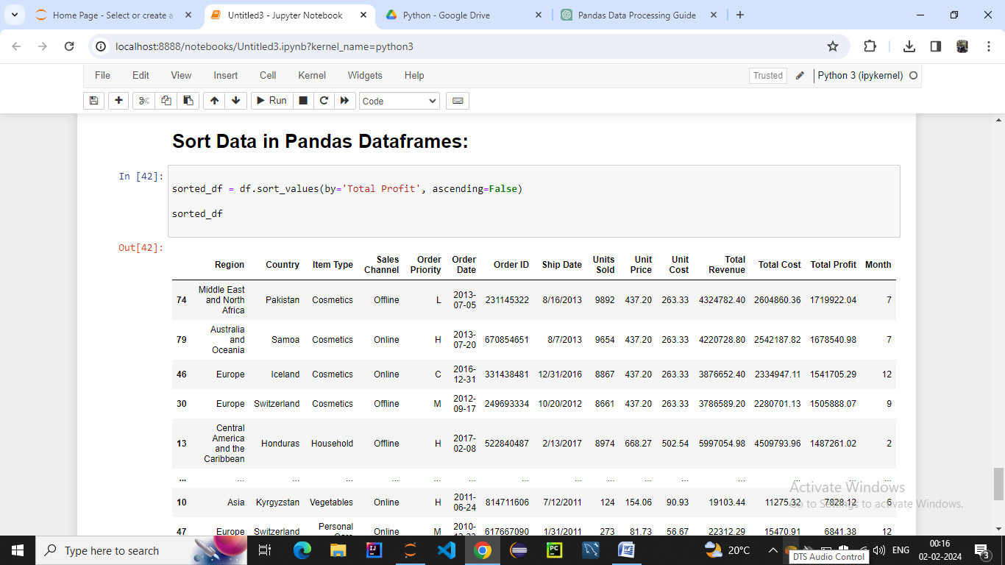

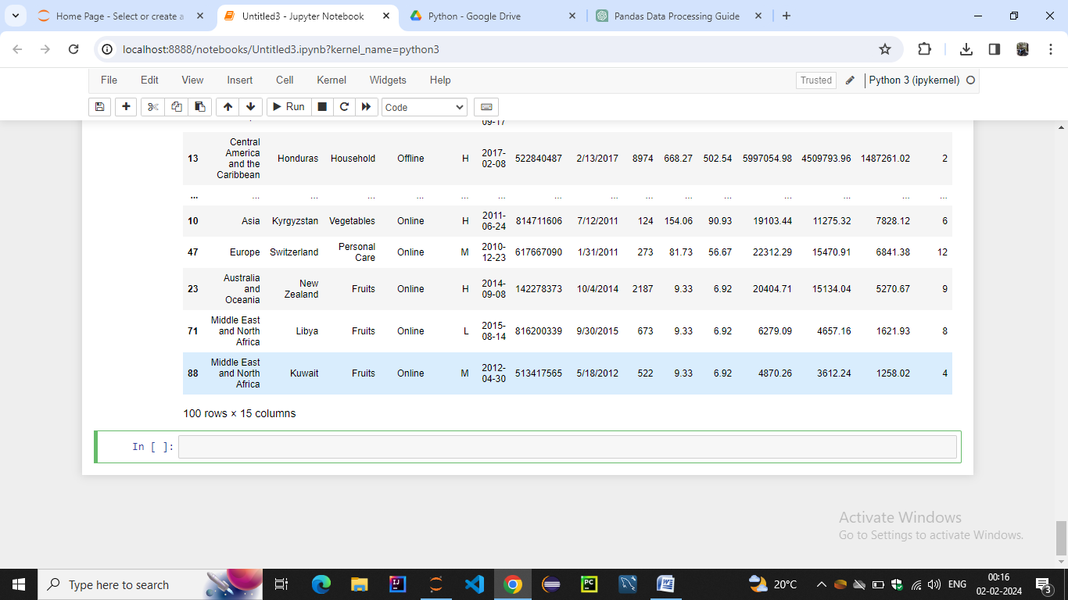

* **Writing Pandas Dataframes to Files**

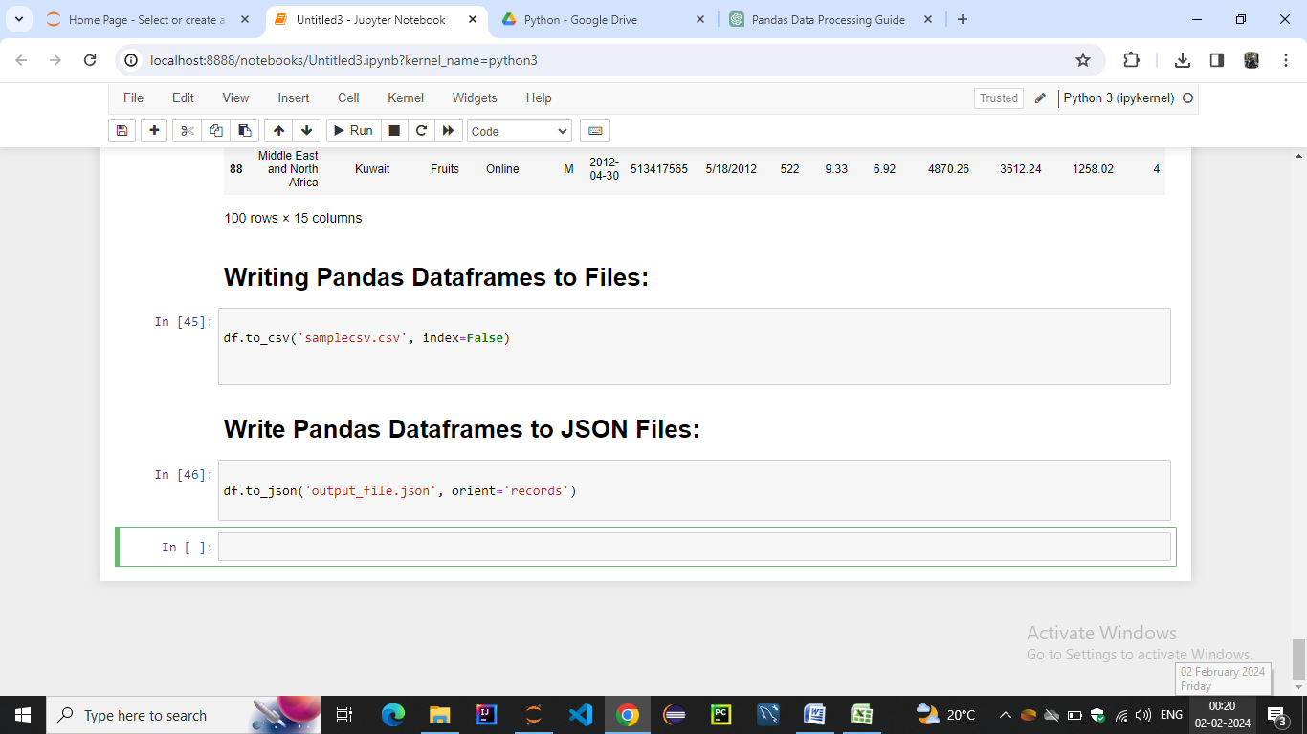

* **Write Pandas Dataframes to JSON Files**