**NAME :- ANIKET SANJAYKUMAR BIYANI**

**DATA ENGINEERING BATCH -1**

**PYTHON CODING ASSESMENT**

1. **Execute with one example Lambda Functions in Python&Read JSON Strings to Python dicts or lists**

* **Lambda Functions in Python**

Lambda functions in Python are anonymous functions defined using the lambda keyword. They are also known as lambda expressions

Unlike regular functions defined using the def keyword, lambda functions are concise and are typically used for short-term operations.

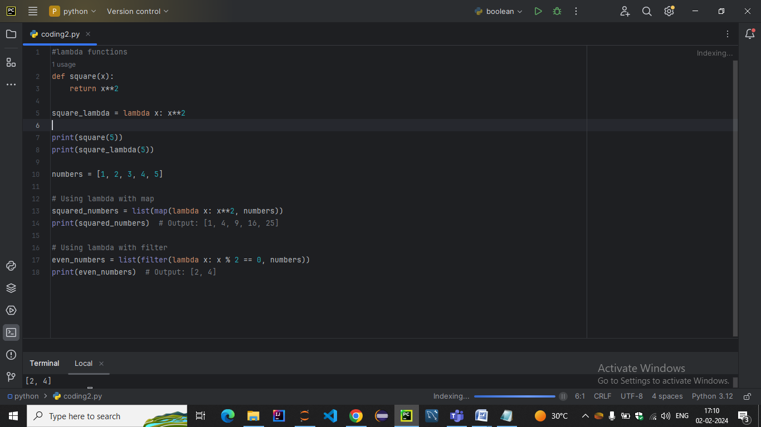

**OUTPUT:-**

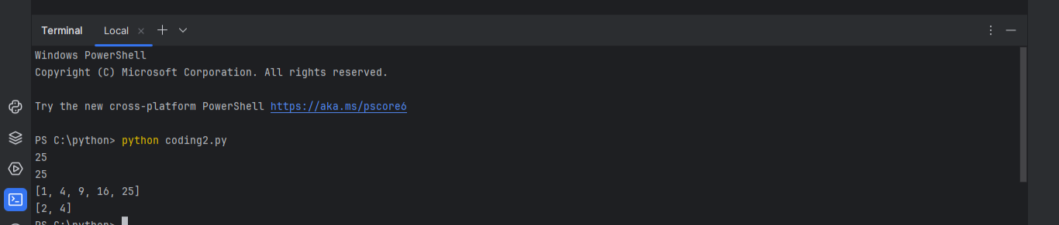

**Read JSON Strings to Python dicts or lists**

* **READING JSON STRINGS TO DICT**

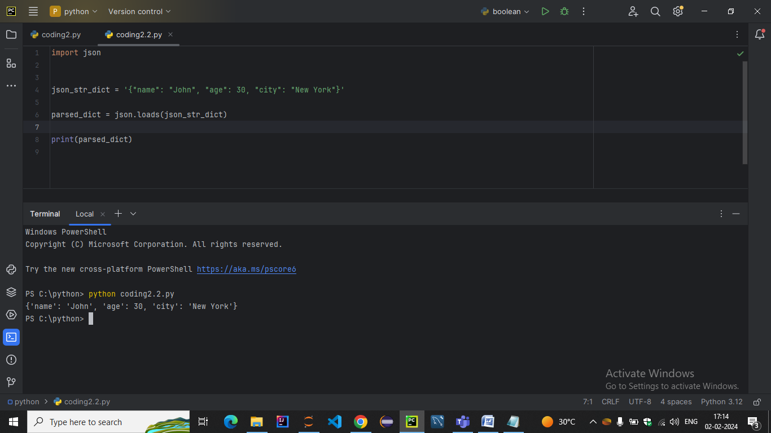

* The json.loads function (loads stands for "load string") is used to parse a JSON string and convert it into a Python object, typically a dictionary or a list.
* **READING JSON STRINGS TO LISTS**

