***NAME: Aniket Biyani***

***DATA ENGINEERING- BATCH 1***

***DAY 3 ASSIGNMENT***

***>>*SQL QUERIES**

* DDL, DCL DCL COMMANDS:-

*🡪Create database named librarymangementsystem.(DDL)*

*🡪 Create table books,book_loans(DDL)*

*🡪Insert Data into tables (DML)*

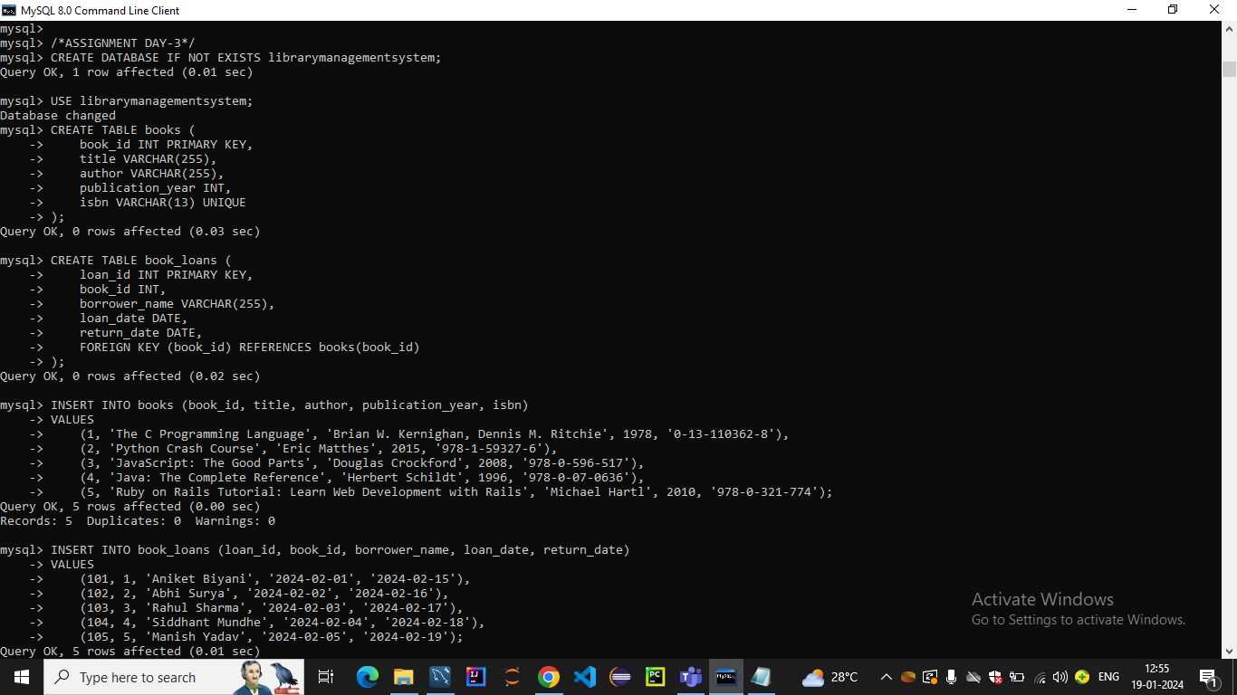

*🡪SHOW TABLES*

*🡪SELECT COLUMNS FROM TABLE*

*🡪SELECT SPECIFIC COLUMN FROM TABLE*

*🡪SELECT WITH WHERE CLAUSE*

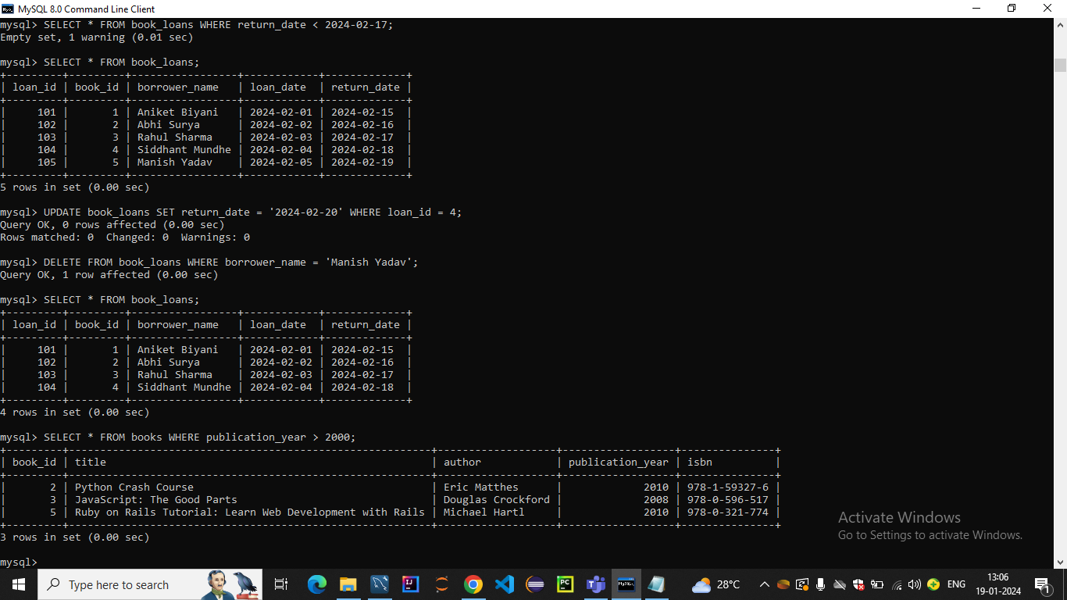

*🡪USE UPDATE QUERY USING CONDITIONS*

*🡪DELETE FROM GIVEN CONDITION*

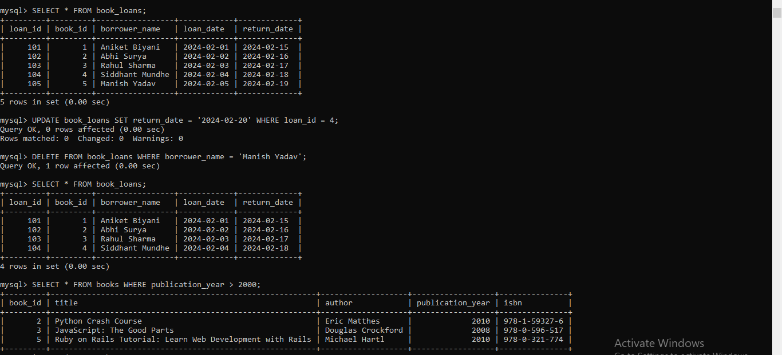

*🡪USE AGGREGATE FUNCTIONS*

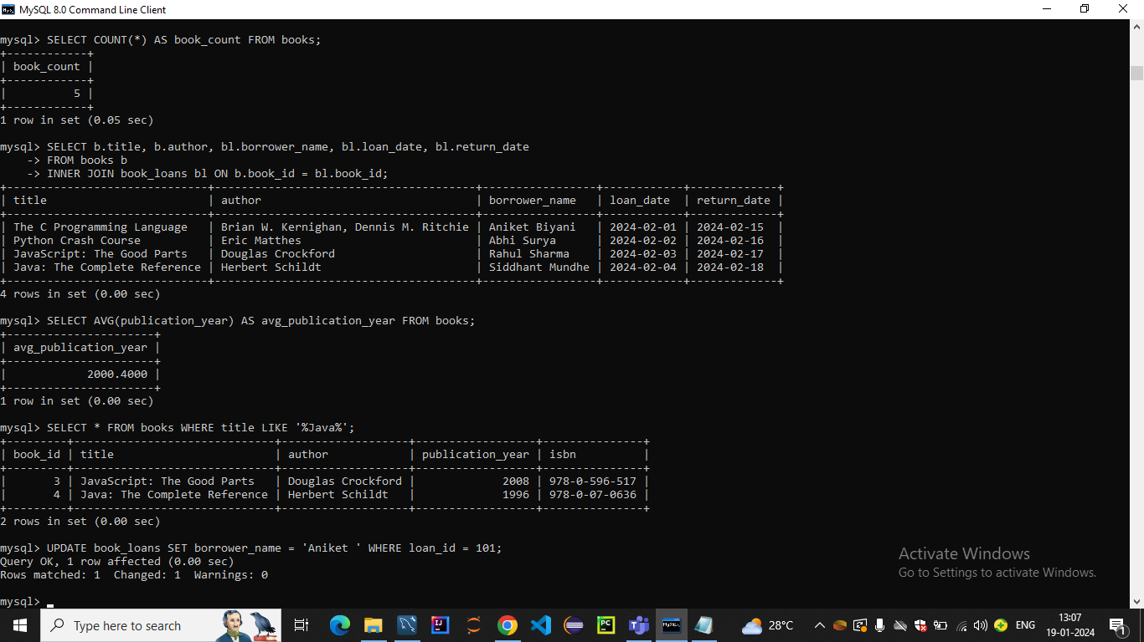

* *USE DDL ALTER MODIFY DROP ADD*

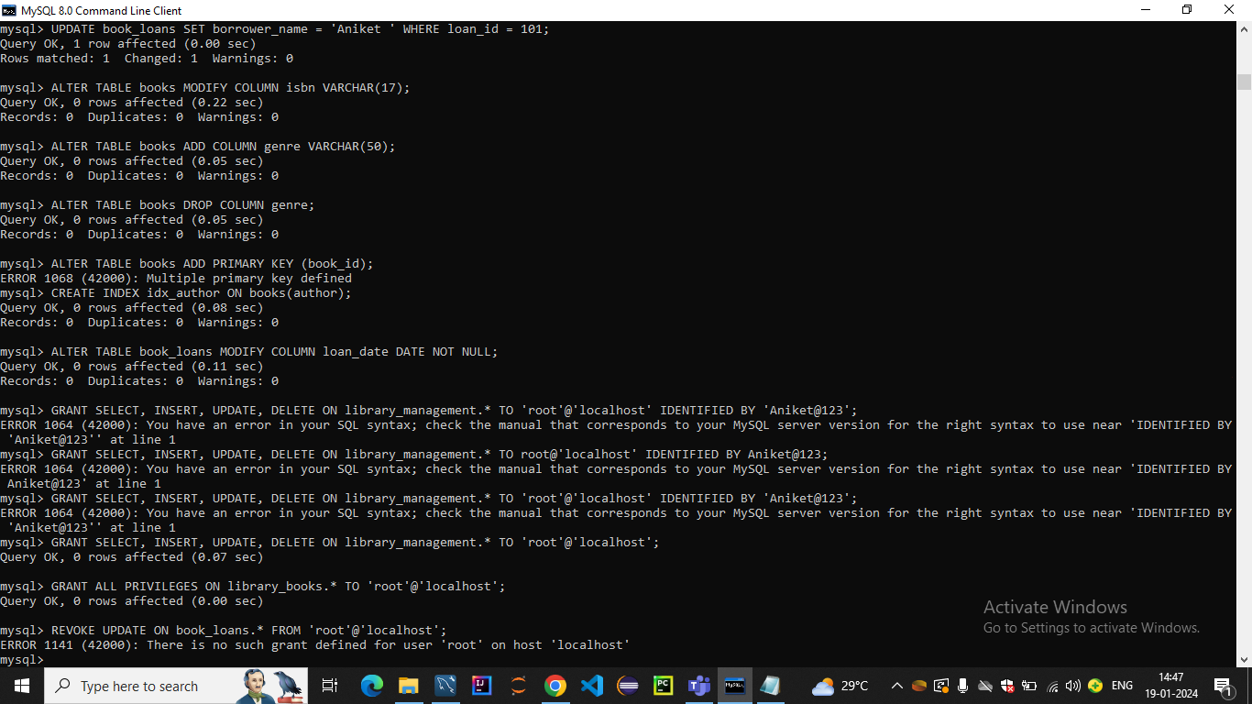

*🡪USE GRANT REVOKE DCL COMMANDS*

* *USE LOGICAL OPERATORS*

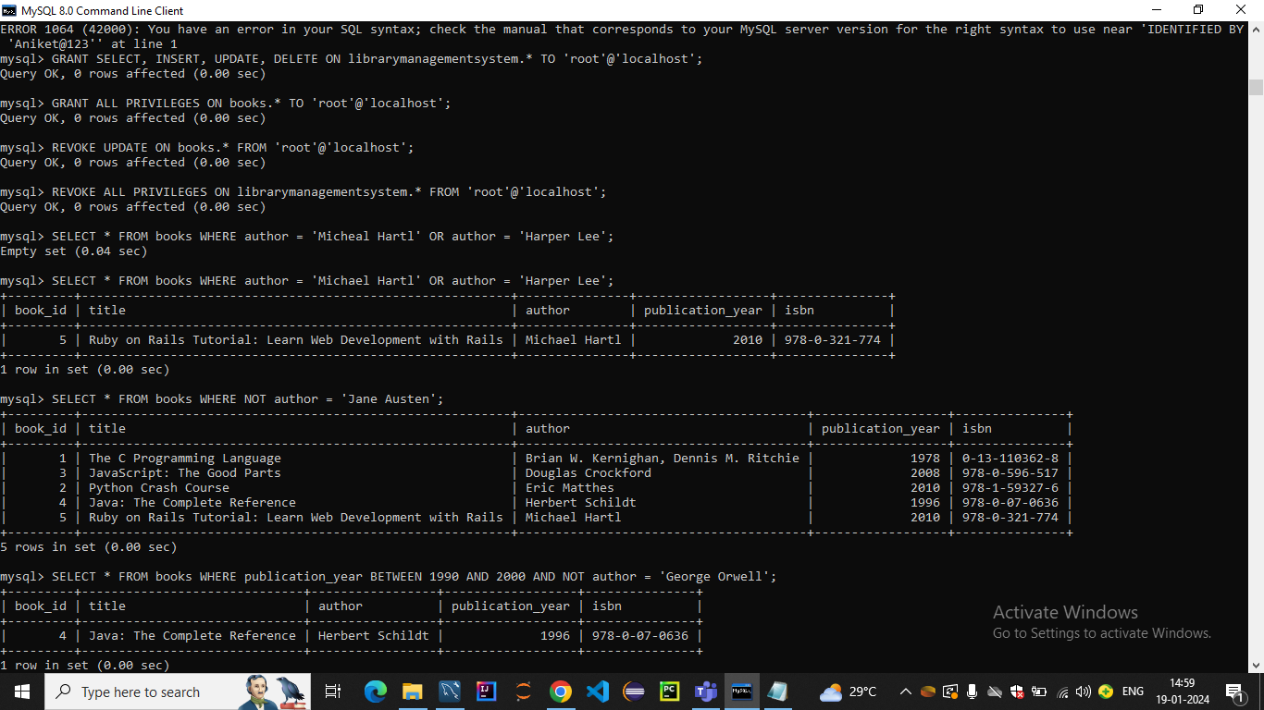

* *AND ,BETWEEN,ALL ,ANY,SOME OPERATORS*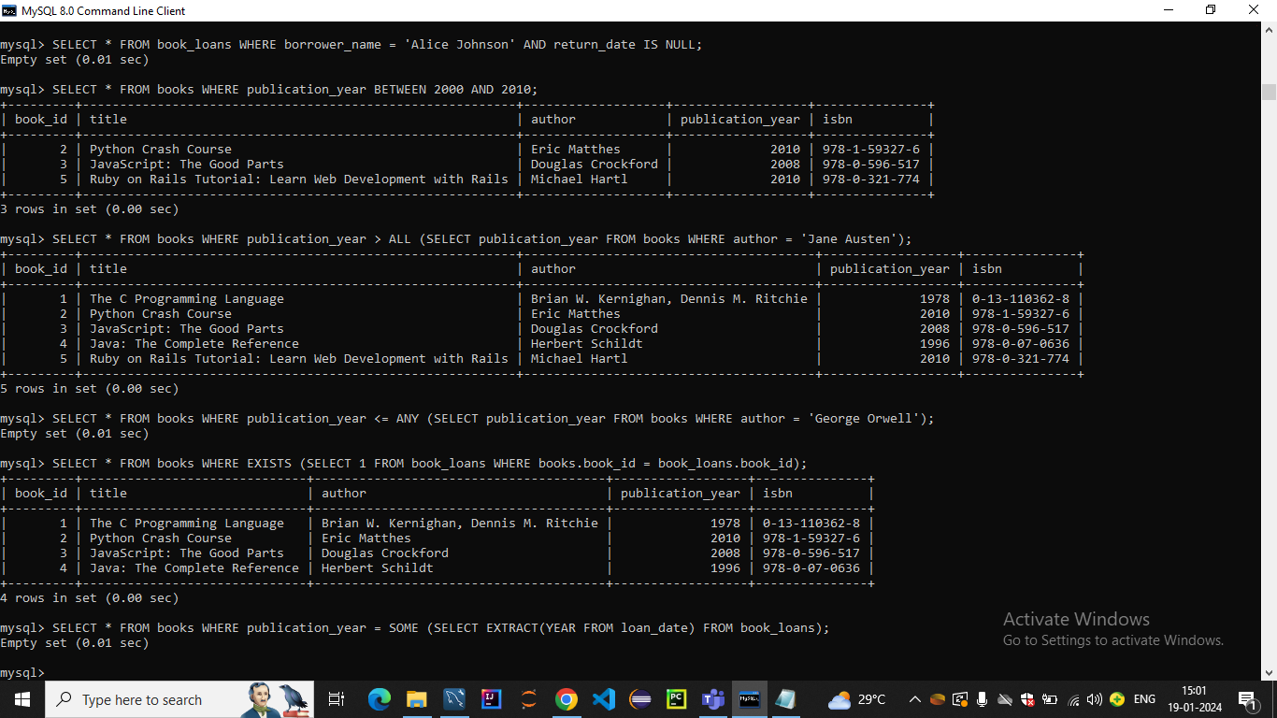
* *COUNT,GROUP BY ,ALIAS, DISTINCT*

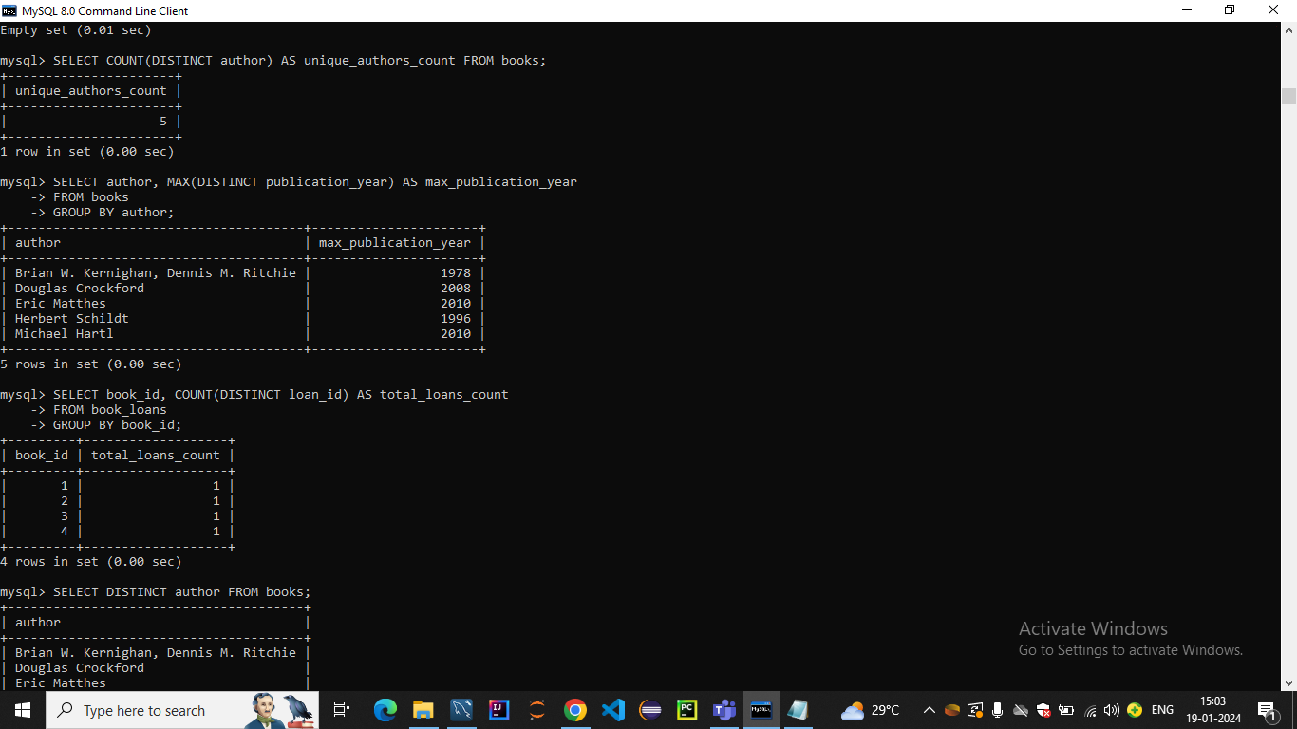

* ***UNION ,INTERSECT,EXCEPT,MINUS***

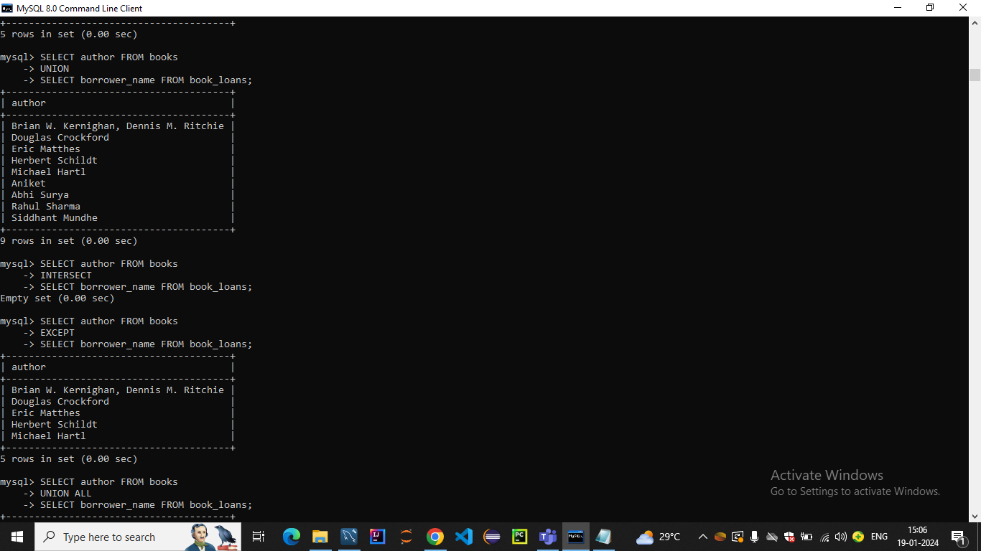

***🡪TCL COMMANDS***

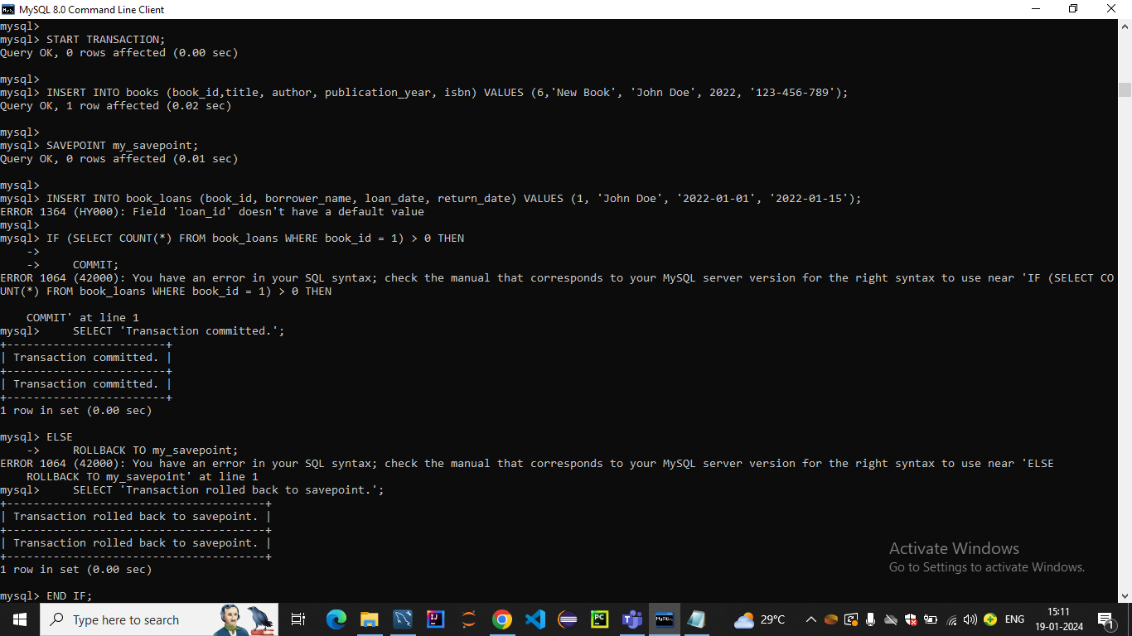

***🡪JOINS :-***

***INNER JOIN***

***LEFT JOIN***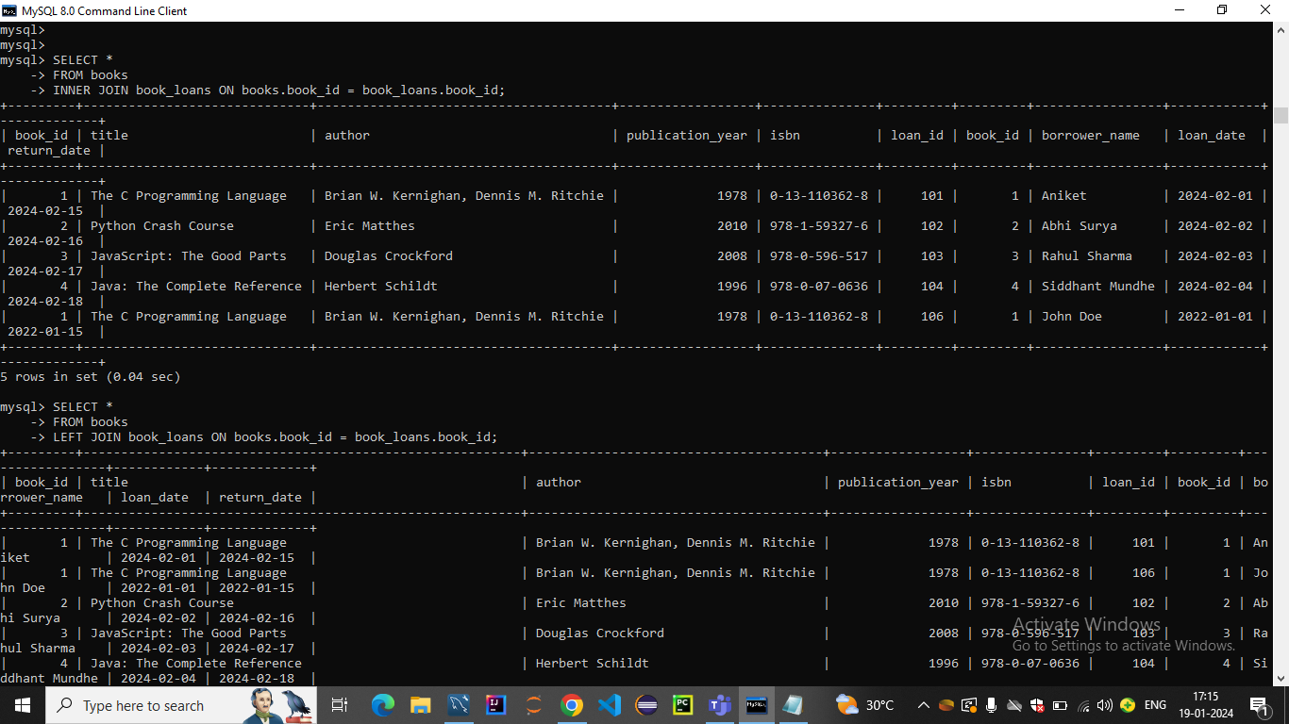

***🡪RIGHT JOIN,NATURAL JOIN***

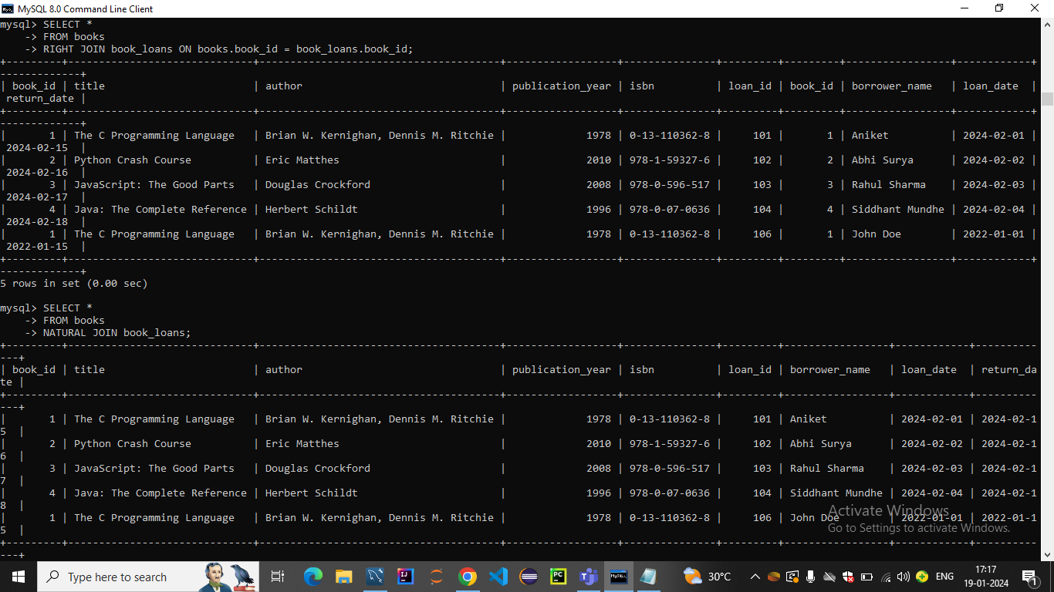

***🡪NON-EQUI JOIN***

