***NAME: Aniket Biyani***

***DATA ENGINEERING- BATCH 1***

***DAY 4 ASSIGNMENT***

***🡪STORING DATA IN A TABLE***

*>>CREATING DATABASE ,TABLES*

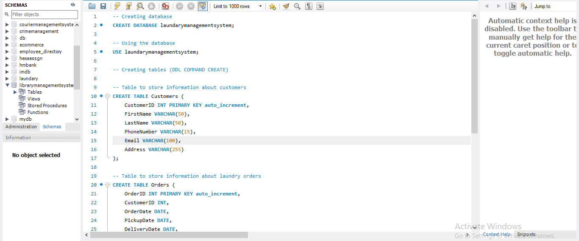

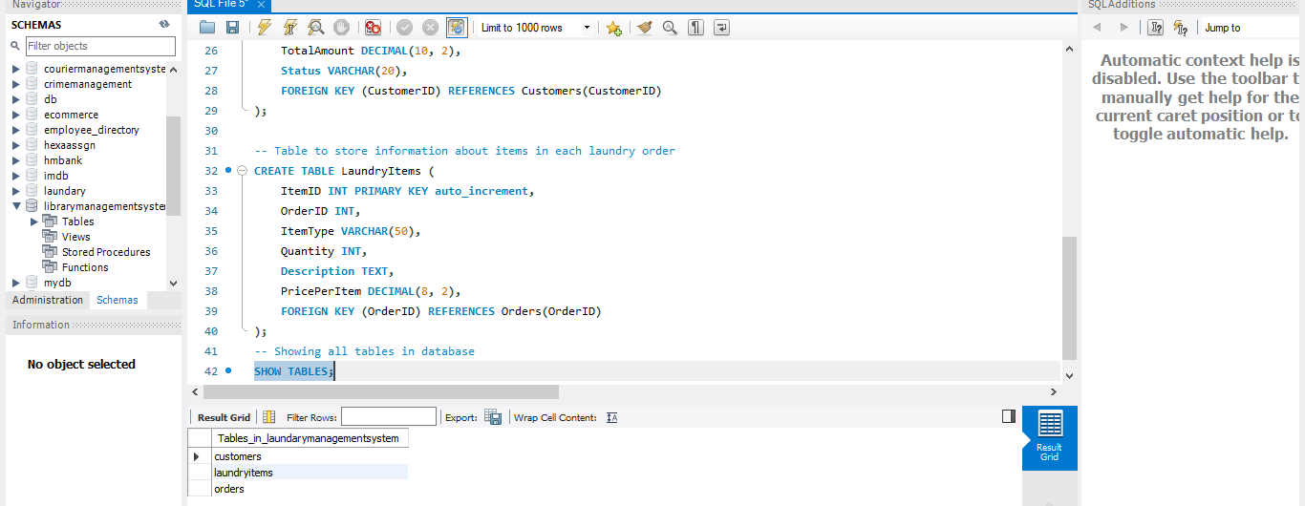

***>> INSERTING DATA INTO TABLES***

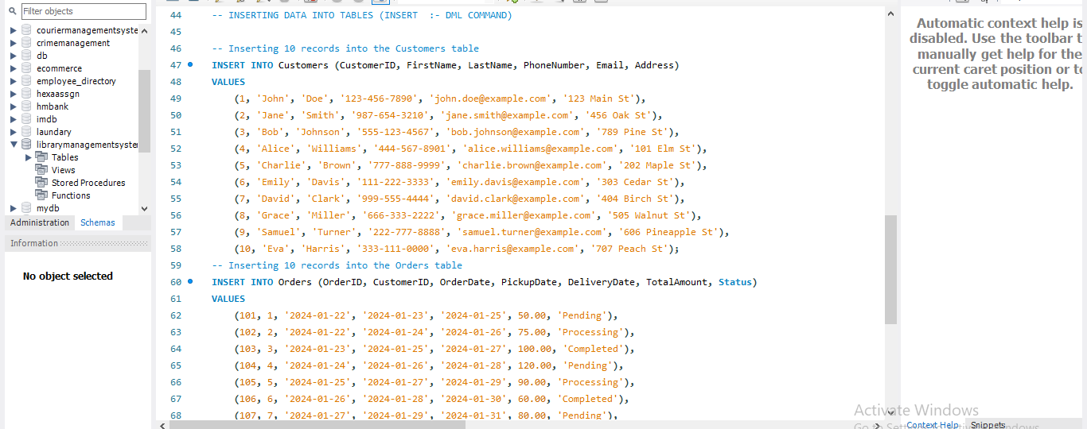

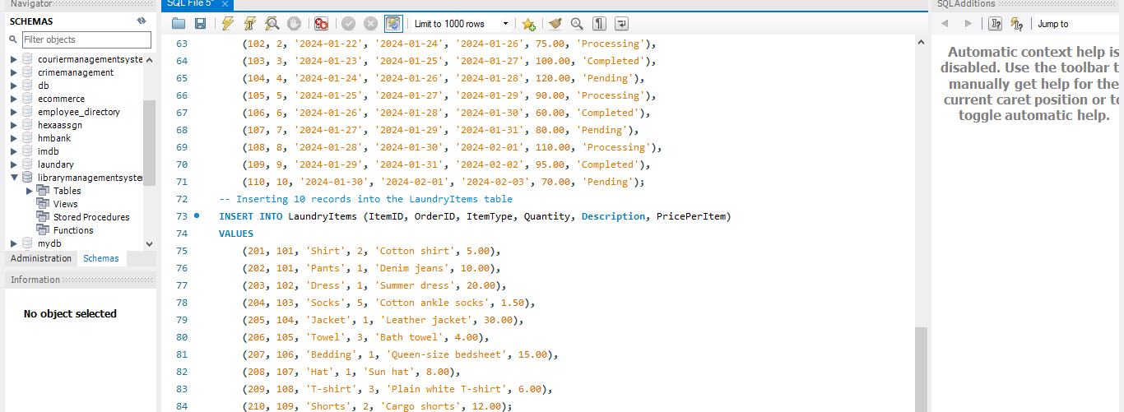

***>> SELECTING ALL COLUMNS FROM CUSTOMERS***

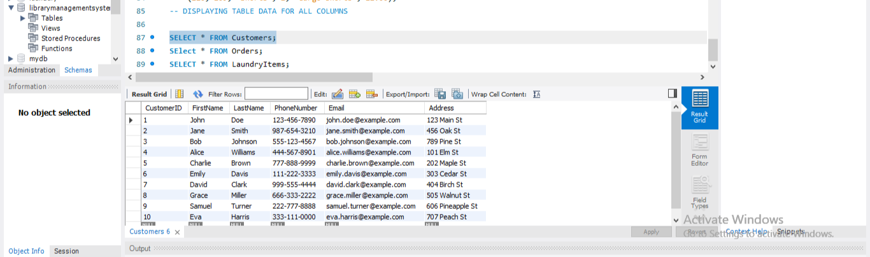

***>> SELECTING ALL COLUMNS FROM ORDERS***

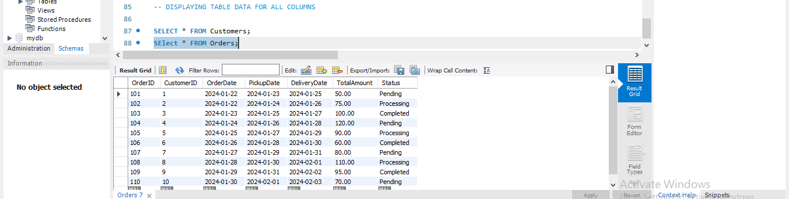

***>> SELECTING ALL COLUMNS FROM LAUNDRYITEMS***

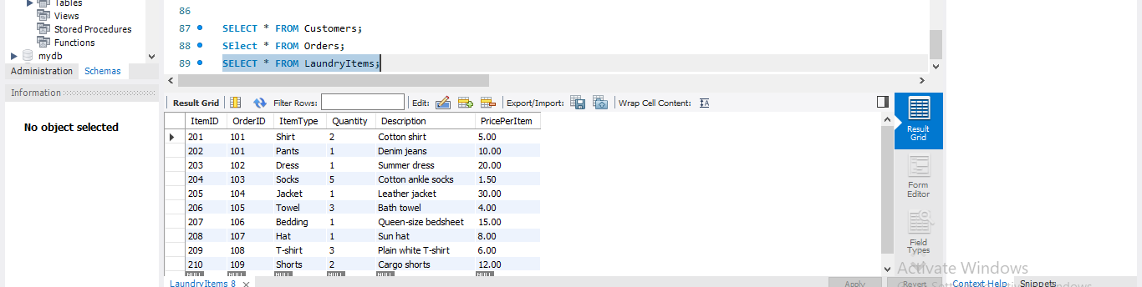

* ***UPDATING DATA IN A TABLE***
* ***DELETING DATA FROM A TABLE***

***>> UPDATING , DELETING , ALTERING ,ADD,MODIFY ,CHANGE,DROP (DDL COMMANDS)***

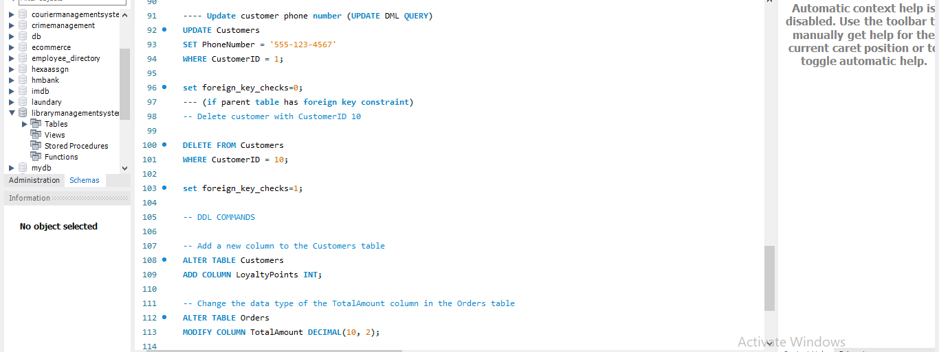

* ***RETRIEVING SPECIFIC ATTRIBUTES***

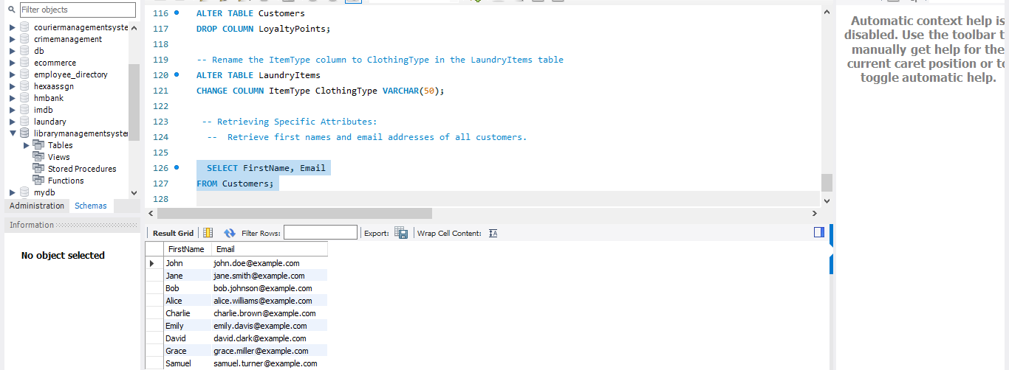

***🡪RETRIEVING SELECTED ROWS***

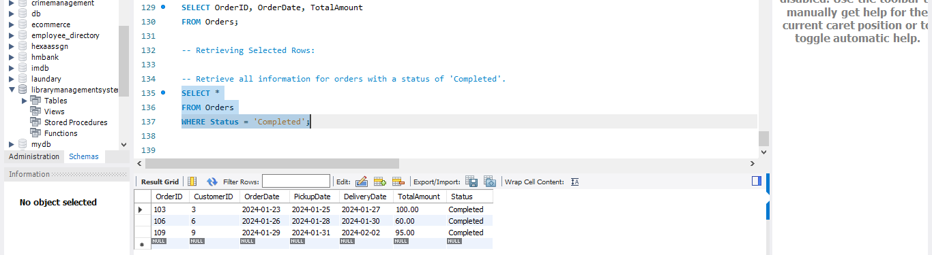

***🡪FILTERING DATA :WHERE CLAUSE***

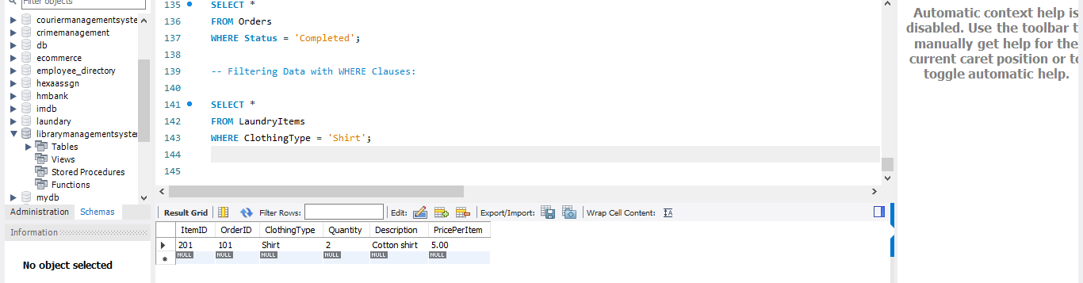

* ***LOGICAL OPERATORS***

***AND OPERATOR***

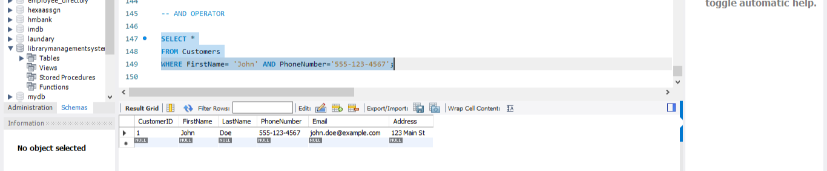

* ***OR OPERATOR***

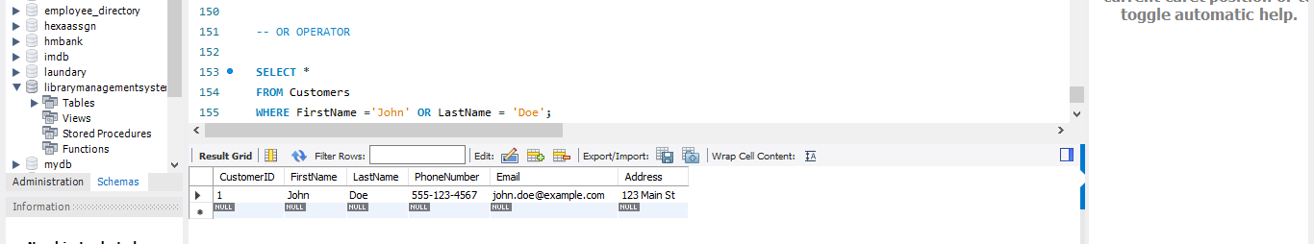

* ***NOT OPERATOR***

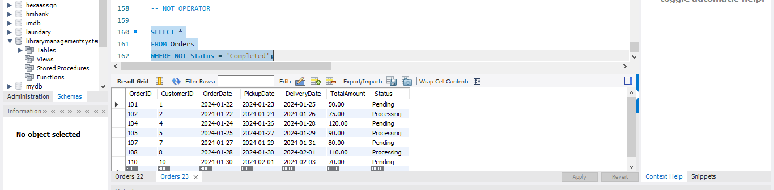

***🡪BETWEEEN OPERATOR :-***

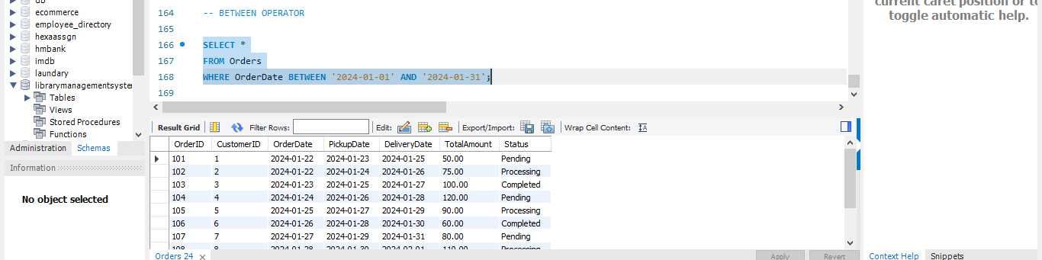

***🡪EXISTS OPERATOR***

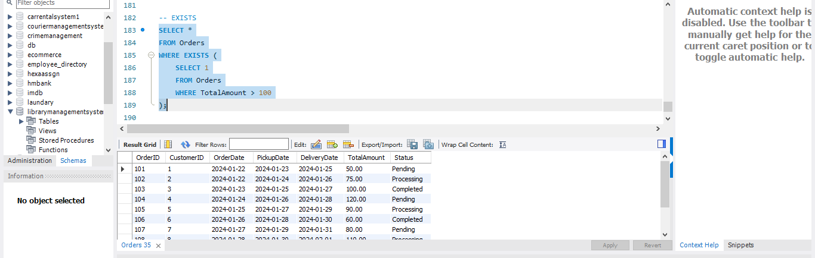

***🡪IN OPERATOR***

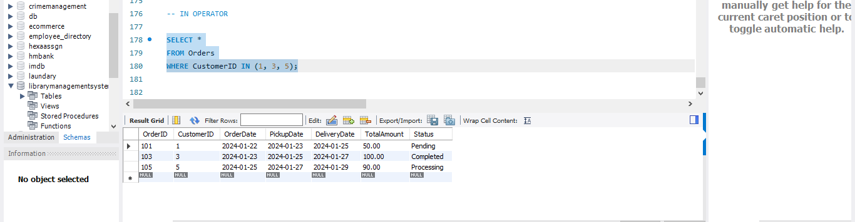

***🡪ANY OPERATOR***

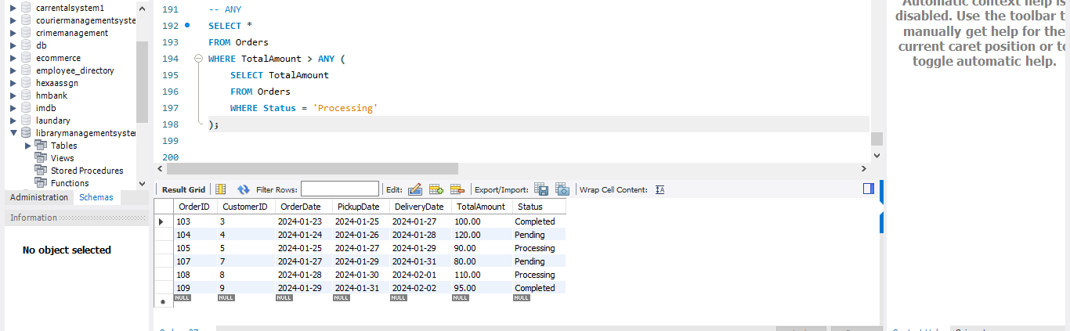

***🡪ALL OPERATOR***

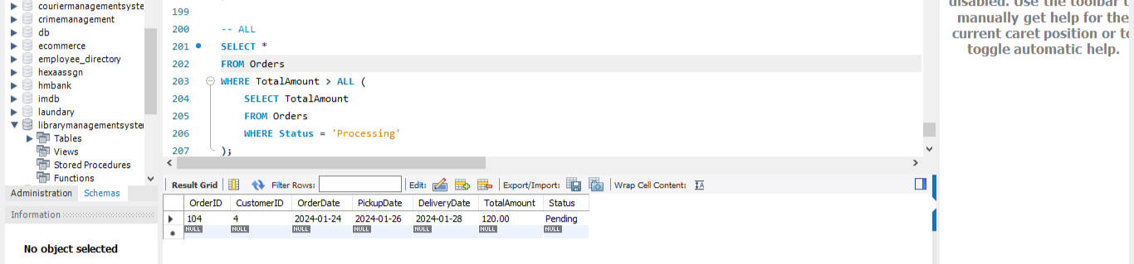

***🡪LIKE OPERATOR***

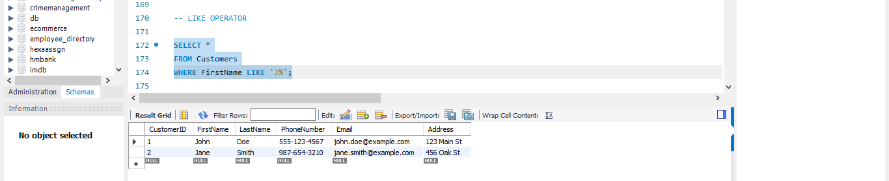

* ***TOTAL AGGREGATION USING QUERIES:-***

***->> COUNT:-***

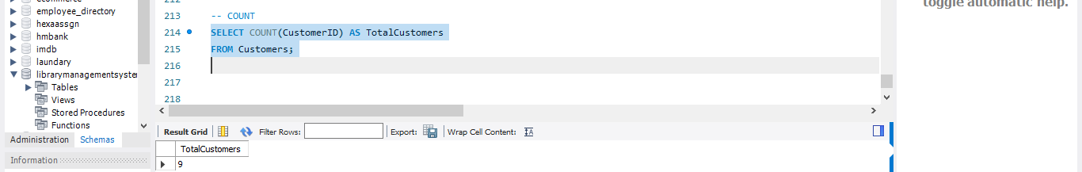***>> AVERAGE :-***

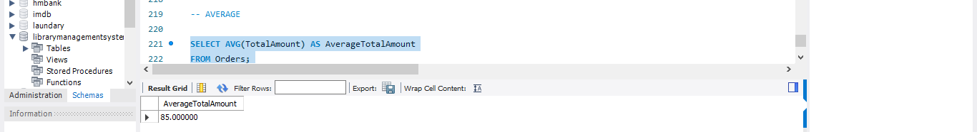***>>MAX :-***

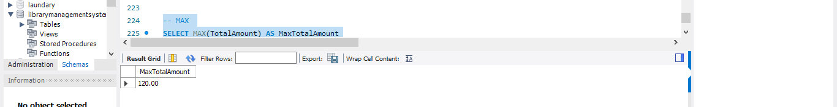***>> SUM :-***

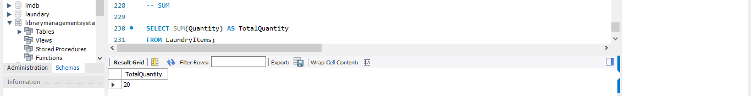***>> MIN:-***

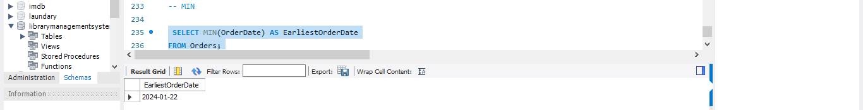

***>> DISTINCT*** 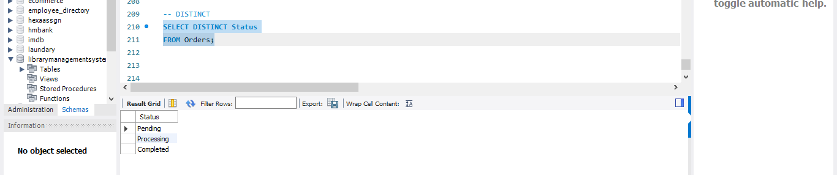

***>> GROUP BY AGGREGATION***

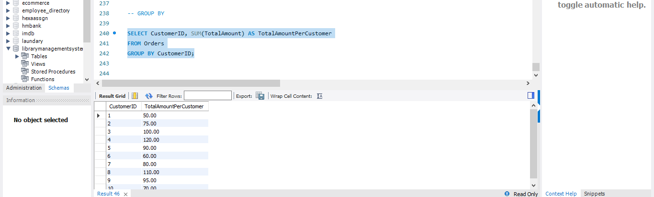***>> ORDER BY***

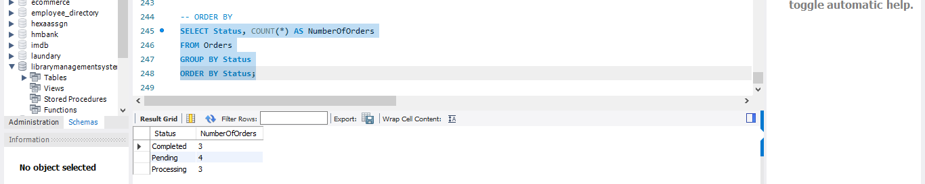

***>> FILTERING DATA USING GROUP BY AND HAVING***

***>> ORDER EXECUTION ,RULES ,RESTRICTIONS TO GROUPBY***

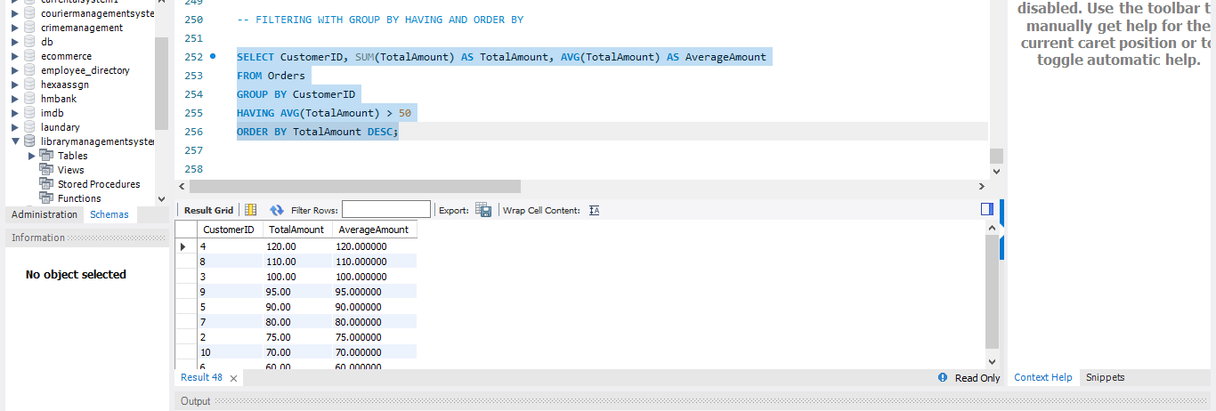

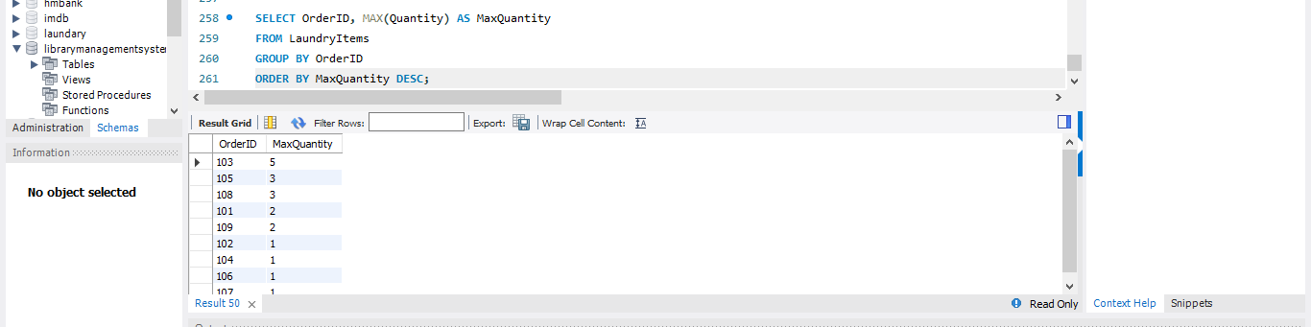

***UNION :-***

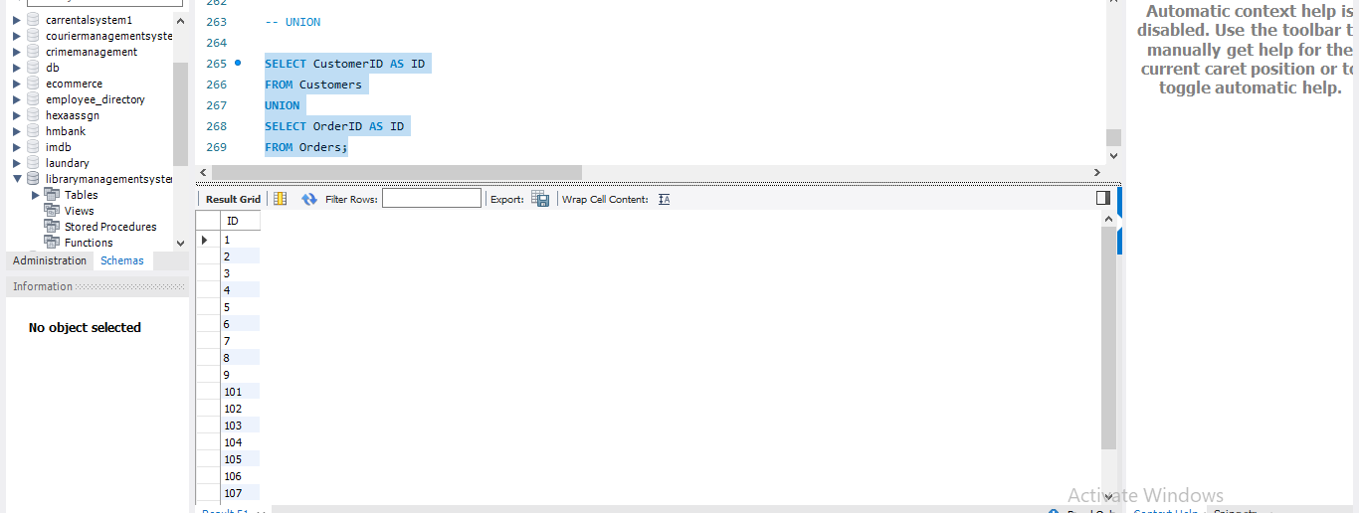

***>> INTERSECT***

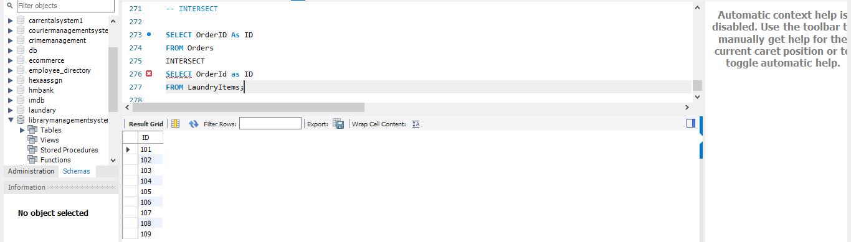

***>>UNION ALL***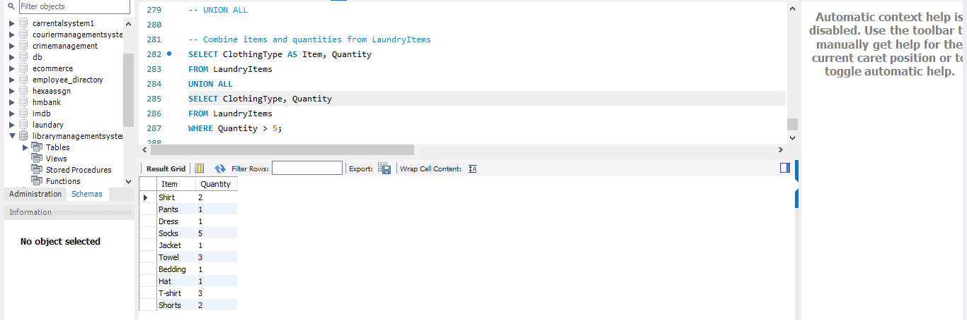

***>> EXCEPT***

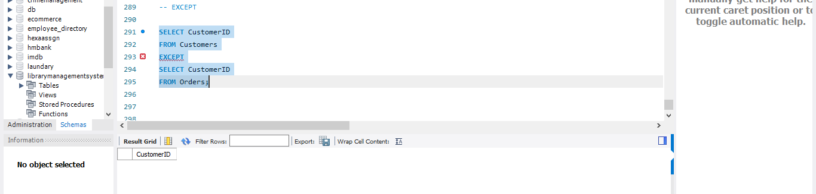

***>> JOINS***

***>> INNER JOIN***

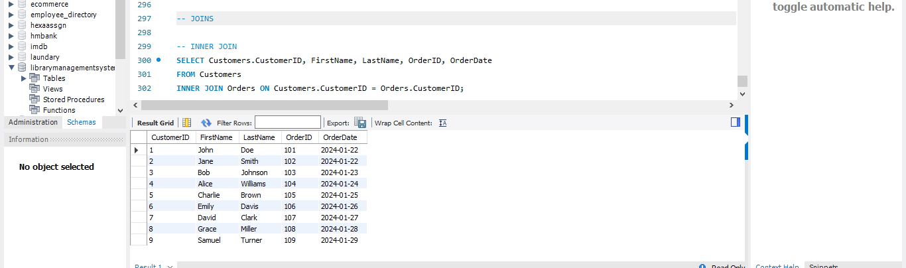

***>> LEFT JOIN***

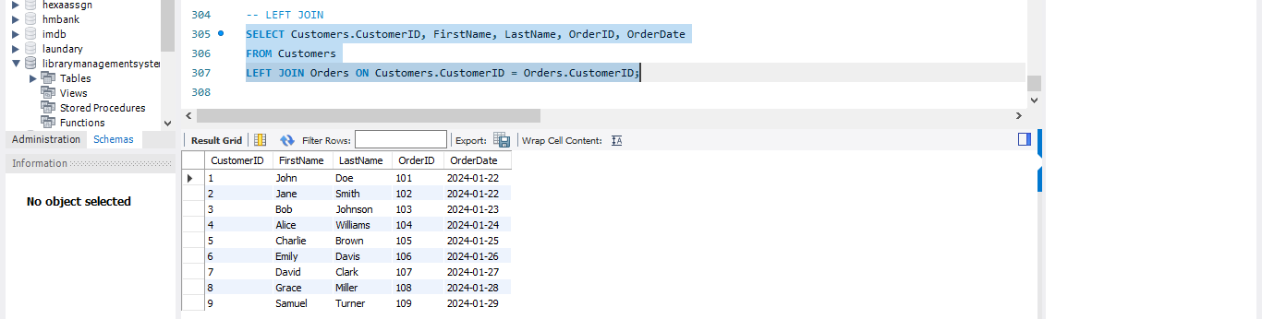

***>>RIGHT JOIN***

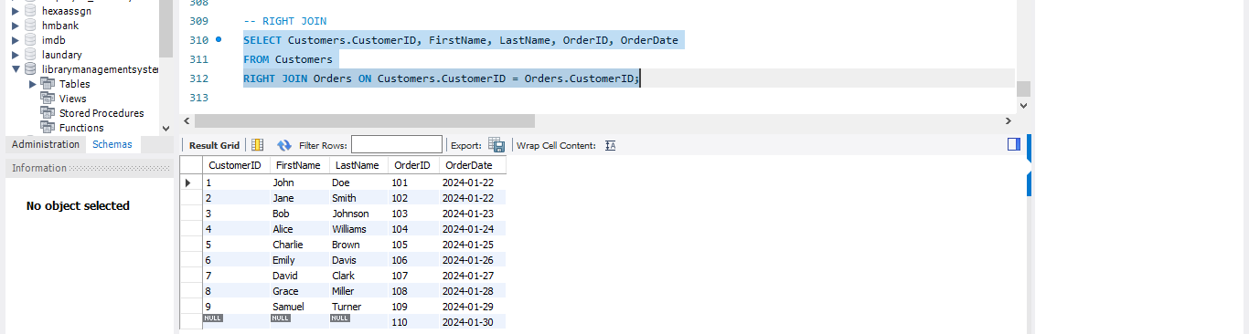

***>> CROSS JOIN***

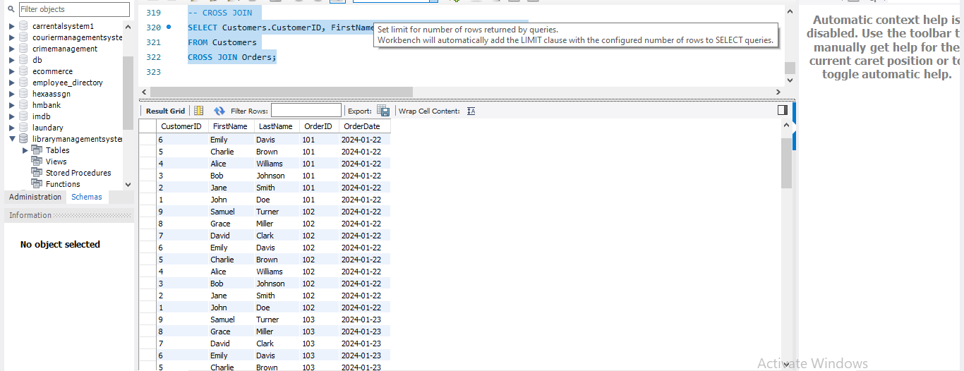

***>> SELF (EQUI JOIN)***



***>> NON –EQUI JOIN*** 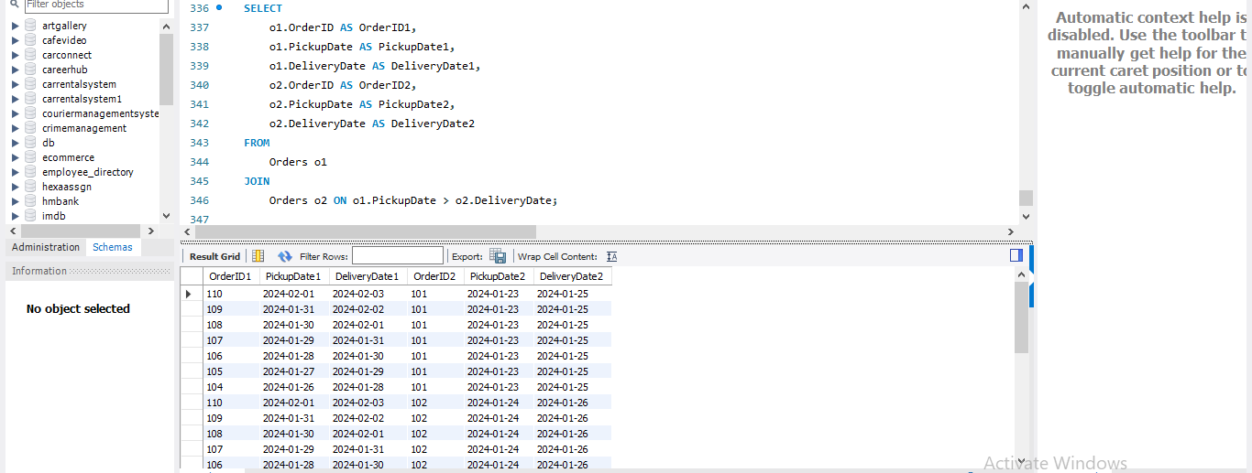

***>> JOINS WITH GROUP BY AND HAVING FUNCTIONS***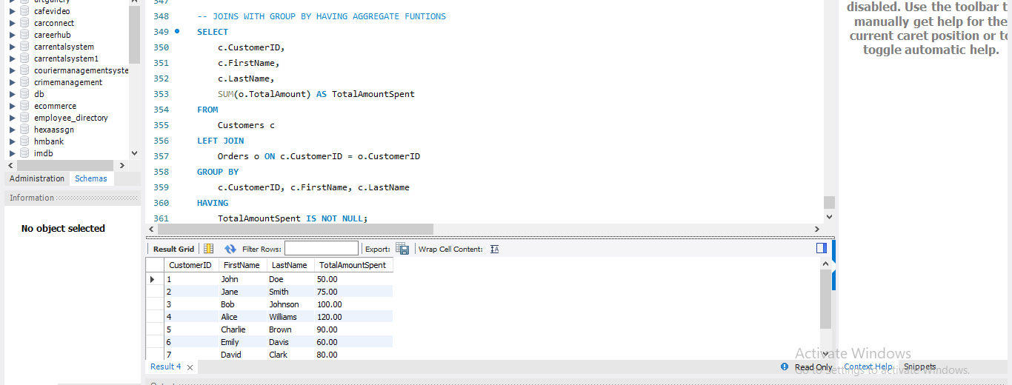

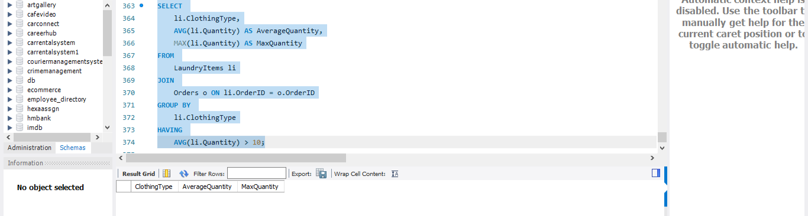

***>> QUERYING WITH SUBQUERIES***

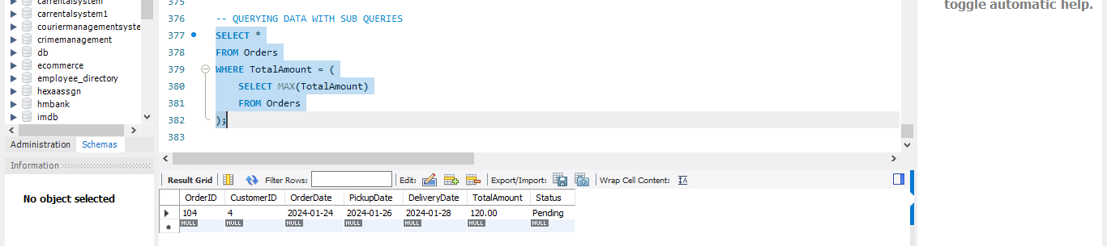

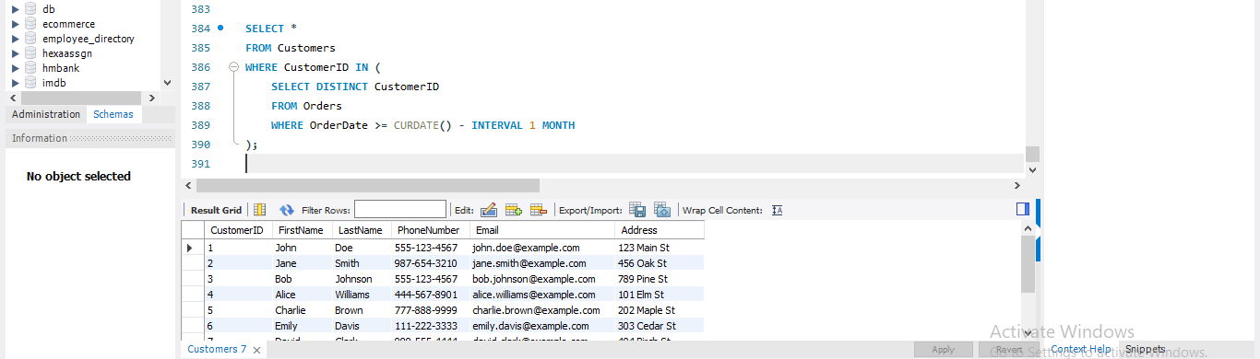

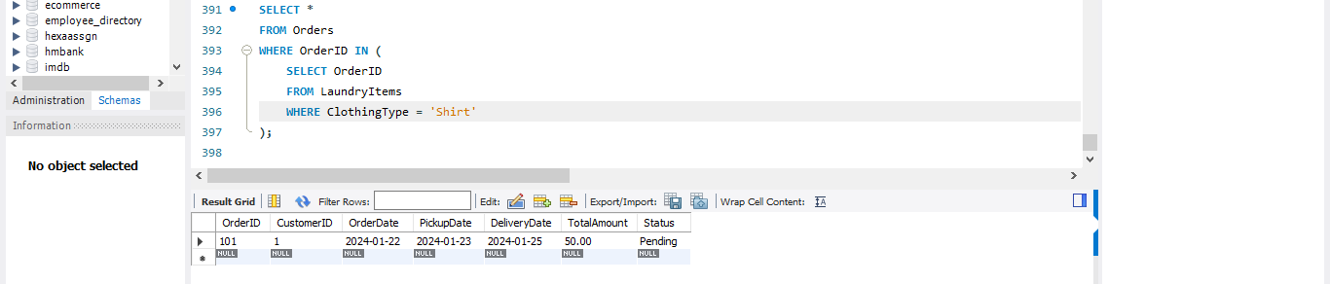

***>> QUERYING WITH NESTED SUBQUERIES***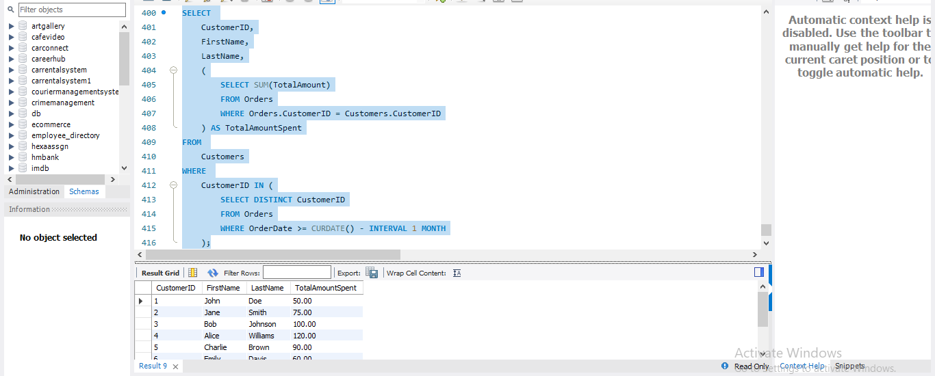

***>> QUERYING WITH CORELATED SUBQUERY*** 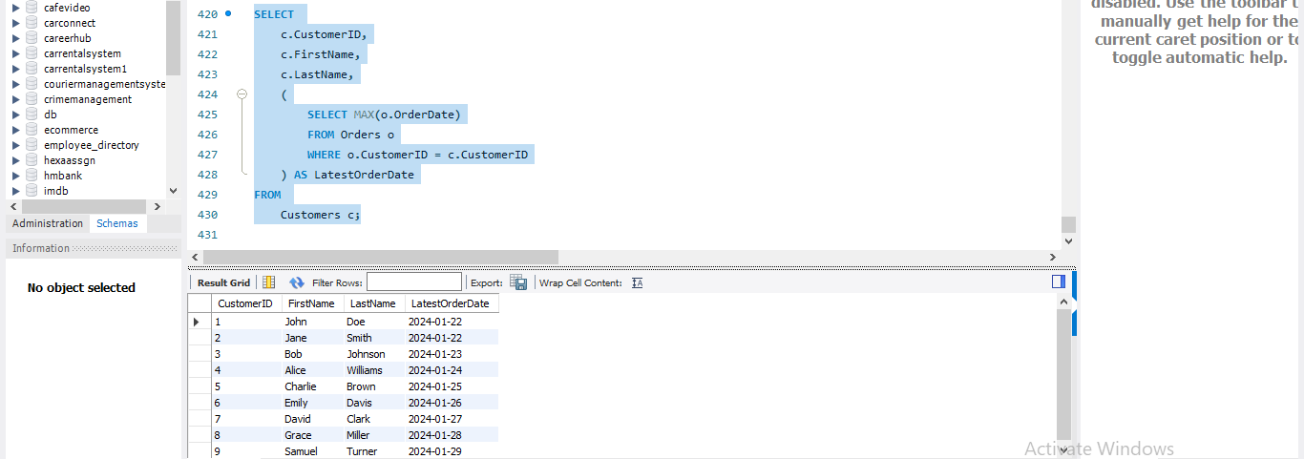

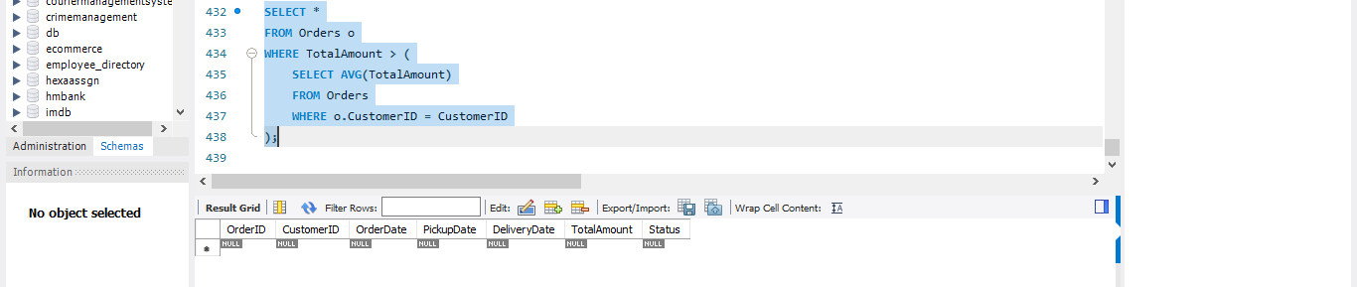

* ***STRING FUNCTIONS***

***>>CONCAT***

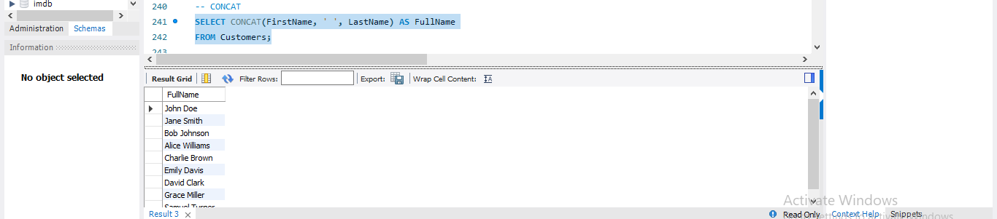

***>>SUBSTRING*** 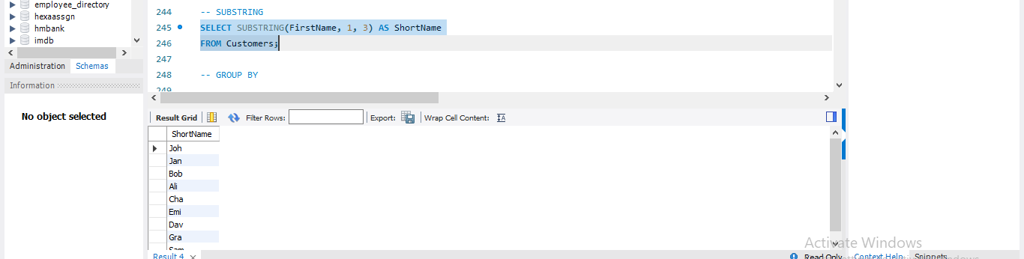

***>>UPPER CASE***

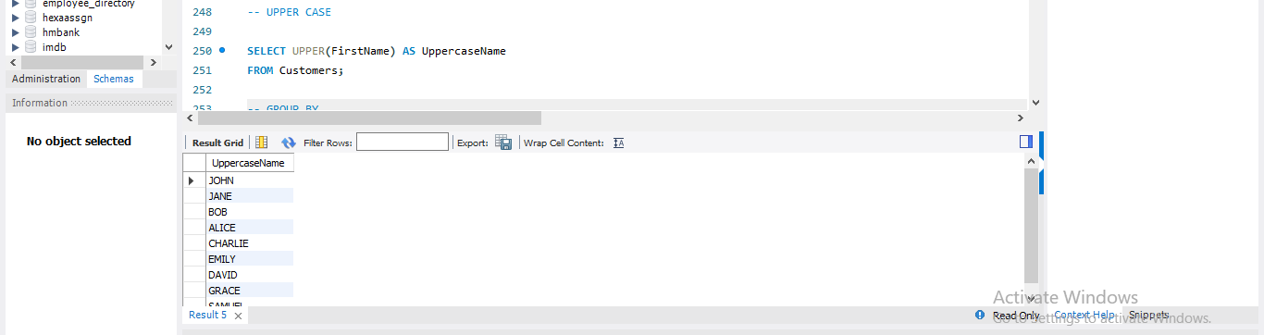

***>> LENGTH***

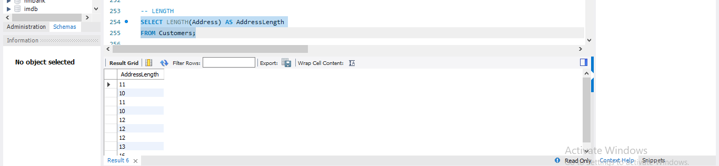

***>>TRIM***

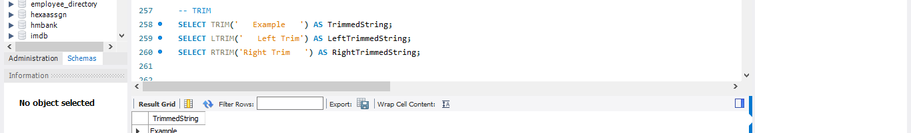

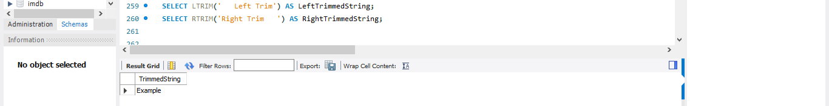

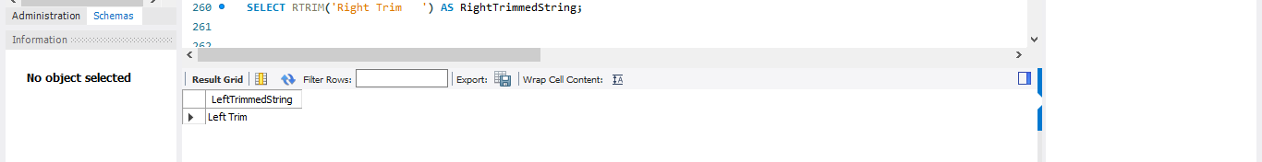

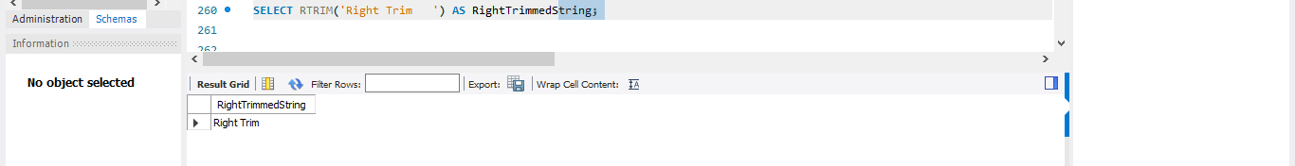

***>> POSITION***

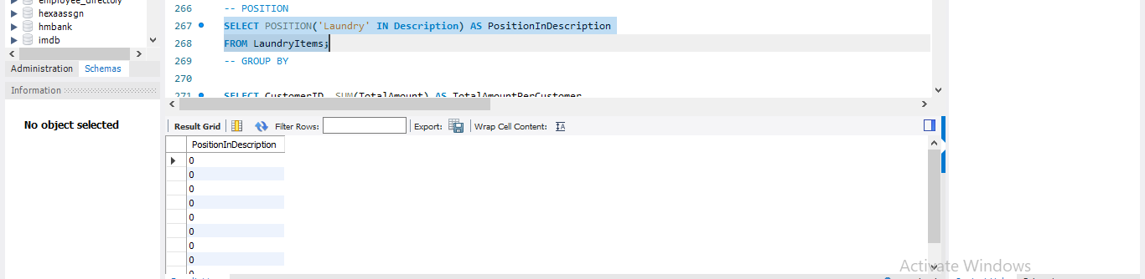

***>> LEFT AND RIGHT PART OF STRING***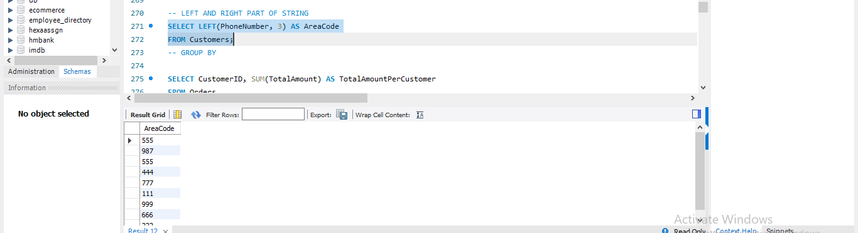

***>>RIGHT PART***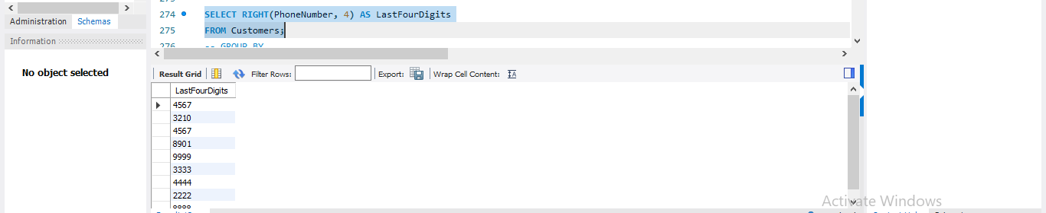

* ***MATHEMATICAL FUNCTIONS***

***>>ABSOLUTE***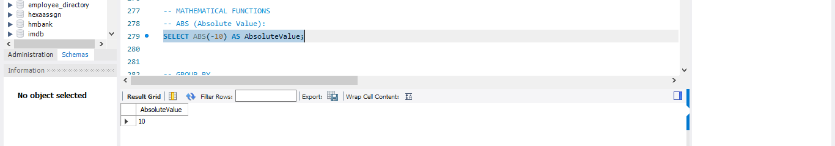

***>> ROUND***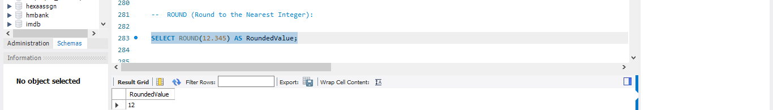

***>>CEIL*** 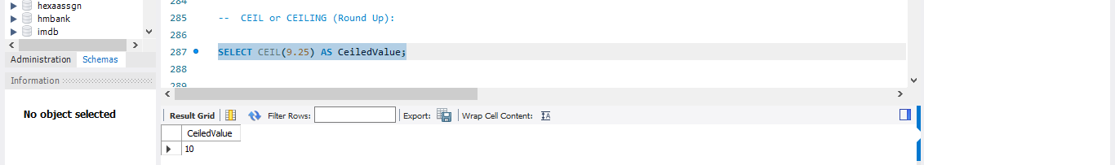

***>> FLOOR***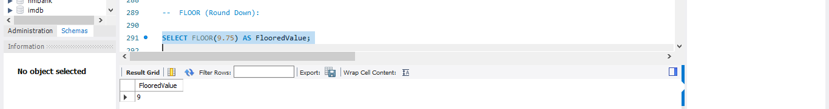

***>> POWER***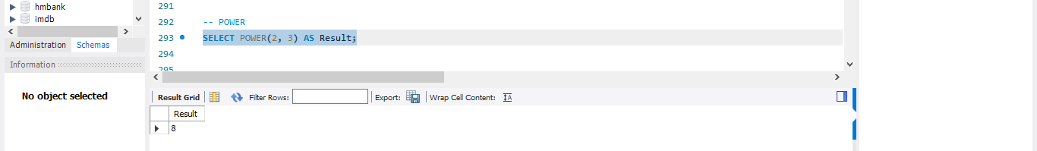

***>> SQRT***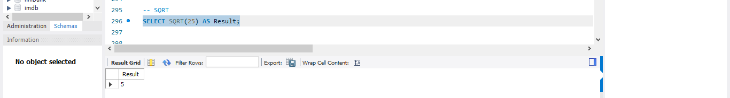

***>>EXPONENTIAL***

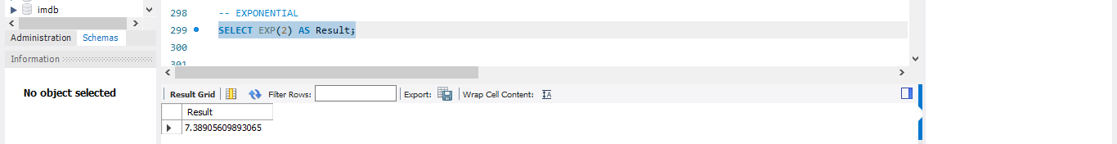

***>>LOG***

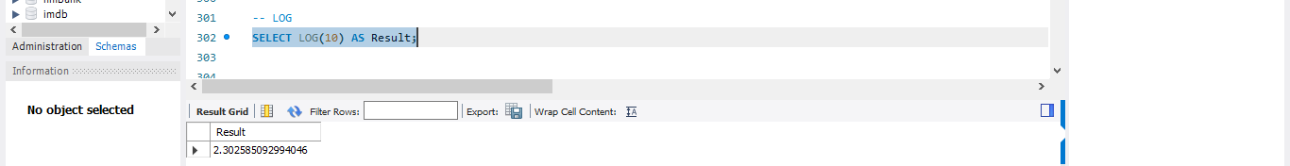

***>>MOD***

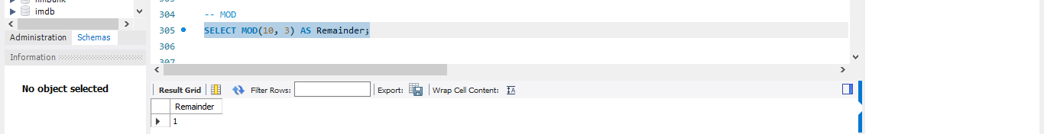

* ***DATE FUNCTIONS***

***>> CURRENT DATE***

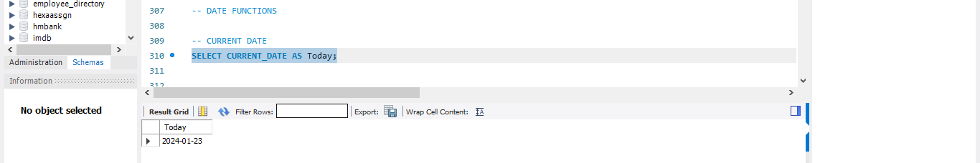

***>>CURRENT TIME AND TIMESTAMP*** 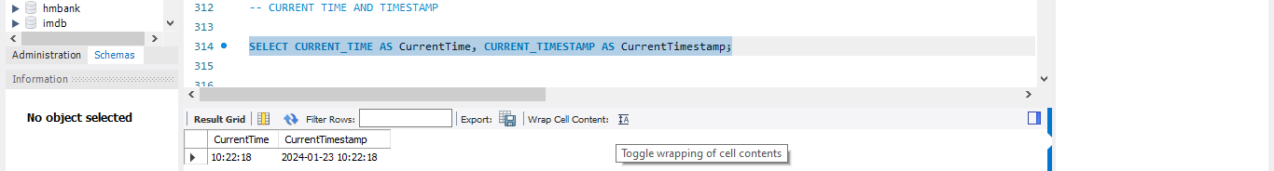

***>> EXTRACT***

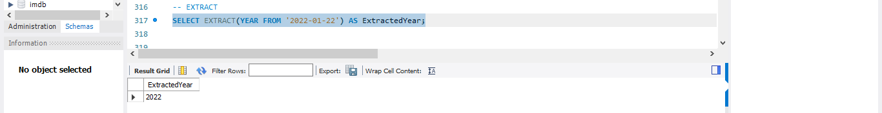

***>>DATEDIFF***

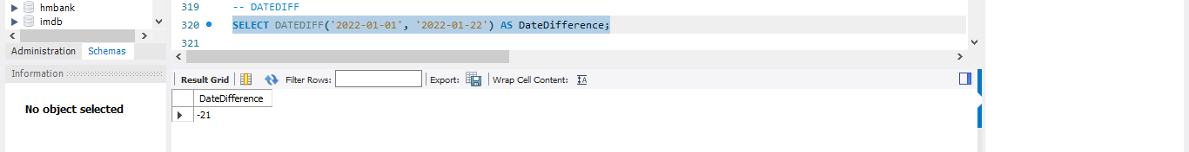

***>> DATE FORMAT***

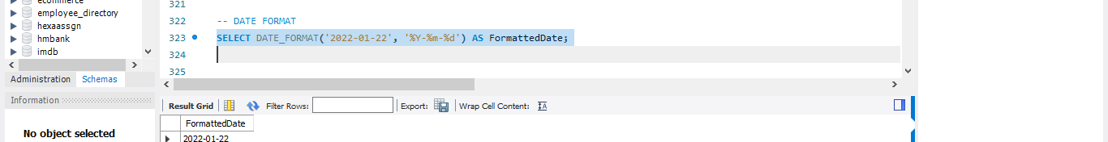

***>>NOW***

