***NAME: Aniket Biyani***

***DATA ENGINEERING- BATCH 1***

***DAY 5 ASSIGNMENT***

* ***SYSTEM FUNCTIONS***

***>> DATABASE VERSION***

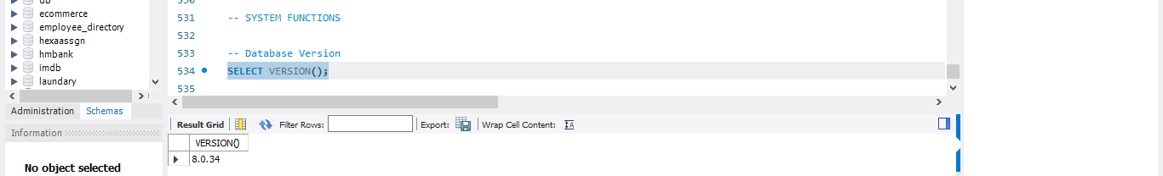

***>>CURRENT USER***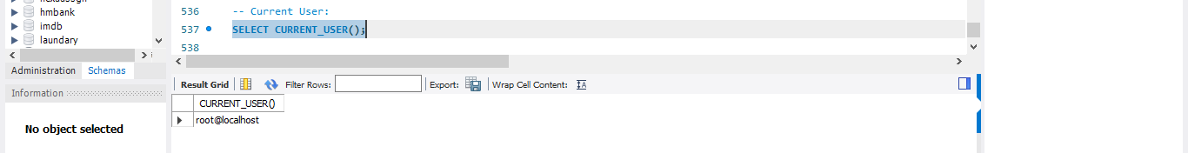

***>> CURRENT DATE AND TIME***

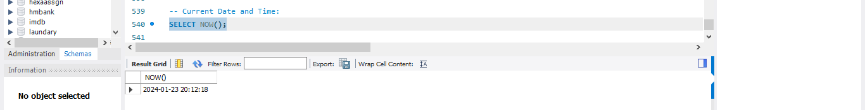

***>> DATABASE NAME***

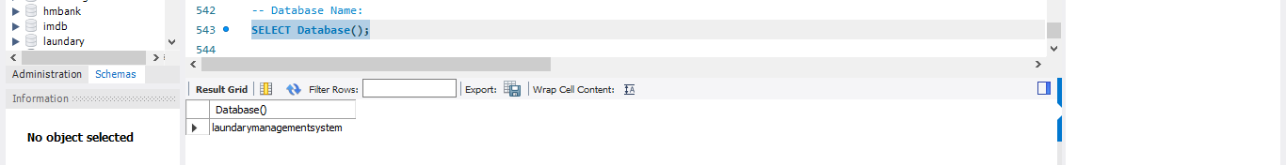

***>>SYSTEM DATE***

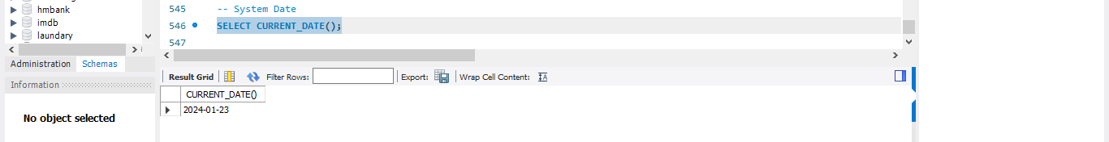

***>>SYSTEM TIME***

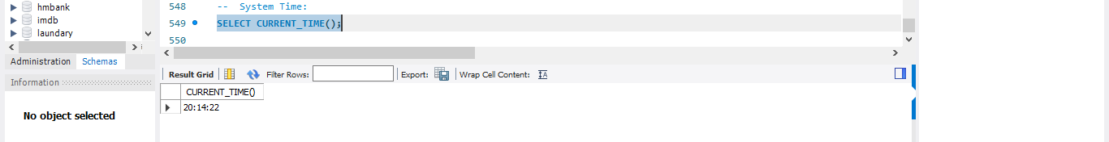

***>> CURRENT TIMESTAMP***

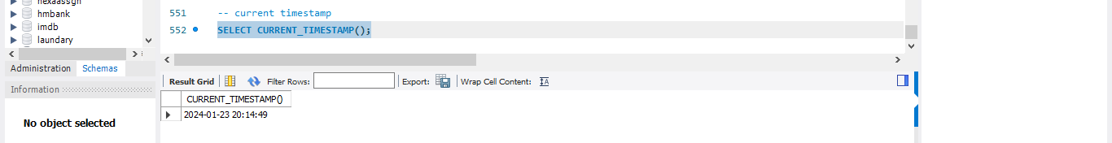

***>>SESSION USER***

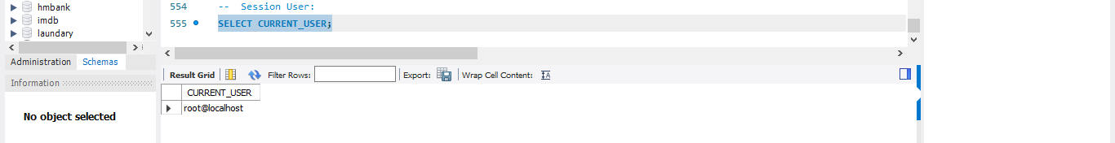

***>> CONNECTION ID***

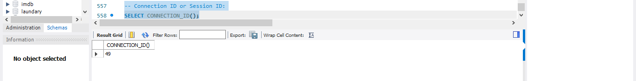

* ***DATA CLEANSING AND MANIPULATION***

***>> Handling Missing Values***

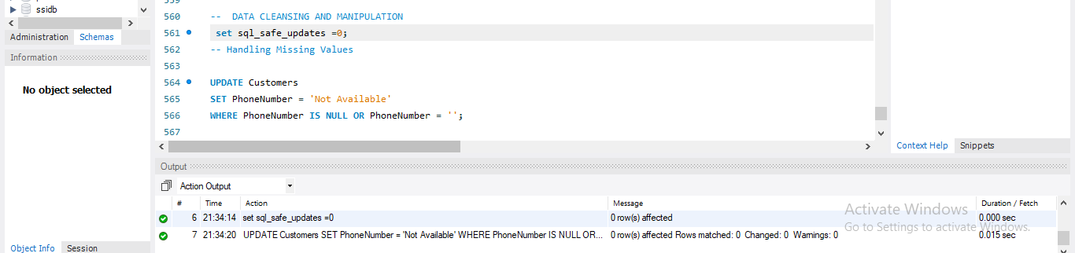

***>> Handling Null Values***

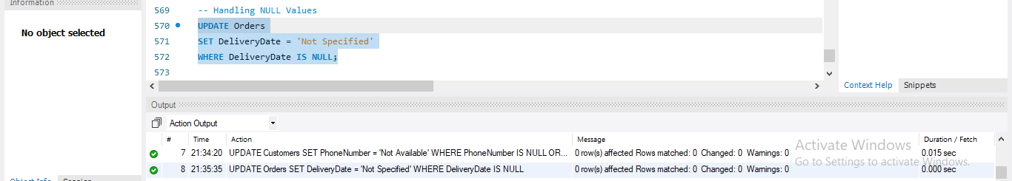

***>> REMOVING UNNECESSARY SPACES***

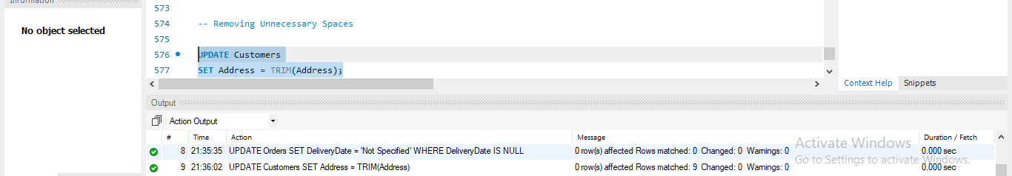

***>> REMOVING IRRELEVANT DATA***

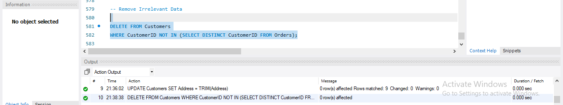

***>> REMOVE DUPLICATE DATA***

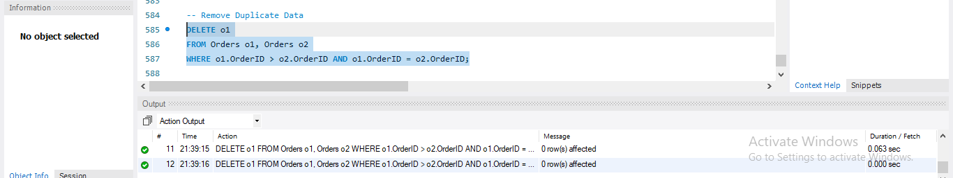

***>> FIX STRUCTURAL ERRORS***

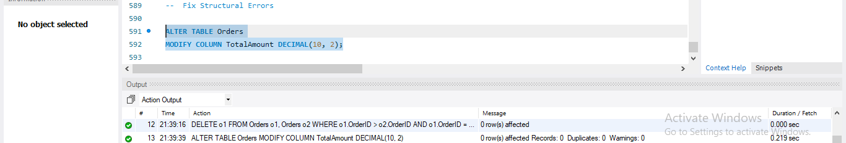

***>> TYPE CONVERSION***

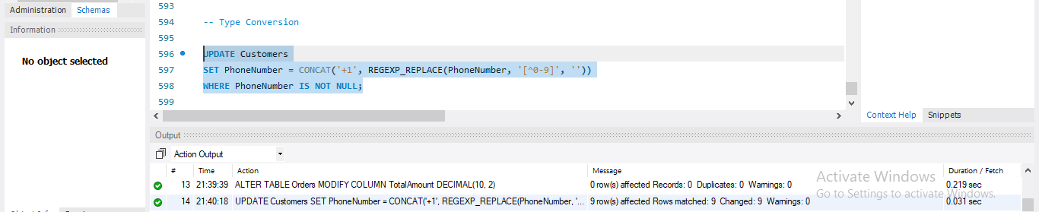

***>> DEAL WITH OUTLIERS***

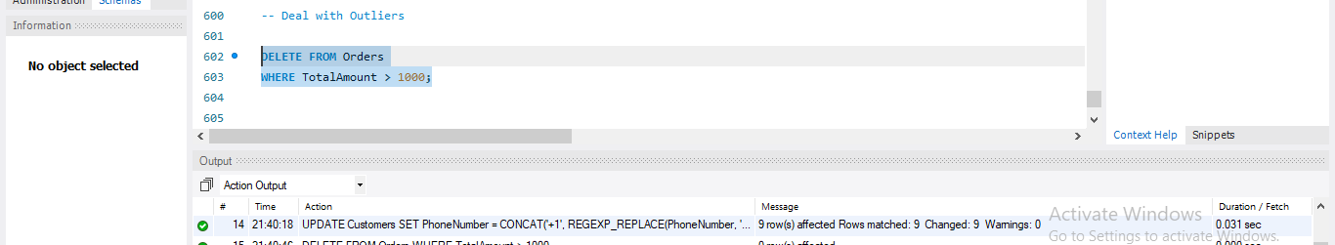

***>> STANDARDIZE / NORMALIZE DATA***

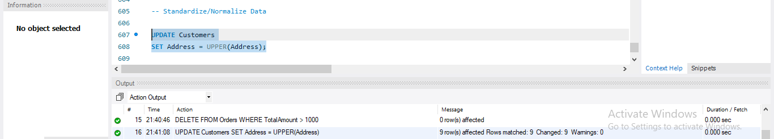

***>> VALIDATE DATA***

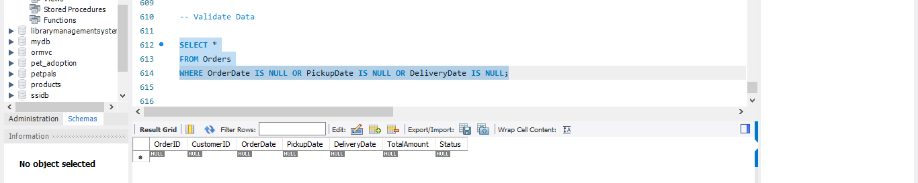

* ***RANKING FUNCTIONS***

***>> RANK***

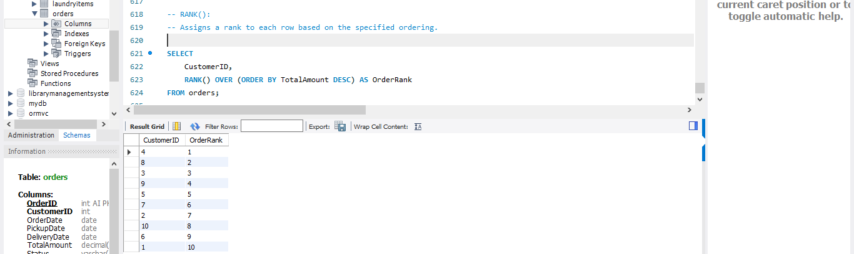

***>> ROW NUMBER***

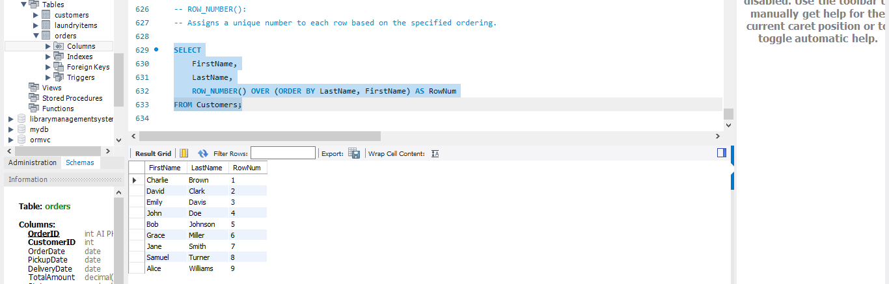

***>> DENSE_RANK***

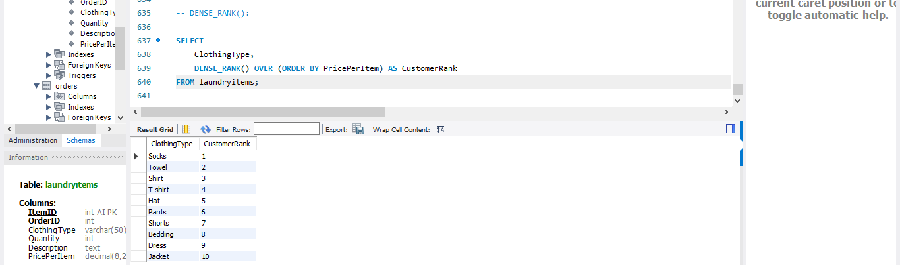

***>> NTILE***

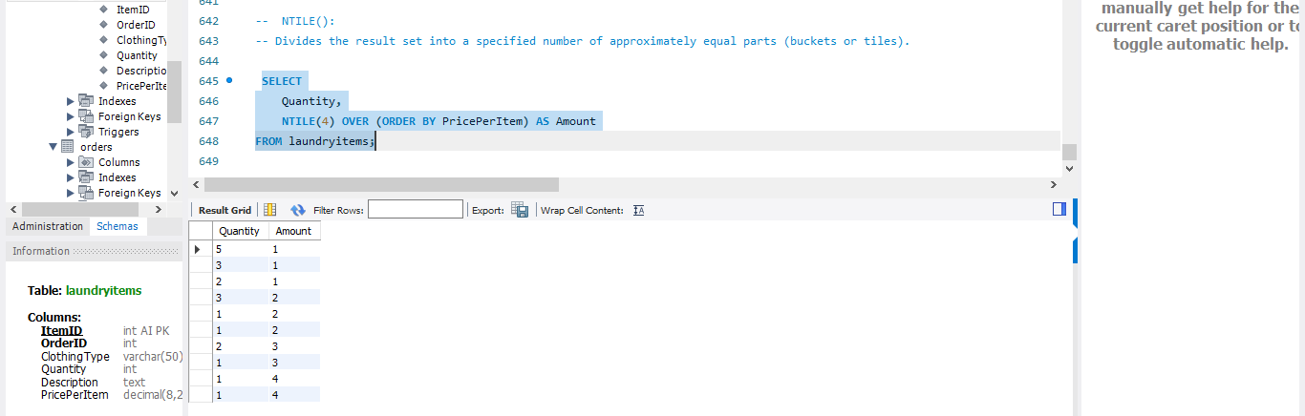

***>> PERCENT_RANK***

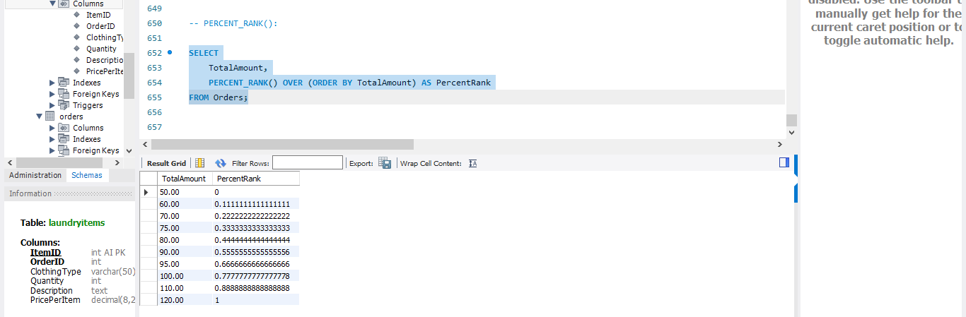

***>> CUME_DIST***

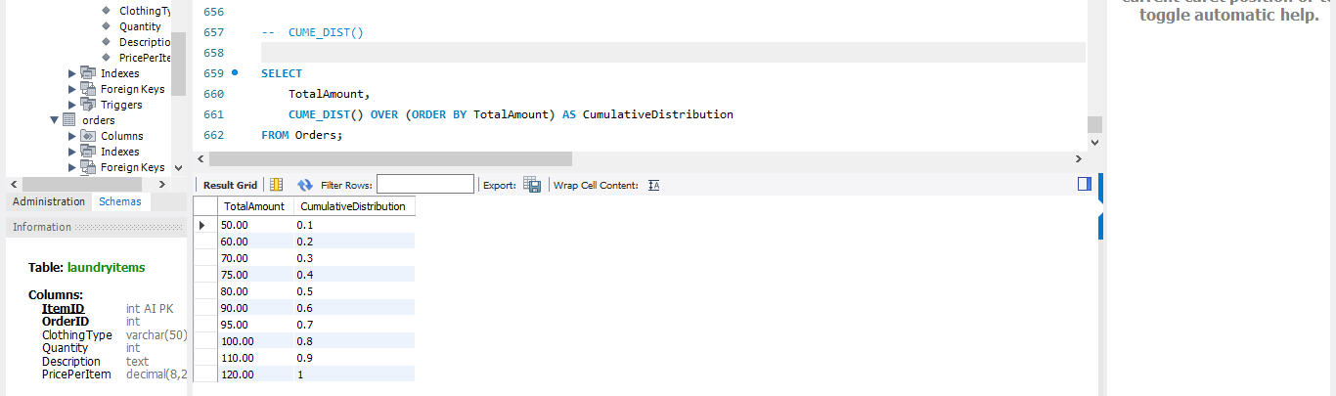

* ***STORED PROCEDURES***

***>>STORED PROCEDURE TO GETCUSTOMERINFO***

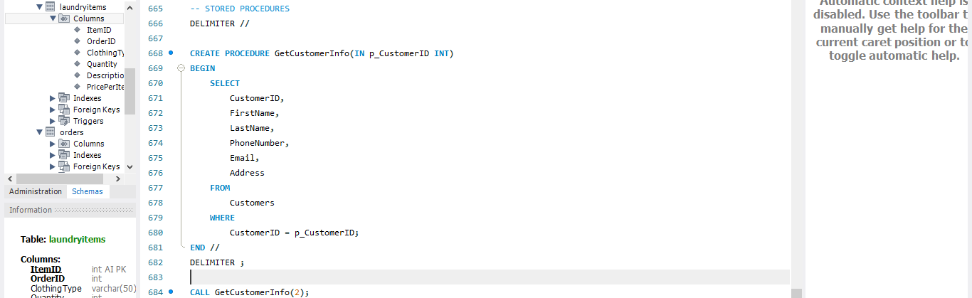

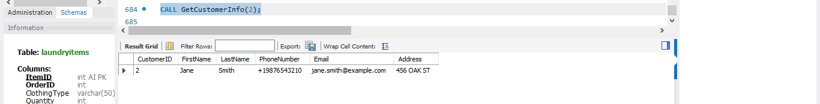

***>> STORED PROCEDURE TO GETCUSTOMERORDERS***

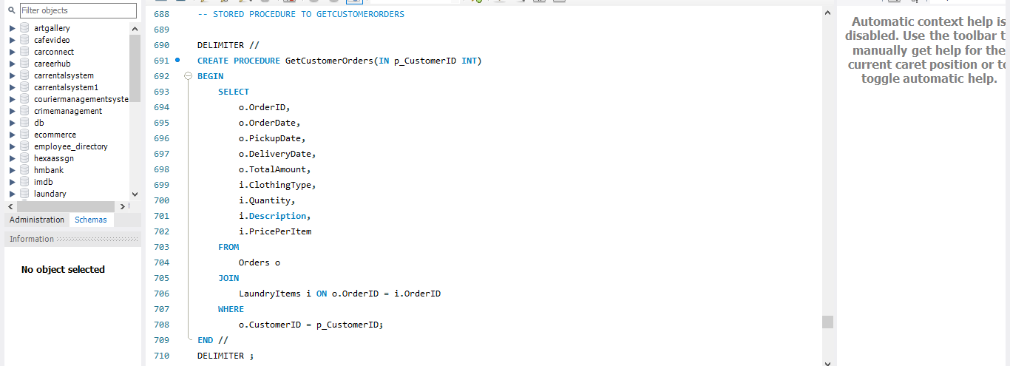

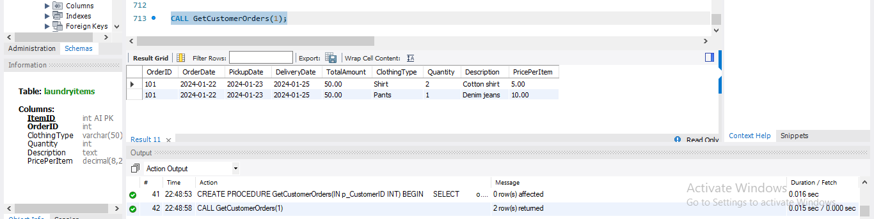

***>> Stored procedure to update the delivery date of an order***

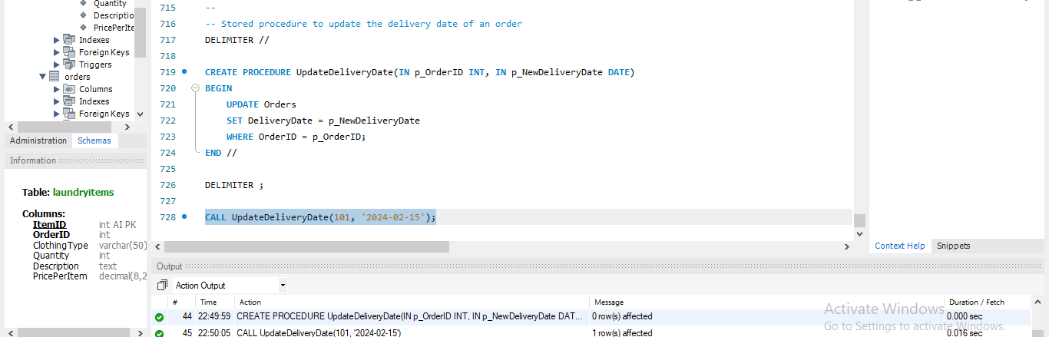

***>> Stored procedure to calculate the total cost for a specific order***

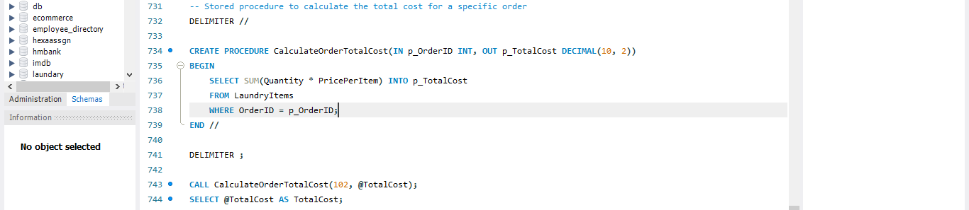

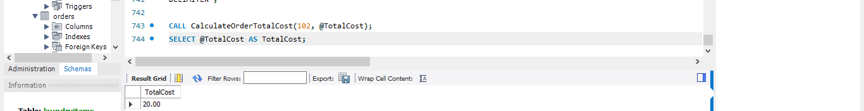

***>>- Stored procedure to insert a new customer***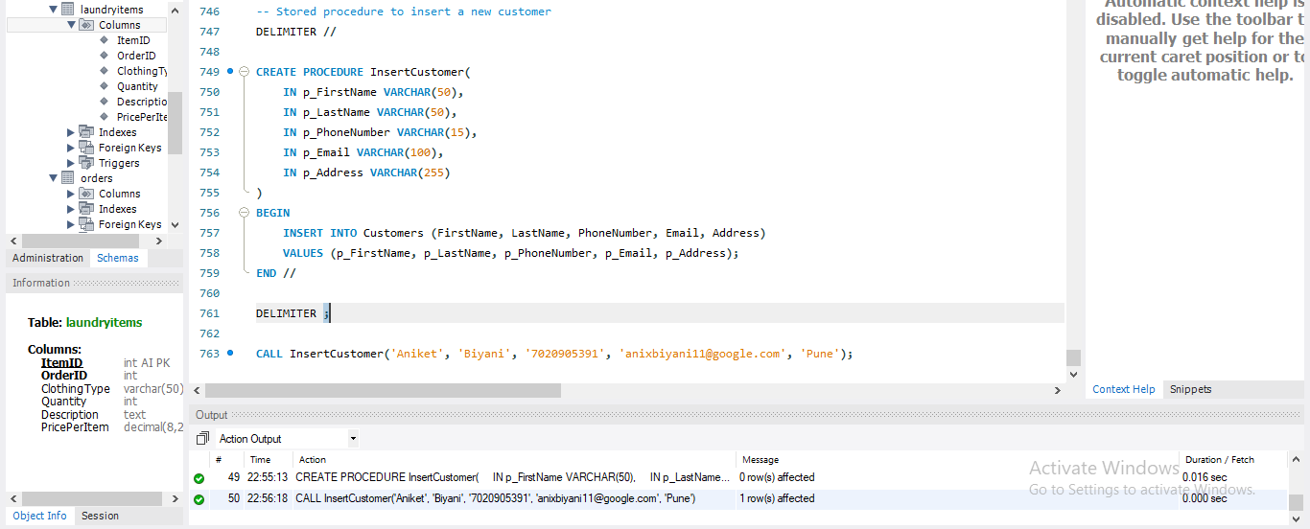

***>> Stored procedure to delete a customer***

